DirectX Tool Kit for DirectX 12 Simple Sample

*This sample is compatible with the Windows 10 Creators Update SDK (15063)*

# Description

The SimpleSample demo shows how to link to the DirectXTK library and demonstrates the use of several DirectXTK components:

* SpriteBatch is used to render a Windows logo
* SpriteFont and SpriteBatch are used to render text
* GeometricPrimitive is used to render a teapot
* PrimitiveBatch is used to render the grid
* Model is used to render a mesh loaded from the legacy DirectX SDK .SDKMESH file "Tiny.SDKMESH"
* Several textures are loaded using DDSTextureLoader
* Plays a looping sound and timed 'one-shot' audio
* Demonstrates a simple handling of audio device scenarios for DirectX for Audio

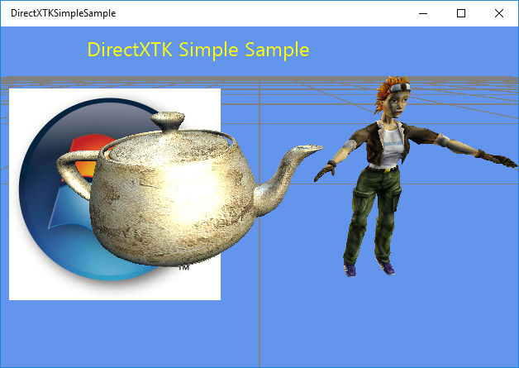

# Using the sample

The sample has no controls other than exiting via the View button or Esc key.

# Implementation notes

This sample includes the DirectX Tool Kit library for DirectX 12 which is available on [GitHub](https://github.com/Microsoft/DirectXTK12).

## UWP on Xbox

To support DirectX 12 on Xbox One, a UWP app must have its app type set to ‘Game’. Otherwise, only the software device (WARP12) is available on developer consoles, which is unsupported for retail consoles. During development the app type can be set via DevHome. This sample uses the [expandedResources](https://msdn.microsoft.com/en-us/library/windows/desktop/mt808808.aspx) restricted capability to achieve this by default, but can be removed after setting the package app type to ‘Game’. Note that apps submitted to the Windows Store will fail validation if using this restricted capability.

# Update history

Initial release June 2016. Updated October 2017 for UWP on Xbox One.

# Privacy statement

When compiling and running a sample, the file name of the sample executable will be sent to Microsoft to help track sample usage. To opt-out of this data collection, you can remove the block of code in Main.cpp labeled “Sample Usage Telemetry”.

For more information about Microsoft’s privacy policies in general, see the [Microsoft Privacy Statement](https://privacy.microsoft.com/en-us/privacystatement/).