

SimpleCompute Sample for Direct3D 11

*This sample is compatible with the Windows 10 Fall Creators Update SDK (16299)*

# Description

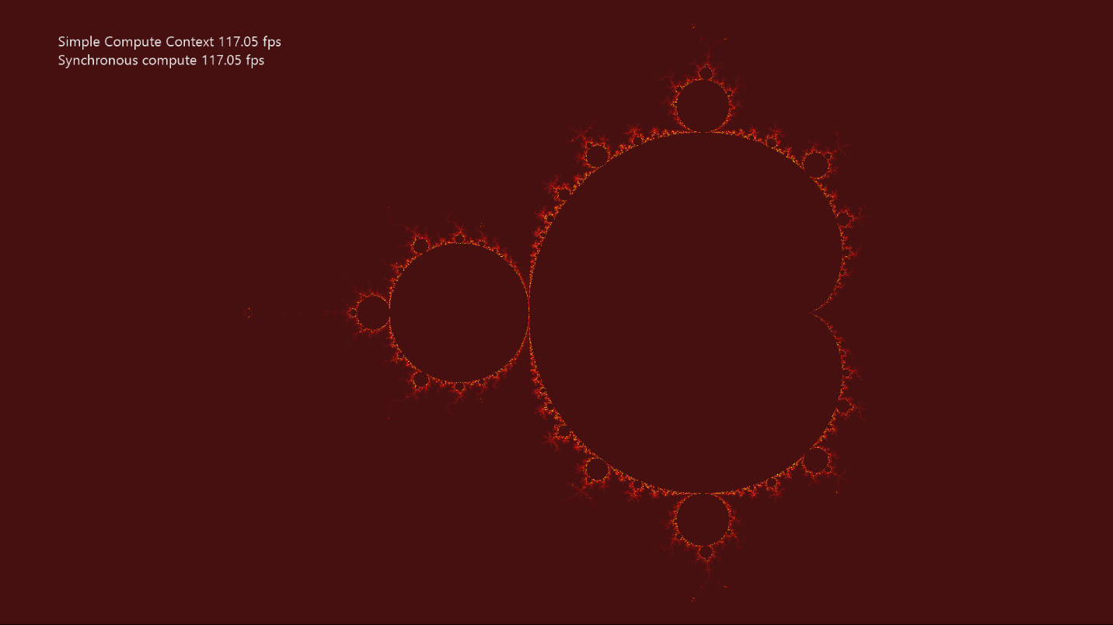

SimpleCompute shows how to use DirectCompute™ (i.e. Direct3D Compute Shader). It updates a texture by computing the Mandelbrot set using a compute shader.

# Using the sample

|  |  |  |
| --- | --- | --- |
| Action | Gamepad | Keyboard |
| Reset Viewport to Default | Y button | Home |
| Pan Viewport | Left stick | WASD |
| Zoom Viewport | Right stick | PgUp/PgDn |
| Increase Zoom Speed | Right trigger | Shift + PgUp/PgDn |
| Exit | View Button | Esc |
| Menu | Show/hide help | F1 |

# Implementation notes

The primary purpose of this sample is to familiarize the reader with creating and using a simple compute shader.

* **CreateDeviceDependentResources**: This is where the compiled compute shader is loaded and the various Direct3D rendering resources are created. The shaders are compiled by Visual Studio.
* **Render**: The compute shader is dispatched before the draw call that needs the results is dispatched. This updates the texture every frame.

## Hardware Feature Level Requirement

The DirectCompute (Shader Model 5) feature of DirectX 11 requires [Direct3D Hardware Feature Level 11.0](https://blogs.msdn.microsoft.com/chuckw/2012/06/20/direct3d-feature-levels/) or better hardware. Note that a limited form of DirectCompute (Shader Model 4.x) is optionally supported on some Feature Levl 10.x hardware, but this scenario is not supported by this sample.

## UWP on Xbox One

Note that this sample always uses the software device (WARP) on Xbox One as DirectX 11 is limited to Feature Level 10.0 (without DirectCompute) for UWP apps on that platform. See the [SimpleCompute Sample for Direct3D 12](https://aka.ms/atgsplsimplecompute12).

# Update history

Initial release September 2017

# Privacy Statement

When compiling and running a sample, the file name of the sample executable will be sent to Microsoft to help track sample usage. To opt-out of this data collection, you can remove the block of code in Main.cpp labeled “Sample Usage Telemetry”.

For more information about Microsoft’s privacy policies in general, see the [Microsoft Privacy Statement](https://privacy.microsoft.com/en-us/privacystatement/).