Simple Texture Sample (DX12)

*This sample is compatible with the Windows 10 Creators Update SDK (15063)*

# Description

This sample demonstrates how to render a simple textured quad using Direct3D 12.

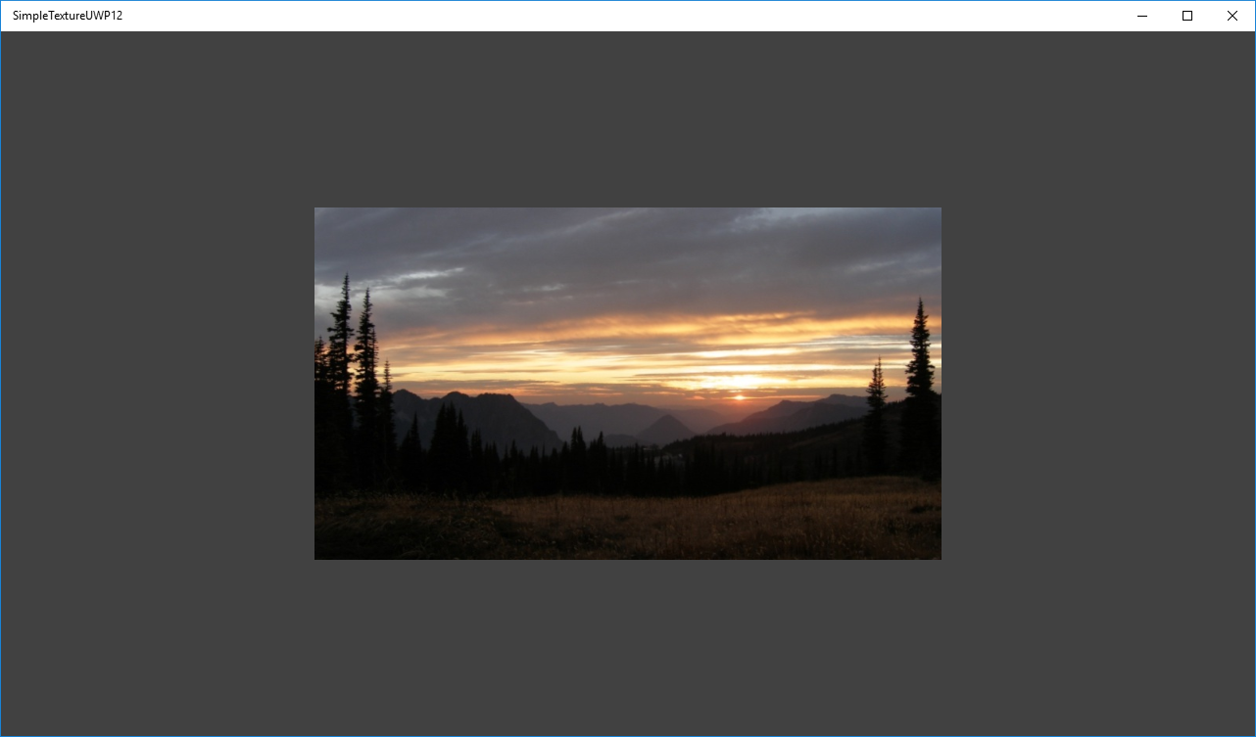

# Using the sample

The sample has no controls other than exiting.

# Implementation notes

The texture is loaded here using a simple helper that uses the Windows Imaging Component (WIC) and is designed for simplicity of learning. For production use, you should look at the DirectX Tool Kit’s [DDSTextureLoader](https://github.com/Microsoft/DirectXTK/wiki/DDSTextureLoader) and [WICTextureLoader](https://github.com/Microsoft/DirectXTK/wiki/WICTextureLoader).

## UWP on Xbox

To support DirectX 12 on Xbox One, a UWP app must have its app type set to ‘Game’. Otherwise, only the software device (WARP12) is available on developer consoles, which is unsupported for retail consoles. During development the app type can be set via DevHome. This sample uses the [expandedResources](https://msdn.microsoft.com/en-us/library/windows/desktop/mt808808.aspx) restricted capability to achieve this by default, but can be removed after setting the package app type to ‘Game’. Note that apps submitted to the Windows Store will fail validation if using this restricted capability.

# Update history

Initial release April 2016. Updated October 2017 for UWP on Xbox One.

# Privacy statement

When compiling and running a sample, the file name of the sample executable will be sent to Microsoft to help track sample usage. To opt-out of this data collection, you can remove the block of code in Main.cpp labeled “Sample Usage Telemetry”.

For more information about Microsoft’s privacy policies in general, see the [Microsoft Privacy Statement](https://privacy.microsoft.com/en-us/privacystatement/).