Simple Triangle Sample (DX12)

# *This sample is compatible with the Windows 10 April 2018 Update SDK (17134)*

# Description

This sample demonstrates how to create a static Direct3D vertex buffer to render a triangle on screen.

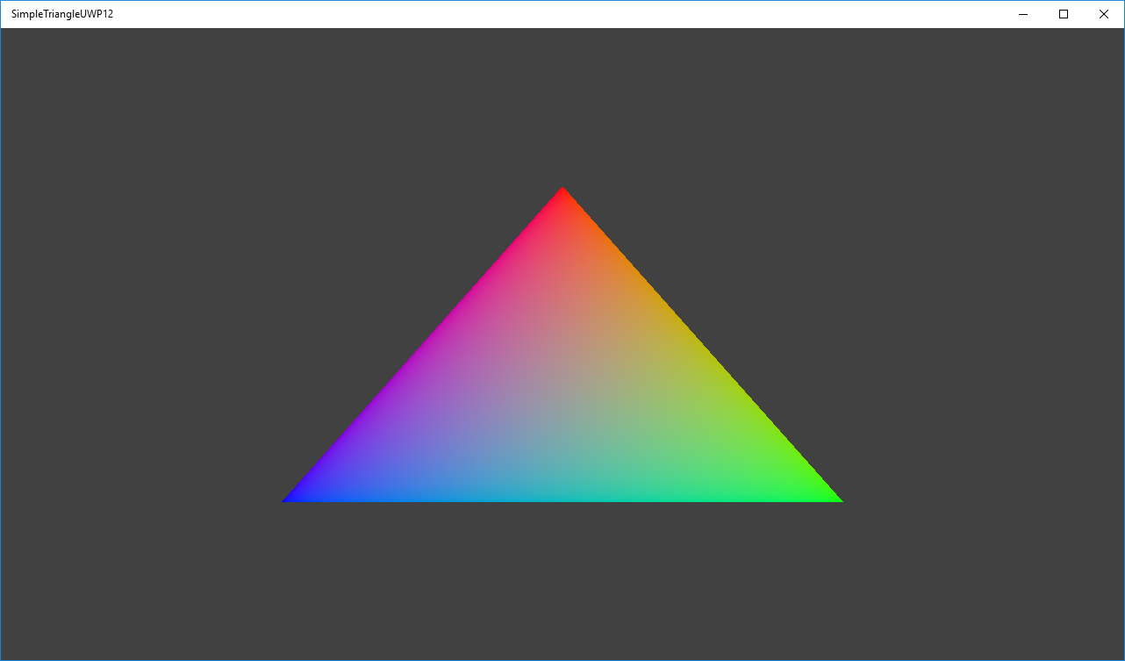

# Using the sample

The sample has no controls other than exiting.

# Implementation notes

The primary purpose of this sample is to familiarize the reader with the ATG samples template structure, as well as provide a simple demonstration of using Direct3D 12 APIs.

**CreateDeviceDependentResources**: This is where the compiled vertex and pixel shaders blobs are loaded and the various Direct3D rendering resources are created. *The shaders are compiled by Visual Studio.*

**Render:** This is where the triangle is rendered and presented to the screen.

For details on device creation and presentation handling, see [DeviceResources](https://github.com/Microsoft/DirectXTK12/wiki/DeviceResources).

For details on the use of the loop timer, see [StepTimer](https://github.com/Microsoft/DirectXTK/wiki/StepTimer).

## UWP on Xbox

To support DirectX 12 on Xbox One, a UWP app must have its app type set to ‘Game’. Otherwise, only the software device (WARP12) is available on developer consoles, which is unsupported for retail consoles. During development the app type can be set via DevHome. This sample uses the [expandedResources](https://msdn.microsoft.com/en-us/library/windows/desktop/mt808808.aspx) restricted capability to achieve this by default, but can be removed after setting the package app type to ‘Game’. Note that apps submitted to the Windows Store will fail validation if using this restricted capability.

# Update history

Initial release March 2016. Updated October 2017 for UWP on Xbox One.

# Privacy statement

When compiling and running a sample, the file name of the sample executable will be sent to Microsoft to help track sample usage. To opt-out of this data collection, you can remove the block of code in Main.cpp labeled “Sample Usage Telemetry”.

For more information about Microsoft’s privacy policies in general, see the [Microsoft Privacy Statement](https://privacy.microsoft.com/en-us/privacystatement/).