

Collision Sample

*This sample is compatible with the Windows 10 Creators Update SDK (15063)*

# Description

This sample demonstrates DirectXMath’s collision types for simple bounding volume tests in a UWP app.

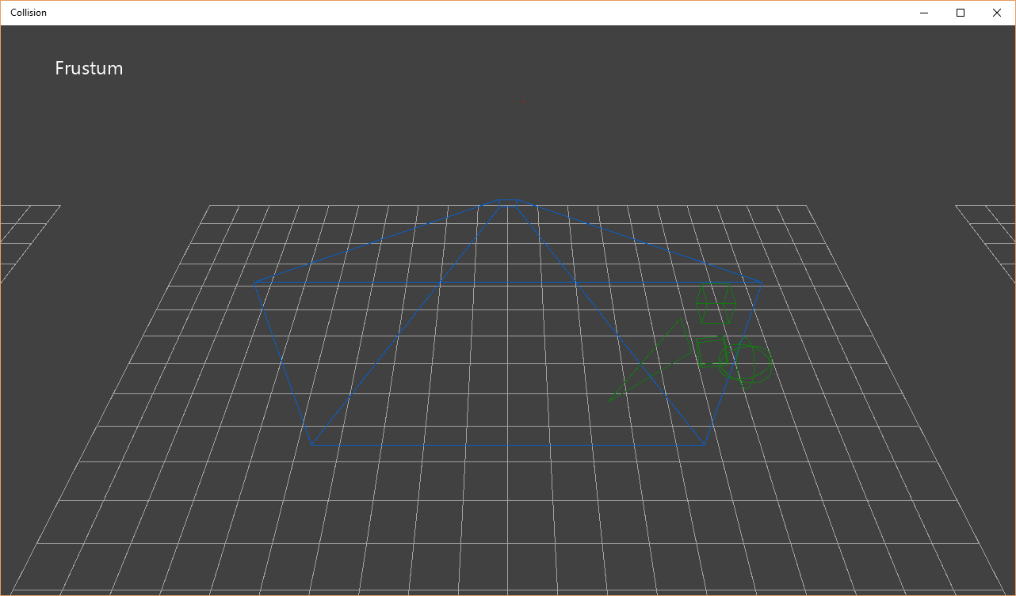

# Using the sample

The sample shows four different ‘collision’ groups:

1. A static bounding **frustum** colliding with an animated sphere, axis-aligned box, oriented box, and a triangle.
2. A static **axis-aligned box** colliding with an animated sphere, axis-aligned box, oriented box, and a triangle.
3. A static **oriented box** colliding with an animated sphere, axis-aligned box, oriented box, and a triangle.
4. An animated **ray** colliding with a static sphere, axis-aligned box, oriented box, and a triangle. If there is a ray hit, a marker box is placed at the intersection point on the target object.

|  |  |  |
| --- | --- | --- |
| Action | Gamepad | Keyboard |
| Orbit camera X/Y around group | Right Thumbstick | WASD, Arrow Keys |
| Reset view | Right Thumstick Button | Home |
| Focus on Frustum group | DPad Up | 1 |
| Focus on Axis-aligned box group | DPad Right | 2 |
| Focus on Oriented box group | DPad Down | 3 |
| Focus on Ray test group | DPad Left | 4 |
| Toggle help | Menu Button | F1 |
| Exit | View Button | Esc |

# Implementation notes

For more on DirectXMath’s bounding volume types, see [MSDN](https://msdn.microsoft.com/en-us/library/windows/desktop/hh437833.aspx) for:

* **BoundingBox** class
* **BoundingFrustum** class
* **BoundingOrientedBox** class
* **BoundingSphere** class
* **TriangleTests** namespace

The latest version of DirectXMath is available on [GitHub](https://github.com/Microsoft/DirectXMath).

# Known issues

DirectXMath’s **BoundingFrustum** class only works with left-handed viewing systems.

# Update history

Initial release of the UWP version of this sample made in May 2016. The most recent legacy DirectX SDK version of this sample can be found on [GitHub](https://github.com/walbourn/directx-sdk-samples/tree/master/Collision).

# Privacy statement

When compiling and running a sample, the file name of the sample executable will be sent to Microsoft to help track sample usage. To opt-out of this data collection, you can remove the block of code in Main.cpp labeled “Sample Usage Telemetry”.

For more information about Microsoft’s privacy policies in general, see the [Microsoft Privacy Statement](https://privacy.microsoft.com/en-us/privacystatement/).