Gamepad Vibration Sample

*This sample is compatible with the Windows 10 Fall Creators Update SDK (16299)*

# Description

This sample demonstrates how to use vibration with a gamepad in a Universal Windows Platform (UWP) app.

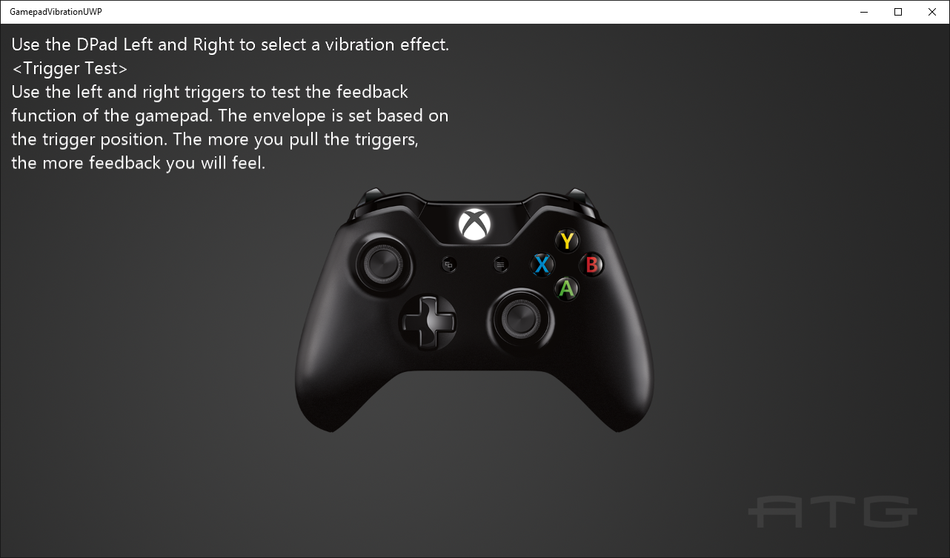

# Using the sample

Use left and right on the DPad to cycle between different vibration examples. Use the triggers in most of these examples to increase the amount of vibration.

# Implementation notes

This sample demonstrates how to use Windows.Gaming.Input to set vibration levels on a gamepad, including the impulse triggers introduced with the Xbox One gamepad.

For more information on Windows.Gaming.Input, see [MSDN](https://msdn.microsoft.com/en-us/library/windows/apps/windows.gaming.input.aspx).

# Update history

Initial release April 2016

# Privacy statement

When compiling and running a sample, the file name of the sample executable will be sent to Microsoft to help track sample usage. To opt-out of this data collection, you can remove the block of code in Main.cpp labeled “Sample Usage Telemetry”.

For more information about Microsoft’s privacy policies in general, see the [Microsoft Privacy Statement](https://privacy.microsoft.com/en-us/privacystatement/).