

NLS and Localization Sample

# *This sample is compatible with the Windows 10 April 2018 Update SDK (17134)*

# Description

This sample demonstrates how to localize package manifest as well as in-title resources. It also demonstrate usage of the NLS APIs.

## Main Screen

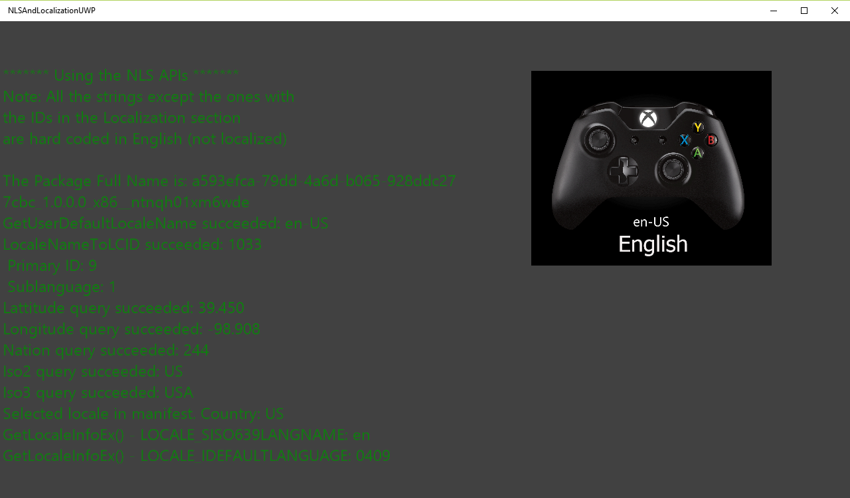

|  |  |  |
| --- | --- | --- |
| Action | Gamepad | Keyboard |
| Exit | View Button | Esc |

# Implementation notes

# This sample is used to demonstrate how to localize a title. It localizes the resources referred in the package manifest as well as the in-title resources. The GetUserDefaultLocaleName() API determines which locale would be the best for localization. This value is based on the console’s locale as well as the locales that the game supports. The GetUserGeoID() and GetGeoInfoW() APIs can be used to retrieve the details about the console locale. The GetUserLocaleEx() API can be used to retrieve more details about the fallback locale in case the console locale is not supported by the title.

# The resource parser used in the sample is a basic temporary parser which does not offer any error checking. The resources are listed in a basic format. So please don’t use the parser and the resource files as is, because it hasn’t been tested and the resources format is not a standard format. It is better to use a proper XML format with a better parser for your localized strings. The goal of the sample is to help developers familiarize with the procedure for localizing resources.

# Update history

Initial release May 2016

# Privacy statement

When compiling and running a sample, the file name of the sample executable will be sent to Microsoft to help track sample usage. To opt-out of this data collection, you can remove the block of code in Main.cpp labeled “Sample Usage Telemetry”.

For more information about Microsoft’s privacy policies in general, see the [Microsoft Privacy Statement](https://privacy.microsoft.com/en-us/privacystatement/).