RawGameControllerUWP Sample

# *This sample is compatible with the Windows 10 Fall Creators Update SDK (16299)*

# Description

This sample demonstrates how to read inputs from a gamepad using RawGameController in a Universal Windows Platform (UWP) app.

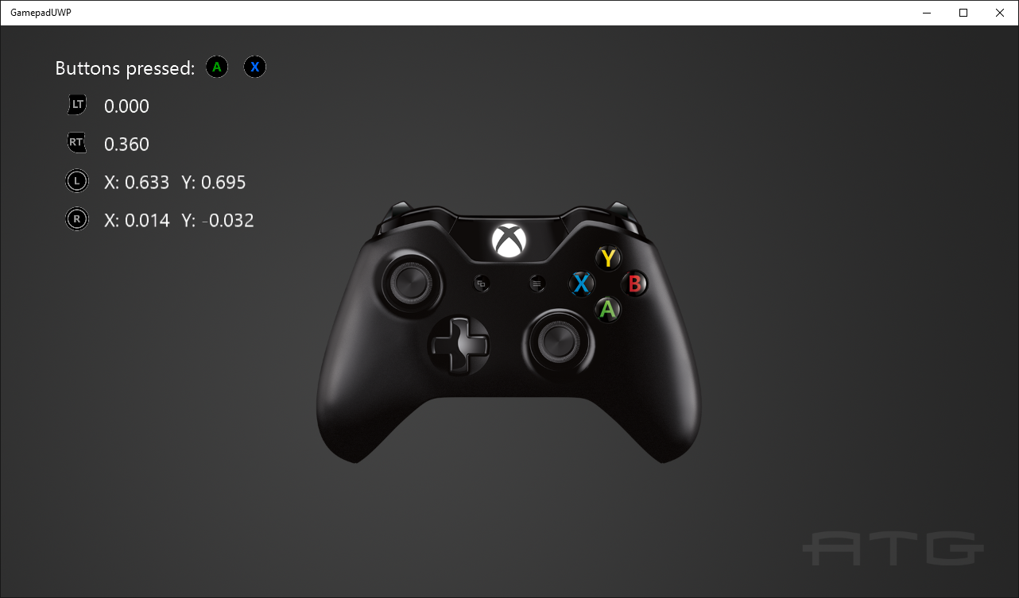

# Using the sample

Press buttons to see them displayed and move the thumbsticks and triggers to see their readings.

# Implementation notes

This sample demonstrates how to use Windows.Gaming.Input RawGameController to read input from a gamepad, including thumbsticks and triggers. Running this sample requires the Windows 10 Creators Update (15063) or later.

For more information on Windows.Gaming.Input, see [MSDN](https://msdn.microsoft.com/en-us/library/windows/apps/windows.gaming.input.aspx).

# Update history

Initial release March 2017

# Privacy statement

When compiling and running a sample, the file name of the sample executable will be sent to Microsoft to help track sample usage. To opt-out of this data collection, you can remove the block of code in Main.cpp labeled “Sample Usage Telemetry”.

For more information about Microsoft’s privacy policies in general, see the [Microsoft Privacy Statement](https://privacy.microsoft.com/en-us/privacystatement/).