SystemInfo Sample

*This sample is compatible with the Windows 10 Fall Creators Update SDK (16299)*

# Description

This sample demonstrates a number of Universal Windows Platform (UWP) APIs for querying system information, statistics, and hardware capabilities.

# Using the sample

This sample displays a series of text pages with technical information.

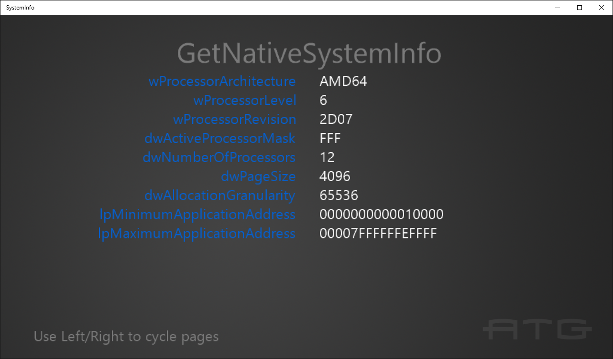

To switch between pages with the keyboard, use the left & right arrow keys.

To switch between pages with the gamepad controller, use A or DPad Right / B or DPad Left.

# Implementation notes

The important code is in the switch case within the **Render** function.

## UWP on Xbox

To support DirectX 12 on Xbox One, a UWP app must have its app type set to ‘Game’. Otherwise, only the software device (WARP12) is available on developer consoles, which is unsupported for retail consoles. During development the app type can be set via DevHome. This sample uses the [expandedResources](https://msdn.microsoft.com/en-us/library/windows/desktop/mt808808.aspx) restricted capability to achieve this by default, but can be removed after setting the package app type to ‘Game’. Note that apps submitted to the Windows Store will fail validation if using this restricted capability.

# Update history

Initial release March 2016. It was updated in August 2016 for new Windows 10 Anniversary Update SDK APIs.

December 2016: Added EasClientInformation output.

February 2017: Added DisplayInformation including new Anniversary Update (14393) properties.

October 2017: Updated for new Direct3D optional features and API contracts.

# Privacy statement

When compiling and running a sample, the file name of the sample executable will be sent to Microsoft to help track sample usage. To opt-out of this data collection, you can remove the block of code in Main.cpp labeled “Sample Usage Telemetry”.

For more information about Microsoft’s privacy policies in general, see the [Microsoft Privacy Statement](https://privacy.microsoft.com/en-us/privacystatement/).