UserGamepadPairing Sample

*This sample is compatible with the Windows 10 Fall Creators Update SDK (16299)*

# Description

This sample demonstrates how to get the user assigned to a given gamepad in UWP

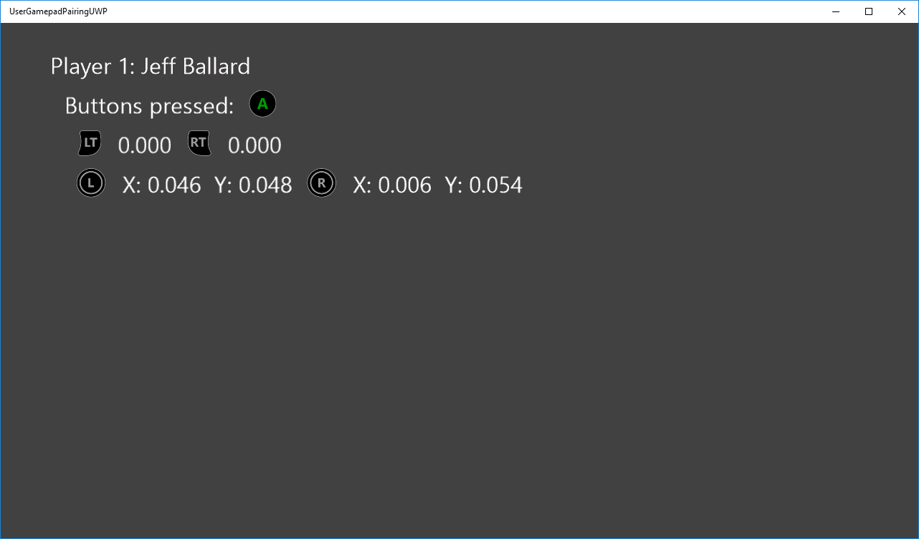

# Using the sample

Provide input to see them displayed under each user.

# Implementation notes

This sample demonstrates how to use Windows.Gaming.Input to read input from a gamepad controller while also getting the user data attached to it. Running this sample requires the Windows 10 Anniversary Update (14393) or later.

For more information on Windows.Gaming.Input, see [MSDN](https://msdn.microsoft.com/en-us/library/windows/apps/windows.gaming.input.aspx).

# Update history

Initial release August 2016

# Privacy statement

When compiling and running a sample, the file name of the sample executable will be sent to Microsoft to help track sample usage. To opt-out of this data collection, you can remove the block of code in Main.cpp labeled “Sample Usage Telemetry”.

For more information about Microsoft’s privacy policies in general, see the [Microsoft Privacy Statement](https://privacy.microsoft.com/en-us/privacystatement/).