DirectX Tool Kit Simple Sample

*This sample is compatible with the November 2015 Xbox One XDK or later.*

# Description

The SimpleSample demo shows how to link to the DirectXTK library and demonstrates the use of several DirectXTK components:

* SpriteBatch is used to render a Windows logo
* SpriteFont and SpriteBatch are used to render text
* GeometricPrimitive is used to render a teapot
* PrimitiveBatch is used to render the grid
* Model is used to render a mesh loaded from the legacy DirectX SDK .SDKMESH file "Tiny.SDKMESH"
* Several textures are loaded using XboxDDSTextureLoader
* Plays a looping sound and timed 'one-shot' audio
* Demonstrates a simple handling of audio device scenarios for *DirectX for Audio*

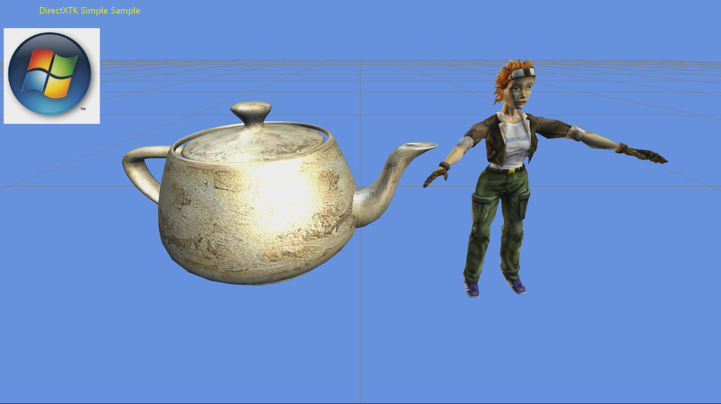

# Using the sample

The sample has no controls other than exiting via the View button.

# Implementation notes

This sample includes the DirectX Tool Kit library which is available on [GitHub](https://github.com/Microsoft/DirectXTK/).

# Update history

Initial release December 2013. Rewrite using new ATG sample template released March 2016. In April 2017, it was updated to support 4k swap chains when run on Project Scorpio.

# Privacy Statement

When compiling and running a sample, the file name of the sample executable will be sent to Microsoft to help track sample usage. To opt-out of this data collection, you can remove the block of code in Main.cpp labeled “Sample Usage Telemetry”.

For more information about Microsoft’s privacy policies in general, see the [Microsoft Privacy Statement](https://privacy.microsoft.com/en-us/privacystatement/).