Simple Triangle Sample (DX12)

*This sample is compatible with the August 2016 Xbox One XDK or later*

# Description

This sample demonstrates how to create a static Direct3D vertex buffer to render a triangle on screen.

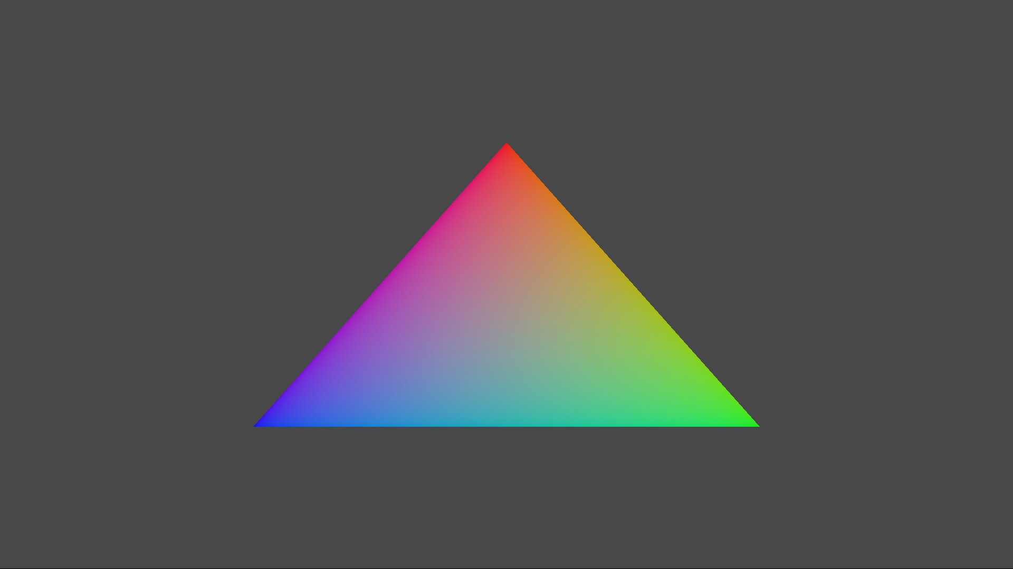

# Using the sample

The sample has no controls other than exiting.

# Implementation notes

The primary purpose of this sample is to familiarize the reader with the ATG samples template structure, as well as provide a simple demonstration of using Direct3D 12 APIs.

**CreateDeviceDependentResources**: This is where the compiled vertex and pixel shaders blobs are loaded and the various Direct3D rendering resources are created. *The shaders are compiled by Visual Studio.*

**Render:** This is where the triangle is rendered and presented to the screen.

For details on device creation and presentation handling, see [DeviceResources](https://github.com/Microsoft/DirectXTK12/wiki/DeviceResources).

For details on the use of the loop timer, see [StepTimer](https://github.com/Microsoft/DirectXTK/wiki/StepTimer).

# Update history

Initial release December 2014. Rewrite using new ATG sample template released March 2016. In April 2017, it was updated to support 4k swap chains when run on Project Scorpio.

# Privacy Statement

When compiling and running a sample, the file name of the sample executable will be sent to Microsoft to help track sample usage. To opt-out of this data collection, you can remove the block of code in Main.cpp labeled “Sample Usage Telemetry”.

For more information about Microsoft’s privacy policies in general, see the [Microsoft Privacy Statement](https://privacy.microsoft.com/en-us/privacystatement/).