Gamepad Sample

*This sample is compatible with the November 2015 Xbox One XDK or later*

# Description

This sample demonstrates how to read inputs from a gamepad one the Xbox One

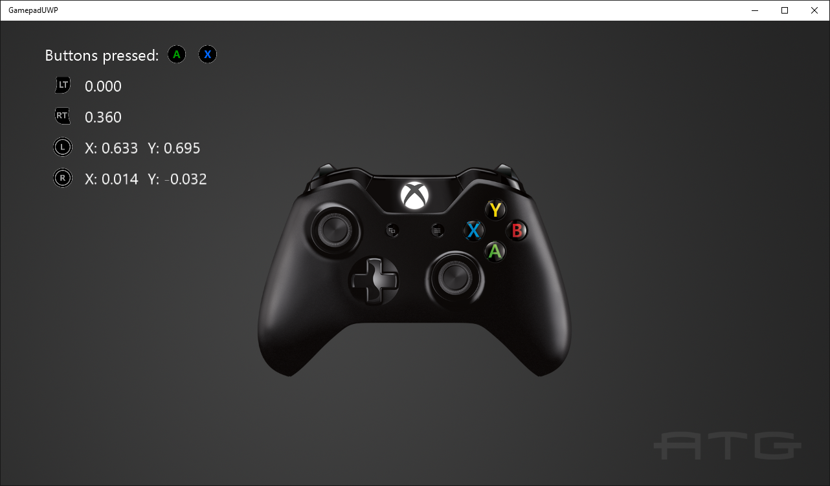

# Using the sample

Press buttons to see them displayed and move the thumbsticks and triggers to see their readings.

# Implementation notes

This sample demonstrates how to use Windows.Xbox.Input to read input from a gamepad, including thumbsticks and triggers.

For more information on Windows.Xbox.Input, see [GDNP](https://developer.xboxlive.com/en-us/platform/development/documentation/software/Pages/durangocontroller_overview_mar16.aspx).

# Update history

Initial release May 2016