Gamepad C++/WinRT Sample

*This sample is compatible with the March 2017 Xbox One XDK or later*

# Description

This sample demonstrates how to read inputs from a gamepad one the Xbox One using the C++/WinRT projection headers.

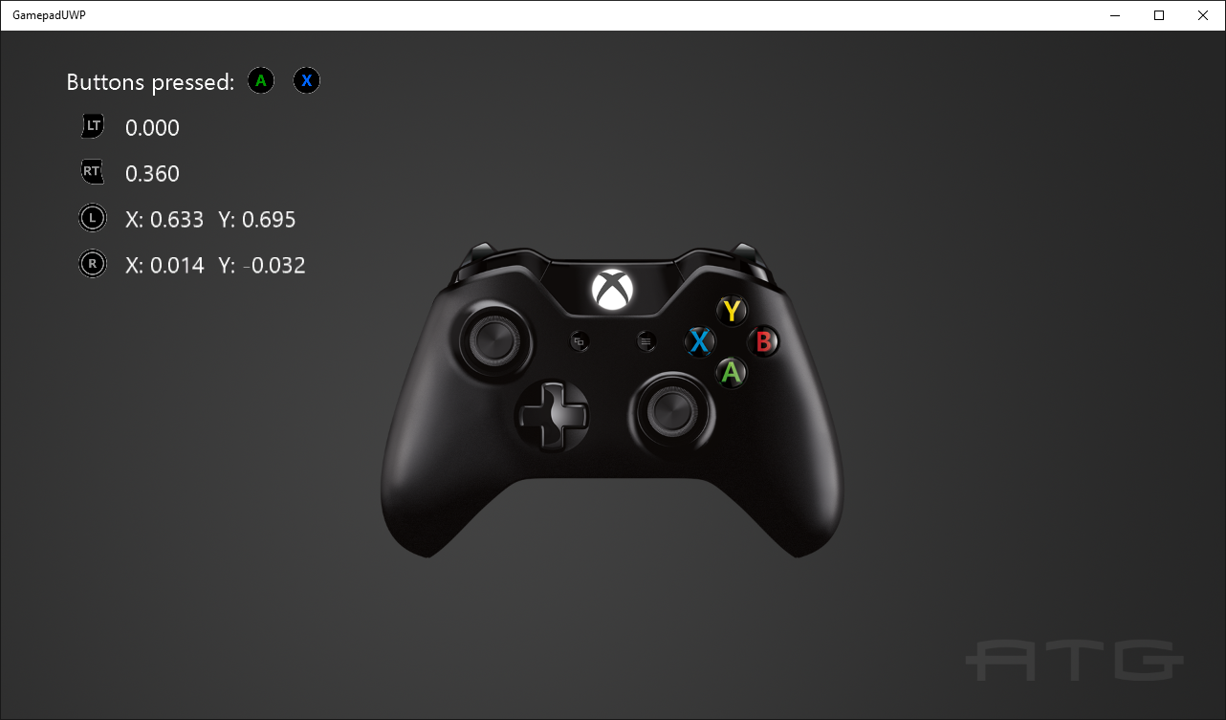

# Using the sample

Press buttons to see them displayed and move the thumbsticks and triggers to see their readings.

# Implementation notes

This sample demonstrates how to use Windows.Xbox.Input to read input from a gamepad, including thumbsticks and triggers. It was implemented with the [C++/WinRT projection headers](https://aka.ms/cpp-winrt-getstarted).

For more information on Windows.Xbox.Input, see [GDNP](https://developer.xboxlive.com/en-us/platform/development/documentation/software/Pages/durangocontroller_overview_mar16.aspx).

*This sample is set up to use Visual Studio 2017 (15.5 update). C++/WinRT is supported with VS 2015 Update 3, but VS 2017 (15.5 update) or later is strongly recommended.*

# Update history

Initial release January 2017. Updated for changes to C++/WinRT between the preview (1610) and final version (1703) in March 2017. Updated to use VS 2017 in March 2018.