SystemInfo Sample

# *This sample is compatible with the August 2016 Xbox One XDK or later*

# Description

This sample demonstrates a number of Xbox One APIs for querying system information and hardware capabilities.

# Using the sample

This sample displays a series of text pages with technical information.

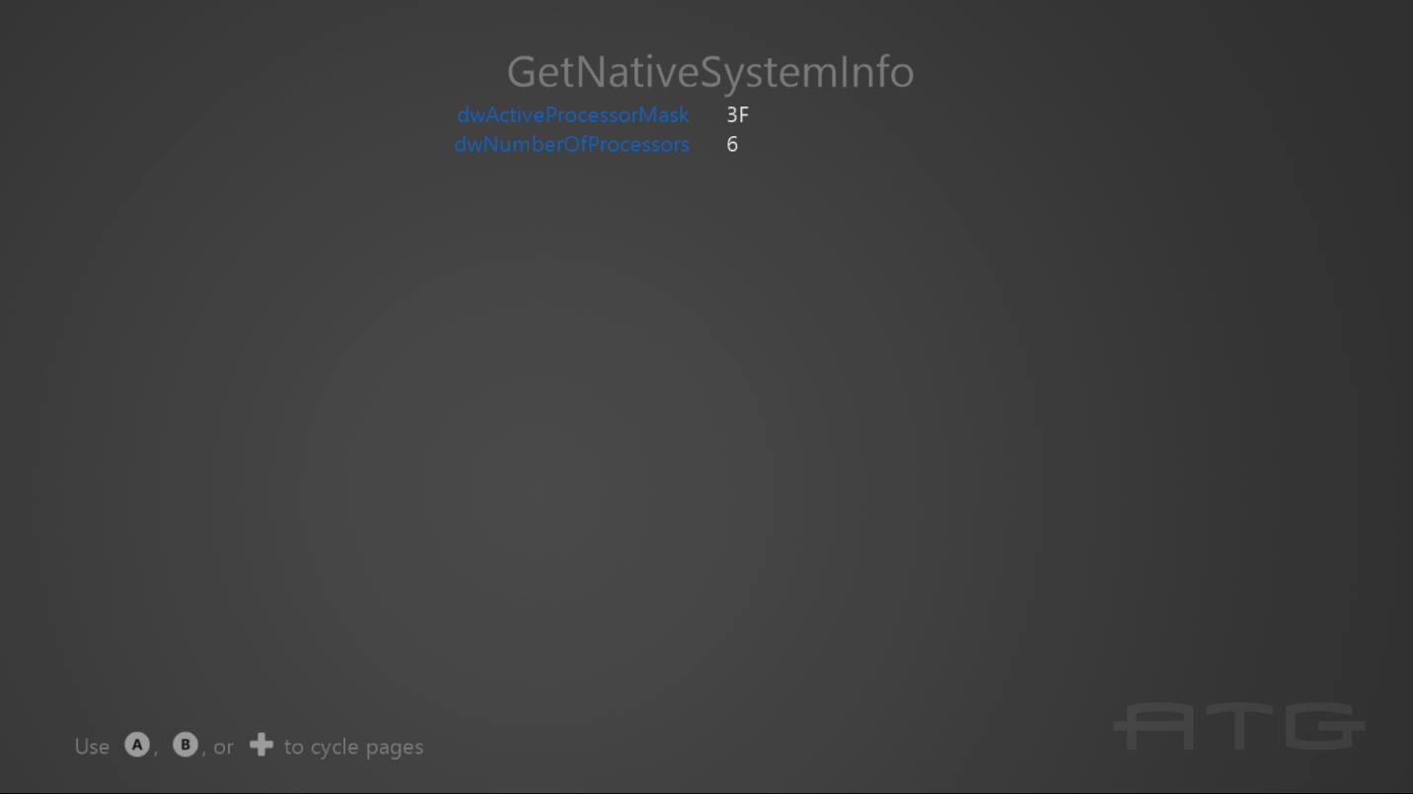

To switch between pages with the gamepad controller, use A or DPad Right / B or DPad Left.

# Implementation notes

The important code is in the switch case within the **Render** function.

# Update history

Initial release for October 2016. Updated for the June 2017 release and the GetConsoleType API.