

CustomSigninUI Sample

*This sample is compatible with the Windows 10 Anniversary Update SDK (14393) and the Xbox Live SDK 1608-160715-003. It requires the Windows 10 Anniversary Update.*

# Description

Xbox Live enabled UWP titles can use the Xbox Live Services SDK to provide customizations to the user sign in UI. This includes setting a game category, selecting emphasis features, and adjusting the background color and image.

This sample is meant to augment the whitepaper [Xbox Live Sign-In APIs – UX Guidance](https://developer.xboxlive.com/en-us/platform/development/education/Documents/Xbox%20Live%20Sign-In%20APIs%20-%20UX%20Guidance.aspx).

The default sign in UI:

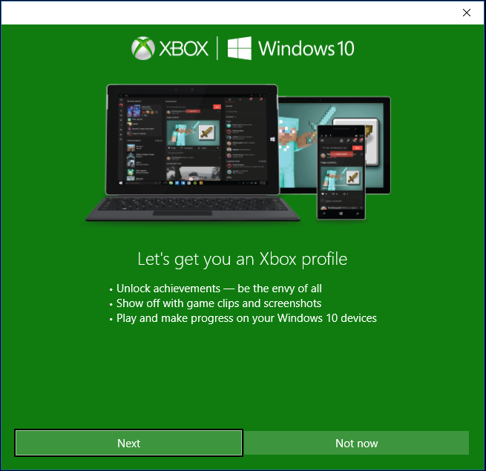

And here is an example of customized UI:

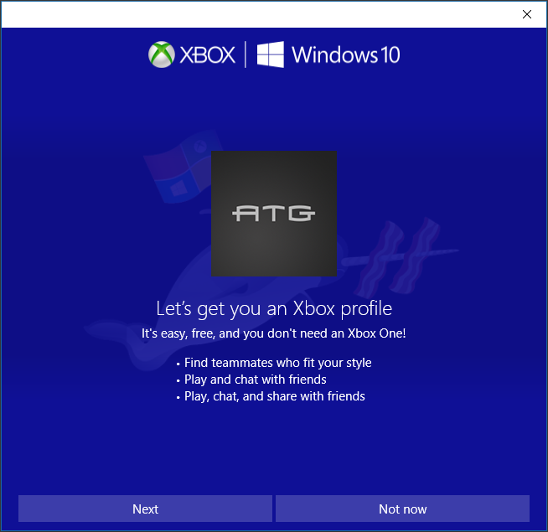

# Building the sample

In order to build the sample, you will need the Xbox Live SDK downloaded and included in your NuGet package manager sources.

The sample declares a dependency on XboxLiveSDK-1608-160715-003, but can safely be re-targeted to any Xbox Live SDK 1604 or later.

# Using the sample

The sample is simple and has only two states. An account is either signed in or signed out. In order for the custom sign in UI to be shown, it is necessary to first be signed out of Xbox Live. This is most easily done from the Settings page in the Xbox UWP App.

When no account is signed in, you may invoke sign in using the customization settings in the sample source.

When an account is signed in, you may either exit the app, or sign out using the Xbox App. The sample will be notified of the sign out and update the UI to allow you to sign in again.

## Signed in

|  |  |  |
| --- | --- | --- |
| Action | Gamepad | Keyboard |
| Exit Sample | A button | Enter |

## Not Signed in

|  |  |  |
| --- | --- | --- |
| Action | Gamepad | Keyboard |
| Sign in | A button | Enter |

# Implementation notes

All of the interesting bits of this sample are in InvokeCustomSignin() in CustomSigninUi.cpp. All available options are shown there.

# 

# Known issues

None at this time.

# Update history

**Initial Release:** *August 2016*