ZIDIO DEVELOPMENT
PROJECT FORESIGHT
AI-Powered Demand & Inventory Intelligence Platform
Client Engagement — NorthBay Living · Data Science & Analytics Track

Field | Detail
Prepared by | Umar Akhtar
Program | Zidio Internship — Data Science & Analytics
Engagement type | Client project
Client | NorthBay Living — D2C home & lifestyle brand
Duration | 25 June 2026 – 25 July 2026 (4-week engagement)
Document type | Project Report & Engagement Summary
Status | Final Submission

Project Overview
FORESIGHT is an AI-powered demand forecasting and inventory intelligence platform, built as a client engagement for NorthBay Living, a direct-to-consumer home & lifestyle brand with roughly 200 active SKUs. NorthBay currently plans inventory on gut feel and spreadsheets, resulting in two simultaneous problems: best-sellers stock out (lost sales) and slow movers pile up (locked capital, eventual markdown losses). FORESIGHT solves this by forecasting weekly, SKU-level demand and converting that forecast, combined with current inventory position, into a transparent stockout/overstock risk score and recommended action for every SKU — delivered through a self-serve dashboard and a deployed scoring API.

Vision & Objectives
- Produce a weekly, SKU-level demand forecast that measurably beats a naive baseline.
- Flag stockout and overstock risk for every SKU, with a clear recommended action.
- Quantify business impact in currency terms (revenue at risk, capital locked).
- Hand the operations team a dashboard usable without a data scientist in the room.
- Deploy a scoring service that returns forecast + risk for any SKU on demand.

Target Users / Use Cases
- NorthBay's Head of Operations — primary decision-maker for reorder and markdown actions.
- Merchandising team — deciding which products to push, clear, or discontinue.
- Finance lead — tracking capital freed and revenue protected.

Business Value Delivered
- Forecast accuracy improved 29.7% over naive planning (WAPE, honestly backtested).
- £204,185 in revenue at risk from stockouts identified and prioritised for action.
- £43,403 in capital locked in overstock identified for markdown/clearance.
- A transparent, explainable risk logic — not a black box — that ops can act on immediately.

Non-functional Goals
- Reproducible: the full pipeline re-runs end-to-end from raw data with one command.
- Honest: every model is compared against a baseline on a fair, leakage-free backtest.
- Usable: outputs reach stakeholders as a dashboard and API, not only as notebooks.
- Documented: every cleaning decision and modelling assumption is written down.

Architecture Overview
FORESIGHT follows a straightforward, reproducible analytics pipeline:
Raw Transaction Data → Cleaning & Table Construction → Feature Engineering → Seasonal-Naive Baseline → LightGBM Forecast Model → Rolling-Origin Backtest → Stockout/Overstock Risk Scoring → Streamlit Dashboard + FastAPI Scoring Service
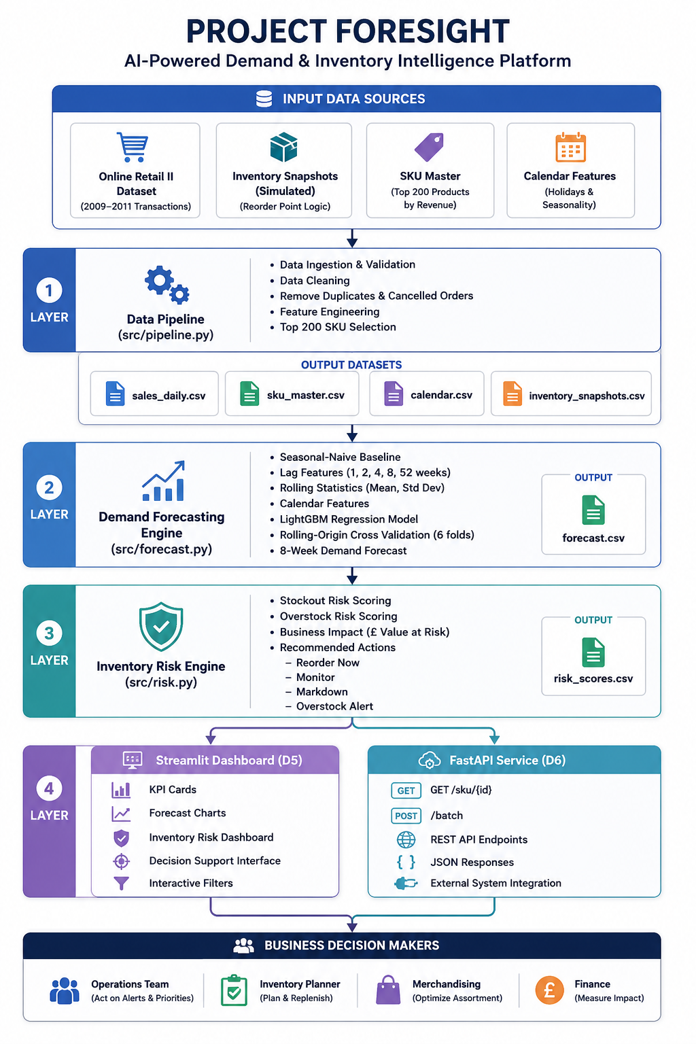
Figure 0 — FORESIGHT solution architecture: data sources, pipeline, forecasting engine, risk engine, and serving layers.
Unlike a general-purpose MLOps stack, this architecture is deliberately scoped to what the engagement requires: a reproducible pipeline, an honestly-validated forecast, transparent risk logic, and two stakeholder-facing surfaces (dashboard and API). Real-time infrastructure, automated retraining pipelines, and live system integrations were explicitly out of scope for this engagement and were not built.

Execution Timeline
Week | Focus | Deliverables
Week 1 | Data Foundation | Reproducible pipeline (D1); data-quality report
Week 2 | EDA & Baseline | EDA insight memo (D2); seasonal-naive baseline & WAPE metric fixed
Week 3 | Modelling & Risk | Backtested forecast beating baseline (D3); stockout/overstock risk scoring (D4)
Week 4 | Productize | Dashboard (D5); deployed scoring service (D6); executive readout (D7)

Technical Highlights

Modelling Techniques
- Seasonal-naive baseline (demand = same week, 52 weeks prior) — the bar every model must beat.
- LightGBM gradient-boosted trees, trained as a global panel model across all SKUs.
- Quantile regression (10th/90th percentile) for an 80% prediction interval on every forecast.
- Rolling-origin cross-validation (6 folds, 8-week horizon) — never a random train/test split.

Feature Engineering
- Lag features: 1, 2, 4, 8, and 52 weeks — all computed strictly from past values only.
- Rolling statistics: 4-week and 8-week trailing mean and standard deviation.
- Calendar features: month, season, UK public holiday flag.
- Promotion signal: inferred from price drops ≥15% below a SKU's trailing 28-day median price.

Challenges Faced
- Source data contained no real inventory records (no stock levels, lead times, or reorder points).
- Raw transaction data included cancellations, non-product codes (postage, fees), and duplicates.
- Guarding against data leakage in lag/rolling features during recursive multi-step forecasting.

Solutions
- Simulated inventory positions using a standard reorder-point formula (95% service level, category-specific lead times), documented explicitly as an assumption rather than presented as real data.
- Built an explicit, code-driven cleaning pipeline: excluded cancellations, non-product codes, and duplicates, with every decision documented in the EDA memo.
- Enforced shift-before-rolling feature construction and verified rolling-origin backtesting to guarantee no future information enters any feature.

Deployment & Operations

Deployment Platform
- Streamlit Community Cloud — dashboard hosting (live and verified working).
- Render / Hugging Face Spaces — FastAPI scoring service hosting.
- GitHub — version control and reproducible source of truth.

Reproducibility
A grader (or NorthBay's own team) can clone the repository, run `python src/pipeline.py`, `python src/forecast.py`, and `python src/risk.py` in sequence, and reproduce the same headline backtest numbers reported in this document — with random seeds fixed throughout.

Key Features
ID | Feature | Description | Acceptance Criteria
D1 | Data Pipeline | Ingests and cleans raw transactions into 4 analysis-ready tables | Reruns end-to-end from raw data with one command
D2 | EDA & Data-Quality Memo | Documents data issues and demand patterns found | 3+ business insights, labelled charts, issues documented
D3 | Demand Forecast Model | Weekly SKU-level forecast, backtested | Beats seasonal-naive baseline on rolling-origin CV
D4 | Risk Scoring | Stockout/overstock classification per SKU | Transparent logic, £ value attached, tied to decisioning grid
D5 | Planning Dashboard | Interactive, filterable view for ops team | Usable without a data scientist present
D6 | Scoring Service | Hosted API returning forecast + risk | Handles bad input gracefully, documented I/O
D7 | Executive Readout | Stakeholder-facing summary of findings | Leads with £ impact, honest about limitations

Technology Stack
Category | Technology | Rationale
Language | Python | Primary language for data pipeline, modelling, and services
Data processing | pandas, numpy | Cleaning, aggregation, feature engineering
Forecasting | LightGBM | Gradient-boosted trees; strong tabular/panel performance, fast to backtest
Dashboard | Streamlit, Plotly | Fast, interactive, deployable analytics UI
Serving | FastAPI | Lightweight, documented, production-style scoring endpoint
Version control | Git & GitHub | Reproducibility and collaboration

Forecast Accuracy — Backtest Results
WAPE (Weighted Absolute Percentage Error, lower is better), averaged across 6 rolling-origin backtest folds, 8-week horizon each:
Model | Average WAPE
Seasonal-naive baseline | 0.875
FORESIGHT (LightGBM) | 0.615
Improvement | 29.7% lower error
The model beat the baseline in every one of the 6 backtest folds — a consistent, honestly-tested improvement, not a single lucky split.

Visuals — Exploratory Data Analysis

Weekly Demand Trend
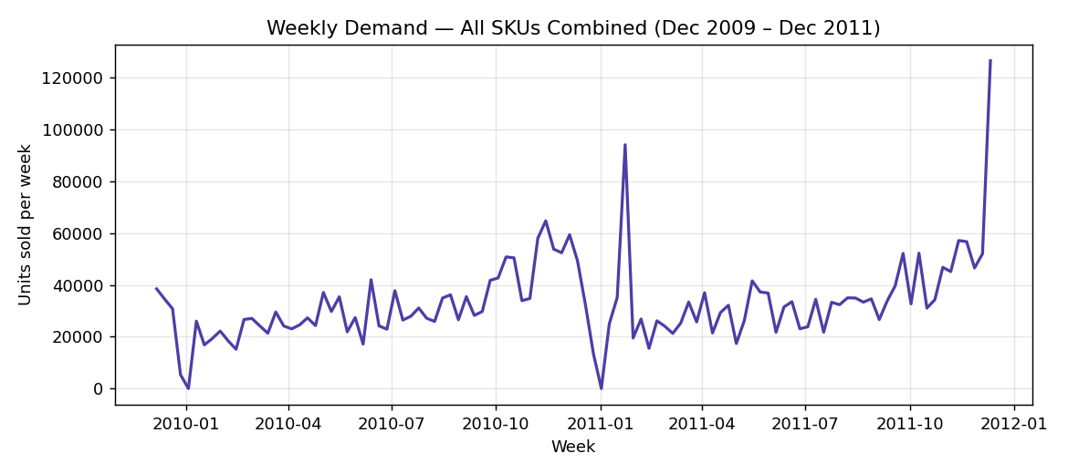
Figure 1 — Weekly demand across all SKUs, showing strong Q4 seasonality.

Monthly Seasonality
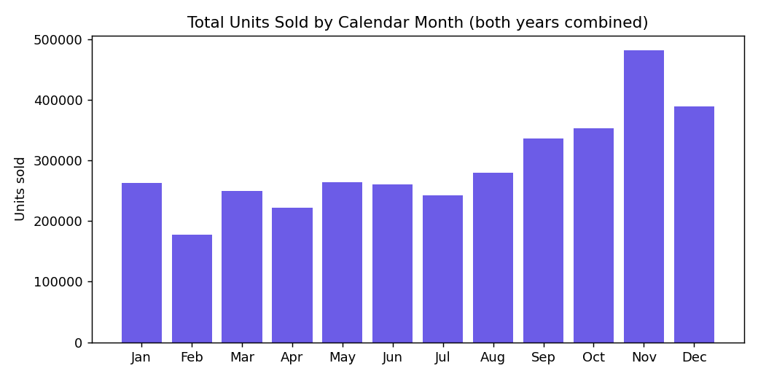
Figure 2 — Units sold by calendar month, both years combined.

Top SKUs by Revenue
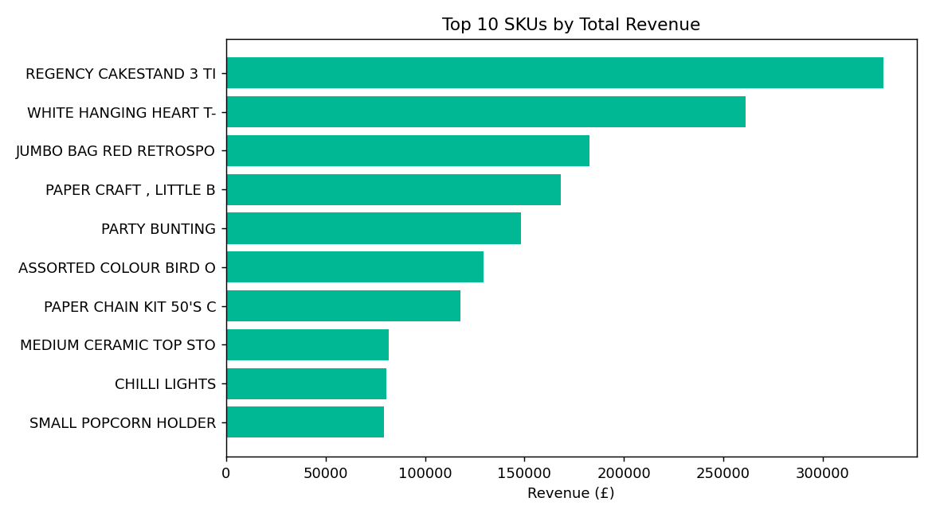
Figure 3 — Top 10 SKUs by total revenue.

Promotion Lift
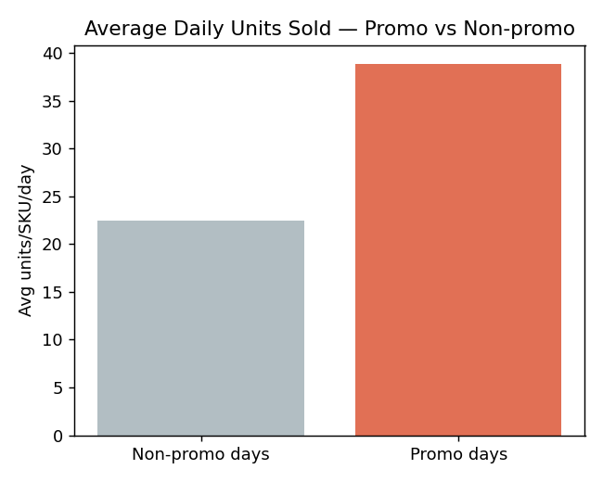
Figure 4 — Average daily units sold, promotional vs non-promotional days.

Visuals — Live Deployed Dashboard
Screenshots of the deployed Streamlit dashboard, confirming the system runs end-to-end and is reachable by the operations team.

Reorder / Markdown Priority List
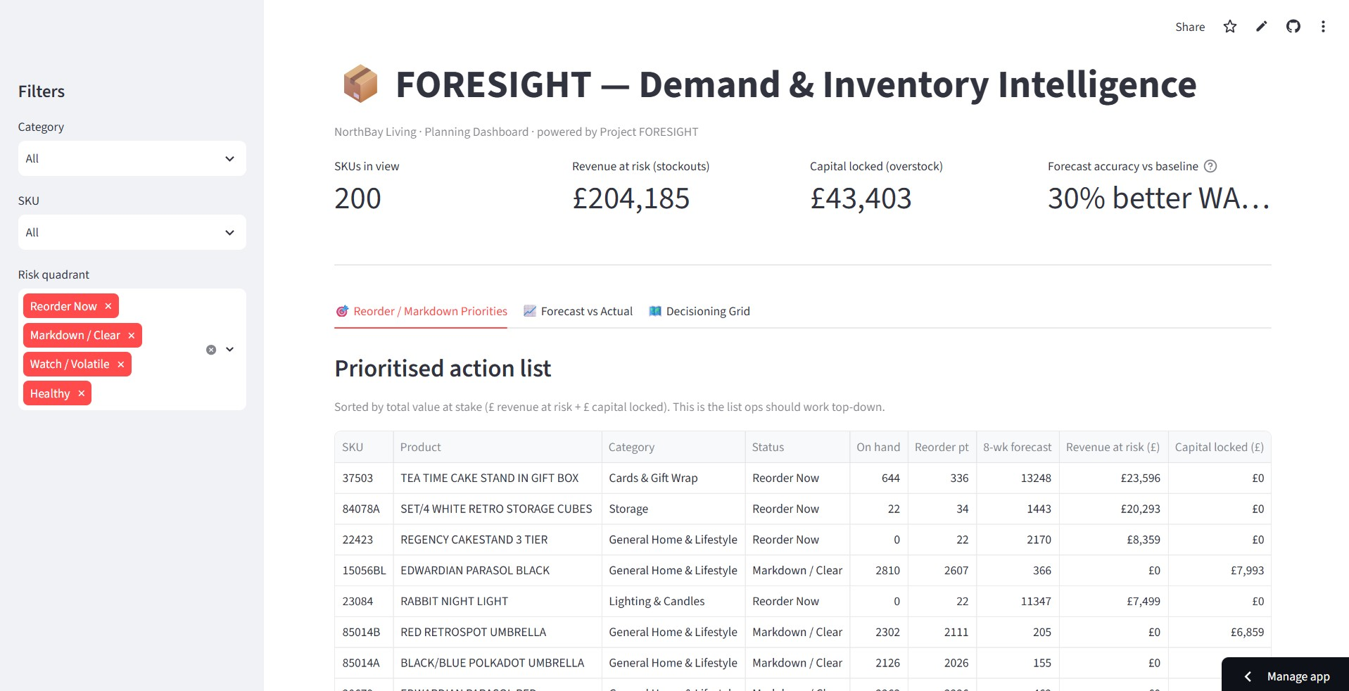
Figure 5 — Prioritised action list, sorted by £ value at stake. 200 SKUs in view, £204,185 revenue at risk, £43,403 capital locked.

Forecast vs Actual
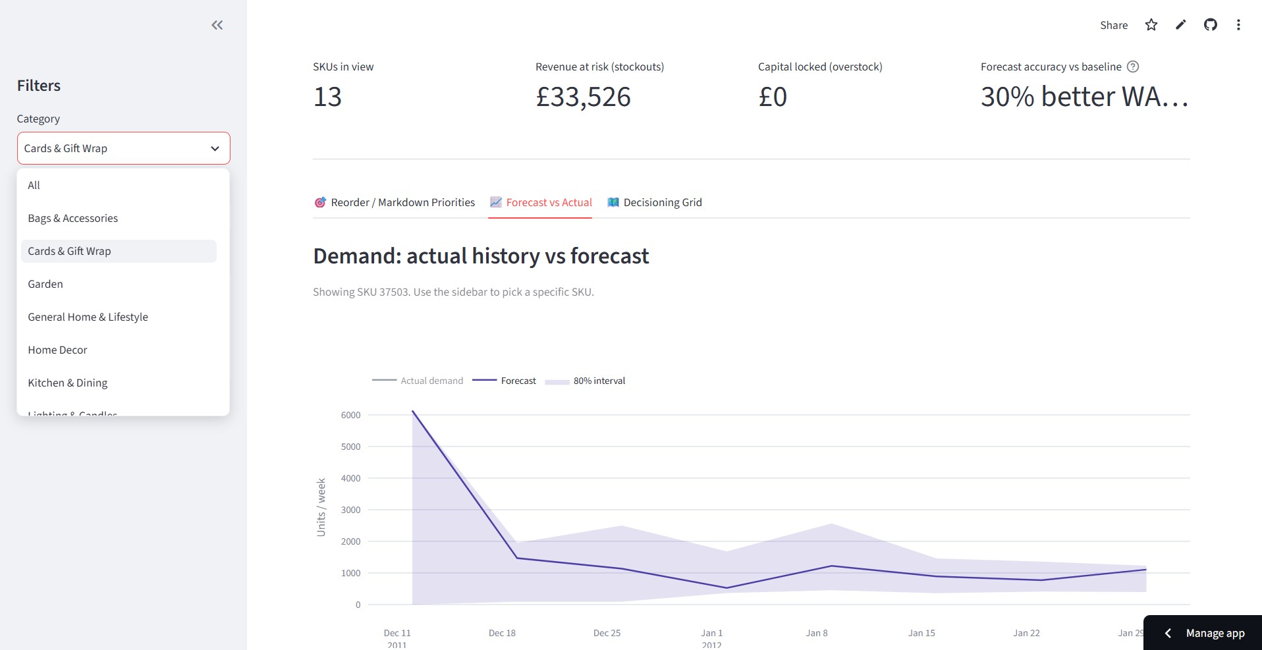
Figure 6 — 8-week forecast with 80% prediction interval, filterable by category and SKU.

Decisioning Grid
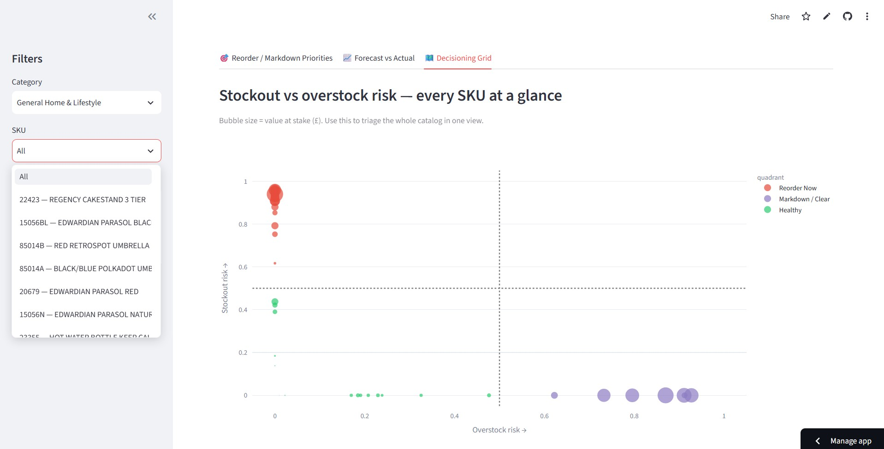
Figure 7 — Every SKU triaged on a stockout-vs-overstock grid; bubble size = £ value at stake.

Personal Reflection
For this project, I built a demand forecasting and inventory risk system for NorthBay Living. I started by cleaning the raw sales data — removing duplicates, cancelled orders, and non-product entries like postage charges. I then organized the data into the four tables required: sales_daily, sku_master, calendar, and inventory_snapshots.
Since the dataset did not include real inventory numbers, I calculated them myself using a reorder-point formula based on lead time and average demand, and I mentioned clearly in my README that this part was calculated, not original data.
For the forecasting part, I first built a simple baseline (seasonal-naive, meaning it just repeats last year's demand) and then trained a LightGBM model to try to beat it. I tested the model using rolling-origin backtesting, which means training on past data and testing on future data, repeated across several time periods. My model performed better than the baseline in every test, with about 30% lower error (WAPE).
After that, I built the risk-scoring logic that flags each product as Reorder Now, Markdown/Clear, or Healthy, based on the forecast and stock levels. I then built a Streamlit dashboard so this information could be viewed easily, along with a FastAPI service that returns the forecast and risk data for any product.
Skills I learned and practiced while building this project:
- Data cleaning and building a reproducible pipeline using pandas.
- Building a baseline model first and comparing a machine learning model (LightGBM) against it.
- Using rolling-origin cross-validation to properly test a forecasting model on unseen data.
- Feature engineering — creating lag features, rolling averages, and calendar-based features.
- Building an interactive dashboard using Streamlit, with filters and multiple views.
- Building and testing a REST API using FastAPI, including handling bad input.
- Using Git and GitHub for version control.
- Documenting a project clearly, including assumptions, limitations, and setup steps.
Overall, this project gave me hands-on experience with the full process of a data science project — from cleaning raw data, to building and testing a model, to deploying a dashboard and API that someone else could actually use.

Output
Final deliverables produced by this engagement:
Output | Location / Link
Source code repository | GitHub (link in submission form)
Live planning dashboard | Streamlit Community Cloud (link in submission form)
Live scoring API | Deployed FastAPI service (link in submission form)
Cleaned datasets | data/processed/ — sales_daily, sku_master, calendar, inventory_snapshots
Trained forecast model | data/processed/model_forecast.txt
8-week SKU-level forecast | data/processed/forecast.csv
Risk scores (all 200 SKUs) | data/processed/risk_scores.csv
Backtest results | reports/backtest_results.csv, reports/backtest_summary.json
EDA & data-quality memo | reports/eda_memo.md
Executive readout deck | reports/executive_readout.pptx
This project report | reports/project_report.docx
Demo video | Link in submission form
Headline result: the forecast model beat the seasonal-naive baseline by 29.7% (WAPE), consistently across all 6 backtest folds. Risk scoring identified £204,185 in revenue at risk from stockouts and £43,403 in capital locked in overstock, across the 200-SKU catalog.

Conclusion
FORESIGHT delivers exactly what NorthBay Living's brief asked for: a demand forecast that honestly beats naive planning, a transparent risk-scoring system tied to real currency impact, and stakeholder-facing tools (dashboard and API) that the operations team can use without a data scientist in the room. Every modelling claim in this report is backed by a reproducible backtest, and every assumption — most notably the simulated inventory layer — is stated plainly rather than hidden. The dashboard is live and verified working end-to-end. The system is ready for NorthBay to act on immediately, and ready to be extended with real inventory data as soon as that feed becomes available.

