**Digital Signal Processing Fundamentals [5ESC0]**

**Lab1**

**‘Answer form’**

***Assignment 1 to 10***

**Group number:**

**Names with ID:**

**Date:**

**Assignment 1: Convolution**

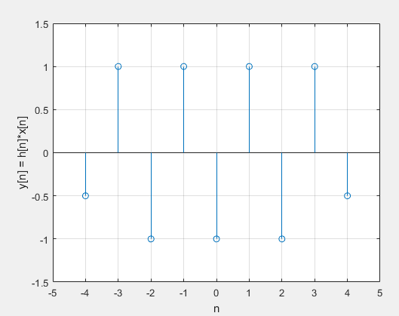

Figure 1: Convolution result of assignment 1

**Assignment 2: Fade-in and fade-out of convolution**

1. What is the length of the output and the length of the fade-in and fade-out phenomenon, as a function of N and M?

Suppose N is the length of h[n] and M is the length of x[n] and the function y[n] = x[n]*h[n] is evaluated

Length(y) = N + M -1

Length(fade-in) =

1. How many, and which, output samples have no fade-in and/or fade-out?

**Assignment 3: Causality**

1. Value for L in order to make the impulse response causal:  
   L = 5

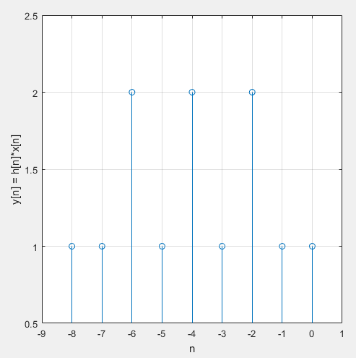

Figure 2: Convolution result of assignment 3 with non-causal filter

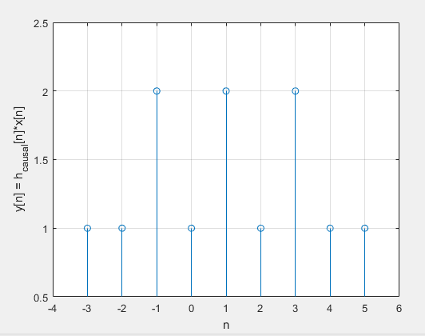

Figure 3: Convolution result of assignment 3 with causal filter

**Assignment 4: Frequency response**

1. Frequency response H­­(ejθ) of non-causal impulse response:

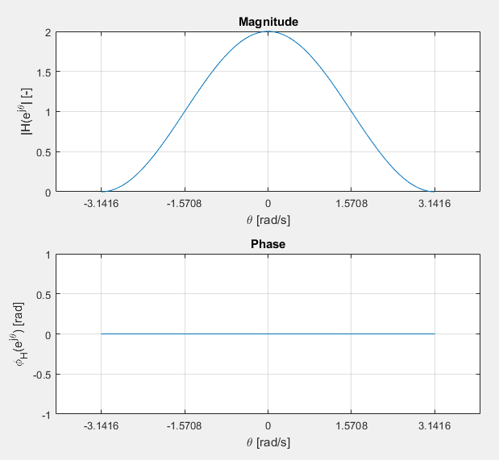

Figure 4: Magnitude and phase of H­­(ejθ)

1. What is the main character of this filter (low-pass, high-pass or band-pass)? Give a short explanation:

In my explanation, I will use the following equation:

From Figure 4, it can be seen that for low values of , the magnitude of the filter is high. Using the equation introduced 2 lines ago, shows that, if we keep constant, low values of correspond to low values of , the frequency. From this we conclude that this filter is a low-pass filter.

**Assignment 5: Frequency response of causal filter**

1. Expression for the frequency response H­causal­­(ejθ):

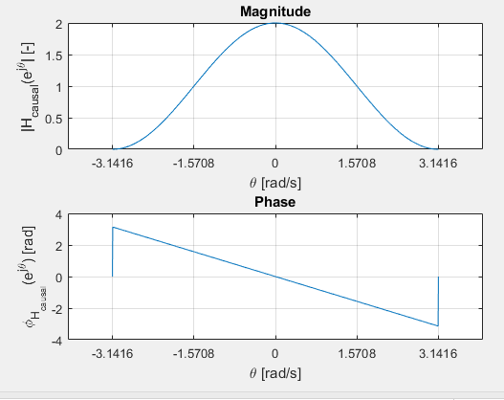

Figure 5: Magnitude and phase of Hcausal­­(ejθ)

1. Write H­causal­­(ejθ) as the product H(ejθ)∙D­­(ejθ) and explain the difference between H(ejθ) and H­causal­­(ejθ):

The difference between and is only the phase. Because has been shifted one sample to the right compared to , it has a different phase.

**Assignment 6: Impulse response of low pass filter**

1. Expression for the impulse response:

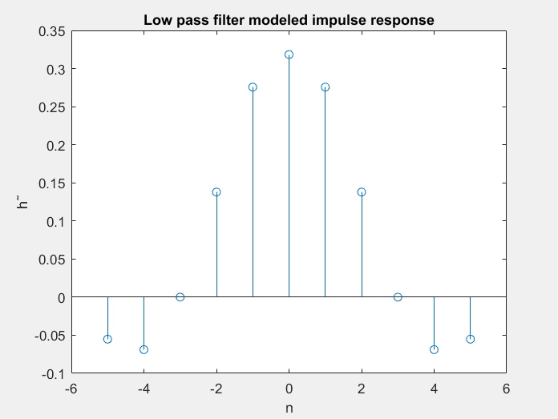

Figure 6: impulse response for N = 11

1. Play x[n] and explain what you hear:

It sounds lower then the original signal, while also sounding misshaped. This is because the low pass filter’s impulse respons is not infinite thus passing through artifacts of the original higher frequent signal.

**Assignment 7: Calculation of convolution via FTD and IFTD**

Calculation:

**Assignment 8: Sampling a sinusoidal signal**

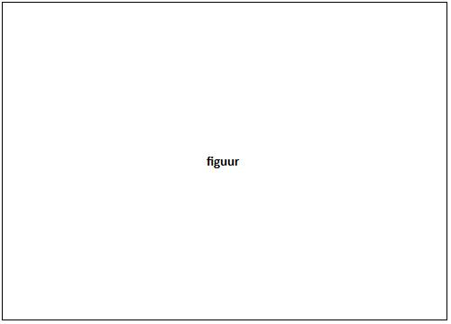

Figure 8: continuous signal xc(t) and samples x[n]

1. What do you notice when playing the sound?

**Assignment 9: Visualization of ‘aliasing’ via time domain**

Think of at least two different sinuses with different frequencies between 0Hz and 1Hz which cross the same sample points and plot these signals.



Figure 9: Plot of assignment 8

Explain your results:

**Assignment 10: Up- and down-sampling**

1. Implement all 3 versions. Print Matlab code in appendix and upload Matlab code. Explain results:
2. Implement all 3 versions. Print Matlab code in appendix and upload Matlab code. Explain results: