**Digital Signal Processing Fundamentals [5ESC0]**

**Lab2**

**‘Answer form’**

***Assignment 11 to 17***

**Group number: 38**

**Names with ID: W.R. Tonnon – 09xxxxx, M.P. Favier - 0951737**

**Date: 9-10-2017**

**Assignment 11: The DFT of a finite length discrete-time signal**

1. Calculation of X(ejθ)  
   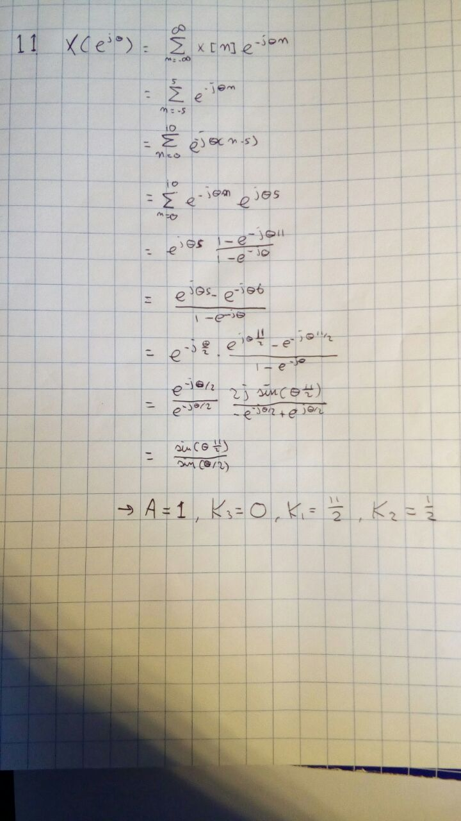

b,c)

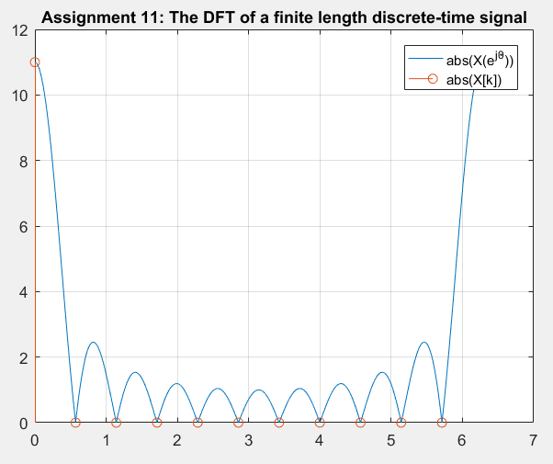

Figure 1: plot for |X(ejθ)| and |X[k]|

**Assignment 12: Spectrum of a sine wave of different frequencies**

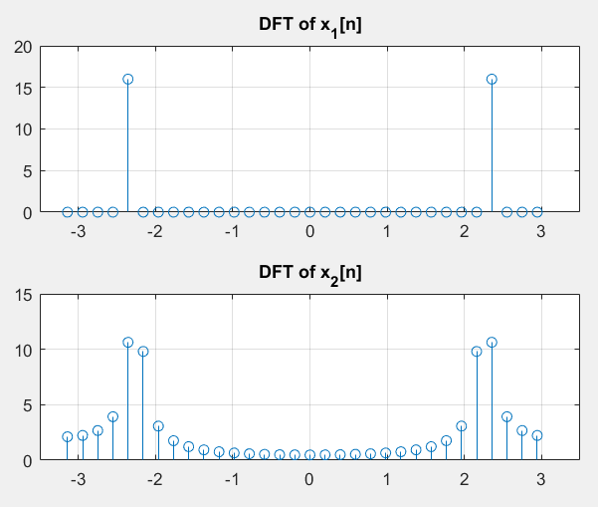

Figure 2: DFT of x1[n] and x2[n]

1. *Explain what you see, why it happens and how to prevent it.*

The DFT of x2 gets ‘smeared’ over a several frequencies. This happens because the frequency of x2 is 9/64 Hz, which cannot be represented by a single frequency in the discrete frequency domain and thus has to be approximated.

To prevent this, the sample frequency would have to be a multiple of both f1 and f2.

**Assignment 13: Approximation of the FTD**

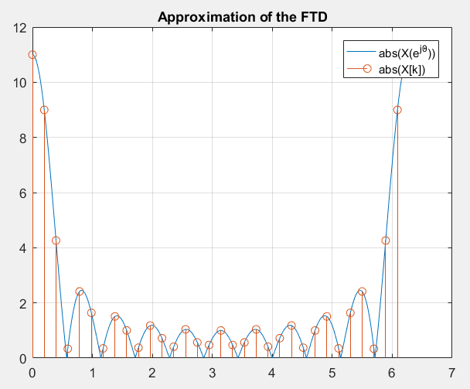

Figure 3: Plot of DFT and approximated FTD

**Assignment 14: Calculating the minimum resolution of a spectrum**

1. Find the minimum length Na:

It is given that the 3dB bandwidth of a rectangular window with magnitude 1 is given as

$$θ_{BW}=0.89\frac{2π}{N}$$

In order to distinguish between the two peaks, the amplitudes at the frequency corresponding to the peaks should be higher than the amplitudes of the surrounding frequencies. Because multiplication in time domain is convolution in frequency domain, it happens that the DFT of w[n] is repeated for every frequency components of x[n]. This means that for x1[n] and x2[n] the DFT of w[n] on the position of x1[n] will overlap with the DFT of w[n] on the position of x2[n]. If the 3dB bandwidth of the DFT of w[n] is exactly placed at the same $θ_{BW}$ as the difference between $θ_{1}$ and $θ_{2}$, the peaks will still be distinguishable. If $θ_{BW}$ is smaller than the difference between $θ_{1}$ and $θ_{2}$ it will also be possible to distinguish between the peaks. Using this reasoning, there can be solved for N in the first equation. The result is N = 36.

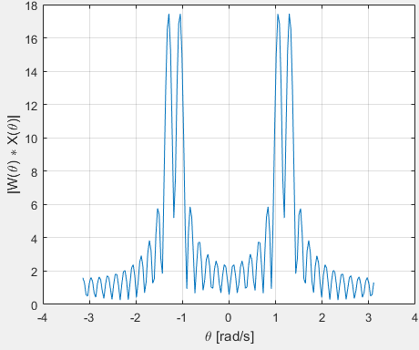

Figure 4: Plot of FTD

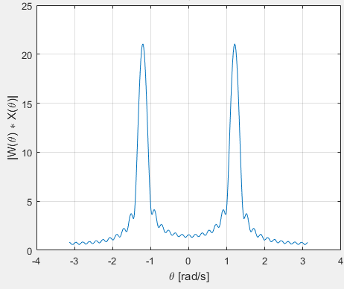

Figure 5: Plot of FTD with new frequencies

The DFT approximates the FTD-spectrum. Using zero-padding increases the solution of this approximated spectrum, but it does not improve the approximation. Since too few samples are used, it is not possible to distinguish the two peaks due to reasons explained in part a of this assignment.

1. Using the same reasoning as in part a of this assignment, the following equation can be applied.

$$N_{b}=0.89\frac{2π}{θ_{BW}}=60$$

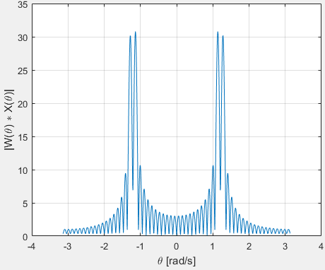

Figure 6: Plot of FTD with the new Nb

1. The value for N­c was determined by using the same reasoning as in part a of this assignment. However, this time the equation given for the 3dB bandwidth of the hanning window was used. This is the following equation.

$$N_{c}=1.44\frac{2π}{θ_{BW}}=96$$

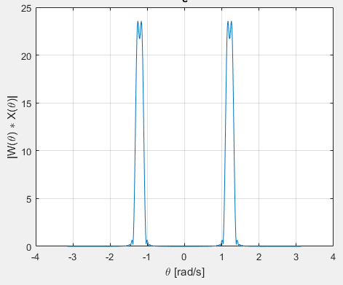

Figure 7: Plot of DFT for Hanning window

The spectral leakage when using a hanning windows is a lot lower than when using a rectangular window. This can be explained by the fact that a rectangular window has an amplitude that goes from a constant value to zero in infinitesimal small time. This means that a spectrum that is non-zero up till and including infinity is necessary to realize the signal. However, a hanning window does not have this jump in amplitude in infinitesimal small time, which means that the frequencies components for higher frequencies will be close to zero, so there is less spectral leakage.

Amplitudes



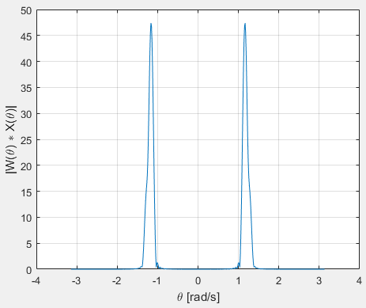

Figure 8: Plot of DFT for the new amplitudes

Using the DFT, an approximation was made of the FTD of w[n]x[n]. In this approximated spectrum, only one peak is visible. This is the case, because the amplitude of the second sine is smaller than half of the amplitude of the first sine. The 3dB bandwidth of the window, when this window is convoluted with the first sine wave, lies exactly on the position of the spectral peak of the second sine. Because the amplitude of this second sine is smaller than half (3dB bandwidth) of the first sine, no second peak will be visible.

**Assignment 15: Linear and circular convolution:**

1. Linear and circular convolution result:

Linear convolution of x[n] with h[n] yields:

[1,1.75,2.25,2,1.125,0.5,0.125]

Circular convolution of x[n] with h[n] yields:

[2.125,2.25,2.375,2]

b,c)

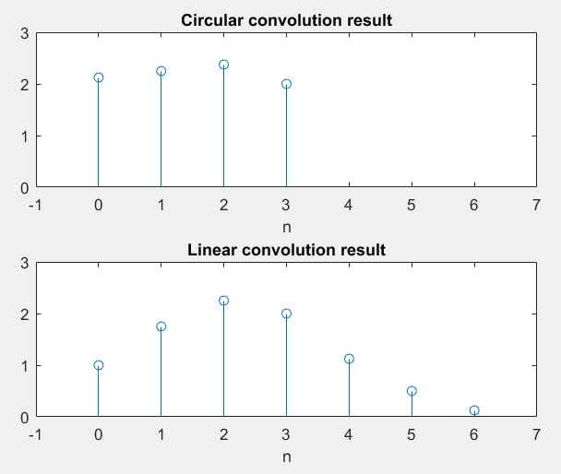

Figure 9: Circular and linear convolution results

**Assignment 16: Frequency plots of LPF**

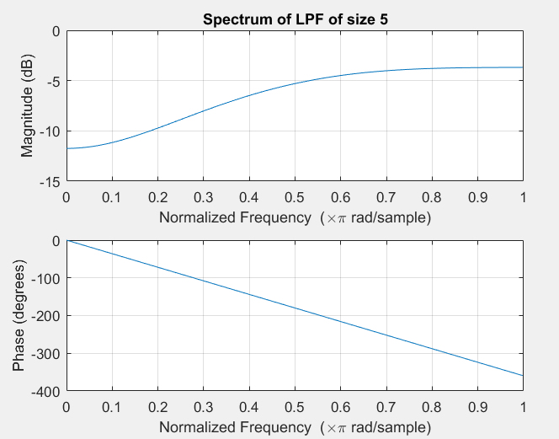

Figure 11: Amplitude and phase plot for N = 5

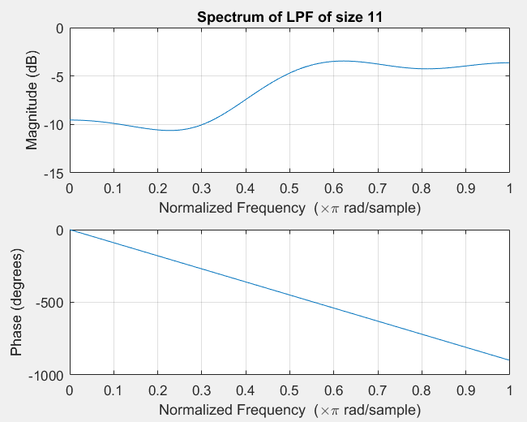

Figure 12: Amplitude and phase plot for N = 11

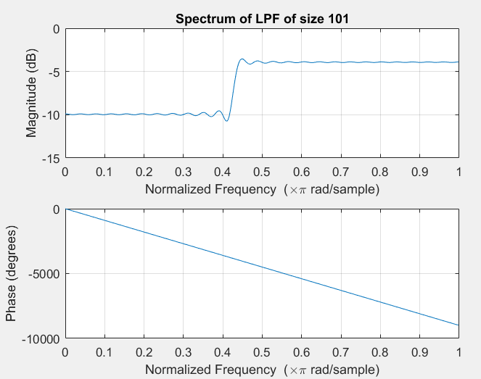

Figure 13: Amplitude and phase plot for N = 101

*Explain the influence of N and the behavior of the phase response:*

With increasing N, the cutoff is sharper. This results in a more ideal low pass filter. The effect on the phase is that it decreases more rapidly with a higher N.

**Assignment 17: Filter design for audio signals 1**

1. Frequency fu:

To determine the frequency fu, the DFT of the audio signal was taken and mapped to frequency domain. The following plot came out.

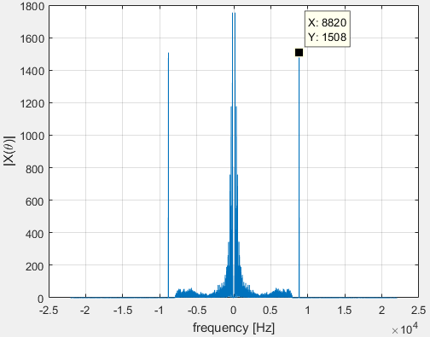

From this plot could be determined that the frequency of the noise in the audio is at 8.82 kHz.

1. To filter out the noise in the audio file, a band-stop filter was used. The filter was designed using the fdatool in MATLAB. The sine wave could have been filtered out using a low-pass filter only. However, by making the filter a band-stop filter, the filter was made more general. This filter can filter out the same noise out of every audio file without removing all the frequency above the frequency of the noise.

*{Email your filtered output sound file to* [*t.w.v.d.laar@tue.nl*](mailto:t.w.v.d.laar@tue.nl)*. Please mention your group number in the subject line, and both your names in the email message.}*