**Digital Signal Processing Fundamentals [5ESC0]**

**Lab3**

**‘Answer form’**

***Assignment 18 to 26***

**Group number: 38**

**Names with ID: Wouter Tonnon – 0954049, Michiel Favier -**

**Date: 21-10-2017**

**Assignment 18: Mean and variance**

1. Expression for the mean and variance:

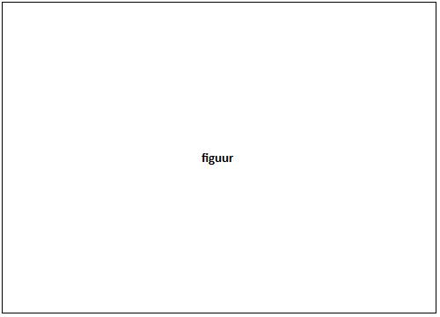

**Figure 4: u[n] for different N**

1. Statement about the mean and variance of a random variable which consists of the normalized sum of N IID random variables:

**Assignment 19: Mathematical expressions for variance and correlation coefficients**

1. Expression and plot of variance:

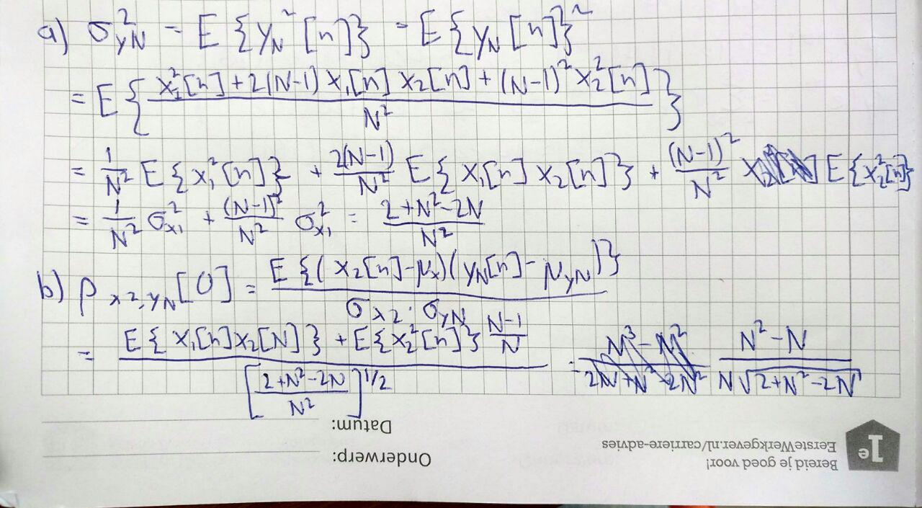

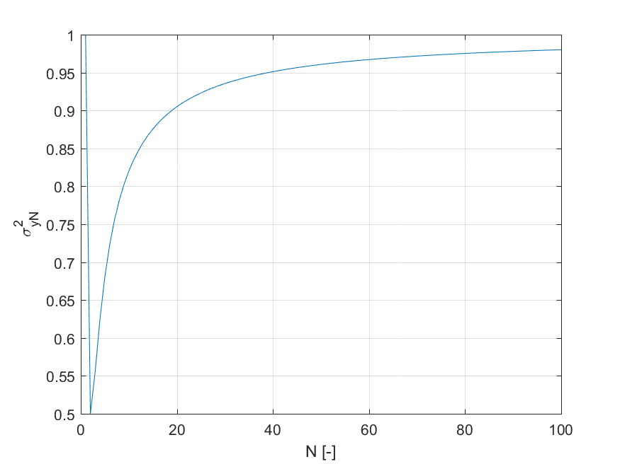

**Figure 1: Plot of variance as a function of N**

1. Expression and plot of normalized cross correlation coefficient:



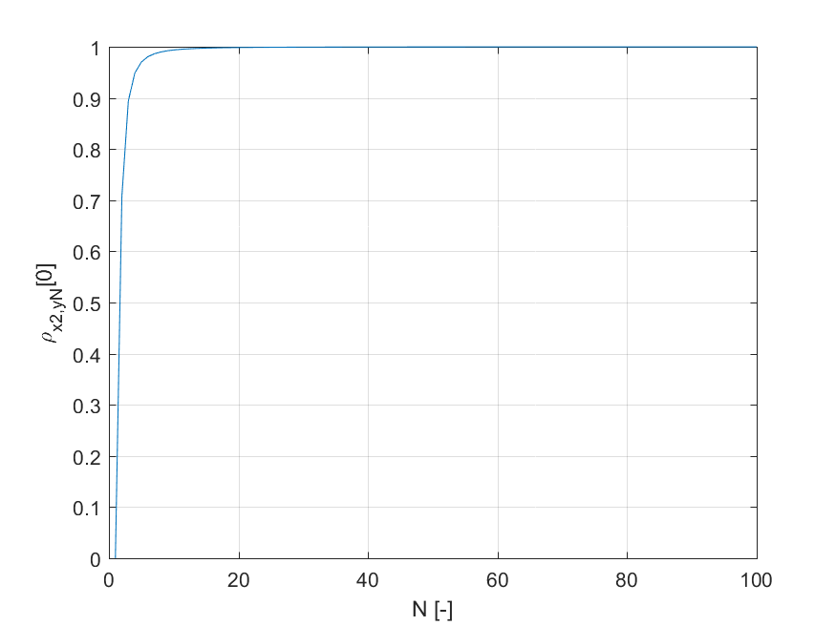

**Figure 2: Plot of normalized cross correlation coefficient as a function of N**

**Assignment 20: Scatter plots and empirically evaluate correlation coefficient**

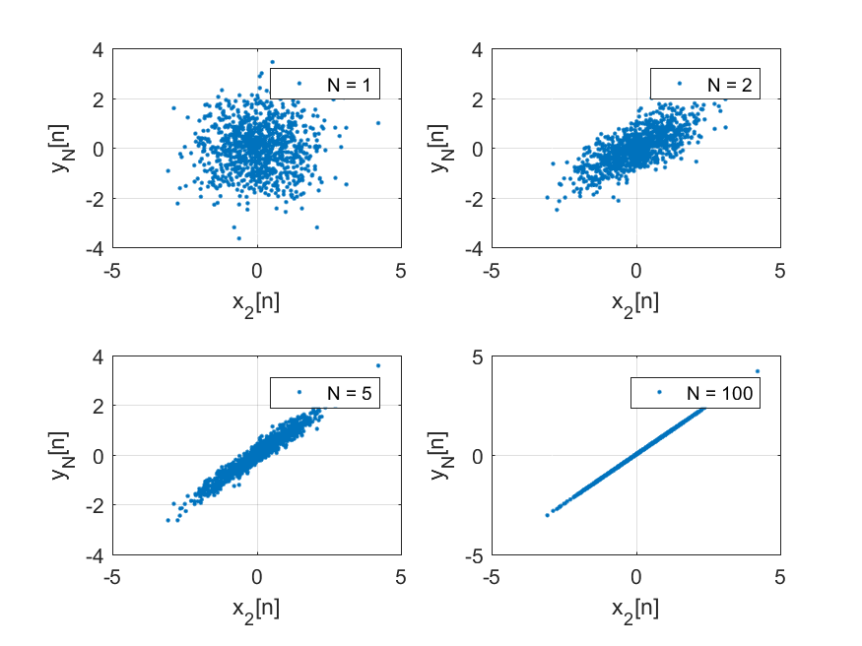

**Figure 3: Scatter plot of ordered pairs of samples**

1. Comparison of numerical estimates and theoretical results:

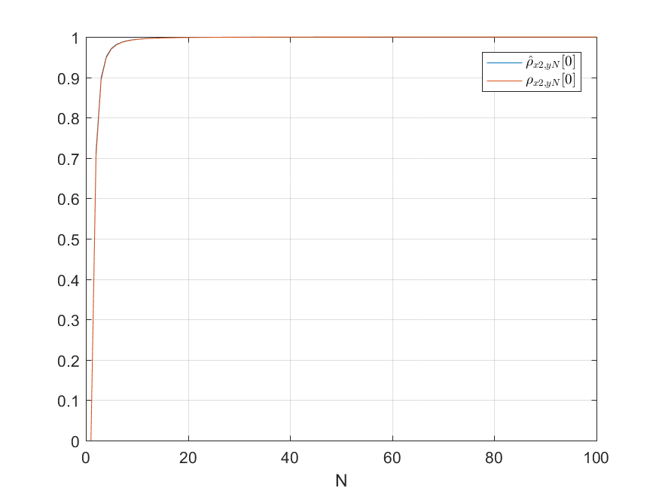

1. Explain how the scatter plots are related to the normalized cross correlation coefficient:

As the value for N becomes larger and larger, the cross correlation increases further and further and asymptotically reaches the value one. This can also be seen in the scatter plots. For N=1, the points seem to be barely correlated. No reasonable relation between Yn and X2 can be found. As N is increased, a more and more clear relation between Yn and X2 becomes visible. This means that the higher the cross correlation is, the clearer the relation between Yn and x2 is.

**Assignment 21: Correlation function and power spectral density (PSD) function**

1. Expression for theoretical correlation:

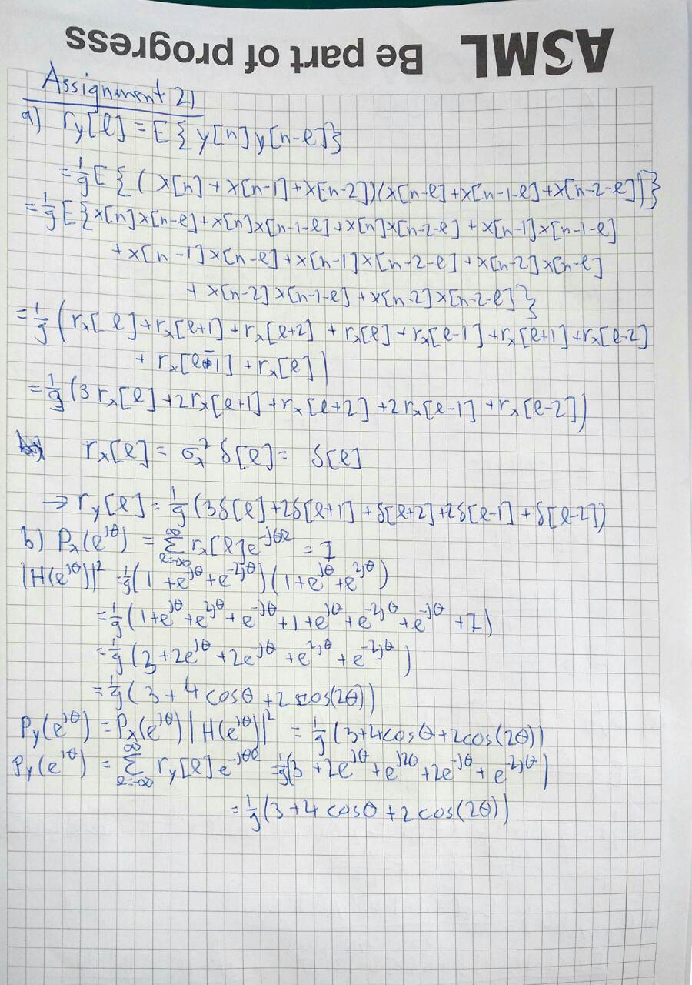

1. Derivations for theoretical PSD (two different ways):



**Assignment 22: Scatter plots**

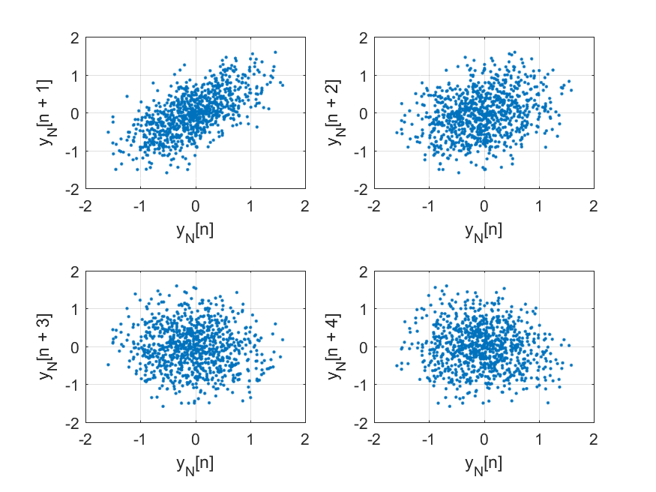

**Figure 5: Scatter plots**

What can you deduce about the random process y[n] from these scatter plots?

It can be seen that the scatter plot for l = 1 has a strong resemblance to the line y = x. As l increases this resemblance decreases. This makes sense, since y is basically a low-passed version of x. A low-passed version of a signal cannot have big differences between neighboring samples, so if the l is low, there is a strong resemblance between the signals y[n] and y[n+l].

**Assignment 23: Empirical correlation and PSD function**

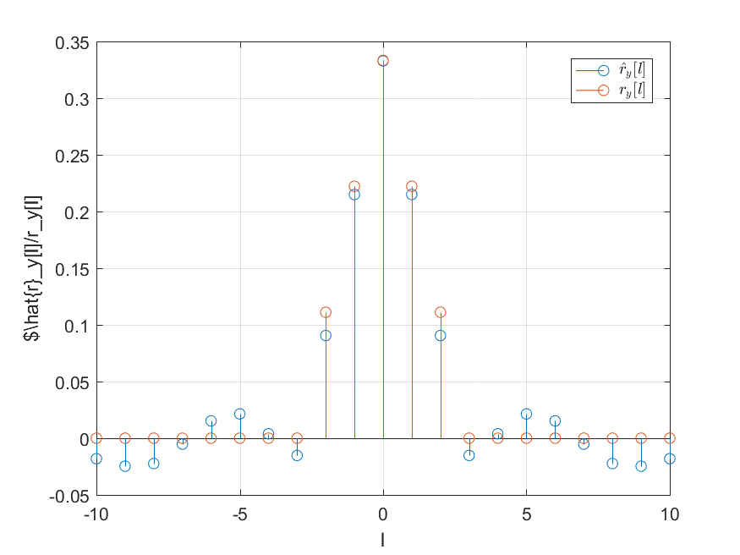

**Figure 6: Theoretical and estimated autocorrelation values**

1. For what value of lag l do the theoretical and estimated autocorrelation reach their maximum values?

Both of them reach their maximum value at l=0. This makes sense, since the signal will always look like itself and the autocorrelation is kind of a measure of how much a signal looks like a shifted version of itself.

1. Procedure for obtaining the PSD from the estimated values of the autocorrelation:

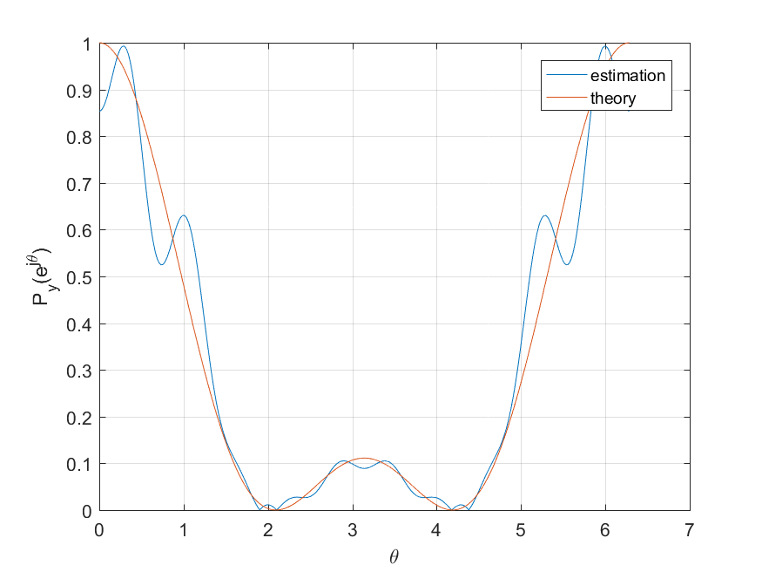

**Figure 7: Theoretical and estimated PSD**

1. Give a short reasoning of possible differences between the theoretical and estimated values of the PSD:

The difference between the estimated and the theoretical PSD can be explained by the fact that not a lot of samples are used. Due to the relatively low amount of samples, the influence of outliers increases. The more samples are used, the more the estimated values will converge towards the theoretical values.

**Assignment 24: Expression for cross-correlation**

1. Short derivation for rxy[l]:

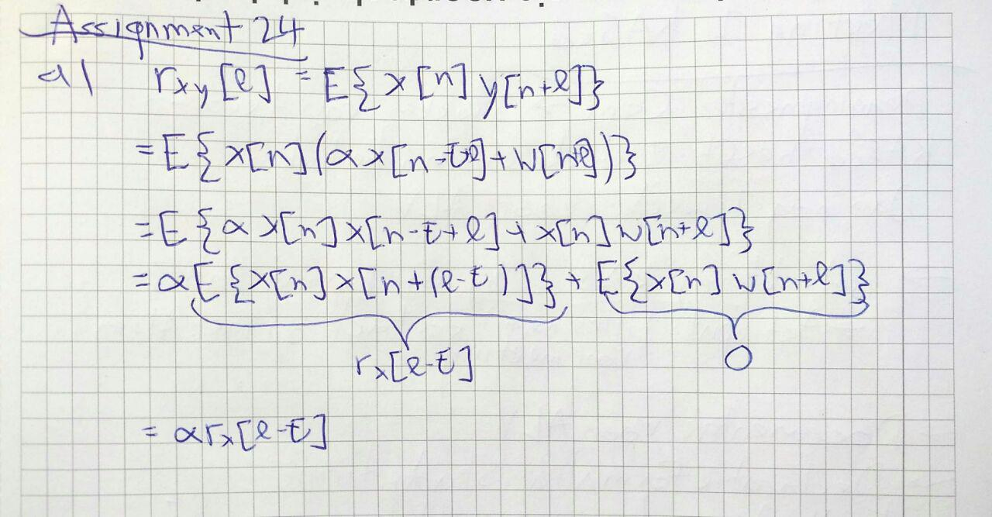

1. Procedure for estimating :

It is known that the autocorrelation of a signal has its peak at l=0, because the signal always corresponds best to itself. Since the cross correlation of x and y is basically a scaled up and shifted version of the autocorrelation of x (as proven in a), the location of the peak of the cross correlation can be compared to the location of the peak of the autocorrelation of x. The difference between these locations is the delay.

**Assignment 25: Test cross-correlation function**

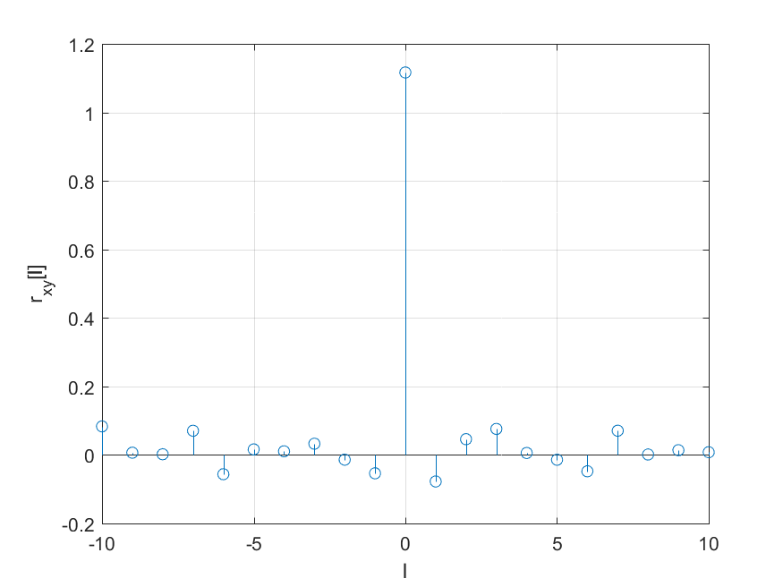

**Figure 8: cross-correlation test plot**

1. Which value of l produces the largest cross-correlation? Why?

The largest value for the cross-correlation is produced when l = 0. This can be explained by the fact that y[n] is a function of the form of equation (22) in the assignment with α=1 and τ=0 and w[n] = z[n]. As proven in Assignment 24, the cross correlation is then given as

Basically the cross-correlation of x and y is the same as the autocorrelation of x and the autocorrelation of a signal always has its peak at l=0, because the signal always corresponds best to a version of its own signal that is not shifted, compared to a shifted version of itself.

1. Is the cross-correlation function an even function? Why or why not?

Since the cross-correlation function is basically a autocorrelation function as explained in b, it should be an even function. However, due to the samples not being exact (but random) it is not perfectly symmetric.

**Assignment 26: Estimate delay for radar data**

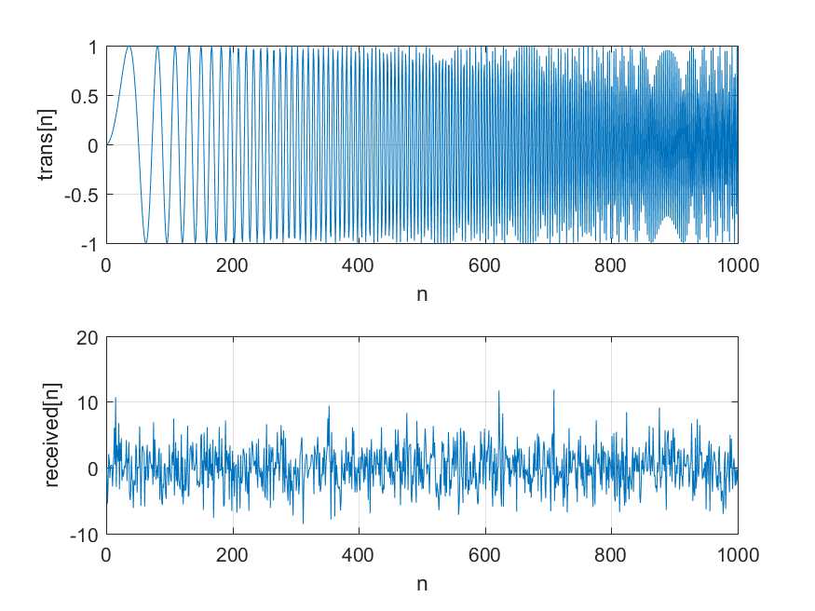

**Figure 9: transmitted and received signal**

The delay cannot be determined from visual inspection.

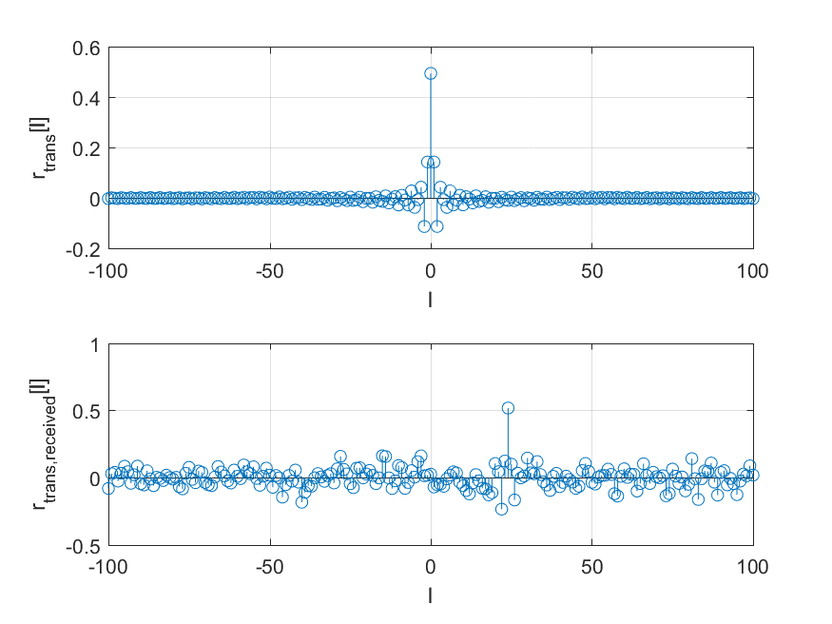

**Figure 10: auto- and cross-correlation**

1. Delay for : 24 samples. This can be determined from the locations of the peaks in the plots for the auto- and cross-correlation.

Bonus questions:

1. How would you reduce the influence of the noise w[n]?
2. How would you handle non-integer values for τ?

The effect of a delay by non-integer values for τ would be that the peaks would be smeared over the neighboring 2 peaks, so there would be 2 peaks that have a significant amplitude. Let these amplitudes be A1 and A2 at location n1 and n2 respectively. The exact value of τ in that case is harder to calculate, but not impossible. It can be assumed that the amplitudes A1 and A2 are proportional to how close the value τ is to the position of the peak. The value τ can then be calculated as follows.