Booth Field Guide
What the photo booth will and won't do for the person in front of the camera.

The roster
Up to 5 animations can be active at once, picked from the bar above the camera.
Animation | How it behaves
Owl | Perches on your arm
Bat | Perches on your arm
Globe | Orbits around you
Drone | Hovers over your palm
Scuba | Wave a hand side to side to summon it. It hovers above your head.
OC Fusion | Follows your hands
Pig Nose & Ears | Face overlay
Bat Ears | Face overlay
Clown Wig & Nose | Face overlay
Sunglasses | Face overlay
Mustache | Face overlay
67 | Lands on your palm
Boxing Gloves | Puts a glove on each fist. Creates stars around the person's head when the glove makes contact with their head.
Tap an animation to turn it on, tap again to turn it off. Mix and match freely, up to five at a time — past that, every other button greys out until one is turned off.
Note: Face overlays (Pig Nose & Ears, Bat Ears, Clown Wig & Nose, Sunglasses, Mustache) all sit on the same face. Turning on more than one or two at once isn't blocked, but they'll overlap and crowd each other — not recommended.

Three pairs don't mix
Pair | Why
Owl × Bat | Both land in the exact same spot on your forearm as picking both stacks two creatures on one arm instead of giving you two.
Drone × 67 | Both trigger off the same raised-palm signal as together they’d spawn on top of each other every time you raise a hand.
Boxing Glove × Scuba | Scuba is summoned by swinging a hand from side to side, which is exactly the motion of throwing a punch with a glove on. With both picked, every punch would also call up the scuba cat.
The booth blocks the second pick in each pair rather than letting them collide.
Note: Boxing Gloves can now be used together with 67 and with the Drone. A glove appears on a closed fist, while those two need an open palm, so the same hand rarely qualifies for both. These used to be blocked and no longer are.

67 Mode (separate mode)
Switches the whole screen over to a 20-second exciting game. While it's running,
- Press Start
- Type in your name
- Do 67 as fast as you can for 20 seconds
- See your score and rank land on the leader board
Your name rides along with your score, so it shows up right next to it on the leader board.
The board keeps one entry per name. If you play again with the same name and beat your previous score, your entry is raised to the new one. If you score lower, your best score stays on the board. The results screen shows what you scored this round, what your best is, and whether you have just beaten it.

QR Code Mode (separate mode)
Instead of tapping the animations on screen, the booth can be switched to recognize a set of physical QR cards. Hold the card for a character up to the camera and that character locks onto you. It will keep following the participant that held the QR card, even once the card is put away or a photo is taken.

Getting your photo
Once a photo (or strip) is confirmed, a QR code is printed right onto it. Scan that code with your phone to open an online copy of the photo you can download or share. You don’t need to wait around for a print.

Company logos
Two logo slots are set by the operator, not the participant, but you'll see both:
- Banner logo
A company logo shown on screen over the live camera feed while you're in front of the booth.
- Footer logo
A company logo printed in the footer of your photo strip, alongside the fixed event logo and the download QR code.
Which company's logo shows up can change between participants if the operator switches it.

Good to know
- Burst Mode When it’s on, three shots are taken back to back and printed onto one strip instead of a single photo. A strip can only have a maximum of three photos.

Camera choice
Two cameras were tested with the booth: a Hikvision IP camera and a DSLR camera connected by USB.
Both work. However, we recommend using the DSLR camera.
First, the picture is better. The DSLR has a larger sensor and a better lens, so the photos people take home are clearer and sharper.
Second, there is no delay. The Hikvision sends its video over the network in a compressed format, and that video slowly falls behind real life the longer it runs. The booth already works around this by quietly reconnecting to the camera every five minutes to catch it back up, but each reconnect causes a short freeze of about one second on screen. The DSLR is plugged in directly by USB, so it does not drift behind and does not need this fix at all. What you do in front of the booth appears on screen straight away.
This was measured, not estimated: the DSLR feed reports 60 frames per second at 5 ms of delay on screen (see Figure 10). The Hikvision has no equivalent figure here, but it is the camera the five-minute reconnect exists for.
The Hikvision is still a usable backup if the DSLR is not available.

Limitations
- 5 animations is the most that can run at once.
- For animations require hand gestures limit to 5 people/10 hands
- Max distance tested: 5 m 35 cm on the Hikvision camera, 6 m 50 cm on the DSLR
- Doesn’t work well in very low light areas

Testing evidence
The photos below come straight out of the booth — they are captured frames, complete with the footer logos and download QR, not mock-ups.

Five animations at once
This one is a hard limit rather than an observation: the booth stops accepting a sixth pick. Once five animations are on, every remaining button greys out until one is turned off, so the limit cannot be exceeded by accident. The photos below show several animations coexisting on the same group, each tracking its own target.
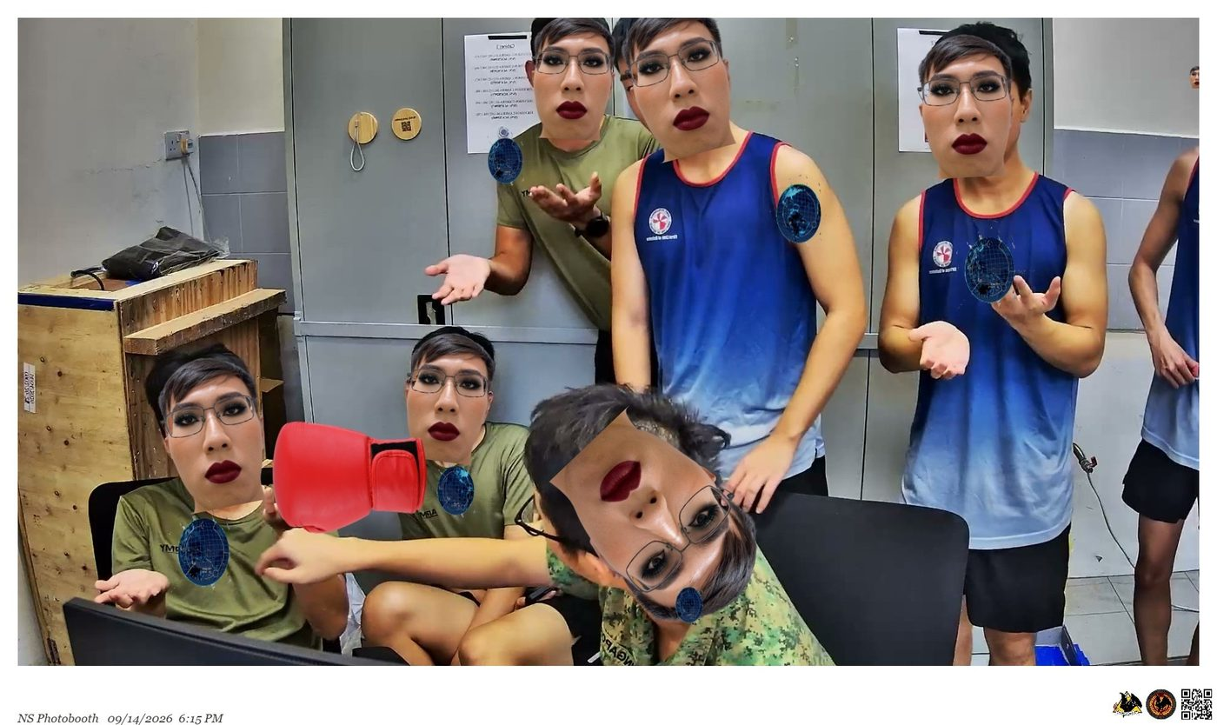
Figure 1 — Three different animations running in the same frame on a full group Each animation is tracking its own person independently.
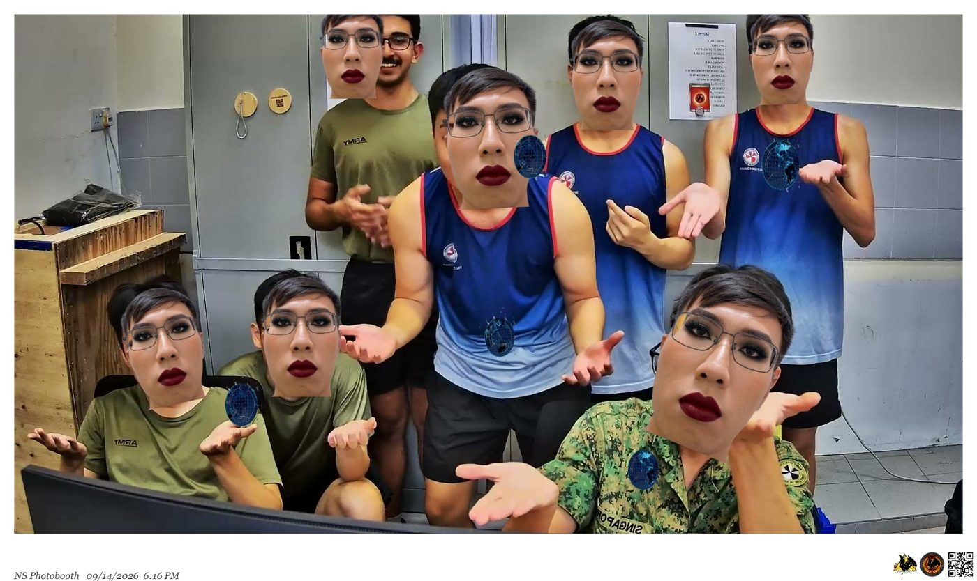
Figure 2 — The same group a minute later. The face overlay has been picked up by everyone the booth is tracking.

Hand gestures: five people, ten hands
Each animation that uses hand gestures has a set number of "slots". A slot is one space for one hand. Boxing Gloves and the Drone have ten slots, so they can cover ten hands. 67 uses both of your hands together, so it has five slots — one per person.
This is why the limit is five people, or ten hands. It is built into the booth on purpose. If an eleventh hand appears, it simply does not get an animation. It will not take one away from someone who already has it.
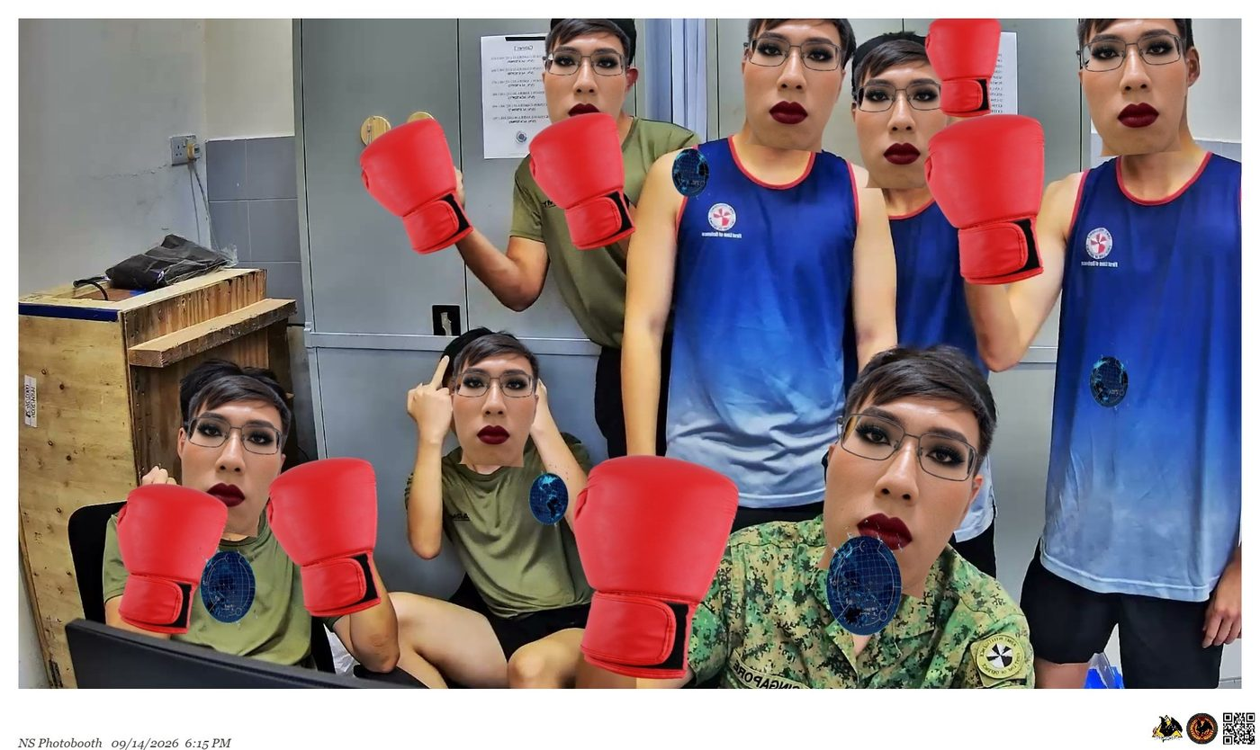
Figure 3 — Boxing Gloves appearing on the raised fists of the whole group at the same time. Every glove is on its own fist, and no fist has two gloves on it. This is exactly what the slots are meant to do.
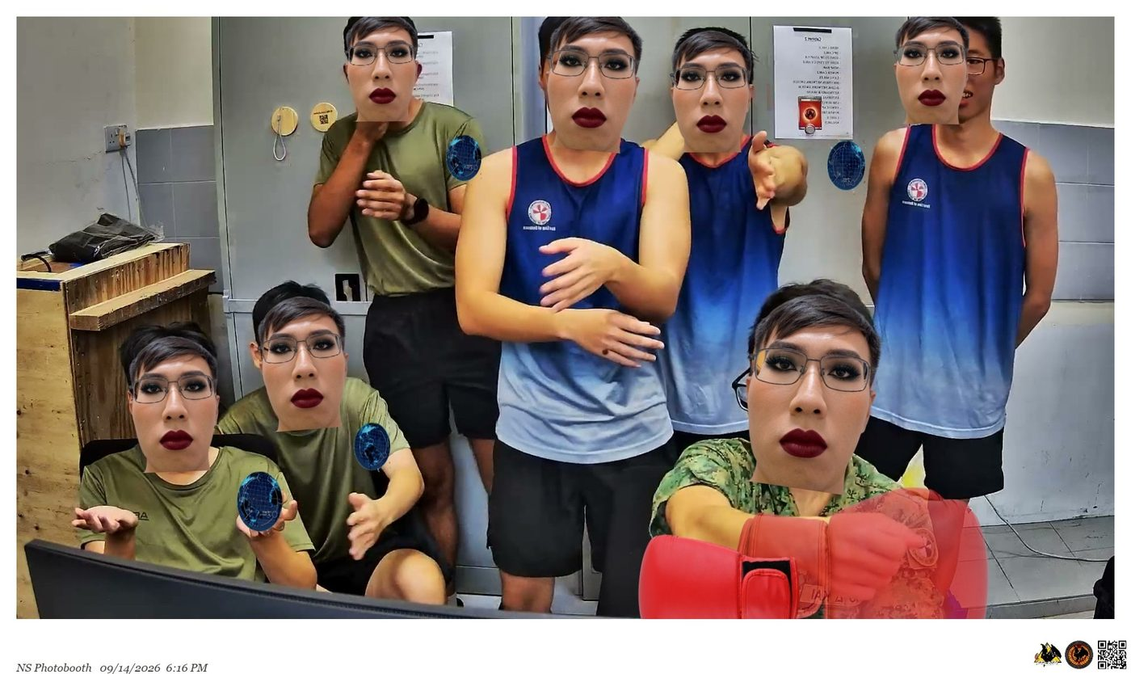
Figure 4 — The same group, but more crowded. At the bottom right, a glove has slipped off the fist it belongs to and is sitting on another person's shoulder and face instead. The person at the back right has no animation at all. This is the problem the limit is there to prevent: the more people and hands there are in the picture, the more likely an animation lands on the wrong person.

Maximum distance tested — 5 m 35 cm (Using Hikvision camera)
The subject is placed at the far side of the room, 5 m 35 cm from the camera. Both kinds of animation were checked at that range: the ones that anchor to the body (Owl, Globe, Scuba) and the ones that need a recognised hand gesture (Drone). All of them still acquired and held their target.
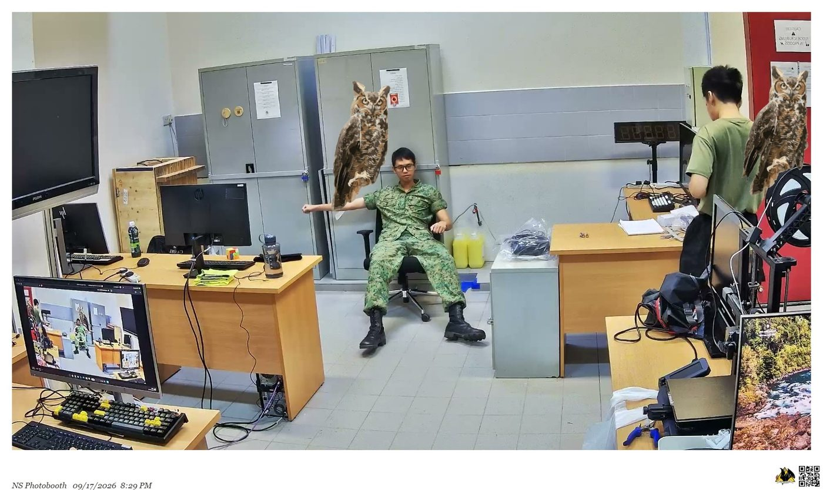
Figure 5 — Distance test, 17 Sep. The subject is seated at the far side of the room with the Owl perched on his outstretched arm, and a second Owl has locked onto another person at the right edge of frame. Arm tracking still resolves cleanly at this range.
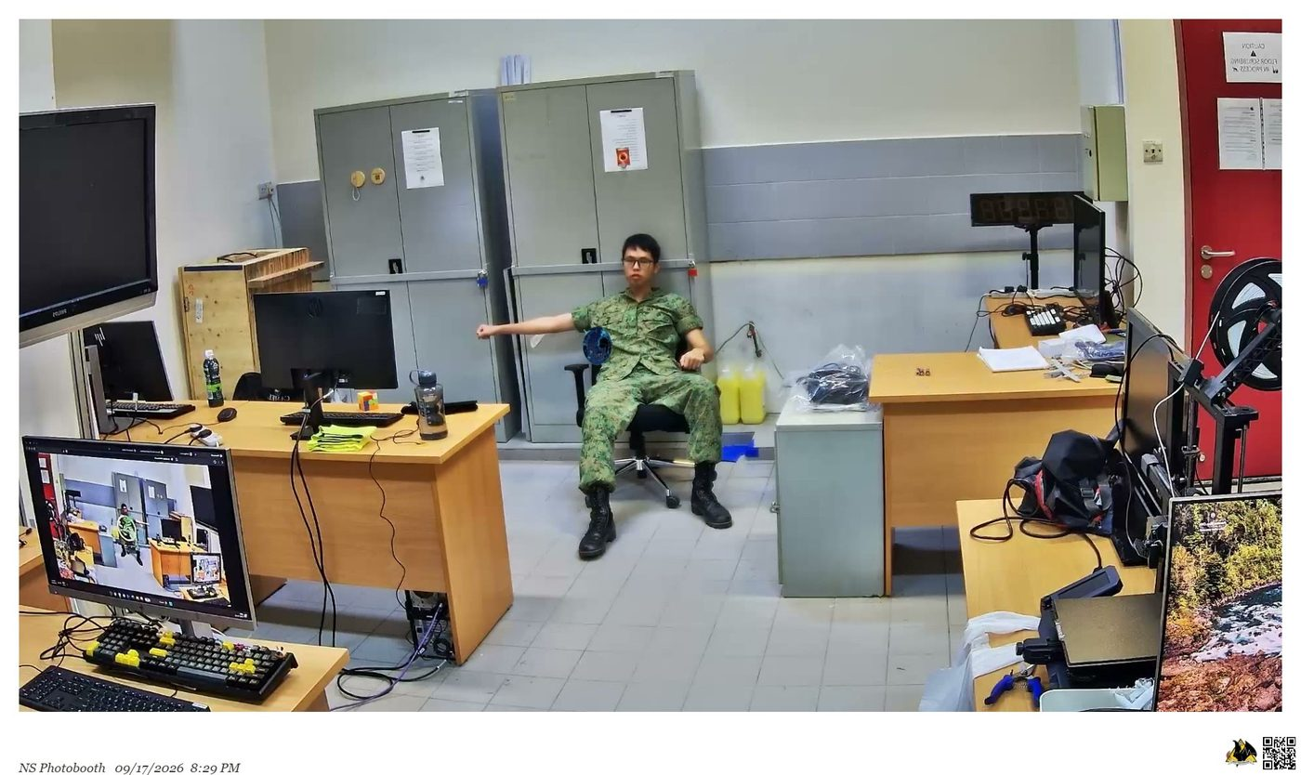
Figure 6 — The Globe at the same distance, still anchored to the arm. Props scale down with the person, so a distant subject gets a correspondingly small prop rather than an oversized one floating loose.
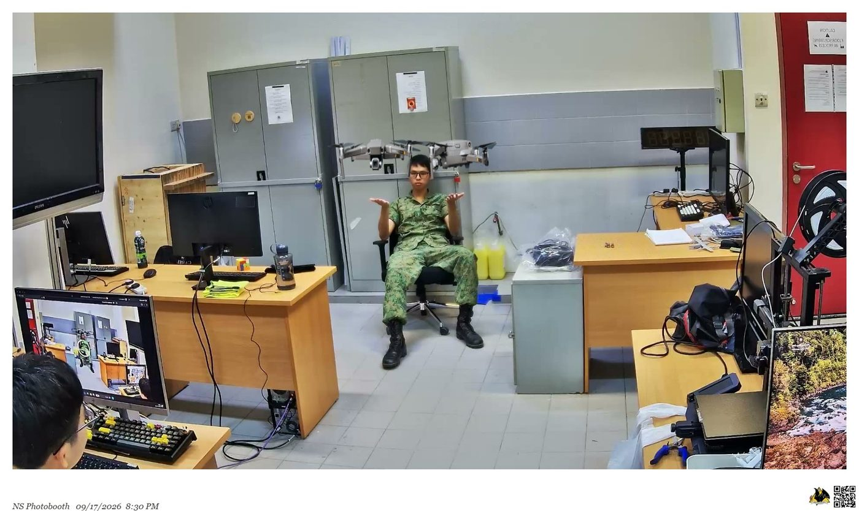
Figure 7 — The Drone — a hand-gesture animation — acquired from both raised palms at the far end of the room. Gesture recognition, not just body tracking, still fires at the tested maximum distance.
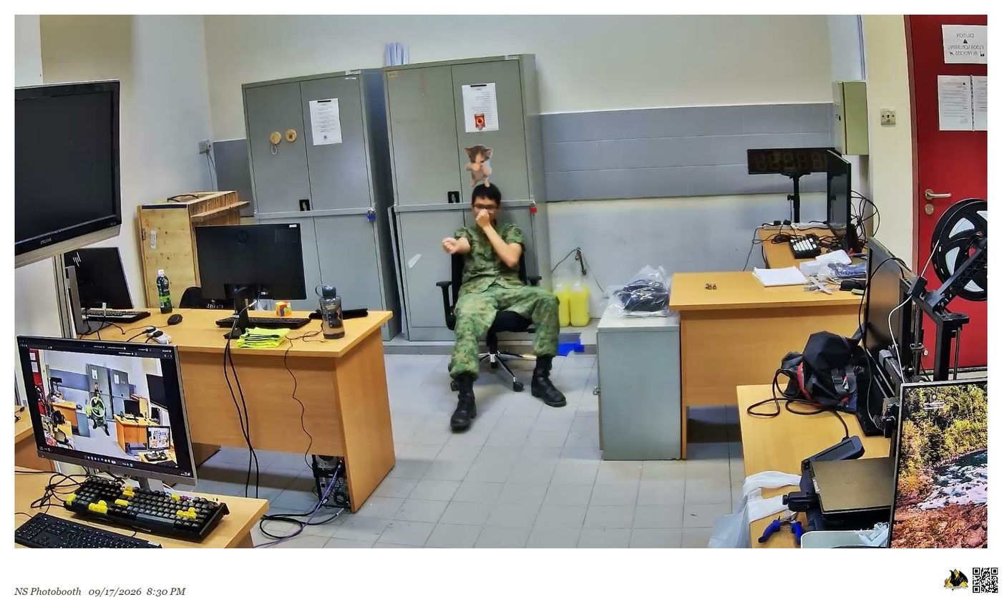
Figure 8 — Scuba summoned by waving at the same distance, hovering above the subject's head. Note this was taken at 8:30 PM under ordinary indoor lighting.
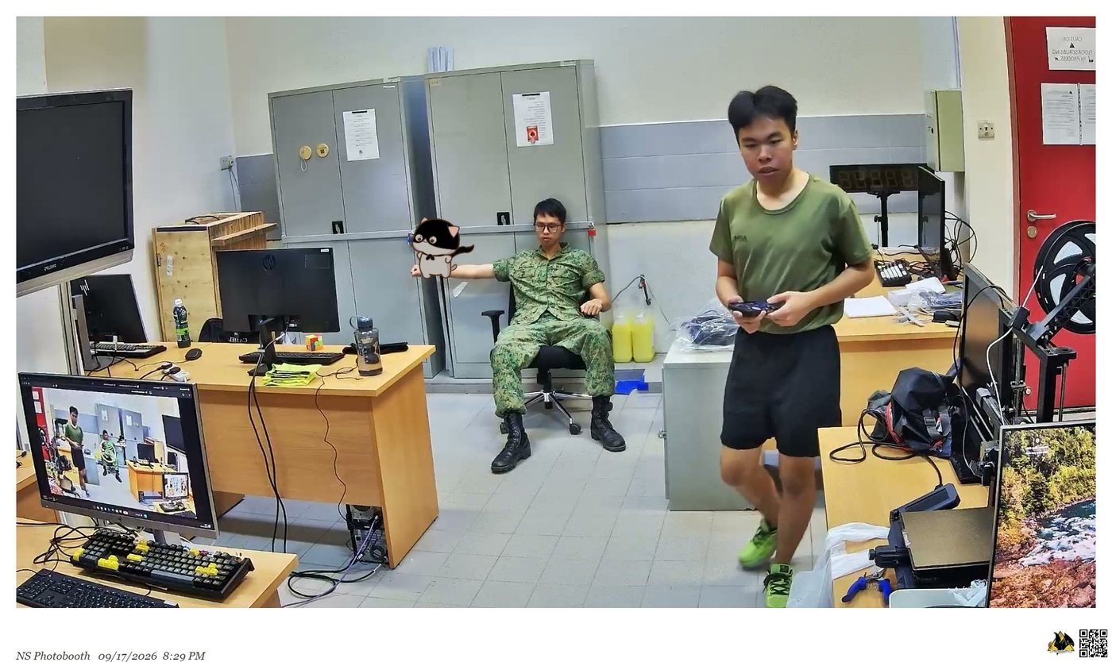
Figure 9 — Bat riding the arm of the seated subject across the room. The second person, much nearer the camera but turned away and holding a controller, gets nothing — the booth needs to see you facing it, and distance alone is not what decides who is tracked.

Maximum distance tested — 6 m 50 cm (Using the DSLR camera)
The test was repeated with the DSLR camera, which reached further than the Hikvision: 6 m 50 cm, against 5 m 35 cm. Body-anchored animations (Bat) and gesture-driven ones (67) were both checked again at that range and both still worked.
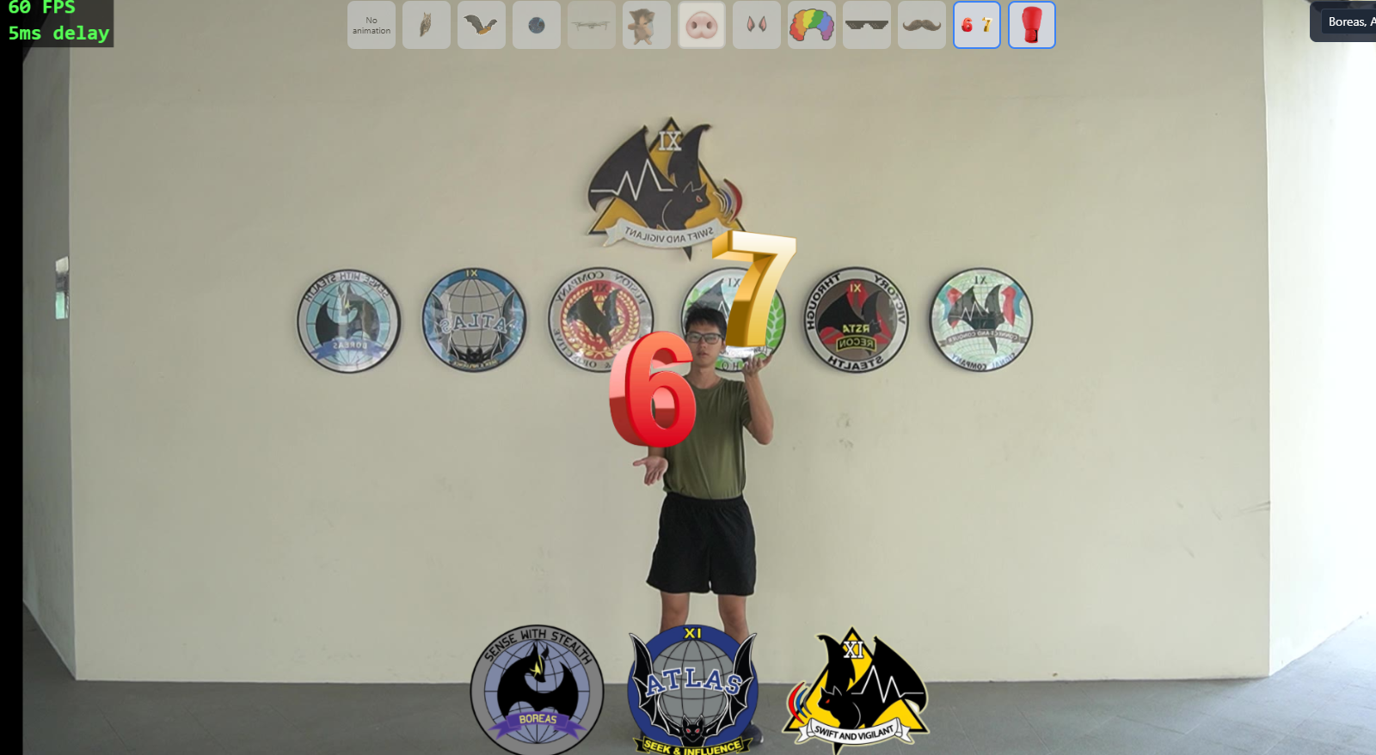
Figure 10 — The DSLR at 6 m 50 cm — further out than the Hikvision was tested at — and the 67 gesture is still read correctly, with the 6 and the 7 landing on the right palms.
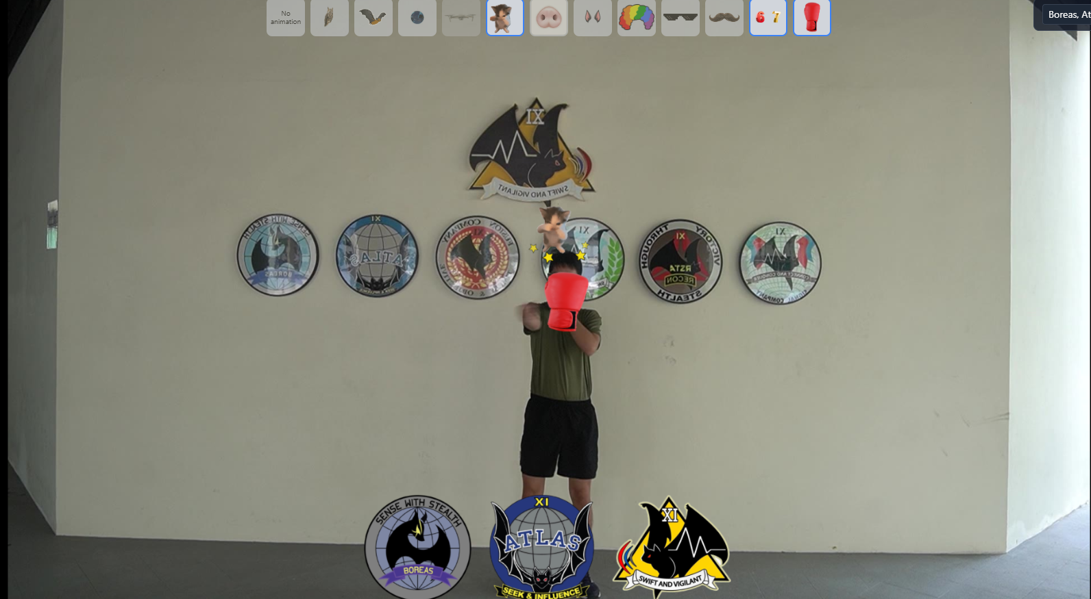
Figure 11 — Why Scuba and Boxing Gloves are not picked together. The glove is on the raised fist as intended, but the punching motion is a hand swinging from side to side, which is also how Scuba is summoned — so the cat has appeared above the head at the same time, surrounded by the dizzy stars the glove sets off. Both animations fire off the same movement.
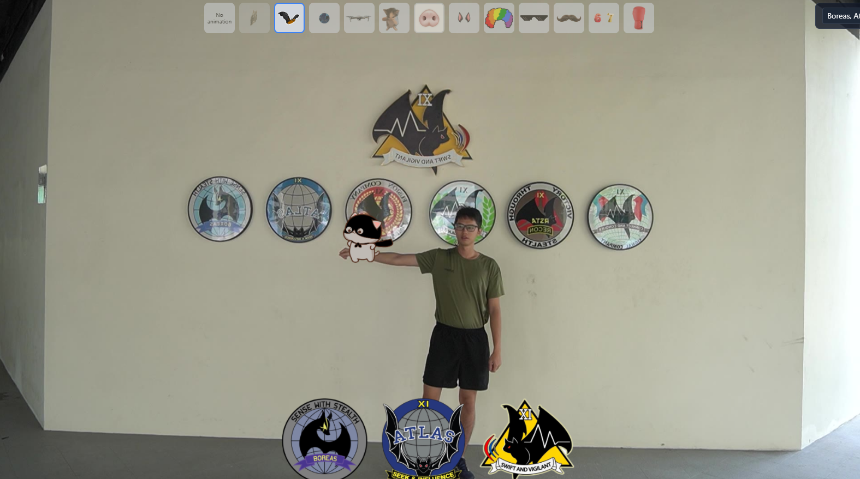
Figure 12 — The Bat perched on an outstretched arm at the same 6 m 50 cm. Arm tracking holds at this distance, and the picture is visibly sharper and better exposed than the Hikvision frames earlier in this section.

Low light
This is the one limitation the screenshots above do not demonstrate, and it is worth saying so plainly rather than implying otherwise. Every photo here was taken in a normally lit room — including the 8:30 PM session, which tracked without trouble under ordinary indoor lighting. What they establish is the lower bound: artificial indoor light at night is sufficient. The degradation reported in very low light is from live observation during setup and is not evidenced by a captured frame here; a screenshot taken in the dim conditions in question would close that gap.

