Software Requirements Specification

For

Pepper Quest

[October 2022]

Prepared By:

Troy Furlow, Mikey Crispin, Sarah Martel, Kana Voelckers

**Table of Contents**

1. Introduction.......................................................................................................................................3

1.1 Overview............................................................................................................................3

1.2 Goals and Objectives.....................................................................................................3

1.3 Definitions..........................................................................................................................3

1.4 Document Conventions………………………………………………………………………3

1.5 Assumptions……………………………………………………………………………………..3

2. General Design Constraints……………………………………………………………………………4

2.1 Product Environment......................................................................................................4

2.2 User Characteristics……………………………………………………………………….…..4

2.3 Mandated Constraints…………………………………………………………………….…..4

3. Nonfunctional Requirements…………………………………………………………………….….….4

3.1 Operational Requirements............................................................................................4

3.2 Performance Requirements..........................................................................................4

3.3 Product Requirements....................................................................................................4

3.4 External Requirements...................................................................................................4

3.5 Organizational Requirements.......................................................................................4

4. System Features.............................................................................................................................5

4.1 Starting Menu…................................................................................................................5

4.1.1 Use Case: Starting Menu….…..................................................................................5

4.2 Gameplay..........................................................................................................................6

4.2.1 Use Case: Planting Seeds……….............................................................................6

4.2.2 Use Case: Purchasing Seeds..................................................................................6

4.2.3 Use Case: Pepper Hub……………………………………………………………………7

4.3 Functional Area Overview…………………………………………………………………..7

5. Appendix...........................................................................................................................................9

5.1 Team Roles.......................................................................................................................9

1. **Introduction**

**1.1.Overview**

This document provides software information about the game Pepper Quest to interested parties. The purpose of this document is to provide a clear understanding of the functionalities, capabilities, and system requirements for Pepper Quest. This game is still under development, but here we present a plan of our process. We explain what a user who plays the game will expect, with a flowchart on how to obtain a high score and finish the game.By reading this document, one should have a clear understanding of how the gameplay, characters, and features are implemented. Instructions on how to install and play the game are also included.

**1.2. Goals and Objectives**

The main goals of this application are as follows:

* An all-ages friendly game that will be accessible and fun for all players.
* Provide a source of quick entertainment and an accessible way to relieve stress.
* Be able to visualize and easily maneuver the main character from environment to environment.
* A quick and casual game.

**1.3. Definitions**

* Application - the software system described in this document.
* User - Those who are, or are interested in, playing Pepper Quest.
* PQ - Current holding name for game, Pepper Quest.
* UI - User Interface

**1.4. Document Conventions**

Information on this documentation that is not completed will be marked as TBD (to be determined). Information that is marked as TBD should have an estimated date of availability or contact information in case the deadline has passed or for any need of assistance.

**1.5. Assumptions**

* User has windows
* Has PC newer than 2010
* PC has a keyboard and mouse

1. **General Design Constraints (TBD)**

**2.1 Product Environment (TBD)**

**2.2 User Characteristics (TBD)**

**2.3 Mandated Constraints (TBD)**

1. **Nonfunctional Requirements**

**3.1 Operational Requirements**

* The user must be able to use a keyboard to play the game.

**3.2 Performance Requirements**

* The game will not crash <at least 50> percent of the time.

**3.3 Product Requirements**

* The game requires that the user has at least <amount> amount of memory available on their PC. Currently, the game will only be available for PC’s using Windows 10.

**3.4 External Requirements**

* The game will meet the standards for an E rating from the ESRB.

**3.5 Organizational Requirements**

* The game will be written using Unreal Engine V.5 (Blueprint/C++).
* A user will be able to play the game without confusion after 10 minutes.

1. **System Features**

**4.1 Starting Menu**

* **Use Case: Starting Menu**
  + Actors: User
  + Description: This is the starting screen of the game, what the user will first see upon starting the game up.
  + Basic Path:
    - The user will select “Start Game” and gameplay will be initiated.
  + Alternate Path:
    - The user will select “Exit Game” and the program will close.
  + Alternate Path: (TBD)
    - The user will select “Load Game” and a new menu will appear displaying previously saved game data.

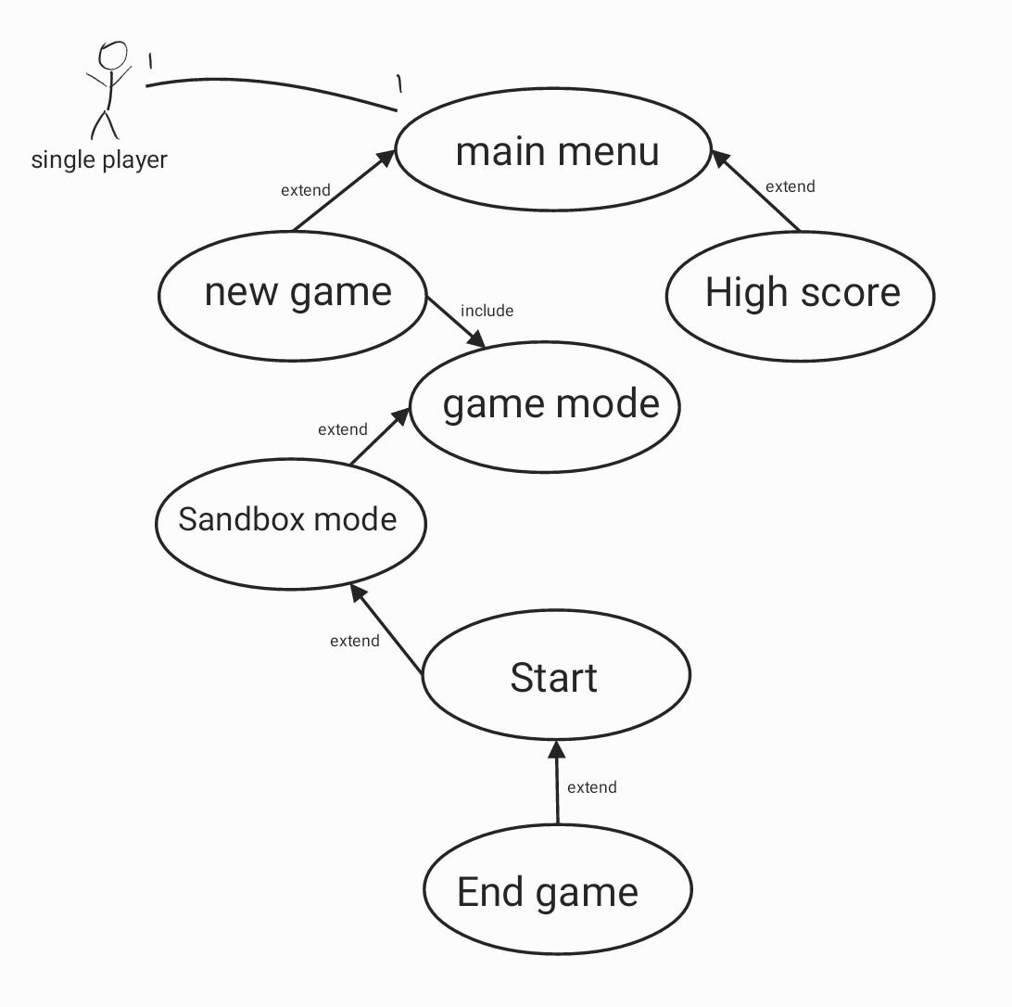

**4.2 Gameplay**

* **Use Case: Planting Seeds**
  + Actors: User
  + Description: The user will see their farm and their free ranging peppers. They will have the ability to plant the pepper seeds they carry in inventory in any location containing dirt. They’re also required to water the seeds after they’ve been planted before the seed will grow.
  + Basic Path:
    - Use the keyboard keys (w, s, a, d) to orient the Sprite on top of a dirt area
    - Select the corresponding key on the keyboard (1, 2, 3, 4, 5, 6, 7, 8, 9, 0) to activate an Inventory square containing Pepper Seeds
    - If the seed has been planted then the dirt will now contain a small mound
    - Select the corresponding key on the keyboard to activate the Inventory square containing the Watering Can
    - If the seed has been watered, the ground will turn a darker shade of brown

* **Use Case: Purchasing Seeds**
  + Actors: User
  + Description: The user is able to purchase seeds from the Farm Stand that resides on the main interfacing area. Pepper Seeds are purchased using coins in the users Coin Purse (quantity is visible from the main interface).
  + Basic Path:
    - Use the keyboard keys (w, s, a, d) to orient the Sprite within one tile of the Farm Stand.
    - Use the action key (e) to initiate conversation with the Farmer.
    - Use the keyboard keys (w, s, a, d) to select which Seeds the user is wanting to purchase.
    - Use the action key (e) to confirm purchase.
    - Seeds will then appear in the users Inventory Bar.
  + Alternate Path:
    - The user is able to cancel the purchase and exit out of the Farm Stand menu.
* **Use Case: Pepper Hub**
  + Actors: User
  + Description: From this menu, the user is able to view a preview list of each Pepper that resides on their farm. They can see the selling price for each pepper, and can sell them directly. They also have the ability to choose a Pepper, view the Peppers that are available to breed with it, and then breed those two Peppers creating new Pepper seeds.
  + Basic Path:
    - Use the keyboard keys (w, s, a, d) to highlight the Pepper Hub from the main interface
    - Use the action key to select (e)
    - Use the keyboard keys (w, s, a, d) to highlight the selling price next to a pepper image.
    - Use the action key to select (e)
    - Selling price funds will be added to the users Coin Purse and Coin Purse amount will automatically update
  + Alternative Path:
    - User can also use the keyboard keys (w, s, a, d) to highlight the Breed option next to a pepper image.
    - Use the action key to select (e)
    - User will view a list of Peppers that are available to breed with the one selected. Use the keyboard keys (w, s, a, d) to highlight one, and the action key (e) to select Breed.
    - The resulting Seeds from the breeding action will automatically be added to the users inventory.
  + Alternative Path:
    - The user is also able to exit out of the Pepper Hub by highlighting and then using the action key (e) on the Exit menu button.

**4.3 Functional Area Overview**

* **Functional Area: Menu**
  + Player can start a new game
  + Player can possibly load a save game (TBD)
  + Player can exit the game
* **Functional Area: Gameplay**
  + Player will press on keys to move character
  + Player can interact with objects and do things:
    - Plant pepper seeds
    - Water pepper seeds
    - Interact with NPCs
  + Player can interact with Shop and do things:
    - Purchase more peppers seeds
  + Player can interact with Pepper Hub:
    - See a preview image of adult peppers
    - Sell adult peppers
    - Breed adult peppers
  + Player will have a clear view of the user interface:
    - Free-range Peppers on Farm
    - Inventory bar
    - Time of day
    - Day number
    - Coins in Purse
* **Functional Area: Pause**
  + Gameplay can be paused at any time.
  + A minimal selection of options can be accessed when paused.
    - The game can be saved (TBD)
    - The game can be closed
    - the resolution can be changed (TBD)
    - The same button unpauses the gameplay.

1. **Appendix**

**5.1 Team Roles**

* Sarah - Team Leader (SCRUM Master)
  + Organize Team meetings/work sessions
  + Ensures the project is progressing as scheduled
  + Identifies weaknesses and strengths
* Troy - Lead Designer
  + Designs game layout and sprite characters
  + Designs audio soundtrack including soundfx
* Mikey - Lead Programmer
  + Responsible for bulk of coding operations
  + Communicates with Lead Designer to ensure specifications are being met
* Kana - QA Leader
  + Locates game bugs and flaws
  + Makes usability suggestions
* Everyone - Analyst/Requirements Engineer
  + Since we’re the client, we will confer with each other about game specifications