程式作業二

Group 6

107502501林廷真 107502502林欣蓓

107502503陸品潔 107502504歐亭昀

107502509王君安 107502511廖冠閔

107502540陳皇宇

1. **traditional multiplication**

**資料結構**：因為int 有大小上限，因此把input 用string 來存。

**演算法**：按照傳統乘法

**時間複雜度**：O($n^{2}$)

**Pseudo code**：

string multiplication(string num1, string num2)

{

if num1.size() < num2.size()

swap(num1,num2)

int maxlen = max(num1.size(), num2.size());

paddingzero(&num1, maxlen - num1.size(), 1);

paddingzero(&num2, maxlen - num2.size(), 1);

for (int i = maxlen - 1; i >= 0; i--)

{

plus_num = "";

c = 0;

for (int j = maxlen - 1; j >= 0; j--)

{

int mult = num1[i]* num2[j];

mult = mult + c;

c = mult / 10;

mult = mult % 10;

plus_num = to_string(mult) + plus_num;

}

paddingzero(&plus_num, (maxlen - i - 1), 0);

final_num = plusnum(final_num, plus_num);

}

return final_num;

}

1. **Karatsuba algorithm**

**資料結構**：因為int 有大小上限，因此把input 用string 來存。

**演算法**：

設 A = a*10+b , B = c*10+d

r = (a+b)*(c+d)-a*c-b*d

A*B = (a*c) ${10}^{2}$* + (r) ${10}^{1}$* + (b*d) ${10}^{0}$

*

**黃底**為乘法，共3次

可看出原本要 b*d , b*c , a*d , a*c 4次乘法降為3次

**時間複雜度**：

T(n) = 3T(n/2)+O(n) 根據 master theorem

a = 3 , b = 2 , f(n) = n

因為f(n) = O($n^{\log_{2}3-c}$)

所以T(n) = Θ($n^{\log_{2}3})$

**Pseudo code**：

string karatsuba(string num1, string num2)

{

if num1.size() < num2.size()

swap(num1,num2)

if (min(num1.size(), num2.size()) <= 1)

return to_string(stoi(num1) * stoi(num2));

maxlen = max(num1.size(), num2.size());

paddingzero(&num1, maxlen - num1.size(), 1);

paddingzero(&num2, maxlen - num2.size(), 1);

maxlen_2 = maxlen / 2;

x = num1.substr(0, maxlen - maxlen_2);

y = num1.substr(maxlen - maxlen_2, maxlen);

w = num2.substr(0, maxlen - maxlen_2);

z = num2.substr(maxlen - maxlen_2, maxlen);

xw = karatsuba(x, w);

yz = karatsuba(y, z);

plus_xw_yz = subnum(subnum(karatsuba(plusnum(x, y), plusnum(w, z)), xw), yz);

paddingzero(&xw, maxlen_2 * 2, 0);

paddingzero(&plus_xw_yz, maxlen_2, 0);

string final_num = plusnum(plusnum(xw, yz), plus_xw_yz);

return final_num;

}

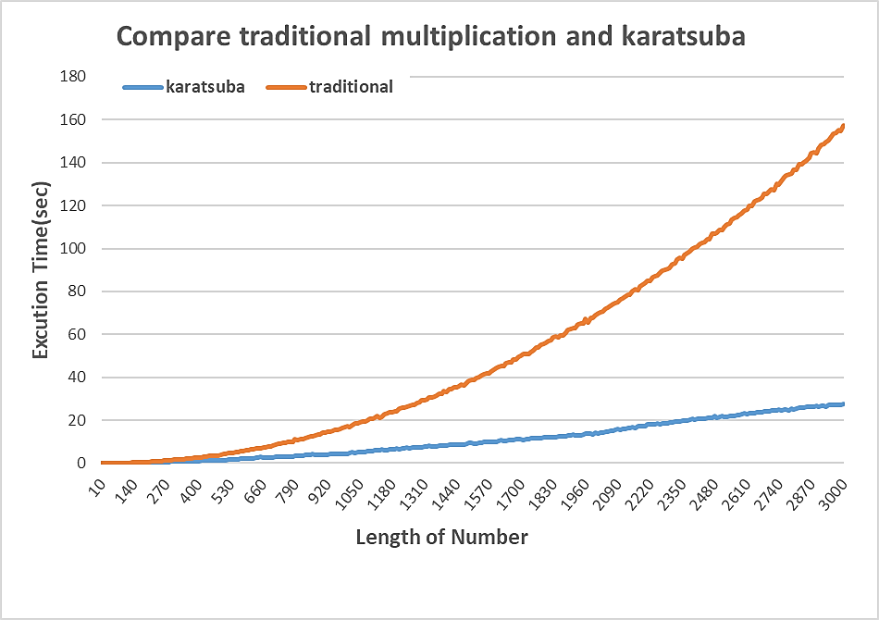

**n=95**

When n>95 karatsuba algorithm will faster then traditional method.

1. dynamic karatsuba

我們試著把只能分兩段的karatsuba改成能夠自由分段的karatsuba

但是發現我們的算法分越多個，就會執行越多次的乘法

演算法：(以divide 3為例)

A = a ${10}^{2}$*+b ${10}^{1}$*+c

B=d ${10}^{2}$*+e ${10}^{1}$*+f

A*B = a*d ${10}^{4}$* +

((a+b)*(d+e)-a*d-b*e) ${10}^{3}$* +

b*e ${10}^{2}$* +

((a+c)*(d+f)-a*d-c*f) ${10}^{2}$* +

((b+c)*(e+f)-b*e-c*f) ${10}^{1}$* +

c*f ${10}^{0}$

*

共 6 次乘法

Trandition 9次乘法

Divide 2 karatsuba 5次乘法

**Pseudo code**：

string dynamic_karatsuba(int divide, string num1, string num2)

{

if num1.size() < num2.size()

swap(num1,num2)

int maxlen = max(num1.size(), num2.size());

if (min(num1.size(), num2.size()) <= 1)

return to_string(stoi(num1) * stoi(num2));

else if (maxlen < divide)

divide = 2;

paddingzero(&num1, maxlen - num1.size(), 1);

paddingzero(&num2, maxlen - num2.size(), 1);

maxlen_divide = maxlen / divide;

last_len = (maxlen - maxlen_divide * divide);

for (int i = 0; i < divide; i++)

if (i == 0 && last_len != 0)

{

tmp1 = num1.substr(0, last_len + maxlen_divide);

tmp2 = num2.substr(0, last_len + maxlen_divide);

sub_num1.append (tmp1);

sub_num2. append (tmp2);

}

else

{

tmp1 = num1.substr(last_len + maxlen_divide * i, maxlen_divide);

tmp2 = num2.substr(last_len + maxlen_divide * i, maxlen_divide);

sub_num1.append(tmp1);

sub_num2.append(tmp2);

}

for (int i = 0; i < terms; i++)

tmp = dynamic_karatsuba(divide, sub_num1[i], sub_num2[i]);

part_multiplication.append (tmp);

for (int i = 0; i < terms - 1; i++)

for (int j = i + 1; j < terms; j++)

plus_num1 = sub_num1[i];

plus_num2 = sub_num2[i];

plus_num1 = plusnum(sub_num1[i], sub_num1[j]);

plus_num2 = plusnum(sub_num2[i], sub_num2[j]);

multiplication_plus = dynamic_karatsuba(divide, plus_num1, plus_num2);

multiplication_plus = subnum(subnum(multiplication_plus, part_multiplication[i]), part_multiplication[j]);

padd = (part_multiplication.size() - i - 1);

padd = padd + (part_multiplication.size() - j - 1);

paddingzero(&multiplication_plus, ((terms - i - 1) + (terms - j - 1)) * maxlen_divide, 0);

part_plus.append(multiplication_plus);

for (int i = 0; i < terms; i++)

paddingzero(&part_multiplication[i], maxlen_divide * (terms - i - 1) * 2, 0);

final_num = part_multiplication[0];

for (int i = 1; i < terms; i++)

final_num = plusnum(final_num, part_multiplication[i]);

for (int i = 0; i < part_plus.size(); i++)

final_num = plusnum(final_num, part_plus[i]);

return final_num;

}

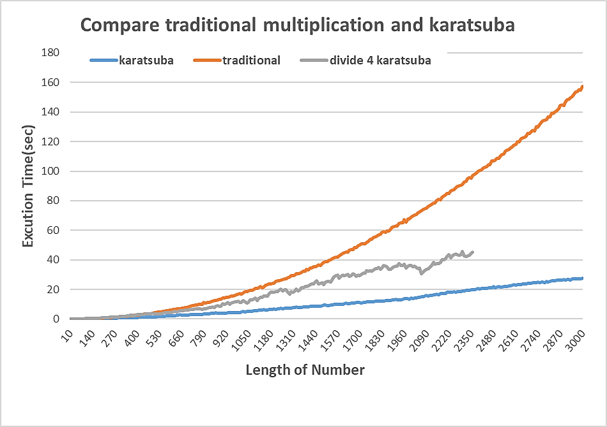

**n=400**

When n>400 karatsuba algorithm will faster then traditional method.