1. 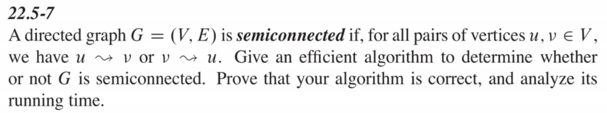找出G所有的SCC
2. 做 Topological Sorting
3. 檢查是否 (SCC(i),SCC(i+1)) for every SCC的邊是否存在
4. 若(SCC(i),SCC(i+1))有邊不存在則不是semi-connection

若(SCC(i),SCC(i+1))都存在則是semi-connection

Pseudocode

Function Check_semi_connection()

For v in V

DFS(V,G)

S 第一次 DFS 所得到的stack

G’ = G transform

while(S not empty)

v = S.pop()

If v not visite

DFS(v,G’)

SCC 做完兩次DFS所得到的SCCs

SCC_sort = Topological_Sorting(SCC)

for i in len(SCC_sort)-2:

if (SCC_sort[i],SCC_sort(i+1)) not exist edge

return not a semi-connection graph

return Is a semi-connection graph