問題分成這兩個，都要用B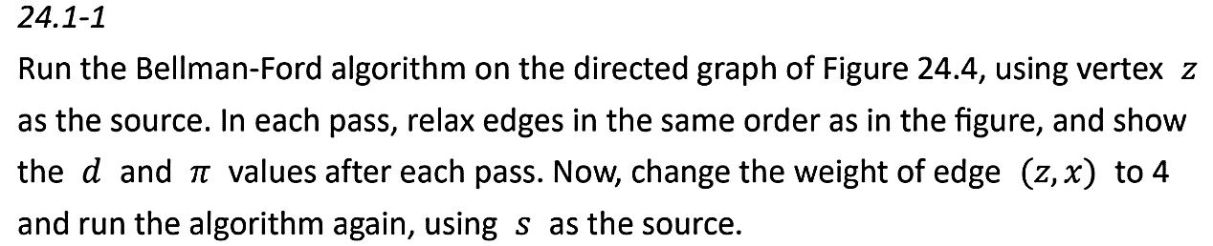ellman-Ford algorithm 跑一遍

1. Using z vertex as the Source
2. Change the weight of edge (z,x) to 4 ,using s as source

**Bellman-Ford algorithm**

(i,u) Є E , dist[u] = min( dist[i] + weight[i][u] , dist[u] )

Pseudocode:

for i from 1 to size(vertices)-1:

for each edge (u, v) with weight w in edges:

if distance[u] != ꝏ:

if distance[u] + w < distance[v]:

distance[v] = distance[u] + w

predecessor[v] = u

1. 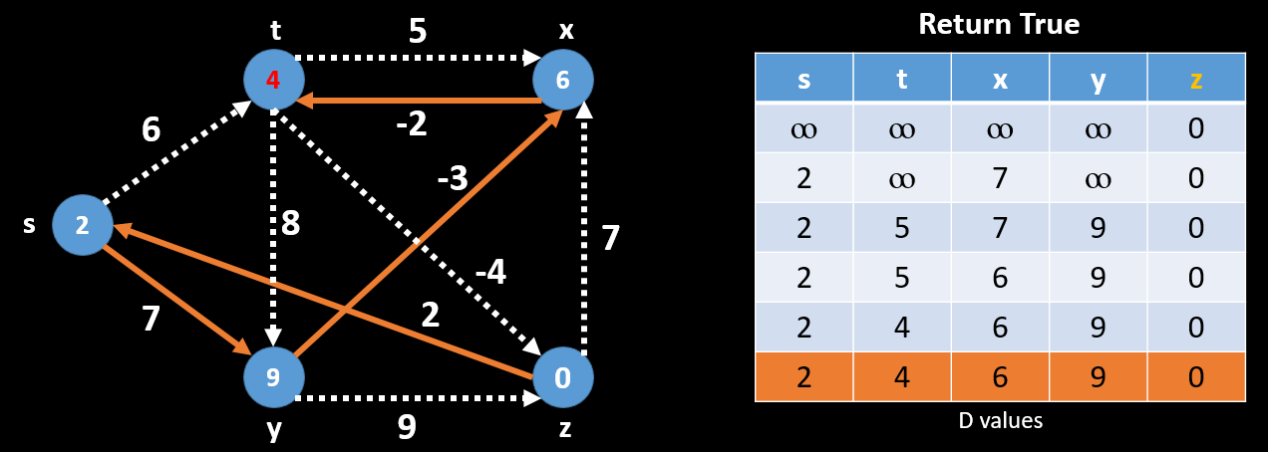Using z vertex as the Source

橘色ROW為檢查是否有負迴圈，只要跑V-1次以上還可更新代表有負迴圈存在，檢查結果為沒有負迴圈，return True

1. Change the weight of edge (z,x) to 4 ,using s as source

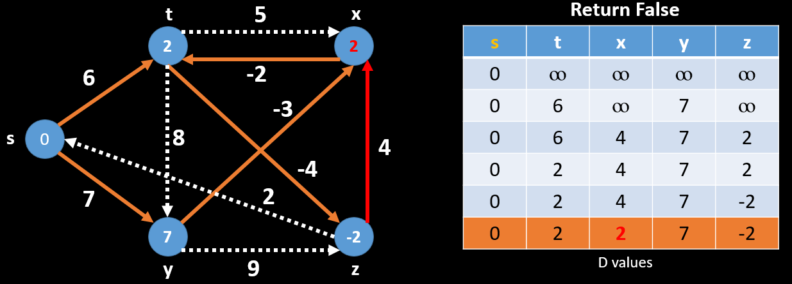

更新第V次 dist[x](4) >　dist[z](-2) + weight[z][x](4)

4 > -2+4

因此Return False