1. 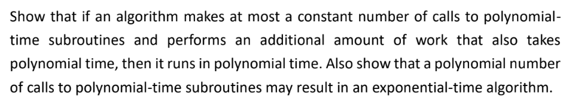證明呼叫常數數量run time in polynomial time的subroutines ，Runtime 也會在polynomial time

定義一連串的subroutine of S {S1,S2,S3,S4…..,Si}，run time is O($n^{k}$)for every subroutine in S，所有的subroutine Si(n)= $n^{k}$，定義一個演算法會依序呼叫S中的subroutine， Si 的polynomial runtime 定義為pi(n)，且pi(n)≦p(n)= $n^{k}$

用數學歸納法證明即使在很大的return value跟worst case runtime經過i次呼叫仍然都會在O(p(n))

**當i=1**

p1(n) = $n^{k}=O(n^{k})$ 為polynomial runtime

**當第i次呼叫**

pi(n) = p(p(. . .(p( n)). . .) = $n^{k^{i}}=O(n^{k})$ 為polynomial runtime

**當第i+1次呼叫**

Pi+1(n) = O(${(pi(n))}^{k}$) = $O(n^{k})$ 還是polynomial runtime

設m為i<m **總total runtime**為

O($\sum_{i=1}^{m}{pi(n)}$)=O(mpm(n)) = O(m $n^{k^{m}}$)為polynomial runtime for any k and m

根據數學歸納法得證

1. 證明呼叫polynomial time 後時間複雜度為exponential-time

假設S output 為2倍的input，第i次呼叫S的return value and runtime 會是O(n $2^{i}$)

總runtime 為

O($\sum_{i=1}^{n}{pi(n)}$) = O($n\sum_{i=1}^{n}{2^{i}}$) = O(n $2^{n}$)為exponential-time