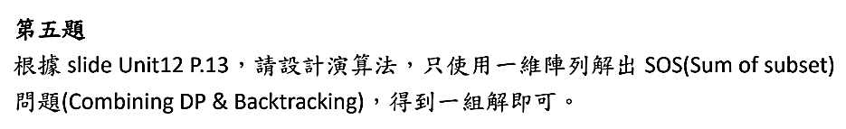**題目：**Use 1 dimension array solve SOS problem

**演算法：**由於原本的演算法也只用的到上一層的array所以可以轉換成一維，陣列大小就是M+1然後從M跑到1避免重複放入element  
最後要找到子集合元素只需要判斷 dp[i-S[e]] 是否=True，若是True則把S[e]放入subset

**Pseudocode：**

S is a set of input numbers

dp = array of M+1 element of boolean

**// init**

All element of dp are False

dp[0] = True

**//run algorithm**

for e from 0 to (length of S )-1

for i from M to 0

if i < S[e]

break

if dp[i] or dp[i - S[e]]

dp[i] = True

**//get subset**

if dp[M] == 1

v = M

elementindex = len(S)-1

subset = []

while(v != 0)

if S[elementindex] <= v and dp[v-S[elementindex]] == True

subset.append(S[elementindex])

v = v-S[elementindex]

elementindex -= 1

print("Exist")

print(subset)

else

print("Not exist any subset that sum of subset equal M")