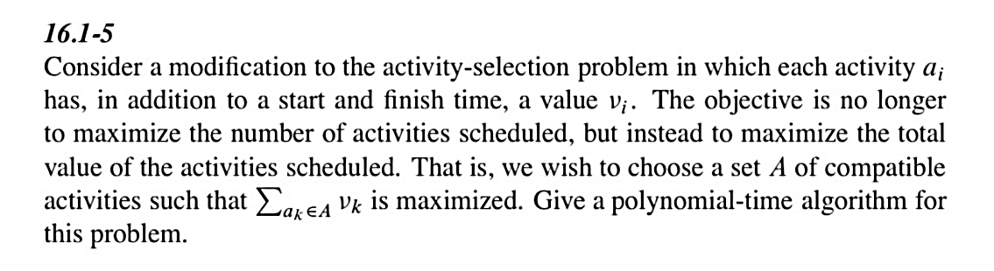P5

**Pseudocode:**

for( i = activityNum; i >=0; --i ) {

for( j = i+1; j < activityNum+2; ++j ) {

for( k = i+1; k < j; ++k ) {

if( starts[k] >= finished[i] && finished[k] <= starts[j] ){

if( dp[i][j] <= (dp[i][k] + v[k] + dp[k][j])){

dp[i][j] = (dp[i][k] + v[k] + dp[k][j])

}

}

}

}

}

時間複雜度：O($n^{3}$)