1. 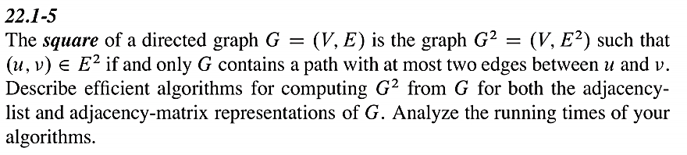Adjacency-list

E is a Eage set of all Vertex

E[v] as Eage list of v vertex

squareE as Eage set of G square

for index , e in E

squareE[index] =e

for v in V

for eg in E[v]

squareE[v].add(checkexist(E[eg]))

Time complexity O(|V||E| + |E|) -> O(|V||E|)

1. Adjacency matrix

squareg = g

for i from 0 to len(V)

for j from 0 to len(V)

for k from 0 to len(V)

if g[i][k] == 1 and g[k][j] == 1

squareg[i][j] =1

Time complexity O(${|V|}^{3}$)