Project 2 Convex Hull

Shiyu Fan (G42039555) | sfan47@gwu.edu

# Problem Statement

N points separated on a 2D plane and find out the Convex Hull of this set of points. The convex hull is defined as the smallest convex polygon that contains all the points. Describe an O(nlogn) time divide and conquer algorithm to find the convex hull of the set P of n points.

# Implementation Characteristics

1. **Algorithm**
2. Using Quick Sort to search the most left and right point.
3. The line formed by these two points cut the set into two pieces. The third point which leave farthest from the line must be on the convex hull.
4. Searching all this kind of points by Divide & Conquer method.
5. **Time Complexity.**

$T\left(n\right)=2T\left(n/2\right)+n=O(nlogn)$.

# Experimental Analysis

## Programe Listing(Divide&Conquer Part)

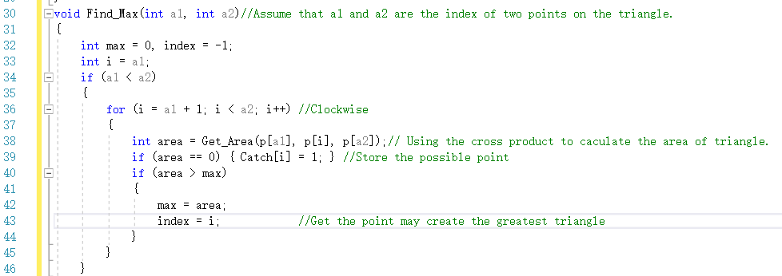

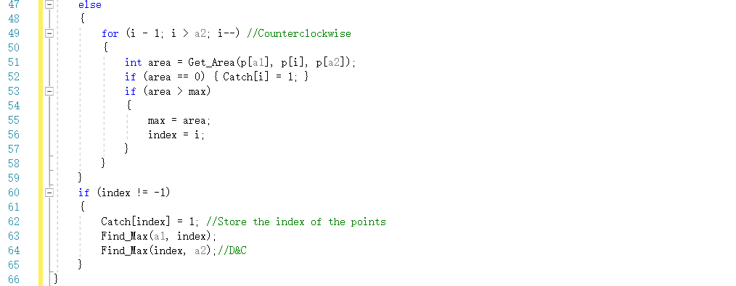

Fig 1. Divide&Conquer Program

## Data Normalization Notes

In order to see the trend of the growth clearly, I take the $\log_{10}{f(n)}$ function for the theoretical and actual results.Also the abscissa is based on the $\log_{10}{n}$.

## Output Numerical Data



Fig 2. Output Numerical Data

## Graph

Output :

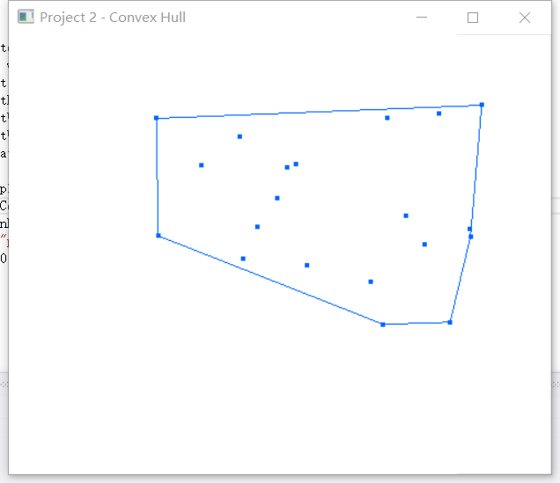

Fig 3. Convex Hull Output

Line Chart :

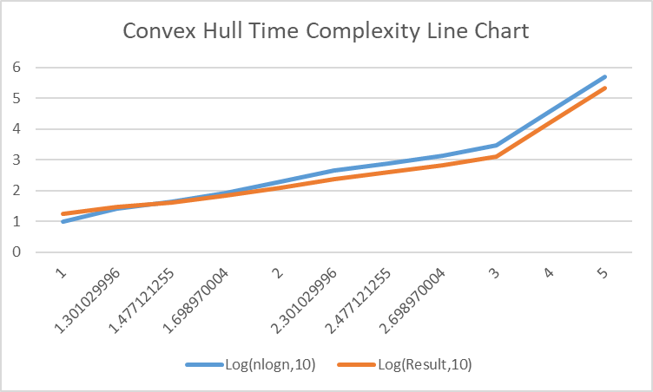

Fig 4. Time Complexity Line Chart

log(10,y)/us

Log(n,10)

## Graph Observations

From the graph above, when n is less than 30($\log_{10}{n is less than 1.4}$), the actual results is a little bit greater than the theoretical time complexity. When n grows exponentially, the trends of theoretical and actual values growths are consistent.

# Conclusions

In this project, I have tried two completely dissimilar methods to solve this convex hull problem. The first one is called Graham's scan (I also have uploaded it on blackboard). The other one is this D&C method. In D&C, the most crucial thing is to distinguish the up and down part (or we can say the clockwise and counterclockwise triangles). In this project, D&C method solved the problem efficiently and also achieved the less time complexity.