Software Architecture Document for Project "CoonSpect"

0. Authors
Izmestev Denis, Stubarev Ilya, Vyborceva Anastasiya, Markidonov Vladimir

1. Goals and Limitations
1.1. Key Functional Requirements
- Multi-user remote access with Web-UI: Students must access the system via web browser
- Each user must have personal lecture catalog
- Audio file processing pipeline:
- Upload validation (format, size)
- Speech-to-Text transcription (WhisperX)
- LLM-based summary generation (ollama)
- RAG enhancement with external knowledge bases
- Asynchronous task processing: Long-running operations (STT, LLM) must not block UI
- Summary editing and export: In-app editor with multi-format export (MD, PDF, TXT)

1.2. Non-functional Requirements
- Team expertise: Python (FastAPI), React, PostgreSQL experience available
- Cost optimization: Prefer open-source solutions (WhisperX, ollama) where possible

1.3. Architectural Goals
- Microservices-based pipeline for STT and LLM processing to enable independent scaling
- Event-driven asynchronous architecture using message queue for long-running tasks
- Stateless REST API for horizontal scalability
- Containerized deployment with Docker for environment consistency
- Microservice architecture allowing create maximum isolation of project modules and swap microservices
- Cloud-native design supporting deployment on cloud platforms
- Cost-efficient AI processing with support for local (ollama) and cloud AI services

1.4. Additional Goals, Restrictions and Preferences
Performance:
- STT: 1-hour audio → 5-10 minutes
- LLM: 1-hour lecture → 7-10 minutes
Concurrent processing of multiple user requests
Scalability: Support for growing user base and lecture volume
Extensibility:
- Replaceable STT/LLM services
- Pluggable RAG module
- API-first design for frontend integration
Reliability: Fault-tolerant processing pipeline with error recovery
Maintainability: Containerized deployment, clear separation of concern

2. Goals analysis
This section presents an analysis of the key goals of the Coonspect project, an overview of possible ways to achieve them, and the rationale behind the chosen architectural solutions, taking into account SRS requirements and system constraints.

2.1. Security and Authentication
Since the system involves a multi-user operation mode and the storage of personal data (lectures, notes), it is critical to ensure reliable authentication and authorization of requests. Every API request, except for registration and login, must be protected.
There are several main approaches to session management:
- Session-based authentication
- Token-based authentication (JWT)
- OAuth2 (third-party providers)
Applicability Analysis:
The session-based approach requires storing state on the server, which complicates the horizontal scaling of microservices and Celery workers. OAuth2 reduces the security burden but complicates account logic and introduces an external dependency, which is not required for an educational system. JWT is the most suitable option for an architecture based on FastAPI and Celery, as it allows for authenticity verification without querying the database for every request.
Decision:
The JWT mechanism (Access + Refresh tokens) was chosen. To implement logout, a token blacklist in Redis is used until their expiration. User passwords are not stored in plaintext; they are hashed before being written to PostgreSQL.

2.2. Asynchronous Task Processing
According to the non-functional SRS requirements, processing 1 hour of audio should not exceed 5–10 minutes. Executing such heavy tasks (STT, LLM) within an HTTP request is unacceptable, as it would lead to timeouts and interface locking.
Possible Implementation Options:
- Multithreading
- Task Queues: Offloading tasks to separate workers via a message broker.
Applicability Analysis:
Multithreading in Python is limited by the GIL and scales poorly across multiple servers. Using task queues allows for the decoupling of the API from the computational nodes.
Decision:
The Celery + Redis combination was chosen. The API server receives the file and sends the task to the queue, immediately returning a "processing" status. Celery workers, deployed in separate Docker containers, perform transcription and summary generation. This allows computational nodes to scale independently of the web server and guarantees task restarts upon failure, reducing the risks identified in the risk table (long processing times).

2.3. Web Interface and Cross-platform Capability
The target audience (students) uses various devices to access the system. It is necessary to provide a unified user experience.
The following approaches were considered:
- Native applications (iOS/Android/Desktop)
- Web application (SPA)
- Hybrid applications (Electron/React Native)
Applicability Analysis:
Developing native applications requires maintaining multiple codebases. Hybrid solutions add an abstraction layer that provides no significant advantages for audio uploading and text editing tasks.
Decision:
A Web Application (Single Page Application) based on the React + TypeScript stack was chosen. This allows for covering all user devices via the browser.

2.4. Data and File Storage
The system must store metadata (users, task statuses) and heavy binary objects (lecture audio files).
File Storage Options:
- Local file system
- Inside the database
- Object storage (S3)
Applicability Analysis:
Storing on a local disk makes file access difficult for workers if they are running on other nodes. Storing in database fields bloats the DB size and slows down backups. Object storage ensures the independence of computation and storage.
Decision:
A hybrid scheme is applied. Metadata is stored in PostgreSQL, while audio files are uploaded to S3-compatible cloud storage. Only links to the files are saved in the database.

2.5. AI Pipeline Quality (STT and LLM)
The core value of the product is transcription accuracy and the relevance of the summary. High probabilities of STT quality and generation issues were highlighted in the risk table.
Generation Approaches:
- Basic prompting
- RAG (Retrieval-Augmented Generation)
- Model fine-tuning
Applicability Analysis:
Basic prompting is not effective enough. Model fine-tuning requires significant computational resources and datasets. RAG significantly improves accuracy.
Decision:
The implementation of RAG will allow for the use of external sources and significantly improve the quality of responses.

3. Solution description

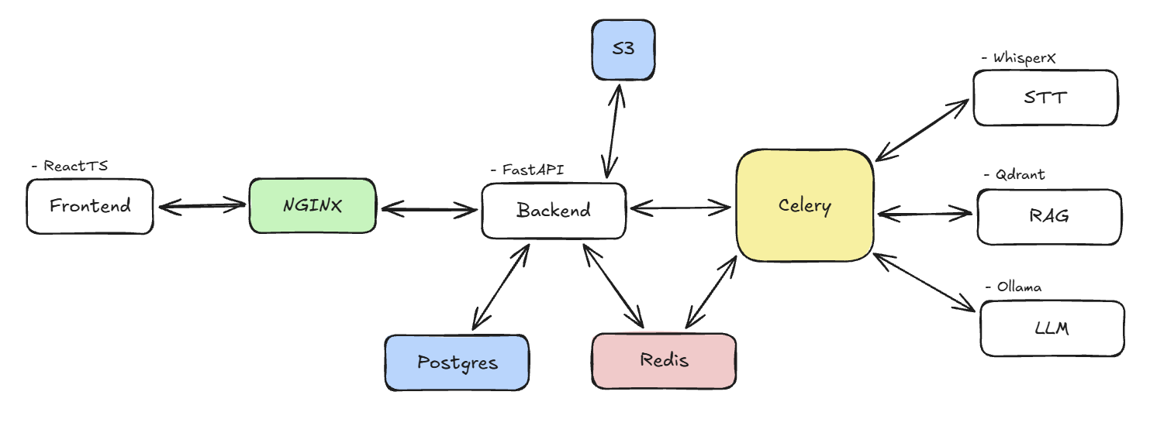

3.1. Modules and Subsystems
The system architecture consists of several key modules, each responsible for strictly defined functionality:
Component Interaction Description:
- Frontend (React + TypeScript) — the client-side of the application that interacts with the user. It sends HTTP requests to the backend via NGINX.
- NGINX — acts as a reverse proxy. It accepts all incoming requests, serves static frontend files, and redirects API requests to the Backend server.
- Backend (FastAPI) — the core of the system. It processes requests from the frontend, manages data in PostgreSQL, places tasks in the Redis queue, and monitors their execution status via Celery.
- PostgreSQL — the primary relational database. It stores information about users, lectures, processing statuses, and completed summaries.
- Redis — performs two key functions:
  - Message broker — passes tasks from the Backend to Celery workers.
  - Result store backend — temporarily stores task execution results.
- S3 — object storage for lecture audio, transcription results, and completed summaries.
- Celery — a system of asynchronous workers. It pulls tasks from Redis and performs resource-intensive operations:
  - Audio transcription (WhisperX)
  - Context search in the vector database (Qdrant)
  - Summary generation (LLM via Ollama)

3.2. Deployment
The system is containerized using Docker, ensuring environment reproducibility and ease of deployment. Container organization is managed via Docker Compose. All services are deployed locally, which guarantees operational autonomy and data security.
Computational loads are distributed between the CPU and GPU depending on the nature of the tasks. Core services (Backend, PostgreSQL, Redis, NGINX) run on the CPU as they do not require specialized calculations. Resource-intensive machine learning tasks performed by Celery workers can use the GPU to accelerate processing: WhisperX and LLM models support execution on NVIDIA graphics cards via CUDA, which reduces audio processing time compared to CPU-only execution.

3.3. Data Processing and Security
- Authentication: Implemented using JWT tokens. The token is stored on the client side and passed in the Authorization header with every API request. User passwords are stored in a hashed format, ensuring credential protection even if the database is compromised.
- Data Security: Access to summaries is strictly delimited. A user can only see and edit their own records.
- Validation: Uploaded audio files undergo double validation: primary validation on the frontend (for user convenience) and mandatory final validation on the backend (size, and compliance with the allowed formats list: .mp3, .wav, .m4a).

4. Key Architectural Elements

4.1. Event-Driven Architecture
- The system is based on the principles of reactive programming and non-blocking I/O.
- Request Dispatching: Incoming connection processing is carried out within the Event Loop.
- Asynchronous Data Access Interfaces: Interaction with external resources and databases is implemented via asynchronous drivers.
- Task State Management: The state of long-running background processes is finalized in a distributed state store, enabling the asynchronous retrieval of results using a task identifier.

4.2. Information Security Architecture
- Ensuring data integrity, confidentiality, and availability is implemented through a multi-layered security system.
- Access Management: Identification and authentication of system subjects are performed using the JWT access tokens.
- Authorization Model: RBAC is applied. Access rights differentiation is implemented at the application service level.
- Injection Protection: Data-level security is ensured by using an ORM and mandatory input validation to prevent XSS attacks.
- Cryptographic Protection: Password hashing is performed using adaptive algorithms.

4.3. API and Internal Decomposition
- Service design follows the Domain-Driven Design and Clean Architecture methodologies.
- Layered Architecture: Modules are separated into independent layers: Infrastructure, Domain, Application, and Presentation.
- DTO and Encapsulation: Interaction between modules and external consumers is carried out via DTOs.
- Versioning and Filtering: API versioning is supported. Mechanisms for filtering, pagination, and partial field selection are implemented to optimize traffic.

4.4. Data Management Strategy
To ensure optimal performance, the concept of specialized storage for specific access patterns is used:

Storage Type | Data Object | Key Pattern
Relational (PostgreSQL) | Transactional data, User profiles | ACID compliance, complex relational joins.
Object Storage (S3) | Media assets, large binary dumps | Scalable unstructured data storage.

Migrations: Data schema management is automated and integrated into the CI/CD process to ensure environment consistency.

4.5. Real-Time Interaction Mechanisms
- To minimize latency in delivering updates to clients, the following protocols are used:
- WebSockets: Providing full-duplex communication for interactive sessions.
- Server-Sent Events: Streaming data and system notifications in one-way mode.
- Redis Pub/Sub: Using the publisher-subscriber mechanism to synchronize events between horizontally scalable application instances.

4.6. Fault Tolerance and Monitoring Mechanisms
- Ensuring the continuous operation of the system:
- Failure Response: Implementation of Circuit Breaker and Retry Policy patterns.
- Exception Handling: Using a Dead Letter Queue for analyzing and reprocessing failed transactions.
- Observability: Integration of Health Checks mechanisms and metric export for real-time infrastructure status monitoring.

5. Platform
- Server platform: x86-64, Linux (Docker/Kubernetes compatible).
- Client platform: Web browser (Edge, Chrome, Firefox).
- Language: Python on the server, TS on the Web-based client.
- Server frameworks and libraries: FastAPI as core web framework, SQLAlchemy as ORM, Celery for distributed task processing, Alembic for database migrations, WhisperX for STT, Ollama for llm, PostgreSQL as DBMS, Redis as message broker and cache, Qdrant as vector database, MinIO/AWS S3 for object storage.
- Web client frameworks and libraries: ReactTS, TailwindCSS for styling, Axios for HTTP requests, and zustand for stores.

