Cultural Questions Analysis

# 1. I am proud to work for this organization.

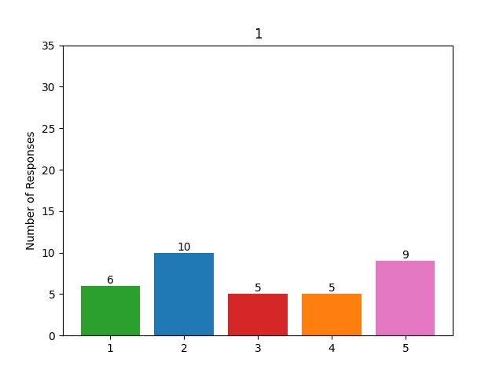

# 2. Overall, I am happy to be working at my company.

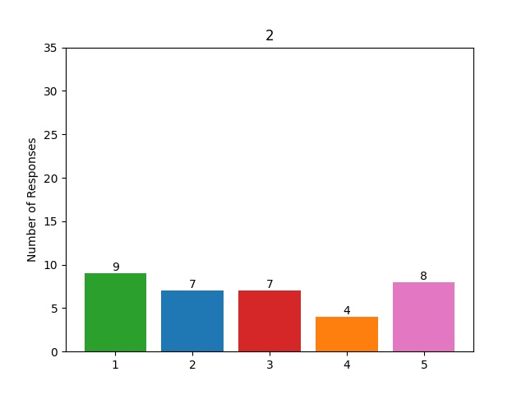

# 3. I can see myself working here in five years.

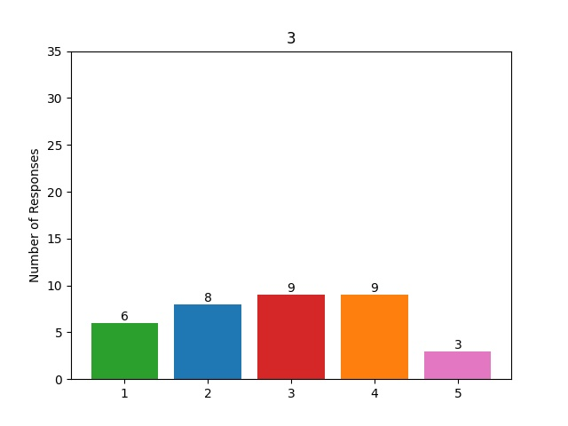

# 4. How happy are you at work?

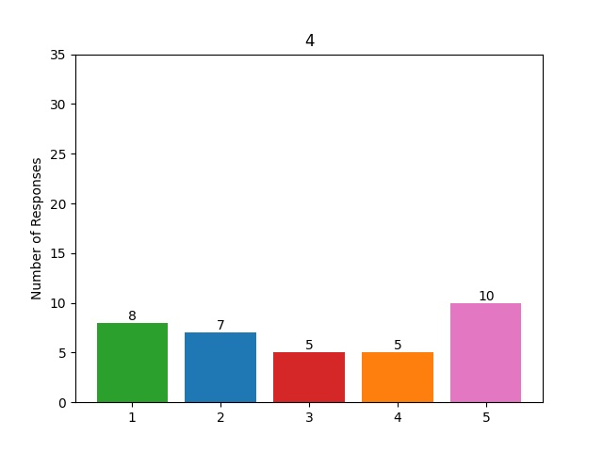

# 5. I feel respected by the people I work with.

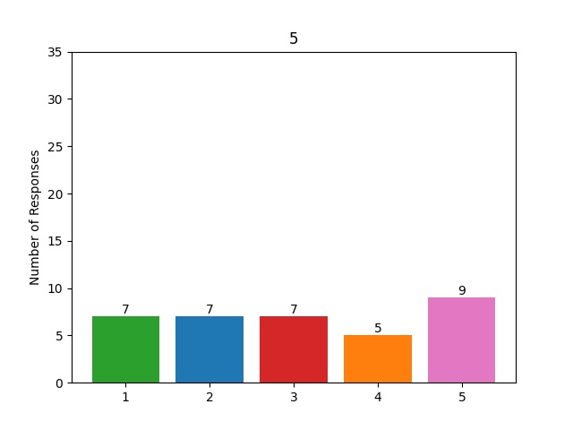

# 6. How would you rate your work-life balance?

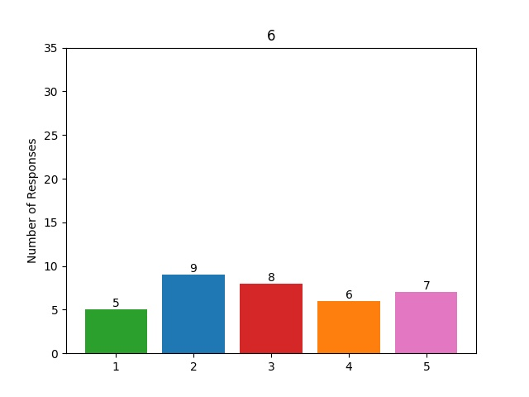

# 7. How likely is it that you would recommend our companyâ€™s products or services, or the company in general, to a friend.

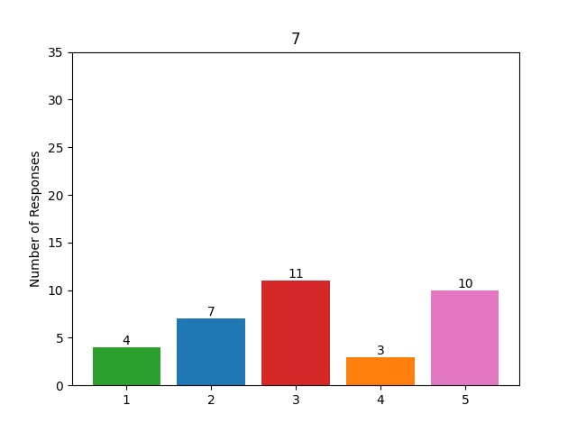

# 8. The last time you accomplished a big project, did you receive any recognition? (No/Somewhat/Yes)

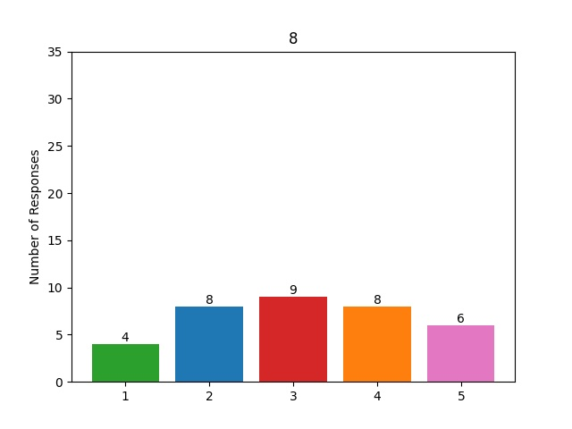

# 9. How would you rate our companyâ€™s culture?

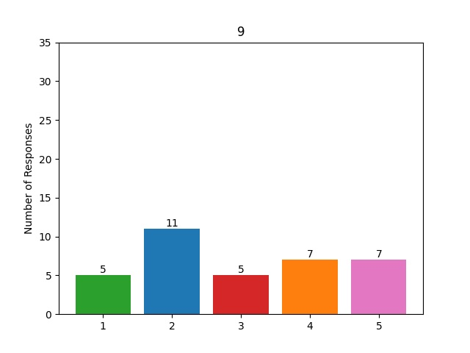

# 10. How would you rate your colleagues and fellow team members or peers?

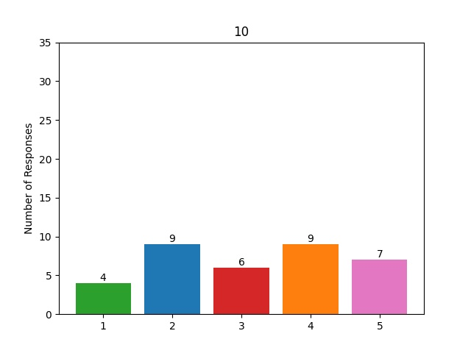

# 11. How would you rate the performance of management?

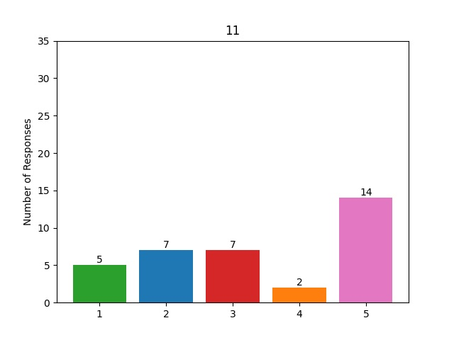

# 12. How valued do you feel at work?

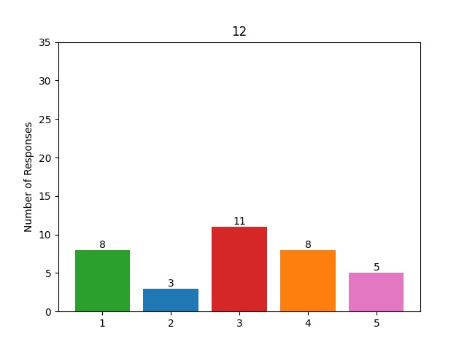

# 13. Iâ€™m proud to be part of this company.

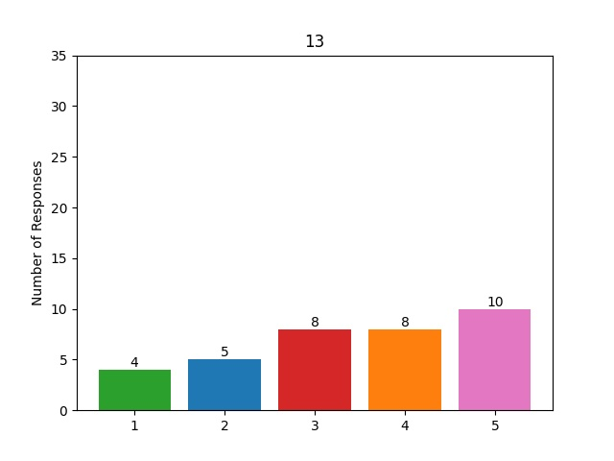

# 14. I believe my company has an outstanding future.

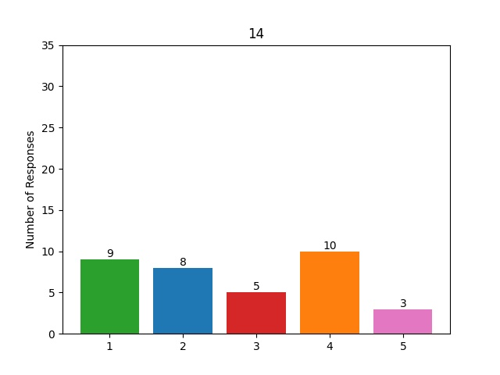

# 15. I trust the senior leadership of my company.

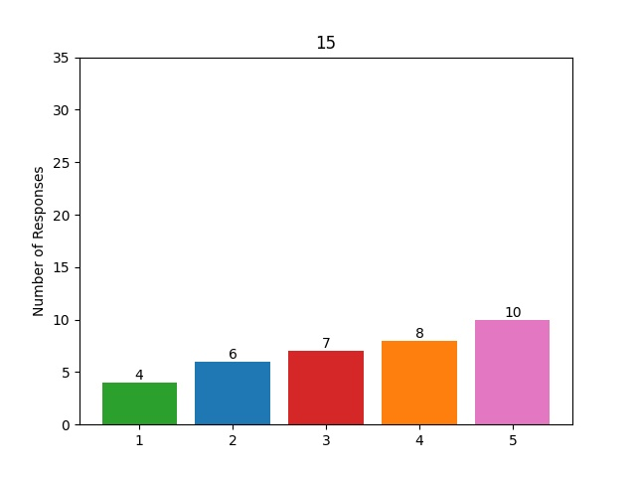

# 16. The work I do makes excellent use of my talents/skills and abilities.

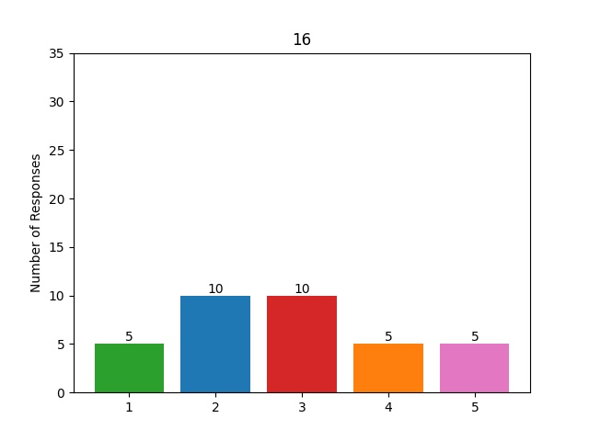

# 17. I always want to give my best whenever Iâ€™m at work.

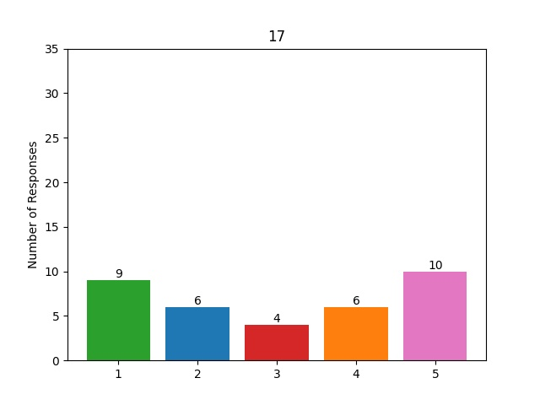

# 18. My manager/supervisor works and leads with integrity.

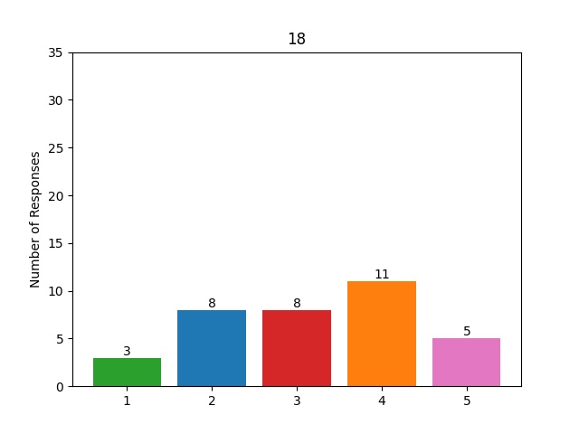

# 19. Employees at my company feel inspired by our company mission (or, the direction our organization is headed).

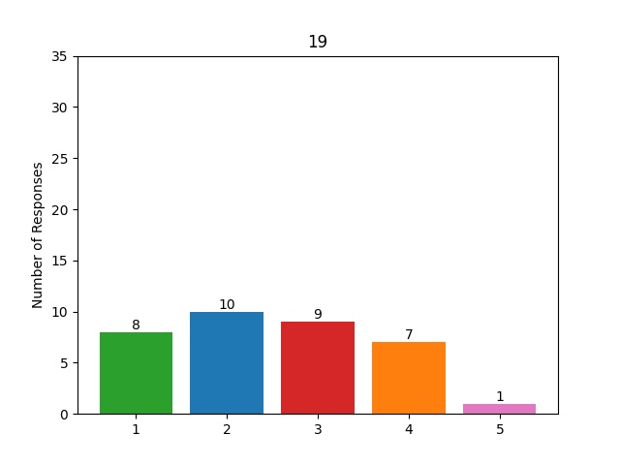

# 20. Employees at my company feel inspired by our company values (or principles we live by that distinguish our organization from others)

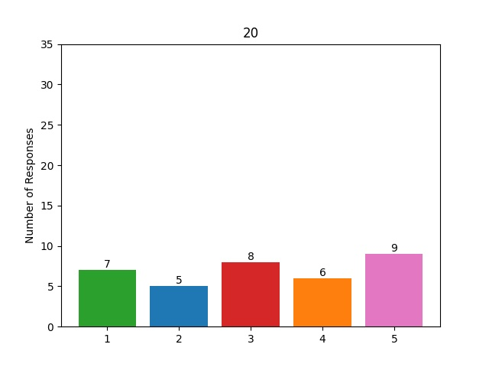

# 21. I always know what is expected of me when it comes to my goals and objectives.

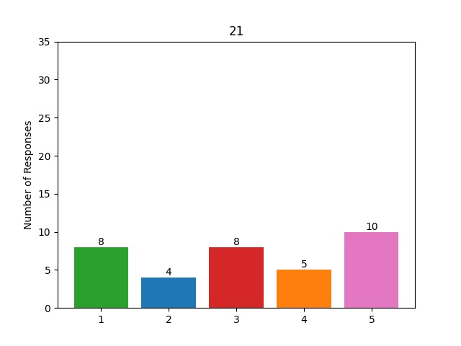

# 22. My manager recognizes my full potential and capitalizes on my strengths.

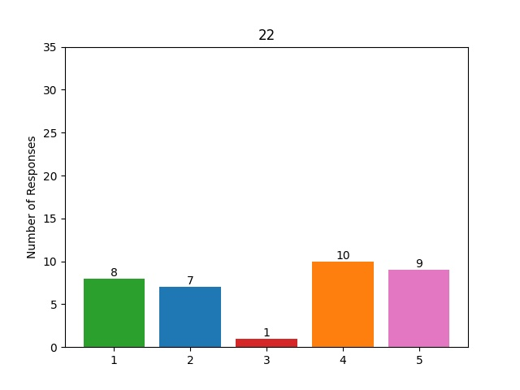

# 23. My company provides me with the opportunity for learning and development.

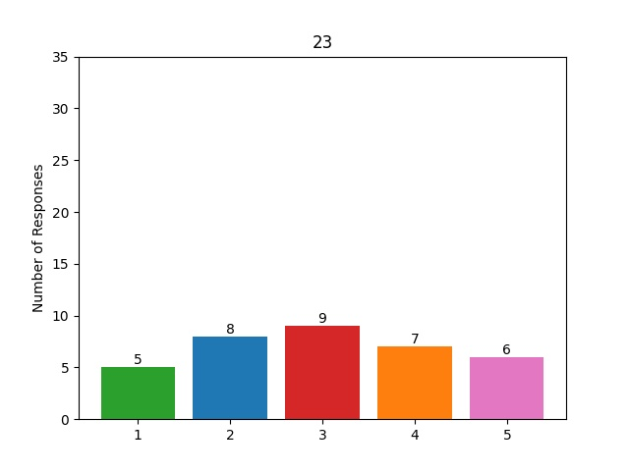

# 24. My manager/supervisor helps bring the best out of people.

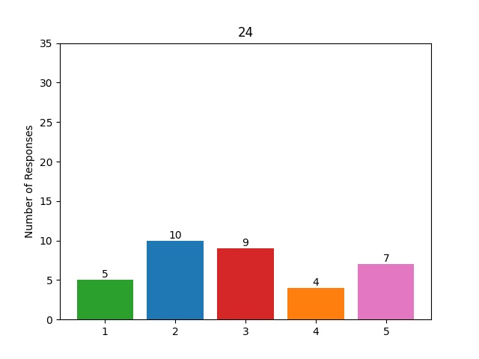

# 25. My manager/supervisor communicates clear performance expectations to our team.

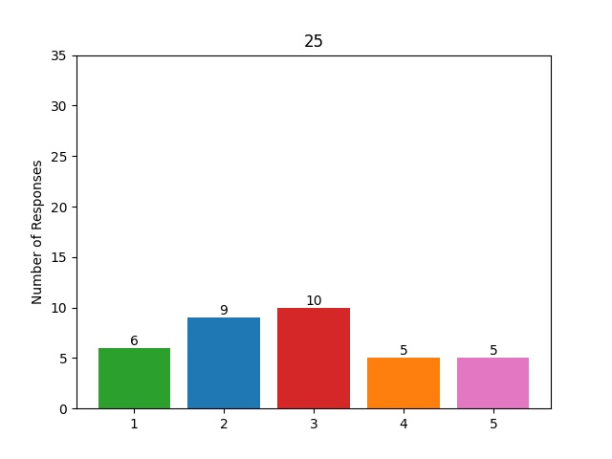

# 26. When conflict arises, the people I work with resolve it respectfully and quickly.

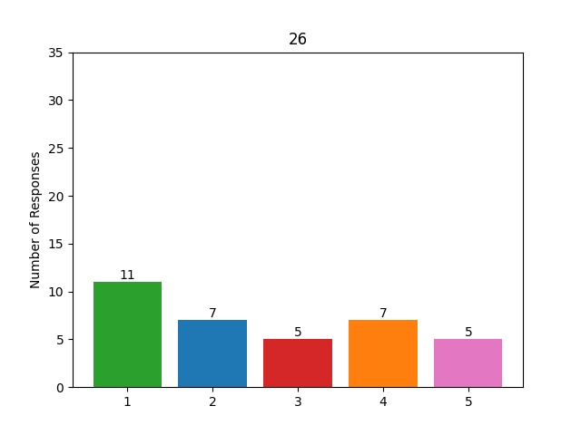

# 27. Employees at my company feel connected to their manager (supervisor).

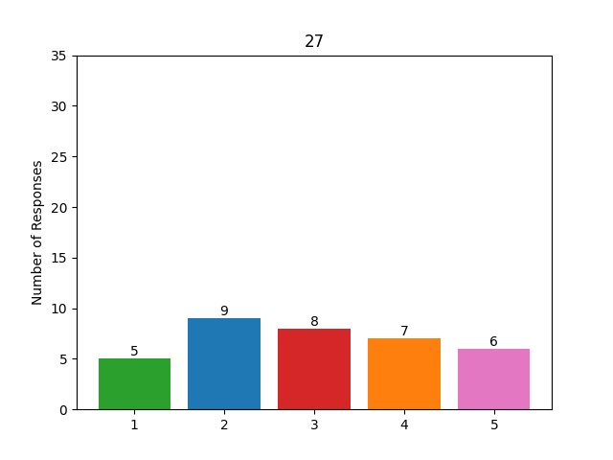

# 28. My companyâ€™s initiatives help employees feel connected to each other, no matter where theyâ€™re working.

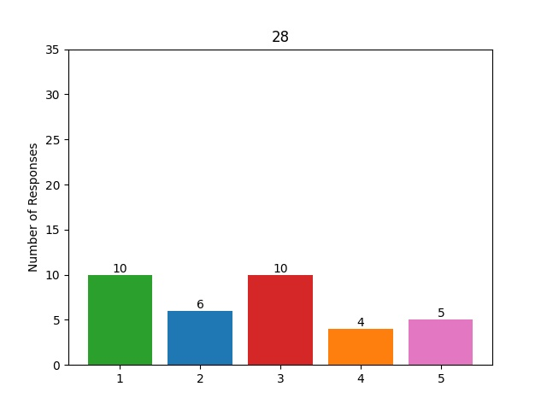

# 29. Employees at my company have access to regularly hear from company leadership.

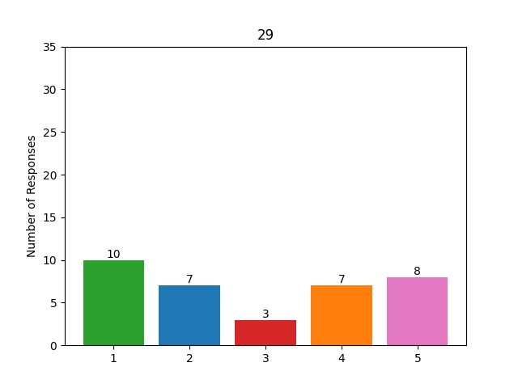

# 30. My company exhibits its core values frequently, in every stage of the employee journey.

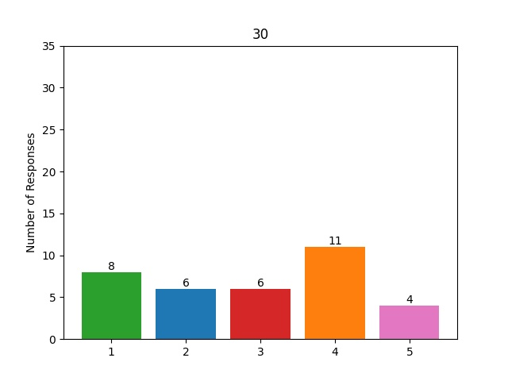

# 31. My company regularly recognizes their employees for their contributions.

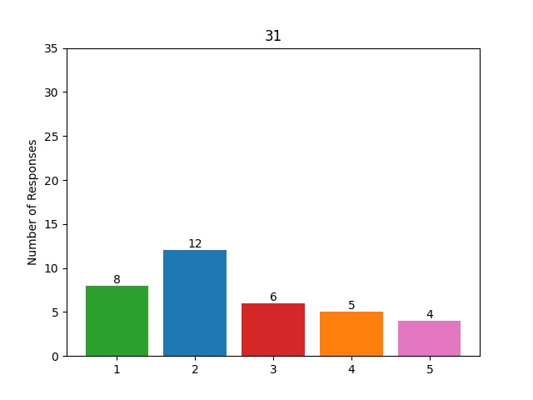

# 32. My company enables employees to recognize each other for their contributions.

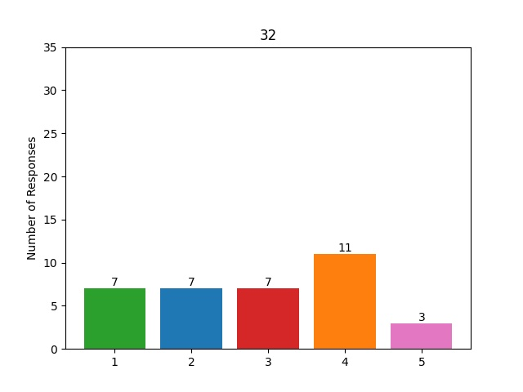

# 33. My company is proactive about ensuring new hires feel connected to their team and coworkers.

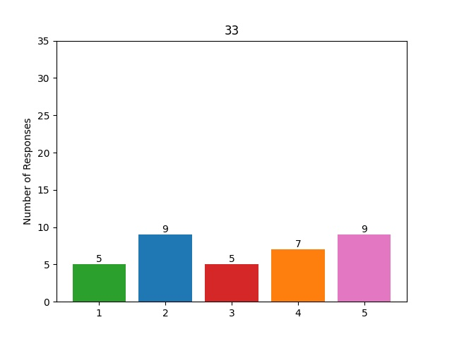

# 34. At my company, leaders are highly involved with employees in a positive way.

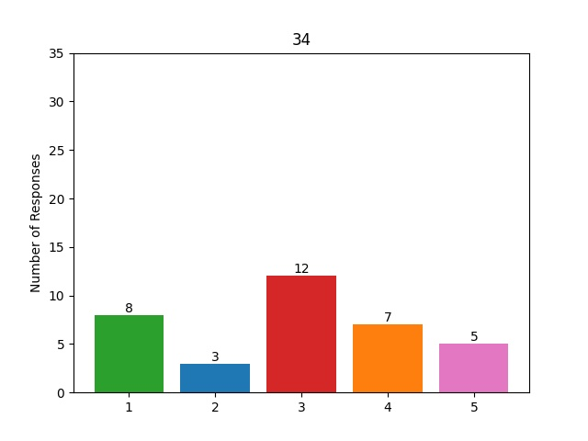

# 35. People at my company value employee experience in the same way we value customer experience.

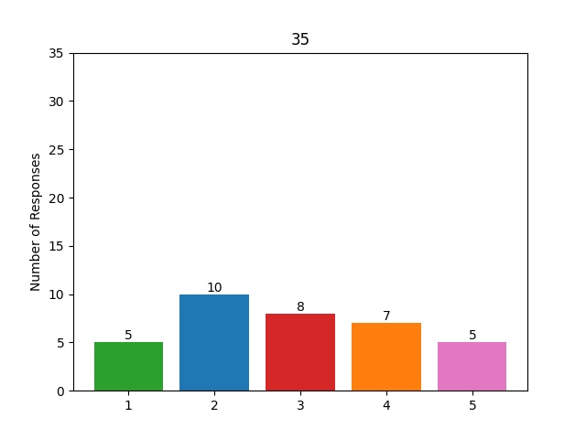

# 36. Employees have access to perks and benefits they find meaningful.

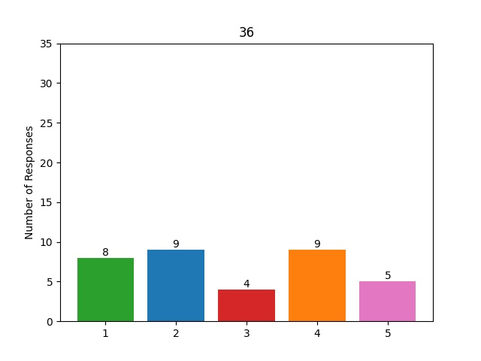

# 37. Employees at my company understand how and why their work matters to the company.

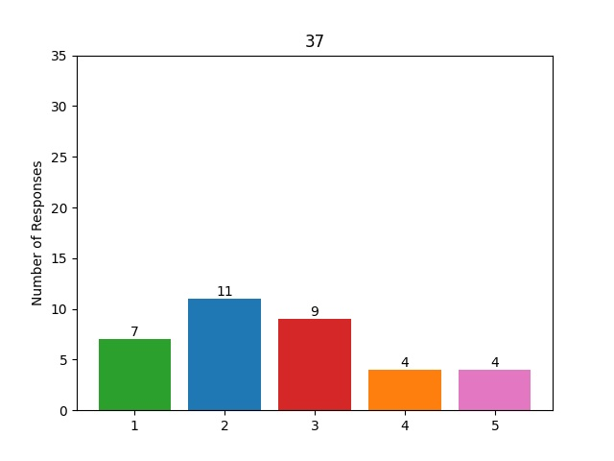

# 38. Employees at my company experience regular 1-1 meetings with their direct supervisor.

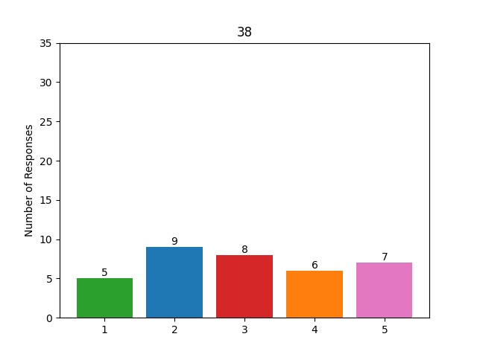

# 39. Employees at my company understand how their work is aligned with the direction the company is headed.

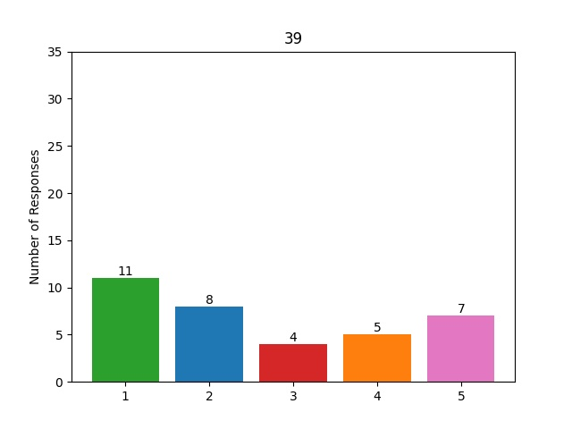

# 40. There is great open, honest, two-way communications in my company.

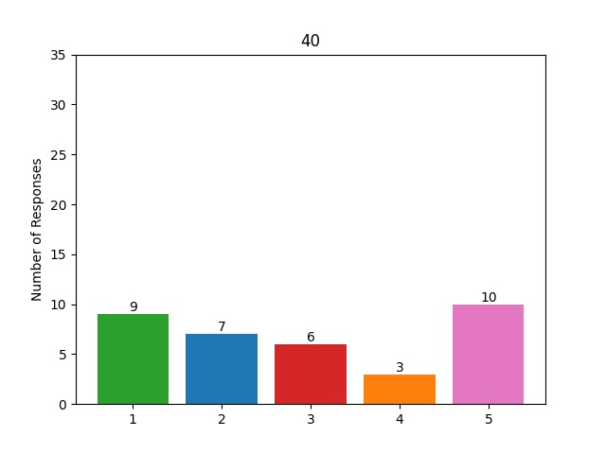

# 42. Employees believe their personal lives matter to their manager.

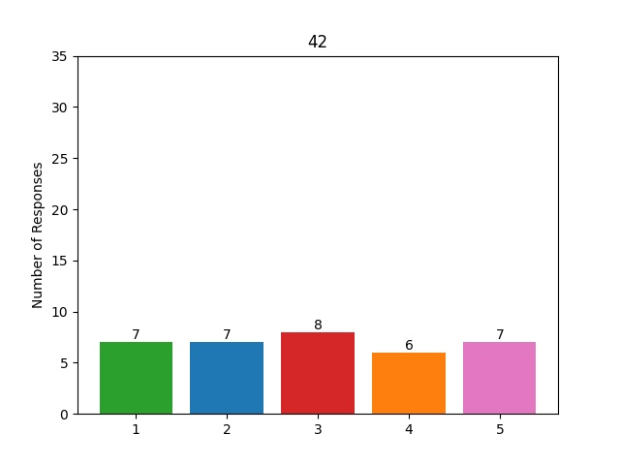

# 43. Leaders demonstrate our companyâ€™s core values consistently.

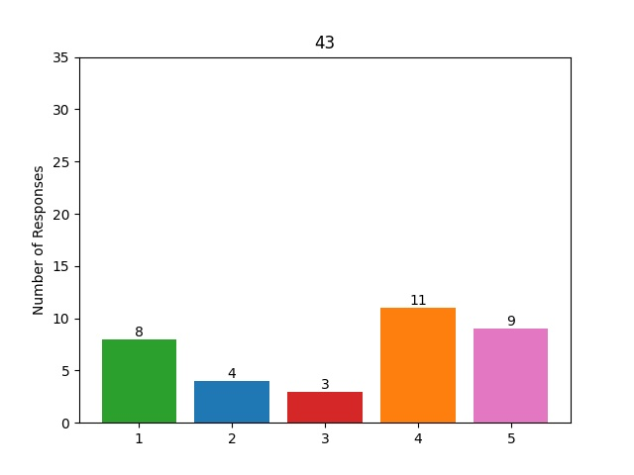

# 44. My company has a system that ensures employees give and receive feedback regularly.

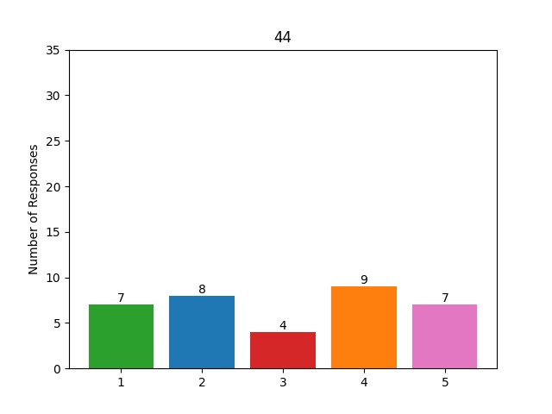

# 45. The technology we use makes it easy to stay aligned internally wherever weâ€™re working.

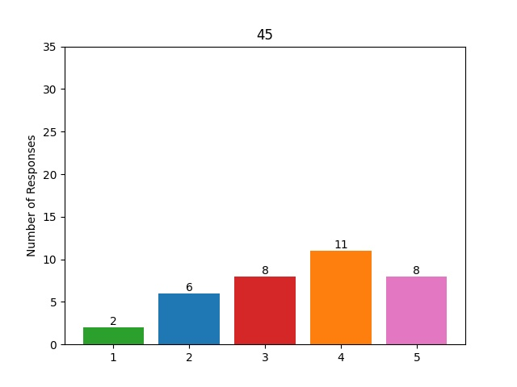

# 46. My company is committed to providing a clear path to growth opportunities and resources within the company.

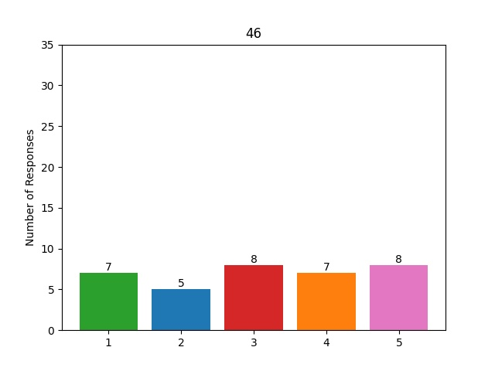

# 47. All employees in my company have access to documented policies that explain how we do things around here.

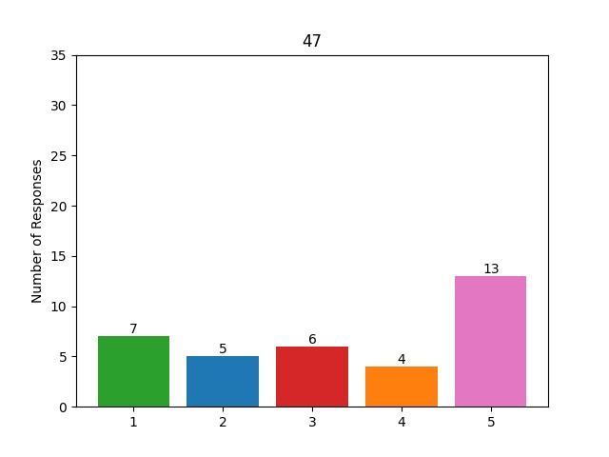

# 48. I believe I am rewarded fairly for my hard work and contribution ( e.g., compensation, benefits, perks).

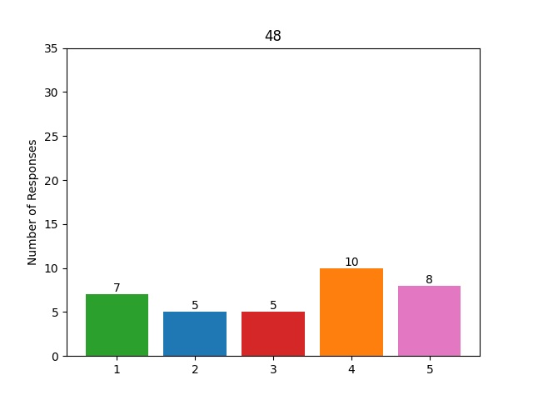

# 49. My manager/supervisor supports us in times of change.

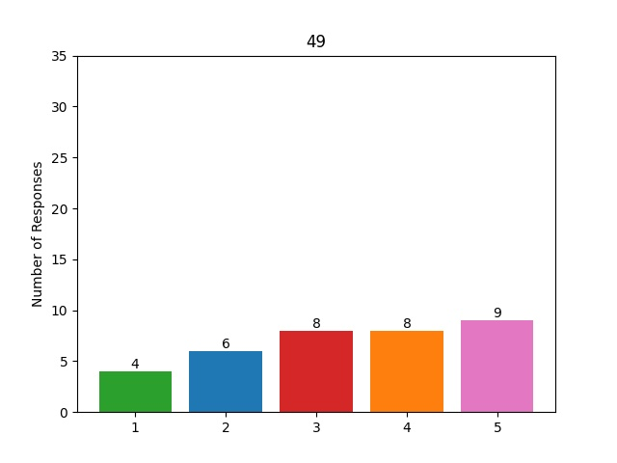

# 50. My company rewards employees solely based on their performance, not by politics or other processes.

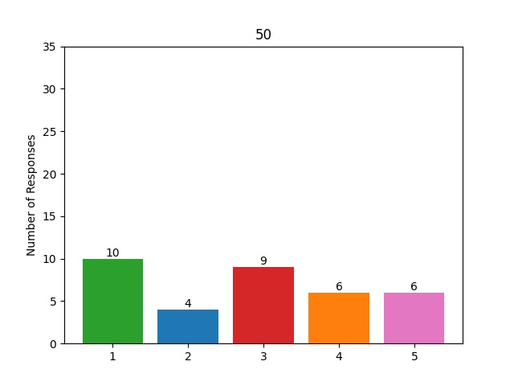

# 51. I believe the company is making the changes necessary to be competitive in the future.

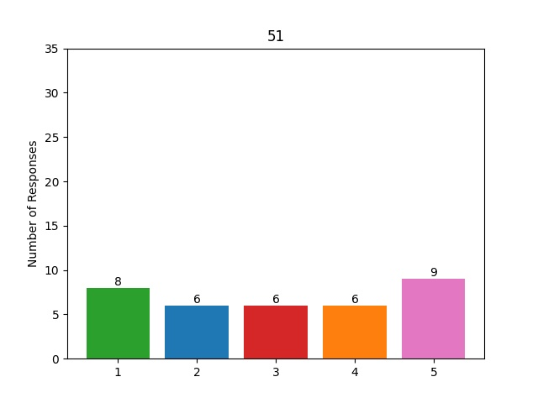

# 52. My company provides me with the opportunity for learning and development.

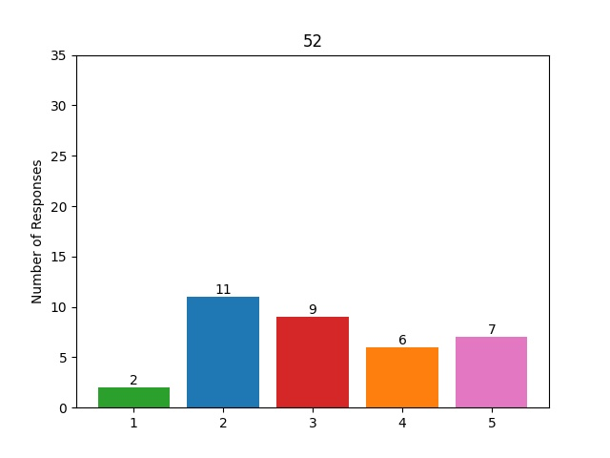

# 53. I believe we are hiring people with the right talents to help us achieve our business strategy.

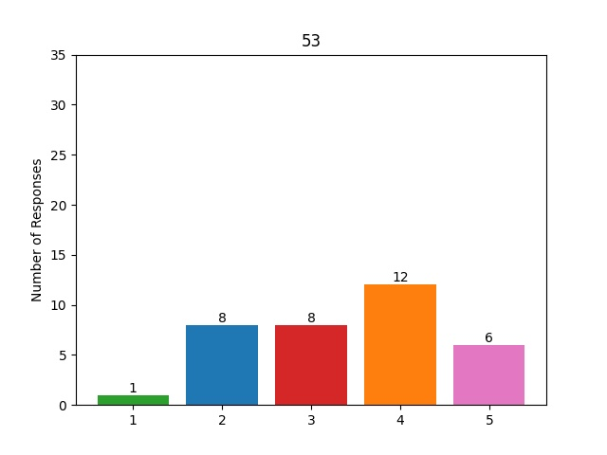

# 54. If you were to be president of the company, what is the first thing you would change?

