General aim & scenarios

Overview & table
Investigate how skewness in spatial subsidies varies among 4 scenarios representing a range of options for conserving grassland and pintail harvest. Increasing grassland to 40% ensures significant change in abundance especially in absence of pintail harvest. All percentages are relative to the conservative scenario.
 |  |  | Expected change in skewness of spatial subsidies
Scenario name | Grassland conserved | Pintail harvest | Robust | Reactive | Explanation
Conservative | Observed, 7% | Conservative, 5% | - | - | Harvest rate of 5% to ensure population viability. All other parameters set to those given in Mattsson et al. {,2020}
Hunting-focus | Observed, 7% | None, 0% | <5% | ≥5% | Effects of hunting moratorium benefit survival across range
Grassland-focus | Increase to 40% | Conservative, 5% | <15% | ≥15% | Improved PPR conditions exert strongest expansion without hunting moratorium
Integrated-focus | Increase to 40% | None, 0% | <10% | ≥10% | Integrating habitat and harvest management has intermediate effect

Scenario folder names
1_Conservative
2_Grassland
3_Hunting
4_Integrated

PPR reproduction as a function of grassland -> results from SciReports paper
R2 = 0.470543 with 7% grassland

> R2_crazy_df3
lcl avg ucl
0_pct_crop_to_grass 0.4071110 0.5014516 0.5957922
10_pct_crop_to_grass 0.4739354 0.5835645 0.6931936
20_pct_crop_to_grass 0.5407599 0.6656774 0.7905950
30_pct_crop_to_grass 0.6075843 0.7477904 0.8879964
40_pct_crop_to_grass 0.6744088 0.8299033 0.9853978
50_pct_crop_to_grass 0.7412332 0.9120162 1.0827991
60_pct_crop_to_grass 0.8080577 0.9941291 1.1802005
70_pct_crop_to_grass 0.8748821 1.0762420 1.2776019
80_pct_crop_to_grass 0.9417066 1.1583549 1.3750033
90_pct_crop_to_grass 1.0085310 1.2404678 1.4724047
100_pct_crop_to_grass 1.0753555 1.3225808 1.5698061

Central Command

General workflow
All scripts and required Excel files are in folder Pintail_subsidies. The R script ecosystem_service_flows*.r is the “master” -> this sources all the required functions and scripts for model structuring, parameterization, and generating tables & graphs. Whenever possible, data/inputs are embedded as tibbles within the scripts. * indicates that there may be multiple versions of the script (even in the main folder as an artifact during development, and the most recent one should be used.
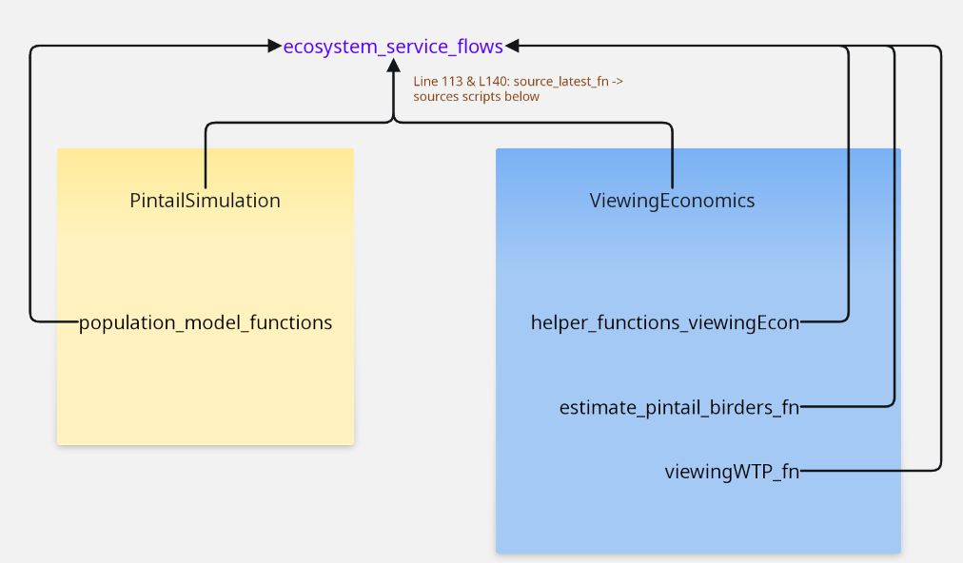

Current tasks
- Calculate local flows, and ask Jeremy to map these along with changes in net flow (one map per scenario)
  - 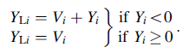
- loop through scenarios and tabulate/plot results
  - Subsidies dot plot (ask if there’s a better option): x-axis = scenario, y-axis = region-specific subsidy (unique symbol per region) -> dataframe with one row per region and 2 columns: scenario & subsidy
  - dataframe with one row per region and one set of columns per scenario, DS, econValue, and subsidy -> Table includes range at bottom of each column, and total econValue
  - dataframe with columns Payer and ScenarioX, where ScenarioX contains amount received by Western Wintering
scenarioName <- "1_Conservative"
scenarioName <- "2_Grassland"
scenarioName <- "3_Hunting"
scenarioName <- "4_Integrated"

Useful code tricks
tibble::lst(Survi, Repro, Trans) # combines 3 vectors into a list while retaining vector names

Completed tasks

Population modeling
- Combine all of the population simulation scripts into a single script for easier troubleshooting
- Make sure the following changes have been made to Joana/Christine’s population model (for consistency with SciReports paper) -> could be they did this already in Collaborations\NSF_Spatial_Subsidies\Subsidy perturb ms\R_files_data _subsidy_perturb
  - remove density-dependent reproduction within breeding regions -> done
  - rescale age ratios for the remaining breeding regions based on our new estimate for PPR from the Observed Conditions scenario. In particular, multiply the original age ratio Ri by RP′PR/RPPR, where i indexes the other two breeding regions, RPPR′ is the estimate of age ratio for PPR based on the Observed Conditions scenario in the current study, and RPPR is the baseline estimate used in the original population model. -> done
  - breeding-season survival rate for males of 0.96 in PPR (the SciReports methods section did not specify for which region, so this should be mentioned in the DynSub paper) -> done but see note about methods description
  - reduced natural mortality rate during fall (i.e., from the start of fall migration to the end of the hunting season) for all cohorts by 0.04 -> done
- Update excel files (FinalCodePintails\Baseline1 -> BaselineDynSub) to match the status quo scenario above, by running relevant parts of the SciReports code to generate the parameters: “inpNOPI continental model.R” and from “simNOPI continental model r1b.R” . Reproduction taken from “status quo” row in “Pintail Model Scenario Results Summary r1.csv” -> from Jim Devries’ PPR model
- Create additional folder of excel files (analogous to those in FinalCodePintails\Baseline1) for each scenario -> change reproduction regression parameters for PR for scenarios 2 & 4, change hunting mortality for scenarios 3 & 4.
- Set NAs to zeroes for juveniles in CR calculation

Economic values
- Estimate the number of “pintail birders” per pintail-region by multiplying the ebird proportions by the number of birders (given in thousands) in each pintail-region
- Write a function called viewingWTP_fn that multiplies pintail birders from estimate_pintail_birders_fn by the annual willingness to pay (WTP) on duck-watching trips, where this WTP depends on the number of pintails (assume that WTP increases linearly with abundance)
  - Use median instead of mean to summarize WTP by region due to severe skewness in the data (cannot use geometric mean, as some values are 0), see graph_skewness_WTP.R
  - Set median per capita WTP from ND & SD equal to that of provinces/territories and the WTP in Alaska to the median for CA and OR, as Canadians and Alaskans were not included in the Loomis et al 2018 survey
  - Calculate trp_num_A as product of trp_num and relative abundance (baseline is the estimated abundance in 2016, the year of survey conducted by Loomis et al 2018 )
  - Calculate median per-capita WTP for each pintail region based on WTP_tbl by multiplying max_WTP_BM by trp_num_A (generates WTP_tot_abund1) then multiply max_WTP_BM by trips_dbl_birds (generates WTP_tot_abund2)

Subsidies & ES flows
- Connected ecosystem_service_flows*.r with other scripts, calculated subsidies & flows

Links
all FWS recreation reports: https://www.fws.gov/program/national-survey-fishing-hunting-and-wildlife-associated-recreation-fhwar

Descriptions of code

Population scenarios (Sci Reports)
Folder: SciReportsPintail
Mattsson, B.J., Devries, J.H., Dubovsky, J.A., Semmens, D., Thogmartin, W.E., Derbridge, J.J. and Lopez-Hoffman, L., 2020. Linking landscape-scale conservation to regional and continental outcomes for a migratory species. Scientific Reports, 10(1), p.4968.

Ds values by Christine & Joana (Bagstad et al)
Bagstad, K.J., Semmens, D.J., Diffendorfer, J.E., Mattsson, B.J., Dubovsky, J., Thogmartin, W.E., Wiederholt, R., Loomis, J., Bieri, J.A., Sample, C. and Goldstein, J., 2019. Ecosystem service flows from a migratory species: Spatial subsidies of the northern pintail. Ambio, 48(1), pp.61-73.
** Keep file structure in tact - folder locations matter!
IN THE FOLDER: FinalCodePintails:
1. Source the file PintailSimulation.R to numerically find the equilibrium population abundance numbers. This code takes values from the .xlsx spreadsheets found in the Baseline1 folder, simulates the network until the population reaches equilibrium, and prints final population counts. The final population numbers are stored in Baseline1/SteadyStatePopulation.csv. The assumptions about density dependent survival and transition rates are programmed in SpeciesFunctions.R. The script DsCode.R is no longer by itself but inserted at the bottom of PintailSimulation.R. This will output both the season dependent and average DS values. It uses the population counts from PintailSimulation.R and the Cr values (male/female) from Cr_Pintail.R

Information about other files and dependencies
** The program CR_ONEEQ.R contains the general CR eqaution. It is called by Cr_pintail.R
** Cr_pintail.R gathers pintail specific survival and transition rates to be used in CR_ONEEQ.R. It is called by DsCode.R and uses data values calculated by PintailSimulation.R and SpeciesFunctions.R
** The program SpeciesFunctions.R contains density dependent assumptions for the pintails. It is used by scripts in the folder NetworkCode1.1 and in Cr_pintail.R
** The folder NetworkCode1.1 contains code to simulate the pintail population. Users should not need to interact with the code located in this folder. It is called by PintailSimulation.R.

Economic values by Wayne (WOTUS paper)
WOTUS_PPR.r
Thogmartin, W.E., Devries, J.H., Semmens, D.J., Diffendorfer, J.E., Dubovsky, J.A., Derbridge, J.J. and Mattsson, B.J., 2023. Potential economic consequences along migratory flyways from reductions in breeding habitat of migratory waterbirds. Biological Conservation, 285, p.110251.

Ecosystem service flows by Jendrik
ecosystem_service_flows.R
Jendrik wrote: “adapted from Darius J. Semmens and Kenneth J. Bagstad, and Christine Sample”
Sources CR.r, and uses the Cr values from this sourced code to calculate Ds along with spatial subsidies

Economic valuation: data & intermediate predictions
Proportion of pintails in ebird from Mattsson et al. 2018

Number of birders in US states
- Table 6 in addendum to 2011 USFWS recreation survey (Carver 2013) -> missing North Dakota, so interpolate based on 2006 FWS recreation survey while correcting for increase in number of residents based on US census
  - ND 2006 -> 636019
    - https://www.census.gov/programs-surveys/popest/technical-documentation/research/evaluation-estimates/2010-evaluation-estimates.html
    - https://www2.census.gov/programs-surveys/popest/datasets/2010/2010-eval-estimates/nst-est2010-01.xls
  - ND 2011: 685526
    - https://www.census.gov/programs-surveys/popest/technical-documentation/research/evaluation-estimates/2020-evaluation-estimates/2010s-totals-national.html
    - https://www2.census.gov/programs-surveys/popest/tables/2010-2020/national/totals/NST-EST2020.xlsx

Number of birders in Canadian provinces and territories
Table 9 in 2012 Canadian Nature Survey (FPTGC 2014) -> gives proportion, then multiply by 2012 Canadian census (Statistics Canada 2012). Number of non-resident birders per geography were not included in the report and estimating these would require several steps of analyses and assumptions based on the raw data from this survey along with the Canadian census.

WTP
- Loomis et al DU survey was conducted in fall 2016 -> year for monetary values and for baseline pintail abundance
- Set pintail abundance relative to baseline (2016) abundance of all age cohorts and across regions at start of breeding -> 2.6185M based on Table B3 in USFWS 2023
- survey questions are in “DU-survey_27-JUL-2016.pdf", most relevant ones:
  - What is the largest increase in travel cost per trip you would have spent in the past 12 months to visit the area where you typically go to see Northern Pintails?
  - How many more trips (if any) would you have taken to this area in the past 12 months if you could have seen twice as many Northern Pintails as you have in the past?
- Please explain this equation for calculating number of expected trips at abundance A:
trips(A)=trp_num+(trips_dbl_birds−trp_num)⋅(A−1); answer from Academic AI:
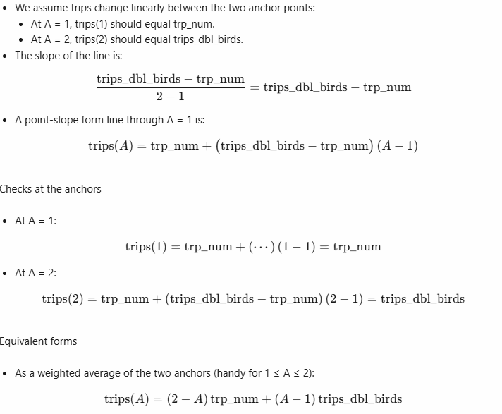
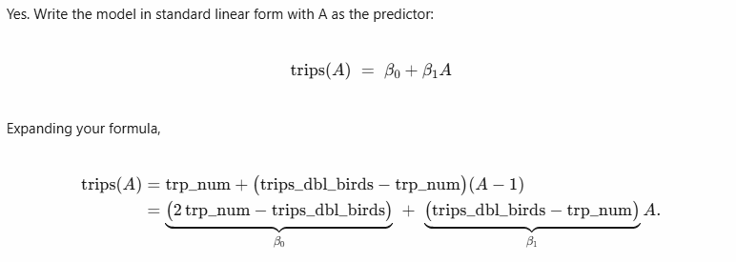

Discussion points
- per capita WTP estimates are quite high; DU members may be willing to pay significantly more than an average pintail viewer

Parking lot
Population modeling
- Format of array N generated by PintailSimulation; dimensions:
  - 300 timesteps: 100 years x 3 seasons per year
  - 4 sex*age cohorts
  - 5 regions
- Linking output of SimNOPI to Cr calculations seems futile, because Cr involves calculating reproduction, survival, and transition rates via the Christine/Joana’s functions (e.g. f_function), so no good way to match the two codes

Economic values
- Economic values from Appendix D of WOTUS paper are given in 2014 USD (noted at bottom of Methods) and summarized in Results section 3.5 of WOTUS paper: “Central Flyway duck enthusiasts claimed to expend $55.64 per year viewing waterfowl (1.99 trips × $27.96 per trip); if the waterfowl population was doubled, they claimed to be willing to expend $244.17 (5.63 trips × $43.37 per trip), >4 times as much. For Mississippi Flyway duck enthusiasts, these values go from $288.10 (2.40 trips × $120.04 per trip) at current waterfowl abundance to $1600.32 (10.31 trips × $155.22 per trip), >5.5 times as much, when doubling the waterfowl population.”
- The WOTUS code does not run without “birding data.RData”, which is apparently in Wayne’s OneDrive Instead, extract information from other sources
Tables & Figs
- Jeremy -> Panel of scenario-specific maps showing ES flows -> send Jeremy csv with columns: scenario, fr_region, to_regionX
    - flows_array[i] where i indexes the scenario, and each element is a 5x5 matrix of flows

Literature cited
Carver, E. 2009. Birding in the United States: A demographic and economic analysis. Addendum to the 2006 National Survey of Fishing, Hunting, and Wildlife-associated Recreation. US Fish and Wildlife Service, Division of Economics, Arlington, Virginia, USA https://www.fws.gov/sites/default/files/documents/2024-04/258.pdf
Carver, E. 2013. Birding in the United States: A demographic and economic analysis. Addendum to the 2011 National Survey of Fishing, Hunting, and Wildlife-associated Recreation. US Fish and Wildlife Service, Division of Economics, Arlington, Virginia, USA. Online: https://digitalmedia.fws.gov/cdm/ref/collection/document/id/1874
Federal, Provincial, and Territorial Governments of Canada (FPTGC). 2014. 2012 Canadian Nature Survey: Awareness, participation, and expenditures in nature-based recreation, conservation, and subsistence activities. Ottawa, ON: Canadian Councils of Resource Ministers. https://www.biodivcanada.ca/reports/canadiannaturesurvey
Statistics Canada. 2012. Population and dwelling counts, for Canada, provinces and territories, 2011 and 2006 censuses (table). Population and Dwelling Count Highlight Tables. 2011 Census. Statistics Canada Catalogue no. 98-310-XWE2011002. https://www12.statcan.gc.ca/census-recensement/2011/dp-pd/hlt-fst/pd-pl/Table-Tableau.cfm?LANG=Eng&T=101&S=50&O=A
U.S. Fish and Wildlife Service. 2023. Waterfowl population status, 2023. U.S. Department of the Interior, Washington, D.C. USA. https://www.fws.gov/library/collections/waterfowl-population-status-reports

End

