Task 1: Problem Statement and Initial Timeline
Problem Statement:
Traditional classroom assessment methods can fail to maintain student engagement and provide immediate feedback, leading to passive learning experiences. While existing platforms like Kahoot exist, educators lack other options that can generate content tailored to their specific curriculum needs without requiring complex technical setup. Our project addresses the need for a trivia platform that enables teachers to engage with entire classrooms through game-based learning. By reducing setup friction, the solution makes interactive assessment feasible for any classroom environment. The integration of an LLM further empowers educators to quickly create relevant content without extensive preparation time. Target beneficiaries include teachers and students in the K-12 range who benefit from immediate feedback and competitive, low-stakes learning experiences that improve retention and participation compared to traditional gaming methods.

Initial Timeline:
Educational Trivia Game
Project Timeline
February 3rd, 2025 – Apr 30th, 2025

Sprint 1: Setup & Foundation | Feb 3– Feb 24
Tools installed (SSMS, SQL Server, Visual Studio)
Team roles defined
Database schema created locally
Share schema via GitHub repo
Write problem statement and architecture document
Install Node.js and set up backend project folder
Install Unity and configure Photon App ID

Sprint 2: Backend Development | Feb 25 – Mar 7
Build Node.js server and connect to SQL database
Create API endpoints
Test all endpoints
In-Progress Presentations | Week of Mar 9–13
Working database with questions
Backend API returning data
Basic Unity project started with Photon connecting

Sprint 3: Unity Development | Mar 11 – Mar 28
Unity setup, Photon PUN 2 configured
Build all game scenes (lobby, gameplay, leaderboard)
Implement full game loop (question → answer → reveal → scores)
Connect Unity to backend via HTTP calls

Sprint 4: Integration & Testing | Mar 29 – Apr 18
Connect all three tiers: Unity → Backend → Database
Full multiplayer testing with real players
Bug fixes, UI polish, sound effects
Deploy to university server (if available)
Buffer week built in for unexpected issues

Sprint 5: Final Polish & Presentation Prep | Apr 19 – Apr 30
Final bug fixes
Prepare presentation slides and live demo
Practice demo
Submit complete codebase to Canvas by Apr 30th

Final Presentations | Apr 27–30 (Date TBD)
Full live multiplayer demo
Teacher creates room, students join with room code
Complete game round with scoring
Results saved to database

Task 2: Software Requirements
Software Requirements Specification (SRS) - Card Clash
Application Server: A single Node.js/Express application hosted on OSU Servers. It handles HTTP requests, serves the HTML dashboard, and manages the database.

Game Logic Authority: The Teacher's Unity Client acts as the "Host" for real-time logic, synchronized via Photon PUN 2.

Data Storage: Microsoft SQL Server using JSON-based storage for flexibility.

AI Module: An inference interface (Ollama) processing session logs to produce natural language feedback.

1.3 Definitions, Acronyms, and Abbreviations
Host/Master Client: The Teacher’s instance of the application, which holds authoritative game state (timer, score calculation) via PUN 2.

MVP: Minimum Viable Product (Target: 4 simultaneous players + 1 Host).

CCU: Concurrent Users.

PUN 2: Photon Unity Networking 2 (Middleware for multiplayer synchronization).

Ollama: Framework for running local Large Language Models (LLMs).

OSU Server: The university-provided Linux hosting environment (HTTP only).

---

2. Overall Description

2.1 Product Perspective

Card Clash is a unified web application. Unlike distributed systems that separate the frontend and backend codebases, Card Clash serves both the Dashboard and the Game Client from a single directory.

- Real-time Gameplay: Peer-to-Peer/Relay via Photon Cloud
- Persistent Data: Direct Server-to-Database communication via the Node.js application

2.2 Product Functions

- Session Management: The Host creates a lobby code; the system synchronizes game states across all connected clients
- Assessment & Combat: Student correctness on multiple-choice questions converts directly into "Action Points" or "Damage" in the game simulation
- AI Analysis: The system aggregates session logs (response times, accuracy per tag) to generate a "Class Summary" via LLM inference
- Content Management: Teachers can create, edit, and save quiz decks to the MS SQL database

2.3 User Classes and Characteristics

- Teacher (Admin/Host): Requires a desktop/laptop environment to act as the Master Client. Accesses the Dashboard to start games
- Student (Player): Variable literacy. Accessing via low-power devices (Chromebooks). Requires a simplified, highly visual interface with minimal text input

2.4 Operating Environment

Client Hardware:
- Teacher: Laptop/Desktop with >8GB RAM (to support Host Unity instance + Browser)
- Student: Chromebooks (4GB RAM) or standard mobile devices

Server Constraints:
- OSU Student Server (Linux environment)
- Microsoft SQL Server (Database)

Network:
- HTTPS is required for the Unity WebGL build to function correctly
- Firewalls must allow outbound traffic on Port 443 (WSS/HTTPS) for Photon Cloud

---

3. Specific Requirements

3.1 Functional Requirements
3.1.1 Authentication & Accounts

- FR-1: The system shall allow Teachers to register and log in using a username and password.
- FR-2: The Node.js backend shall use Session Cookies to maintain authenticated state across dashboard pages.
- FR-3: Students shall join game sessions via a 6-character alphanumeric "Room Code" without requiring account creation.

3.1.2 Gameplay Mechanics (Unity/PUN)

- FR-4 (Lobby): The Master Client shall broadcast a "Game Start" event that transitions all connected clients from the Lobby Scene to the Gameplay Scene
- FR-5 (Lock-Step): The Master Client shall have the ability to control game progress at anytime; Pause, End, Restart, Kick Player.
- FR-6 (Deck System): Students shall have the ability to purchase cards with the points they gain from answer questions.
- FR-7 (Combat Logic): The Master Client (Teacher) shall automatically calculate player question scores based on answer correctness and speed, ensuring a single source of truth for scoring. (In some question set formats)
- FR-8 (Combat Logic): The clients should automatically calculate question scores based on answer correctness and speed, for real-time dependent questions, like randomized mathematical equations. (In some question set formats)

3.1.3 AI & Analytics

- FR-9 (Data Collection): The Master Client shall upload a single JSON blob containing the full game log (Student Name, Questions, Timestamps, Scores) to the Node.js backend upon game completion.
- FR-10 (Performance Summary): The backend shall transmit the JSON log to the LLM (Ollama) to generate a 3-paragraph natural language summary of class performance.
- FR-11 (Review): The system shall store the raw metrics alongside the AI summary for historical review.

3.1.4 Teacher Dashboard (Web Portal)

- FR-12 The Dashboard shall be rendered server side (EJS) and allow teachers to Create, Read, Update, and Delete (CRUD) quiz sets stored in the database
- FR-13: The Dashboard shall display a list of past sessions, allowing the teacher to click into them to view the stored AI Reports

3.1.4 Game Details

- FR-14 The game shall include a welcome scene with the list of players in the lobby, the lobby code, and the start button.
- FR-15: The game shall include a round 1, where players answer as many questions as they can from the set in a certain time limit, or race to answer a set number of questions the fastest.
- FR-16: The game shall include a round 2 shop interface that allows players to choose from a selection of cards.
- FR-17: The game shall include a round 2, where players can exchange their round 1 points for cards. (See functional requirement #6)
- FR-18: The game shall include a round 3, where players use their deck to battle against a boss or each other.

(Additional Requirements if time permits)
3.1.5 Question Set Explore Page(Web page)

- FR-19: The explore page must pull public question sets that teachers have created, and display those in a nice format for teachers to use in their own game.
- FR-20: The explore page must have a "Trending" section of popularly used question sets.

3.2 Non-Functional Requirements

3.2.1 Performance & Reliability

- NFR-1 (Latency): Gameplay actions must synchronize across all MVP clients within 200ms via Photon Cloud
- NFR-2 (Memory): The Student Unity WebGL build must not exceed 250MB (Heap) to prevent crashing Chrome tabs on Chromebooks
- NFR-3 (AI Latency): LLM inference for the post-game summary must complete within 60 seconds of the log upload

3.2.2 Scalability (MVP Constraints)

- NFR-4: The system architecture shall support a minimum of 5 concurrent connections (1 Host + 4 Students) for the Capstone MVP

3.2.3 Security

- NFR-5: Passwords shall be hashed (e.g., bcrypt) before storage in the MS SQL database
- NFR-6: The API shall validate that only the authenticated Session Owner (Teacher) can trigger a game log upload

---

4. System Interface Requirements

4.1 Communication Interfaces

- Unity-to-Unity: Photon User Datagram Protocol (UDP) or WebSocket Secure (WSS) via Photon Cloud for gameplay data
- Unity-to-Backend: HTTP/REST requests for fetching Quiz Data (GET) and uploading Game Logs (POST)
- Browser-to-Backend: Standard HTTP navigation for the Dashboard; Form submissions for Login and Quiz Editing

4.2 Software Interfaces

- Database: Microsoft SQL Server (utilizing NVARCHAR(MAX) for JSON storage)
- AI Engine: Ollama API
- Web Server: Express.js (Node.js) serving both static assets and dynamic views

Task 3: Architectural Design and System Modeling
Architectural Design:
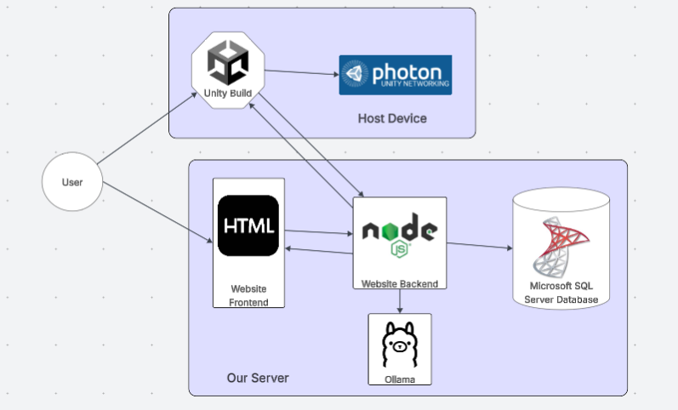
System Modeling:

