WiFi Protected Setup
Wizard
Design Specification

Last Updated: 06/06/2008
Draft/Version: 0.5

Document Control
Revision History
Date | Author | Version | Change Reference
05/22/2008 | WGao | 0.1 | Initial Draft
05/27/2008 | WGao | 0.2 | Updated with feedbacks from David and corrected some logic error in Wizard UI flowchart
06/05/2008 | DTu | 0.3 | Markup for wizard screen shots
06/06/2008 | DTu | 0.4 | Update Configuration Status screen shot
06/06/2005 | WGao | 0.5 | Added “RestoringNetworkEnv” state to WPS state diagram  Added description on each state in the WPS state diagram

Document References
Document Title | Type of Reference | Document Location
WPS MRD |  | http://hwnbu-twiki.sj.broadcom.com/bin/view/Mwgroup/WpsWizard
SecureEasySetup Implementation Specification
Table of Contents
1. Introduction 3
1.1 Terms and Acronym: 3
1.2 WPS GUI Program Comparison 3
2. WPS Wizard Architect Overview 3
2.1 Overview of WPS Configuration Process 3
2.2 OS and System Requirements 3
2.3 Module Architecture 3
2.4 Wizard Process Flow 3
2.5 Sequence Diagram of WPS Provisioning Process 3
2.6 State Diagram of WPS Provisioning Process 3
2.7 Compatibility with TrayApp Utility Client 3
2.8 Deployment Considerations and Capabilities 3
2.8.1 Installation and Packaging 3
3. WPS Wizard GUI and User Experience 3
3.1 GUI Markup 3
3.1.1 Welcome Screen 3
3.1.2 WPS Mode Selection Screen 3
3.1.3 WPS PIN Mode Screen 3
3.1.4 WPS PBC Mode Screen 3
3.1.5 Configuration Status Screen 3
4. Security Protocols 3
4.1 Support Matrix 3
5. Language Support 3

Introduction
This document contains the design specification of WPS Wizard GUI application running on Windows XP and Vista. WPS Wizard is built on top of WPS Windows SDK to help end users to easily and securely configure AP by following the WPS standard/specification which is backed up by Microsoft, Intel and Wi-Fi Alliance

Terms and Acronym:

WPS | Wi-Fi Protected Setup

WPS GUI Program Comparison
The following table shows how WPS functionalities are supported among Microsoft and Brocade products.

WPS Client Comparison:

 | STA Configures AP |  | STA Joins AP Network as an Enrollee
 | PIN Mode | PBC Mode | PIN Mode | PBC Mode
SES Client | × | × | × | √
WPS Wizard Client | × | × | √ | √
Vista WCN | √ | × | √ (As part of the process of STA configuring AP) | √ (Microsoft Claims to support this in a release note though)

WPS Wizard Architect Overview

Overview of WPS Configuration Process
There are two modes to configure AP via WPS protocol: PIN and PBC. Based on user’s selection of WPS modes, the WPS Wizard will go ahead to start the WPS process basically to retrieve AP security settings and create 802.1x profile on the station side automatically.

OS and System Requirements
WPS Wizard client requires Windows XP SP2, XP SP3 and Vista. Specially in order to support WPA2PSK, KB893357 (Wireless Provisioning Service IE) hotfix is required for XP SP2. More details are also described in Section 4 Security Protocols

Module Architecture
WPS Wizard, as GUI client application, is built on top of WPS Windows SDK. WPS Windows SDK provides a set of convenient APIs for upper layer by wrapping WPS engine and handling WPS protocol information exchange.
The following diagram shows the module architecture of WPS Wizard:
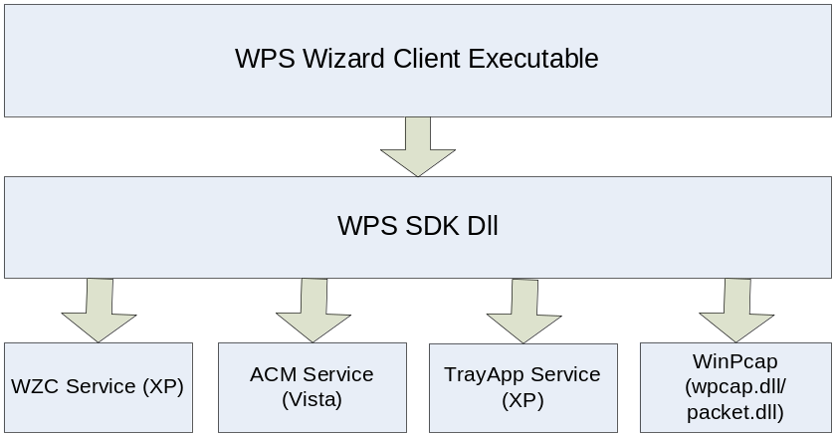

- WPS Wizard Client Executable. The WPS Wizard UI program allowing the end user to create wireless networking profile on via Broadcom TrayApp service, XP Wireless Zero Config service or Vista ACM service
- WPS SDK. The WPS SDK dll exposes Win32 API providing WPS service
- WZC Service. SDK interacts with WZC to create WLAN profile on XP
- ACM Service. SDK interacts with WZC to create WLAN profile on Vista
- TrayApp Service. SDK can interact with TrayApp service to create WLAN profile on XP accessible from Broadcom TrayApp Utility program

Wizard Process Flow
The following flow chart shows the Wizard GUI process guiding the end user to do WPS configuration.
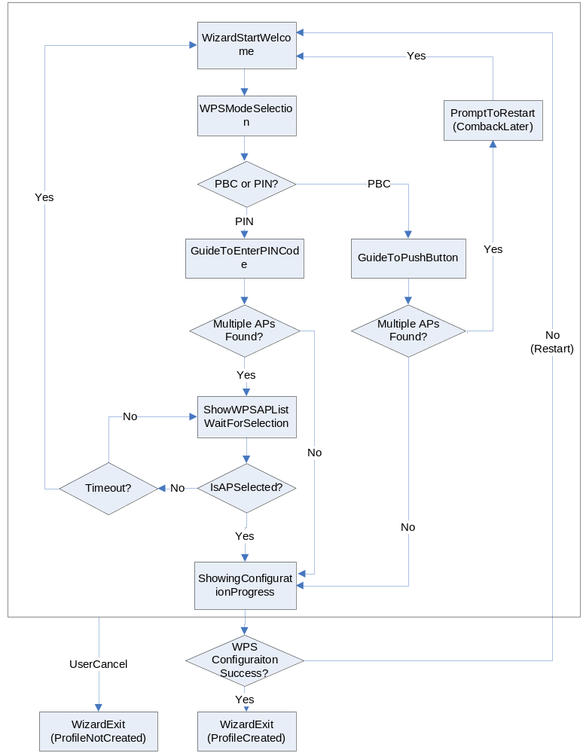

Sequence Diagram of WPS Provisioning Process
The following sequence diagram shows the successful WPS configuration process in PIN mode across multiple components
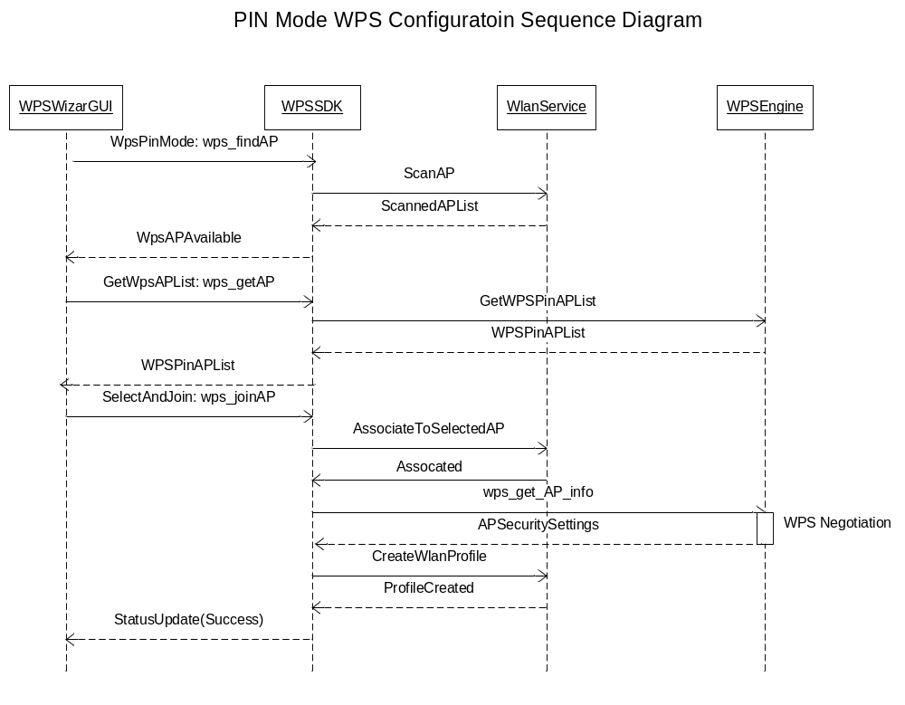

State Diagram of WPS Provisioning Process
The following state diagram shows state transitions during WPS Wizard client handling WPS configuration process.
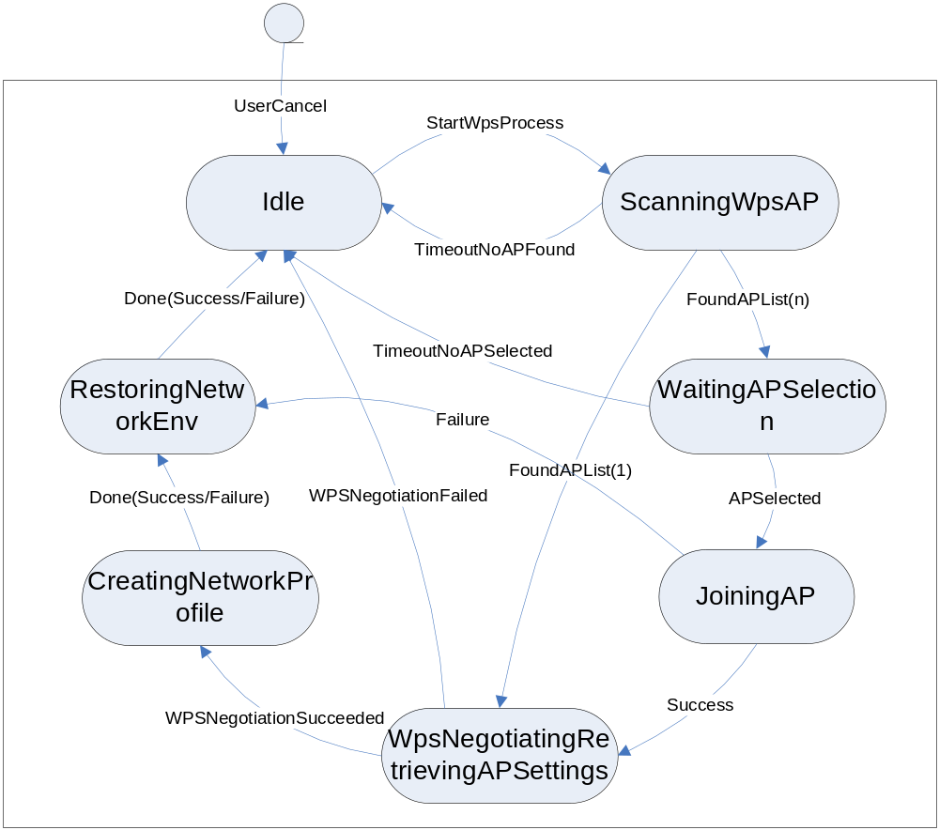

State | Description
Idle | No WPS process is going on
ScanningWpsAP | Searching WPS capable AP to proceed WPS process
WaitingAPSelection | Multiple WPS capable APs are found, waiting for the user to select one to connect to
JoiningAP | Joining the selected AP as part of the protocol process
WpsNegotiatingRetrievingAPSettings | WPS negotiation and client retrieving AP networking settings
RestoringNetworkEnv | Restoring networking environment. E.g. restart TrayApp or WZC service
CreatingNetworkProfile | WPS negotiation and client retrieving AP networking settings

Compatibility with TrayApp Utility Client
When Broadcom TrayApp Utility client is used to manage Wi-Fi connectivity, WPS Wizard client will generate wireless networking profile via TrayApp component preflib.dll. The generated profiles are accessible via TrayApp Utility client. WPS Wizard client is compatible to TrayApp Utility Version 4.100 (product version) and above.

Deployment Considerations and Capabilities

Installation and Packaging
WPS Wizard will be packaged by InstallShield as self-exact executables. The following files should be installed by the WPS installer:
- WpsWizard.exe. The executable of WPS Wizard client executable
- Wps_api.dll. The WPS Win32 SDK library
- Winpcap.exe. Microsoft redistributable self-extract installer. It should be launched as part of the WPS Wizard client installer. It will install “wpcap.dll” and “packaet.dll” to SYSTEM32 directory

WPS Wizard GUI and User Experience
WPS Wizard GUI allows the end user to configure the AP step by step in both PBC (Push Button Configuration) and PIN (PIN code) modes.

GUI Markup
WPS Wizard 1.0 gives the similar user experience and GUI style as that of Broadcom SES Wizard. This is mainly due to user experience consistence and time constraint.
(Note: Screenshot will be updated continuously with development progress to reflect the latest ones. The following will mainly show the logic and design concepts)

Welcome Screen
First page of WPS Wizard showing welcome message and more (TBD)
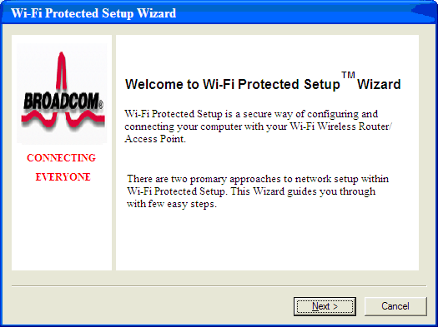

WPS Mode Selection Screen
Allow the user to select PIN or PBC mode for WPS configuration. And the selection will take the user to go to different following pages accordingly.

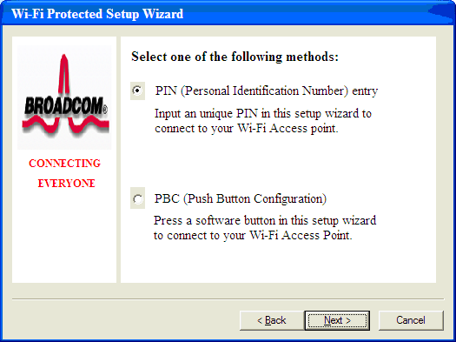

WPS PIN Mode Screen
Allow the user to type in PIN number used for WPS configuration.
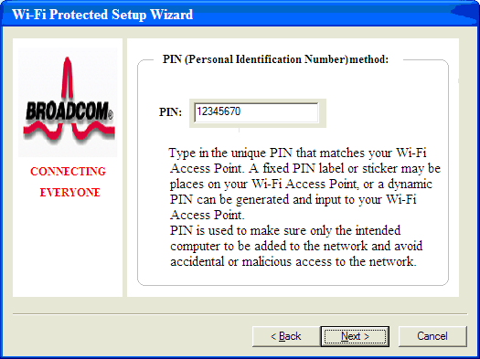

WPS PBC Mode Screen
Allow the user to push button in this page. Either “Press Button” or “Next” will lead to next “Configuration Status” page to start eh actually WPS process.
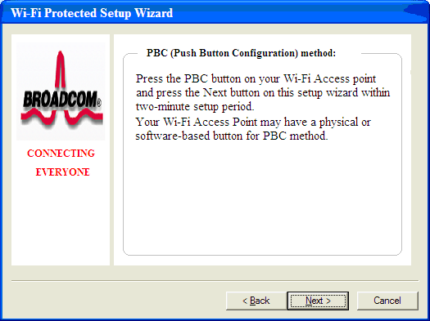

    - Configuration Status Screen
Once “Configuration Status” page is initialized, the WPS configuration process will start. Each stage the process will be examined and the result will be displayed as “Success” or “Failure”.
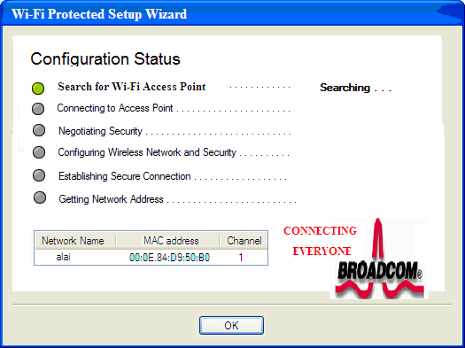

As part of the WPS PIN mode process, when there are multiple WPS APs are scanned, the following dialog will pop up allowing the end user to select the AP to continue.
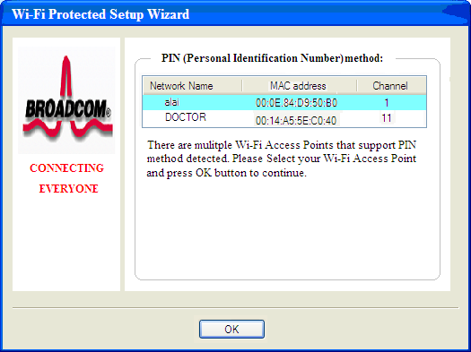

Security Protocols

Support Matrix
The following matrix describes how WPS Wizard (including the underneath WPS SDK) support different Wi-Fi security protocols across different Windows OS and supplicants.
802.1X – Not Supported
Mixed Mode – Depending on OS and 802.1x supplicant, WPS will choose the corresponding authentication and encryption type.
KB893357 - The Wi-Fi Protected Access 2 (WPA2)/Wireless Provisioning Services Information Element (WPS IE) update

802.11 |  | Preflib/XP  (TrayApp) | WZC/XP | ACM/Vista
Open | No WEP | √ | √ | √
Open | WEP | √ | √ | √
Open | WPA/PSK | √ | √ | √
Open | WPA2/PSK | WPA  (WPA2 used actually) | √  (Requires SP3 or KB893357 hotfix on SP2) | √
Open | WPA+WPA2/PSK | WPA  (WPA2 used actually) | WPA2  (Requires SP3 or KB893357 hotfix on SP2) | WPA2
Encryption Type
AES |  | √ | √ | √
TKIP |  | √ | √ | √
AES+TKIP |  | AES | AES | AES

Language Support
WPS Wizard client support 32 languages as TrayApp Utility client do

