Digital Closed Caption library
Design Document
Version 1.0
2-May-08

Revision History

Revision Number | Date | By | Change Description
Version 1.0 | 2-May-08 | Gareth Trevers | Initial version.
Table Of Contents
Data Flow 4
Design 7
Integration 11
Overview 11
Front End Data Feed 12
Front End Control 12
Back End Control 12
Customer Decisions 19
Testing 20

Data Flow
Figure 1 below illustrates how EIA-708 data flows through the Digital Closed Caption library.

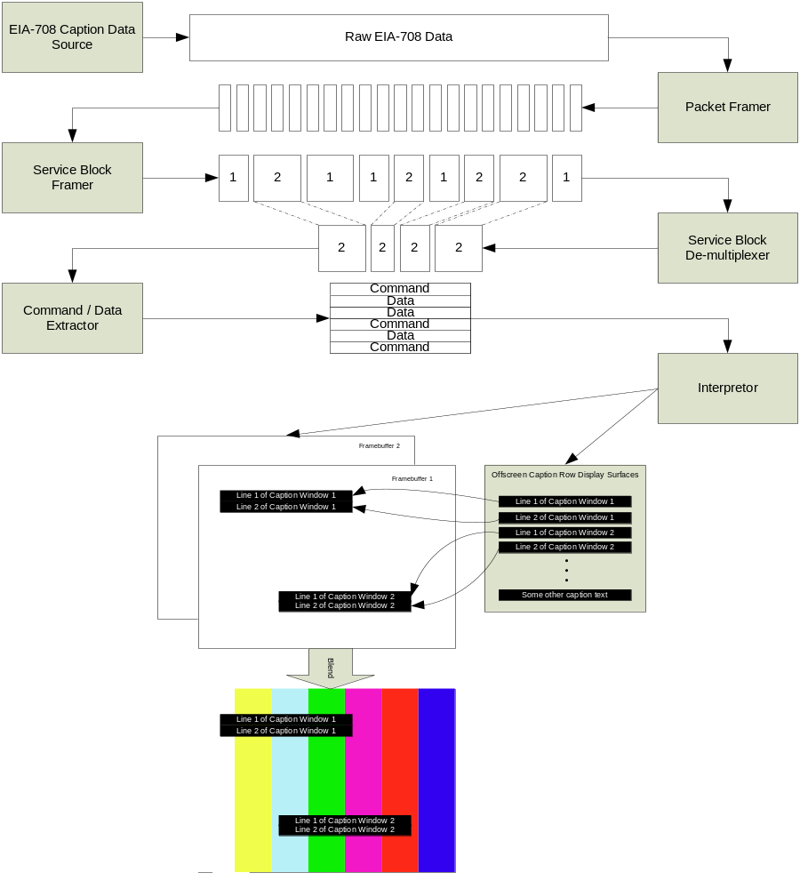
Figure 1: EIA-708 Data Flow

Raw EIA-708 data in the form of triplets {cc_type, data[0], data[1] } are consumed by the library and as a result of the interpretation of these triplets, commands to an abstract window interface are output from the library. The customer is responsible for implementing a concrete version of the the abstract window interface however complete examples for both of the predominant Broadcom high level API’s (Set-Top API and Nexus) exist. Both examples use BWIN (the Broadcom Windowing System) to render the glyphs. The customer can use these examples as the framework for their own implementation. In many cases only a minimal set of changes will be required.
Referring to Figure 1, raw EIA-708 data is first framed into packets. The beginning of the frame is signaled by a value of ‘3’ in the cc_type member of the EIA-708 triplet. Each packet has a sequence number which the Digital Closed Caption library uses in conjunction with packet lengths to detect transmission errors. If a transmission error is detected then the downstream buffers are flushed as per the EIA-708 spec requirements.
The Service Block Framer subsequently combines packets into service blocks. Each service block belongs to one of 63 services. The Service Block De-multiplexer selects the service block for the service that the user has requested.
The Command/Data extractor identifies the commands and data from the service block. Some commands are interpreted at this point. These are the Reset and Delay commands.
Finally the commands and data are interpreted by the Interpreter. The Interpreter is by far the most complex module in the library. It is responsible for directing the rendering, compositing and positioning of the captions. It also controls scrolling and flashing.
The customer provided window interface is responsible for actual compositing and rendering. This approach was adopted to allow the library to be more easily integrated into the customer’s proprietary window environment.
A similar dataflow is used for EIA-608 captions. In this case, the library exploits the fact that EIA-608 captions can effectively be considered a subset of EIA-708 captions. Therefore EIA-608 captions are trans-coded to their EIA-708 counterparts for subsequent processing as EIA-708 captions.
Figure 2 shows the dataflow for EIA-608 captions.
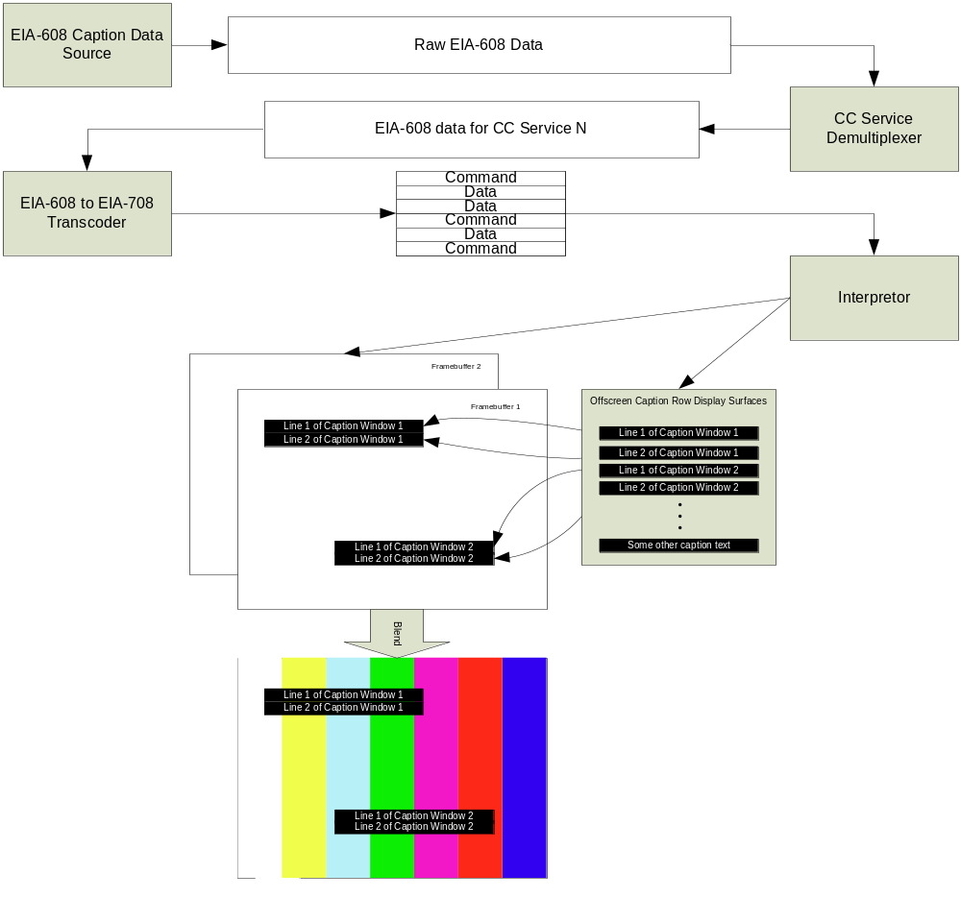
Figure 2: EIA-608 Data Flow

Design
Groups of EIA-608 or 708 triplets are periodically pushed into the Digital Closed Caption Library engine where they are processed as described in Figure 1: EIA-708 Data Flow & Figure 2: EIA-608 Data Flow. These triplets will normally be pushed once per field or frame depending on whether the video is field or frame based. After the triplets have been processed the resultant commands and data find themselves in a data/command buffer. The data/command buffer holds the complete context of all of the active caption windows. The onscreen representation of the caption windows is generated from the data/command buffer by interpreting the commands and data for each Caption Row. Typically this is done on the fly as the commands and data are processed. However, in response for example to a user override, all of the captions can be completely redrawn with the user overridden attributes by re-interpreting all of the commands and data for each Caption Row of each visible caption window.
The design of the Digital Closed Caption Library ‘back-end’ is based around the concept of a Caption Row. Caption Rows are off-screen graphics surfaces with associated data structures that may be copied onscreen at a set position. Each row of the 8 possible caption windows corresponds to a Caption Row. There may be up to 15 Caption Rows in a caption window. Each Caption Row may contain up to 32 characters (glyphs). Theoretically there could be 120 Caption Rows (8 windows x 15 rows) but in practice few Caption Rows are used. This is because the relevant standards allow a decoder to support just 8 Caption Rows (of which only 4 need be visible). Captions encoder manufacturers have ‘toed the line’ since they wish their captions to be universally decoded.
The Digital Closed Caption Library works by directing the customer’s window interface to create a Caption Row, render the characters into the Caption Row (with various attributes such as foreground color, background color, edge type) and then position the Caption Row on the screen.
Flashing is accomplished by using two Caption Rows into which the same characters may be rendered (depending on whether the flash is a foreground flash or background flash) but with different attributes. The two rows are then periodically alternated under the supervision of the caption library. An alternative method is supported that allows the use of just one Caption Row with a requirement to re-render the row with the alternative attributes periodically. Once again this is completely directed by the library. See Figure 3 and Figure 4 for an example of a Caption Row with a flashing foreground.

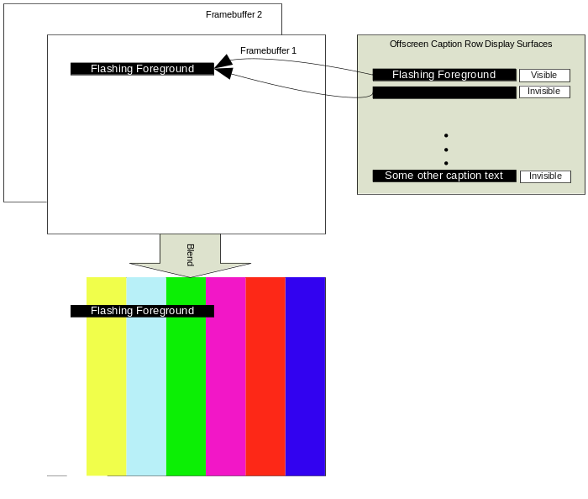
Figure 3: Flashing using 2 Caption Rows - Phase 1, foreground visible
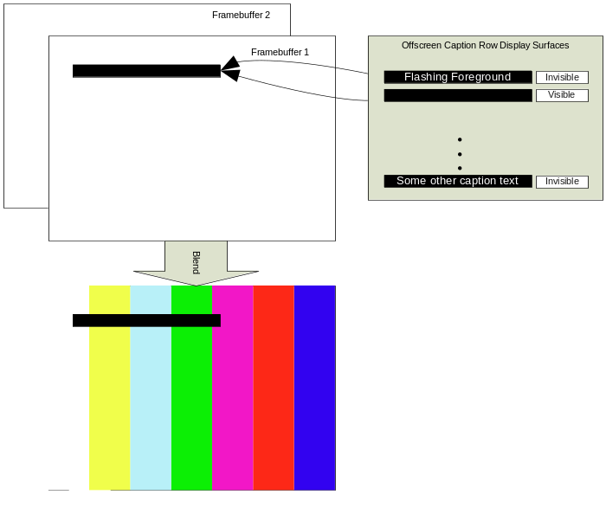
Figure 4: Flashing using 2 Caption Rows- Phase 2, foreground invisible

Scrolling is accomplished by creating one more Caption Row per window than is necessary. During a scroll, as the top row scrolls out of view, the extra row scrolls into view (as caption text is being rendered into it). During the scroll, the position of each of the Caption Rows is adjusted up. After each adjustment, the library directs the window interface to re-composite the screen. See Figure 5 thru Figure 8 for an example of window scroll.

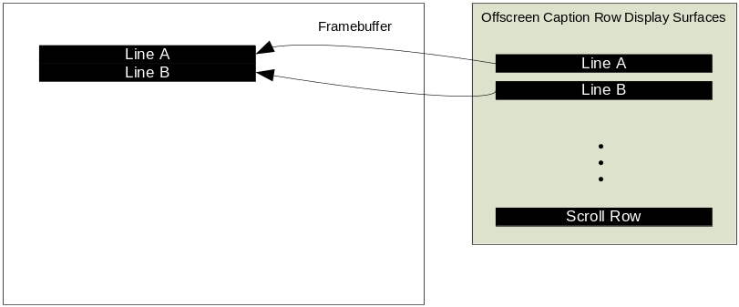
Figure 5: Phase 1 of scroll

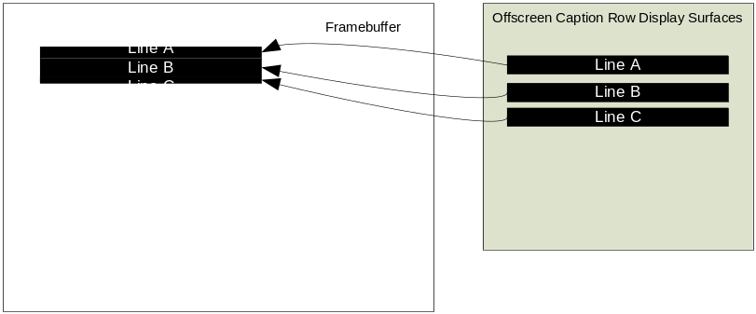
Figure 6: Phase 2 of scroll

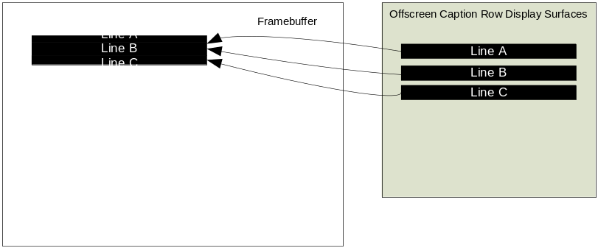
Figure 7: Phase 3 of scroll

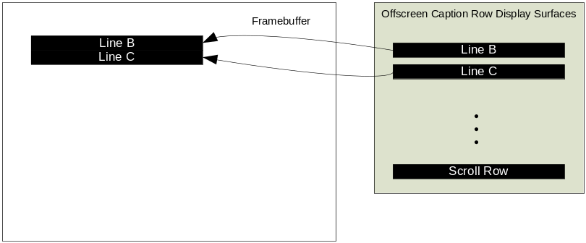
Figure 8: Phase 4 of scroll

Caption Rows are created as needed. When they are no longer needed they are placed on a list ready to be re-used when required, they are not deleted. The surface memory associated with them is not released. This mechanism avoids the potential for memory fragmentation associated with frequent allocation and freeing of memory.
Viewers have a degree of control over how the closed captions are displayed on screen. The Digital Closed Caption Library allows the viewer to override the stream selected font style, font size and font attributes in accordance with FCC regulations. Viewers may also select amongst available caption services.

Integration

Overview
The Digital Closed Caption library interfaces to the rest of the system as shown in Figure 9: Digital Closed Caption Interfaces (below).

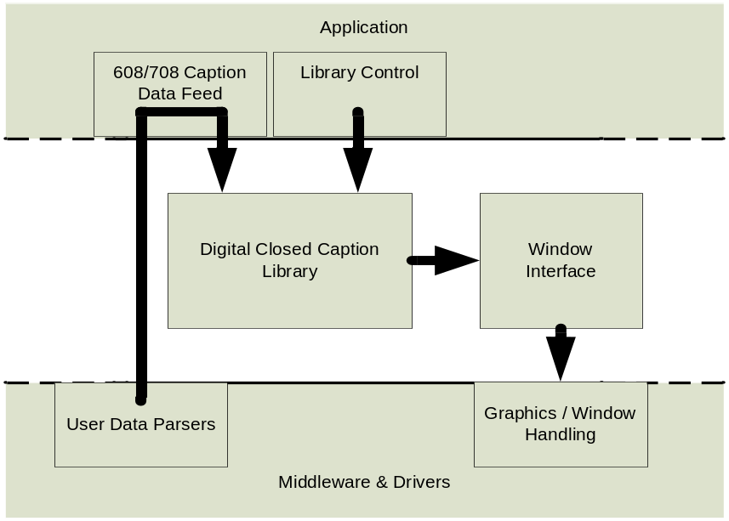
Figure 9: Digital Closed Caption Interfaces

This diagram is simplified and does not show how the library uses kernel resources.

Broadcom supplies a complete example of all of the components shown in the diagram along with the library itself. The Digital Closed Caption library accepts a raw EIA-608 or EIA-708 data stream at its input and directs commands and data to the Window interface component at its output. The customer will implement their own Window Interface component in order to interface the Digital Closed Caption Library with their Graphics / Window environment. However the provided example can be used as a framework for the customer implementation. Should the customer choose to use Nexus and Bwin to manage graphics and window requirements then the modifications should be minimal. The ‘Library Control’ component of the application allows the view to select one of a number of caption services that are available as well as offering the viewer the ability to override the stream with regard to many of the caption attributes. Viewers with poor eyesight may for example opt to increase the font size. Error detection and recovery is handled within the Digital Closed Caption library itself.

Front End Data Feed
Caption data is by its nature periodic. In the case that the caption data source is MPEG, caption data should be retrieved either every field or frame in the form of MPEG User Data. The MPEG User Data can convey both EIA-608 and EIA-708 caption data. The MPEG User Data should be parsed in order to retrieve the EIA-608 and EIA-708 caption data.
In the case of an analog source input only EIA-608 caption data can be retrieved. EIA-608 data is retrieved at a rate of 2 bytes per field.
The Broadcom driver handles retrieval of EIA-608 and EIA-708 caption data. The Application simply has to retrieve the caption data using the Broadcom driver, and feed the data corresponding to the selected caption mode to the Digital Closed Caption engine.
The caption data should be fed into the Digital Closed Caption library engine as soon as it is received. The Application should maintain the state for the selected caption mode (EIA-608 or EIA-708) and for the caption service. If the caption mode is EIA-608 then only the EIA-608 caption data should be fed. If the caption data is EIA-708 then only the EIA-708 caption data should be fed.
The application should periodically invoke the Digital Closed Caption engine irrespective of whether there is any caption data to send (i.e. with a length of 0 bytes). This allows the engine to perform periodic duties such as scrolling caption windows or flashing Caption Rows. The period between invocations should be in the order of 20 – 30 ms. This allows for a smooth scroll.
Data is fed / the Digital Closed Caption engine is invoked using the ENG_Process() call.

Front End Control
The Digital Closed Caption library allows the viewer to select between EIA-608 and EIA-708 captions and between different services within EIA-608 and EIA-708 captions. The library additionally allows the viewer to override the caption bit-stream directives for font size and attributes. If the font style or font attributes are changed then the entire caption screen will be redrawn with the new attributes.
ENG_Override() is used to pass stream overrides into the Digital Closed Caption engine. This API can also be used to remove overrides.
ENG_Reset() can be used to change the caption mode (EIA-608 or EIA-708) or the caption service (CS 1 – CS 63 for EIA-708, CC1 – CC4 for EIA-608).

Back End Control
The back end control (co-ordination of allocation, rendering, compositing and positioning of Caption Rows) is far more complex than the front end control. The customer will often have a proprietary graphics or window library and proprietary fonts that must be used in the implementation of Closed Captioning. Customers may use different strategies in terms of graphics plane organization and frame-buffering schemes. The interface between the Digital Closed Caption library and the customer graphics and window library was designed to be as abstract as possible to ease the burden of integration.
The Window Interface component is used to interface the Digital Closed Caption library to the customer graphics and window libraries. Comprehensive examples are given for both Nexus and SetTop API
Any initialization of the Window Interface component should be performed before the Digital Closed Caption library becomes active. This will typically involve setting up data structures, retrieving handles to graphics and window subsystems and allocating Frame Buffers onto which captions will be composited.
The Window Interface member functions will now be described…
The following interface members simply set the attributes for characters that are to be subsequently rendered

- SetFont()
- SetCharFGColor()
- SetCharBGColor()
- SetCharEdgeColor()
- SetCharEdgeType()

It is mandatory to support the following font styles {default (can be any font), mono-spaced with serifs, mono-spaced without serifs, proportionally spaced with serifs, proportionally spaced without serifs, cursive, casual and small capitals} in systems where the rules are governed by the FCC. Foreground and Background colors are specified as RGB222 with one of four possible opacities {solid, translucent, flashing and transparent} and their support is also mandatory as specified above.
Edge types are {none, raised, depressed, uniform, left drop shadow and right drop shadow} and their support is also mandatory as specified above.
The values set by these interface members must be kept in the Window Interface component state and must be applied to subsequent characters as they are rendered.

The following interface members directly manipulate Caption Rows

- CreateCaptionRow ()
- DestroyCaptionRow ()
- ClearCaptionRow ()
- SetCaptionRowZorder ()

A call to CreateCaptionRow () would typically result in setting up the Caption Row data structure and reserving memory for the associated graphics surface. The size of the surface would most simply be based on the worst case number of characters per row (which is defined in EIA-708 to be 32) multiplied by the size of the largest glyph of any of the fonts used by the Digital Closed Caption library. That is to say, it should be possible for the Caption Row to accommodate 32 of the widest and tallest glyphs of any of the fonts. Moreover the horizontal size should be based on a glyph metric called the advance rather than the width. The advance specifies the number of pixels between the beginning of two adjacent characters.
The customer may also wish to allocate some internal Caption Rows that it can use as temporary storage for the purpose of text justification and for a flash surface in the case that a Caption Row contains flashing text (see the example Window Interface component).
It may be assumed that if a flashing attribute is specified in the caption data stream after a number of characters has already been rendered into a Caption Row, then the associated Caption Row will be cleared and character rendering will start over from the beginning in order to allow the Window Interface component to render the characters into the flash Caption Row as well as the normal Caption Row.
As the Caption Row is created, it may be useful to sort it into a linked list of Caption Rows based on its z-order. When the time comes to composite the Caption Rows onto the screen they should be composited in z-order. This will normally be accomplished by the call to SetCaptionRowZorder () which closely follows the call to CreateCaptionRow () (see below).
DestroyCaptionRow () may result in de-allocation of the off-screen graphics surface and the Caption Row data structure as well as fixing up the linked list of Caption Rows should that structure exist.
ClearCaptionRow () should result in the Caption Row graphics surface being filled with the supplied color. This may also be used as a hook to reset the Caption Row character rendering settings such as the pen position.
SetCaptionRowZorder () should result in a new Z-order being set for the Caption Row. If a Caption Row linked list is being used to aid compositing then this call should be used as a trigger to insert or sort the Caption Row within the linked list.

The following functions allow the Digital Closed Caption library to manage the position and justification of the individual Caption Rows irrespective of the display format or font sizes.

- SetCaptionRowClipRect ()
- SetCaptionRowDispRect ()
- GetCaptionRowTextRect ()
- GetDisplayRect ()
- GetSurfaceRect ()
- GetMaxBoundingRect ()
- GetFrameBufferSize ()

SetCaptionRowClipRect() and SetCaptionRowDispRect() are used to define the portion of the Caption Row graphics surface that will be visible on the display and the position that the portion of the Caption Row graphics surface will occupy on the display. The relationship between clip rectangle and display rectangle is shown below in Figure 10: Relationship between Clip Rect and Display Rect. If the fonts are scaled then the area of the clip rectangle will not be equal to the area of the display rectangle.

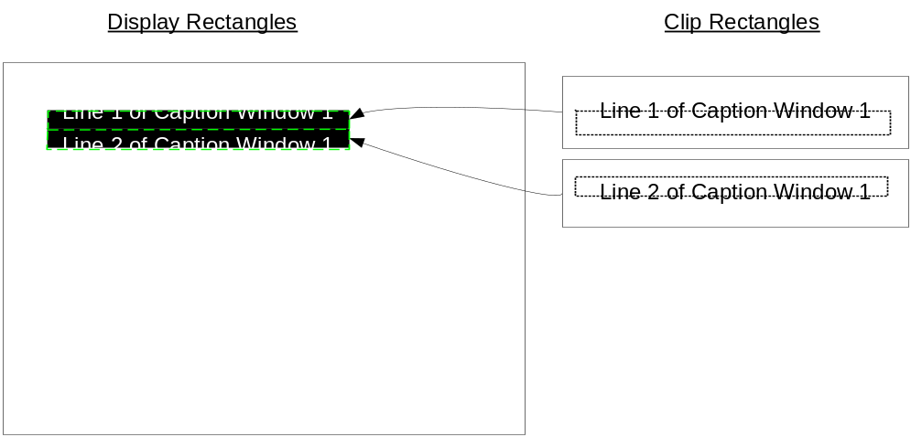
Figure 10: Relationship between Clip Rect and Display Rect
GetDisplayRect () retrieves the previously set Display Rectangle.
The Text Rectangle, Surface Rectangle and Max Bounding Rectangle are all defined pictorially below

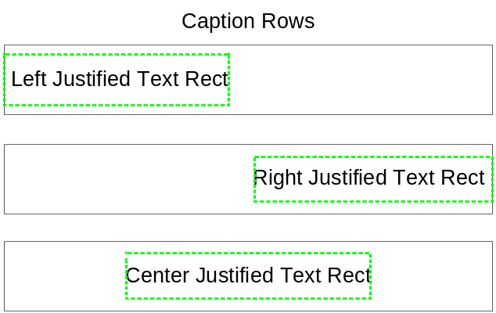
Figure 11: Effect of justification on Text Rect

Figure 11 illustrates the definition of Text Rectangle. The Text Rectangle is the smallest rectangle that encloses the rendered text in a Caption Row. The height of the Text Rectangle is equivalent to the height of the largest glyph rendered into the text rectangle and the width of the Text Rectangle is the sum of the widths of all of the glyphs rendered into the Caption Row. The position of the Text Rectangle depends on both the justification of the Caption Row and the width of the Text Rectangle. The Text Rectangle is used by the Digital Closed Caption library to set the Caption Row Clip Rectangle and Display Rectangle.

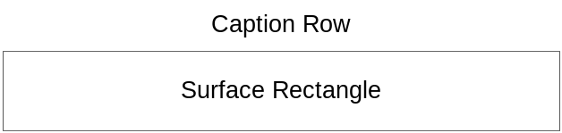
Figure 12: Definition of Surface Rectangle

Figure 12 Illustrates that the Surface Rectangle is simply a rectangle with origin at (0,0) which has the width and height of the Caption Row graphics surface.

The Max Bounding Rectangle defines the rectangle required to accommodate N of the widest characters from any of the caption fonts at a particular font size (small, regular or large). It is used to help calculate the size of a caption window given that the caption window is defined to have a fixed width of N columns. Some examples are given below.

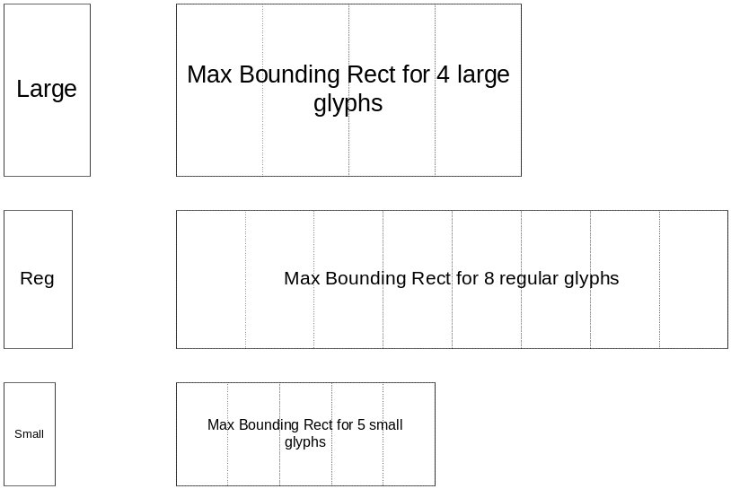
Figure 13: Examples of Max Bounding Rect for various glyph sizes and numbers of columns

GetFrameBufferSize () is used to determine the current display size in pixels. Typical values returned from this function are 1920x1080, 1280x720 or 720x480.

SetFrameBufferSize () is used to set the size in pixels of the framebuffer for each display resolution. It is typically called every time output format is changed and can’t be greater than current display size. The width and height of the frame buffer are initialized during BDCC_WINLIB_Open() call. Note that in many cases the Frame Buffer surface is smaller horizontally and vertically than its display size. This can be beneficial as it can be used to reduce the memory footprint and the memory bandwidth consumed in manipulating the framebuffer.

The following functions relate to whether a Caption Row will ultimately be visible onscreen

- SetClipState ()
- SetCaptionRowVisibility ()
- IsCaptionRowVisible ()

SetClipState() specifies whether or not the Caption Row is entirely outside the caption window or the visible area of the screen (“clipped out”). SetCaptionRowVisibility() specifies whether the Caption Row should be visible or invisible (for example in the case of a flashing Caption Row or for the extra row that is used during a scroll). For a caption window to be displayed it must be visible and not be clipped out. This can be determined by calling IsCaptionRowVisible ().

The following functions are used to control rendering of characters into the Caption Row.
- RenderStart ()
- RenderChar ()
- RenderEnd ()

RenderStart() is called to indicate that the Caption Row is empty of text and should be reset in preparation of rendering the first character. RenderChar() is called to render a single character. RenderEnd() is called to indicate that that the characters rendered thus far in the Caption Row should be displayed. Both RenderChar() and RenderEnd() may be called multiple times following a call to RenderStart() as the text in a Caption Row is progressively displayed. RenderEnd() is normally called in response to the reception of an ETX (End of Text) command in the EIA-708 stream.
RenderChar() is always called progressively. That is, the character is either rendered at the beginning of the row following a call to RenderStart() or the character is rendered immediately following the previously rendered character. The ‘beginning’ of the row is defined with respect to the caption window justification. If the justification is left then the beginning of the row is the leftmost pixel of the Caption Row. If the caption window justification is right then the beginning of the row is the rightmost pixel of the Caption Row. If the Caption Row is center then the beginning of the row is at the horizontal center of the Caption Row. Fully justified text may be treated the same as left justified text, i.e. it is not a requirement to support full justification. Here is an example sequence with center justification.

RenderStart ()

RenderChar ( T )

RenderChar ( H )

RenderChar ( I )

RenderChar ( S )

RenderEnd ()
THIS
RenderChar ( I )
THIS
RenderChar ( S )
THIS
RenderEnd ()
THIS IS
RenderChar ( A )
THIS IS
RenderEnd ()
THIS IS A
RenderChar ( C )

RenderChar ( A )
THIS IS A
RenderChar ( P )
THIS IS A
RenderChar ( T )
THIS IS A
RenderChar ( I )
THIS IS A
RenderChar ( O )
THIS IS A
RenderChar ( N )
THIS IS A
RenderEnd ()
THIS IS A CAPTION

Left justification is a special case. RenderEnd() should be called after every RenderChar() according to the requirements of EIA-708. In general for other justifications, the caption will only be displayed after the last character of the row has been rendered hence the following is more typical for a center justified Caption Row.

RenderStart ()
RenderChar ( T )
RenderChar ( H )
RenderChar ( I )
RenderChar ( S )
RenderChar ( I )
RenderChar ( S )
RenderChar ( A )
RenderChar ( C )
RenderChar ( A )
RenderChar ( P )
RenderChar ( T )
RenderChar ( I )
RenderChar ( O )
RenderChar ( N )
RenderEnd ()
THIS IS A CAPTION

The following function…
UpdateScreen() is called to indicate that either the position or contents of one or more of the Caption Rows has changed AND that it should be made visible. An inefficient was to respond to this call is to re-composite all of the visible Caption Rows onto the framebuffer in z-order however a more elegant way to respond would be to re-composite only the differences since the previous call to UpdateScreen(). The more efficient method requires careful tracking of all activities on Caption Rows between calls to UpdateScreen(). Typically a ‘dirty rectangle’ is defined that encompasses any differences between the output of the previous call to UpdateScreen() and the output of the next call to UpdateScreen(). Each time a Caption Row is created, deleted, has its display rectangle moved or is rendered into, the dirty rectangle should be expanded to include both the old and new display position of the Caption Row (or the part of it which has changed).
Font handling and sizing is the responsibility of the customer however the test application, the provided fonts and the example Window Interface component demonstrate how fonts should be handled. Sizing can be a more difficult task. There are some guidelines in EIA-CEB-10. However, the quick rules are as follows…
All fonts must be smaller in height than 1/15th the height of the "Safe Title Area" of the screen. The "Safe Title Area" is an area that is considered to be the canvas for rendering closed captions and may have been defined to avoid over-scan. CEA-CEB-10 suggests that the safe title area be 80% of the width and height of the display and be centered on the display, thus for 1080i the "Safe Title Area" is the middle 1536 * 864 region. An additional constraint is that the width of the widest character of any font in the STANDARD pen size should be no greater than 1/32 of the width of the "Safe Title Area" for 4:3 aspect ratio displays and 1/42 of the width of the "Safe Title Area" for 16:9 aspect ratio displays. In addition, the width of the widest character of any font in the LARGE pen size should be no greater than 1/32 of the width of the "Safe Title Area" for for 16:9 aspect ratio displays. Please see the EIA-708 spec for further guidance.
The test application has a feature that allows pre-defined EIA-708 test strings to be fed into the Digital Closed Caption engine. This feature can be used to help size the fonts correctly.

Customer Decisions
We recommend that the display of Closed Captions be made mutually exclusive to the display of the GUI. This greatly simplifies matters since the Digital Closed Caption library is not designed to be GUI aware.
There are two options to use CC frame buffers during BDCC_WINLIB_Open() call:
- Off-screen buffer
Use single off-screen buffer as intermediate surface to render CC and blit it with other GUI surface. Every time the cc_surface is updated, a installed callback CC_sync() will be invoked to inform upper application to update final graphics frame buffer.
BDCC_WINLIB_ErrCode BDCC_WINLIB_Open(
BDCC_WINLIB_Handle *phWinLibHandle,
NEXUS_Graphics2DHandle graphics,
NEXUS_DisplayHandle display,
bwin_engine_t bwinEngine,
cc_surface,
cc_surface,
uint16_t framebufferWidth,
uint16_t framebufferHeight,
CC_sync
)
void CCSync(NEXUS_SurfaceHandle cc_surface, NEXUS_Rect *updateRect)
{
/* blitting cc_surface with other GUI surface into final frame buffer*/
}
The typical height and width are 960x540 w/ SCALE_720P_FONTS defined. For 1080i/p, 720p and 480p/i, the frame height and width are set in winlibInterface.SetFrameBufferSize() to 960x540, 960x540 and 720x480 respectively.
- Use final graphics frame buffer as CC buffer
Directly write to final graphics frame buffer. This is the most efficient way but the limitation is that you can’t have any other GUI displayed except closed caption.
BDCC_WINLIB_ErrCode BDCC_WINLIB_Open(
BDCC_WINLIB_Handle *phWinLibHandle,
NEXUS_Graphics2DHandle graphics,
NEXUS_DisplayHandle display,
bwin_engine_t bwinEngine,
gfx_framebuffer1,
gfx_framebuffer2,
uint16_t framebufferWidth,
uint16_t framebufferHeight,
NULL
)

Testing
The test application comes with a set of ‘compiled in’ EIA-708 test strings that focus on testing the customer Window Interface component along with the customer fonts. We recommend that the customer run through all of these tests. The expected output from the tests is shown below…

See EIA-708 section 4.4.1 and ATSC /53

