CSE301 Bio-computation, 2014
Week 11 Tutorial Exercises on SOM and LVQ

Following questions are about SOM:
Q1. How many layers are there in a Kohonen network (Self Organizing Map) and what do they do?

Answer: Bookwork

Q2. How are the weights in a Kohonen network (Self Organizing Map) updated?

Answer: Bookwork

Q3. Describe the architecture of the Self Organising Map (SOM) known as a Kohonen network. What can such a network be useful for?
Answer: Bookwork

Q4. The self organising process can be said to have four major components: Initialization, Competition, Cooperation, and Adaptation. Briefly describe how each of these components is implemented.
Answer: Bookwork

Q5.Two equations used in the context of Kohonen networks are:
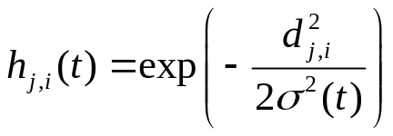

What do each of the symbols in them mean, and how are these equations used in the
Self-organising process?
Answer: Bookwork

Q6. Explain what is meant by the term Self Organising Map (SOM)? In this context, what is meant by the term Vector Quantization?
Answer: Bookwork

Q7. Outline the components of the self-organising process that is used to form topographic maps in a Kohonen Network. Give intuitive explanations of why the size of the topological neighbourhood and the learning rate should both be decreased during a successful course of Kohonen Network training.
Answer: Bookwork

Q8. A self-organizing feature map (SOM) has 8 input units, and 100 output units arranged in a two dimensional grid. How many weights does this network have?
A. 80
B. 100
C. 800
D. 1000
E. 1500

Answer: C

Q9. A self-organizing feature map (SOM) has 8 input units, and 25 output units arranged in a two-dimensional grid. How many weights does this network have?
A. 20
B. 25
C. 200
D. 250
E. 800
Answer: C

Q10. A self-organizing feature map has four cluster units arranged in a one-dimensional ring, as shown in the following diagram
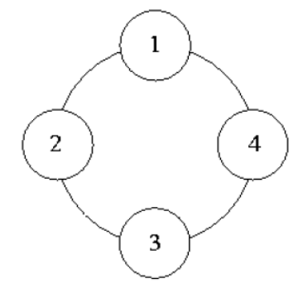
The weight vectors of the four units are given as follows:
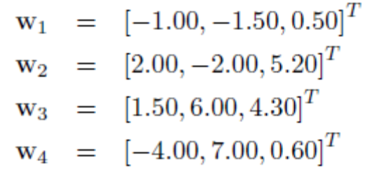
An input vector x = [−1.40, 2.30, 0.20]^{T} is presented to the network. Which unit is nearest to x in terms of Euclidean distance?
A. Unit 1.
B. Unit 2.
C. Unit 3.
D. Unit 4.
Answer: A

Q11. Adapt the weight vector of the winning unit in last question according to the SOM learning algorithm with a learning rate of 0.5, using the same input vector as before. What is the new weight vector?
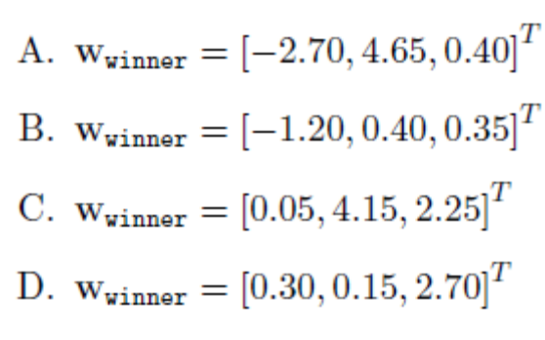
Answer: B

Q12. Which of the following statements is NOT true for a self-organizing feature map (SOM)?
A. The size of the neighbourhood is decreased during training.
B. The SOM training algorithm is based on soft competitive learning.
C. The cluster units are arranged in a regular geometric pattern such as a square or ring.
D. The learning rate is a function of the distance of the adapted units from the winning unit.
E. The network can grow during training by adding new cluster units when required.

Answer: E

Q13.. The following statements is true or false for a self-organizing feature map (SOM)?
After training a Self-Organizing Map, output neurons that win for similar inputs are usually far apart from each other in the map.
A: True
B: False

Answer: B

Q14. Which of the following statements is NOT true for Kohonen’s self-organizing feature map (SOM)?
A. The units are arranged in a regular geometric pattern such as a square or hexagonal shape.
B. The size of the neighbourhood is increased during training.
C. The weights of the winning unit k are adapted by 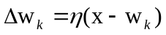, where x is the input vector.
D. The weights of the neighbours j of the winning unit are adapted by 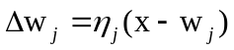, where ´j < ´ and j 6= k.
E. The learning rate is a function of the distance of the adapted units from the winning unit.

Answer: B

Q15. An input vector x and two prototype vectors p1 and p2 are given by
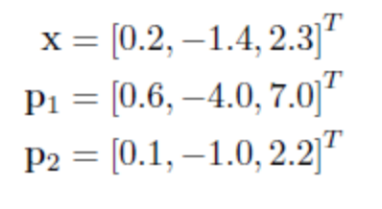
Which prototype is nearest to x in terms of Euclidean distance? Adapt the weight vector of the winning prototype in question 48 according to the SOM learning algorithm with a learning rate of 0:5. What is the new weight vector?
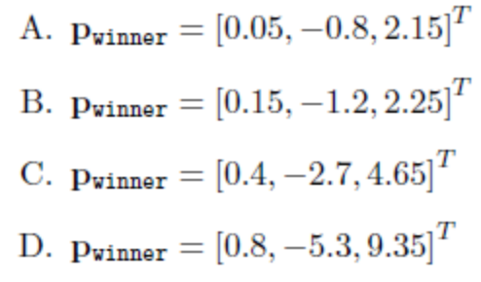
Answer: B

Q16. What is the topological mapping in a self-organizing feature map (SOM)?
A. A map which organizes the robots and tells them where to go.
B. A mapping where similar inputs produce similar outputs, which preserves the probability distribution of the training data.
C. An approximation of a continuous function, which maps the input vectors onto their posterior probabilities.
D. A mapping where similar inputs produce different outputs, which preserves the possibility distribution of the training data.
Answer: B

Q17. What problem could occur in SOM learning if you use a very small neighborhood? Why?

Answer:
It is possible that neurons in separate areas of the output layer become selective
for the same type of input. Because there are no global interactions between neurons in the output layer, separate “islands” of similar selectivity can develop without ever
“meeting” each other and merging.

Q18. SOMs can reduce the dimensionality of a given data space. Explain what that means. Please give an example of how this capability can be used for practical applications.

Answer:
The map layer of an SOM is typically one- or two-dimensional, whereas the
input space for the SOM usually has many more dimensions. Nevertheless, the SOM tries as much as possible to establish a topology conserving mapping such that inputs from neighboring regions in the input space will make neighboring neurons (or even the same neuron) in the map layer win the competition. In this way, the high-dimensional input space is mapped onto a lower dimensional output space. One example is the visual representation of large data sets, for example, image or document databases. Using an SOM, such high-dimensional spaces can be mapped, for example, onto a two-dimensional space in which similar images or documents are usually close to each other. The user can browse through this space to find a desired item much more easily than through the original, high-dimensional space.

Q19. Why are SOMs interesting for researchers who study biological nervous systems?

Answer: The topology-conserving property of the SOM between its input and output spaces is in fact a very common feature of biological neural networks. For instance, neighboring areas in our sensory cortex respond when our ring finger or our middle finger on our right hand is being touched. However, the area responding to touch in our left foot is far away from the first two areas. The development of this mapping and its adaptation to changes (my favorite example: losing one of your fingers) is assumed to be accomplished by competitive mechanisms as in the SOM. SOMs have been used to predict the development of neural connections in our brain with good accuracy.

Q20. In the small country Neuronia there is a concern that the politicians often start a fight when they disagree. In the parliament one therefore intends to place members with similar opinion close to each other. Since there are a multitude of parties and subgroups within parties, one has to base the placement of members upon outcome of voting in a large number of questions. Persons who vote similarly should sit close to each other (you can assume chairs are placed on a rectangular grid). Since the chairman of the parliament is a friend of yours, you have been given the honorary assignment to place the members. Describe how you solve the task using an algorithm used in CSE301. What algorithm is best suited? What do you use as training data? What representation do you use for input and output. What is the network structure (number of nodes, layers, number of weights etc)? How are weights updated during training?

Answer:
I use a SOM. Politicians who vote similar should be placed as neighbours. Training data / input is the answer (vote yes or no) on all the N questions. Each politician thus is described by a binary vector of length N. Output is the position / placement in the room (coordinates X and Y on a 2-D grid on the floor). The SOM should do a N to 2 dimension reduction. In each iteration, find the closest unit. Move the unit and its neighbours towards the input.

Q21. We often say that the SOM-algorithm is capable of creating a topology preserving map. What does this mean? Explain how one can use the trained network (after training is over) to map points in a 10-dimensional space onto a wo-dimensional
plane.

Answer:
Topology preserving maps means that neighbouring points in the input space tends to lie close in the output space. A 10-dimensional inputs space is mapped to a 2D-plane by 10 nodes coupled to nodes arranged in a 2D-grid (2D neighbourhood grid). The outnode stronges activated is the winner and this and its neighbours are moved closer to the input pattern.

Following questions are about LVQ

Q1. Describe the relationship between the Self-Organising Map algorithm, and the Learning Vector Quantisation algorithm.

Answer:
In order to use Learning Vector Quantisation (LVQ), a set of approximate
reconstruction vectors is first found using the unsupervised SOM algorithm. The supervised LVQ algorithm is then used to fine-tune the vectors found using SOM.

Q2. Briefly explain the term code book in the context of learning vector quantization

Answer:
When compressing data by representing vectors by the labels of a relatively small set of reconstruction vectors, the set of reconstruction vectors is called the code book.

