**Tutorial: How to set up HenshinTGG**

Overview:

1. Setting up Eclipse
2. GIT
3. Starting HenshinTGG
4. Import an instance in HenshinTGG

**1. Setting up Eclipse**

* Install: “Eclipse Modeling Tools”
* Set API Baseline:

Window->Preferences->Plug-in Development->API Baseline  
Add Baseline…  
Name: Eclipse  
Reset  
Finish  
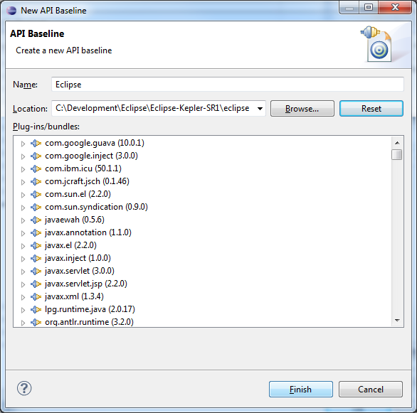

* Install ZEST (layouter plugins):  
  Help->Install new software  
  Work with: … Add..   
  Update Site: ZEST - http://download.eclipse.org/tools/gef/updates/releases/  
  Select ZEST  
  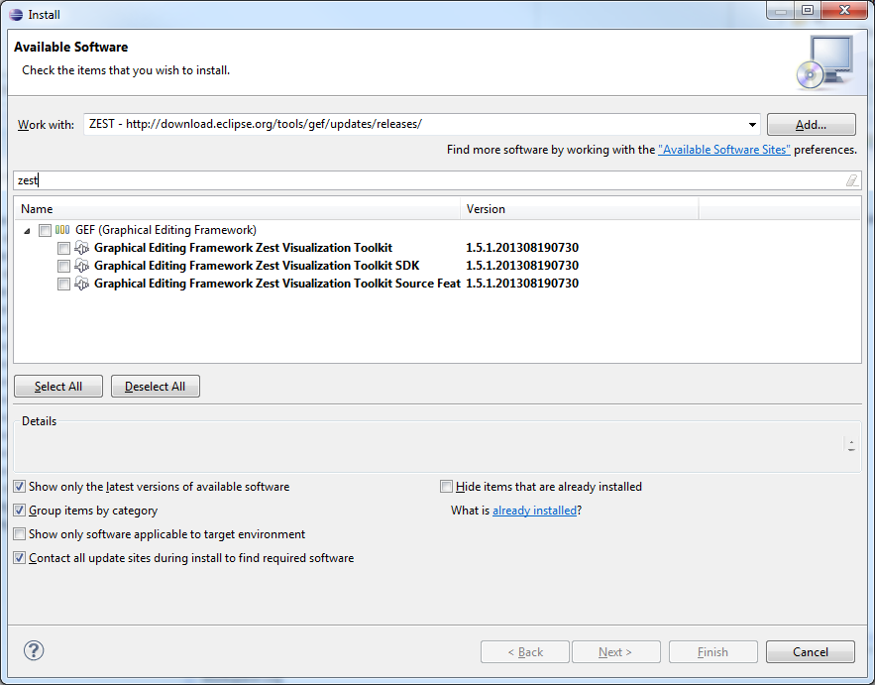

**2. GIT**

* Clone the GIT repository

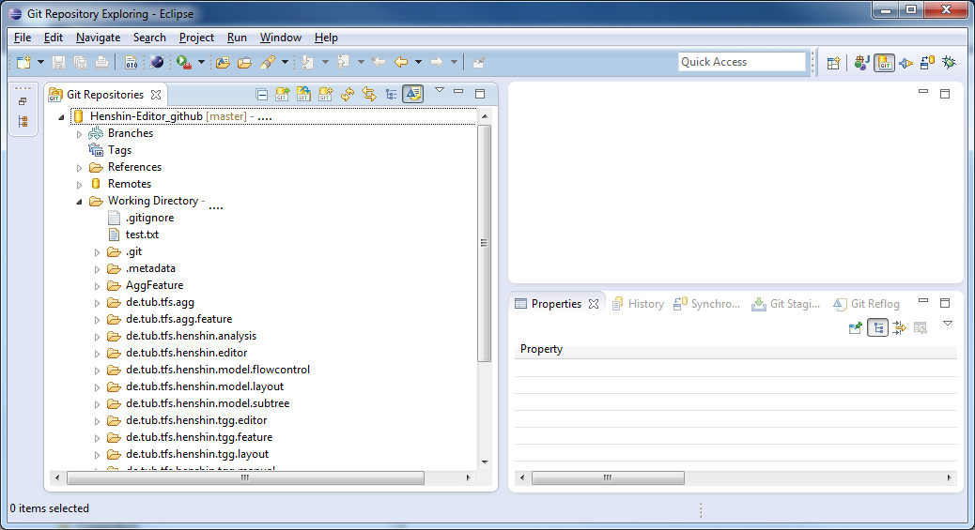

* Check out all projects

**3. Starting HenshinTGG**

* Set up run configuration  
  Run->Run Configurations…  
  Double Click on “Eclipse Application”  
  Arguments  
  add VM argument “-XX:MaxPermSize=256m”  
  Apply  
  Run  
  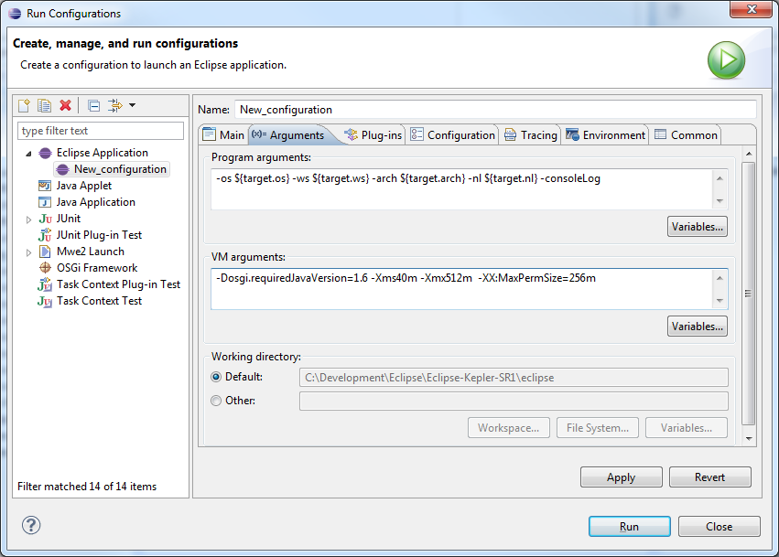

From now on, you just need to click on   
Run->Run As->Eclipse Application   
to start the runtime workbench with HenshinTGG

**4. Import instance in HenshinTGG**

- As an example, import the plugins under “de.tub.tfs.henshin.tgg.editor/Examples/Repeat2While” from your GIT repository.

- In your runtime-workbench, you can now import an example TGG project   
 “de.tub.tfs.henshin.tgg.editor/Examples/Repeat2While /lu.uni.snt.Xtext-Examples”   
 (main file is the “.henshin” file)

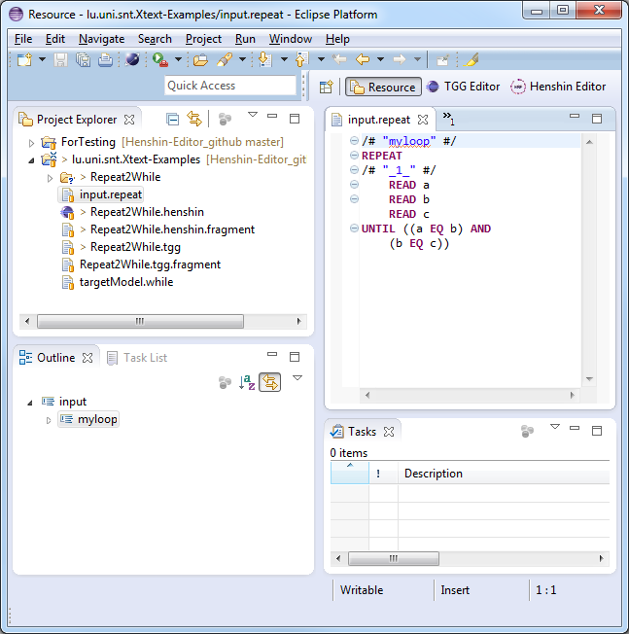

Create a new Henshin file: New->Other->Other->TGG File Creation Wizzard

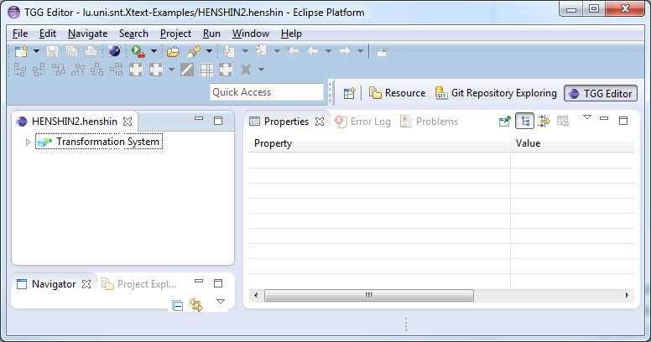

Import the meta model of your Xtext-DSL:  
Click on “Imports”  
->Import Source->  
*repeat->OK

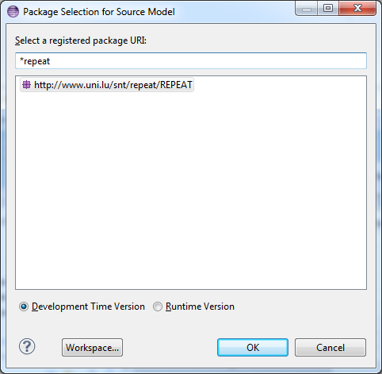

Import your Xtext-DSL file as graph in Henshin:  
Click on “Graphs”

->Import an instance model.->Browse Workspace->select your file  
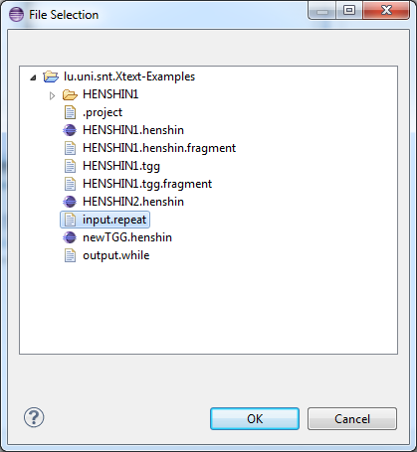

Double click on the new graph

Click on “Automatic TGG Tree Layout”

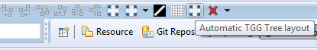

You obtain a layouted AST of your Xtext-DSL-file

