Functional Requirement Elaboration

Automated URL Program
- Input => zip or dropbox
- Extract theses files on the netfirms server
- Display uploaded images as a list (style number, file image, url and size)
- Input filter to research an image
- Image thumbnail in each entry of the list
- Export data into a spreadsheet with all selected entries

Functional Requirements
Below details the step by step process of how the program needs to function from an end to end perspective.

1.1 Step by Step Process
NOTE: This URL Program needs to point to the customers Netfirms sub-domain environment, where the details have been listed in this document.
Below illustrates the requirements of how the program needs to look and function:
- All products and images are received from the customer’s supplier in the two following formats:
  - In a zip file
  - Or in a dropbox
- These images are to be stored in a directory on the clients netfirms server
  - NOTE: To be discussed further with client
- All images are downloaded or unzipped in a random directory on the client’s netfirms server as singular files.
- The program needs to build to accommodate the upload of files to the netfirms sub-domain (connection details in Section 2), identical to the shopify example below:
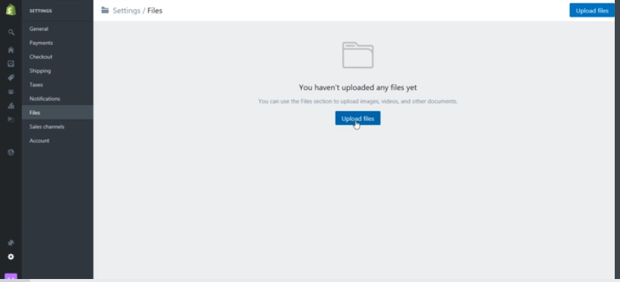

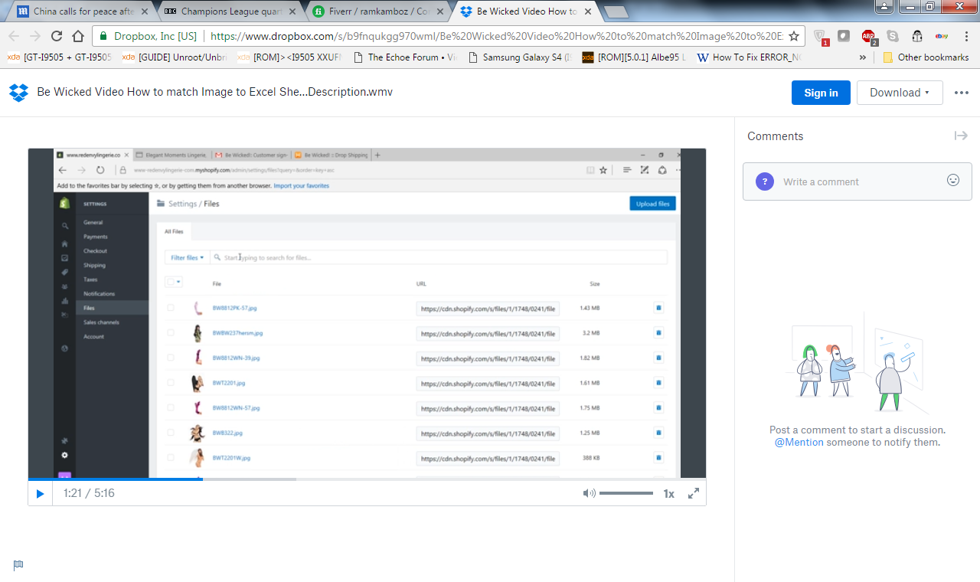

- The above URL examples link to the Shopify website. The Shopify abbreviation in the link must change to illustrate the clients sub-domain Netfirms server, an example below:
  - http://netfirms/BK1234
  - Full URL information to be confirmed by the client

- The GUI must look identical to the Shopify example above and show the following information:
  - Style Number (This can be found in the Feather Robes example sheet)
  - File Image (File Upload)
  - URL (URL of each image)
  - Size of File (Size of File uploaded)
NOTE: There should be no file size restrictions placed in the program.

- Functionally, the program must also do the following for the course of the image uploads:
  - Have the ability to filter through each image by typing in the ‘File Image’ name, where the image filtered must appear on the GUI screen (not the file type extension).
  - The image should also be displayed as an Icon next to the ‘File Image’ name and expand on screen when clicked on.
  - The program should have either one of the following:
    - The ability to click a button which will take all of the images displayed and input them within a certain column in the product spreadsheet OR
    - Click on each URL and this should then place the URL within a certain column in the product spreadsheet. (Hyperlink)
NOTE: For Option ‘C’, the product spreadsheet must be open on the desktop.

- Below is a basic example of how the GUI should look, in relation to the Shopify website layout:
Image File Name should display here
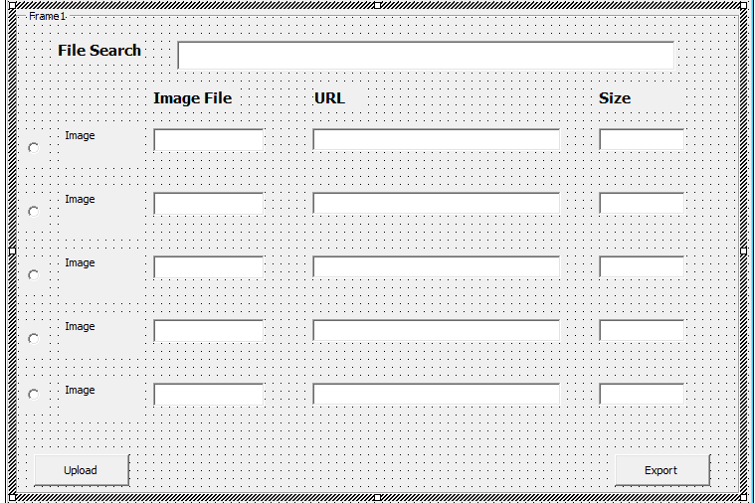
User should be able to filter image file here

Image should be visible here once uplopaded

This should bring up the file directory pop up to drag all images from directory into the program
This should export all selected URL’s into the cells of the spreadsheet

- The program should upload the images from the directory it is stored. Ideally the program should be able to upload all images from the specific directory at one time.

- Once the images are uploaded into the programme, the URL’s that are created must point to the subdomain Netfirms (Section 2 for more details) and be illustrated in the URL:

  - Style number Image File URL Address Example
BK 1234 BK1234.jpg http://netfirms/BK1234
  - Full URL information to be confirmed by the client

- The program should extract the URL’s and must conform to the correct style number in the product spreadsheet and the listed style number in the program. The image filename will include the style number as the file name. (Please see above diagram for details)
NOTE: See the ‘Displaying URL’ section for more details.
- The URL’s produced must be listed (or imported) back into the products spreadsheet via one of the following methods:
  - Be dragged and dropped into the appropriate excel cells
  - Take each URL from the program and paste it into the appropriate excel cell (i.e. D4)
- For the purpose of the Feather Roabs spreadsheet, all image URL’s should be listed under Column H for front image and Column I for back of image.
(Please see Section 1.2 for more details)
NOTE: Please see Appendix for import and export URL’s in the Product spreadsheet.
- All URL’s inputted within the system should be conditionally formatted to check that each URL matches the Style Number and Product Description in the product spreadsheet.

  - I believe there is a method to do this in the Excel sheet.

1.2 Listing Multiple Images per item
Each product may come with more than one image, per product. The image files that could be given are:
- Front of the product image
- Back of the product image
The filenames of these products may be named as the following:
- BW834MG.jpg (Front of the Image)
- BW834MG_B.jpg (Back of the Image)
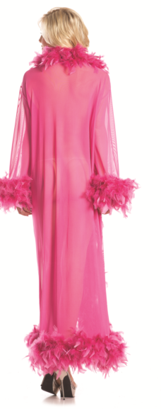
Where an image file name includes ‘_B’, this is represented as ‘Back of the Image’, example images below:
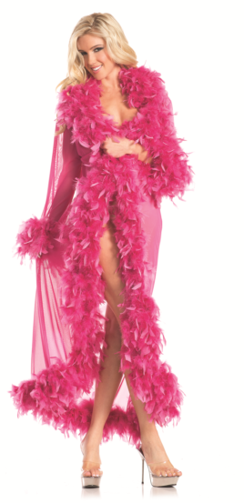

(BW834MG.jpg) – Front of the Image (BW834MG_B.jpg) – Back of the Image
The program must be able to accept multiple image file types such as:
- JPG
- PNG
- JPEG

1.3 Displaying URL’s
A URL must be produced for each and every image uploaded individually within the program, as per the requirements.
Some image items may have a front image and back image. A URL should be created for both sets of images.
Each product sheet may have two Image columns. This is because some images may come with a front and back image. To do this, the program should have a condition to check the following:
- The program must take the Style Number from the product image spreadsheet; match it with the image file name in order for the correct URL to be displayed next to the image file name.
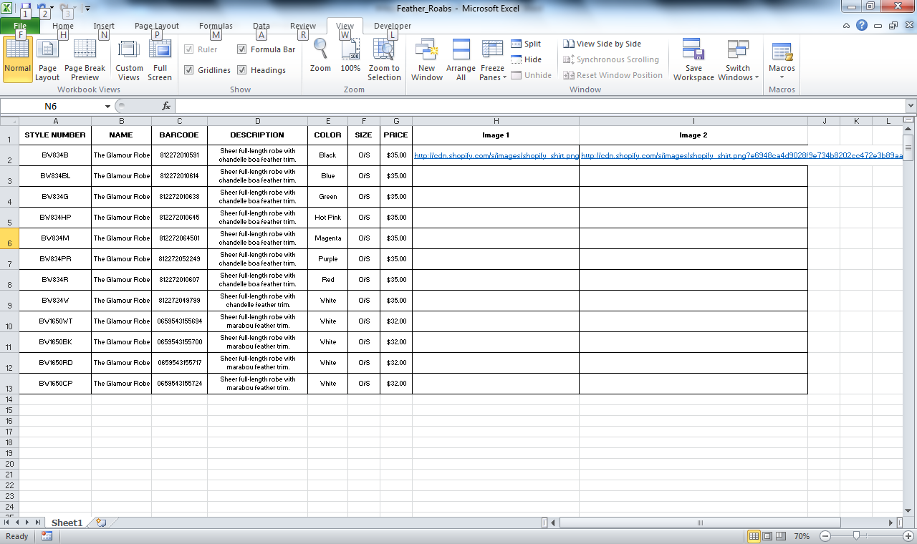
- IF each image file name displays a ‘_B’, the product has two images and must be listed in the spreadsheet as per the following example:

- The front of the image must be displayed under the ‘Image 1’ column.
- The back of the image must be displayed under the ‘Image 2’ column – IF ‘_B’ is displayed in the same style number in the 2nd image.
- If each image file name in the zip file is unique (no ‘Back of the image’), then all URL’s must be displayed under the ‘Image 1’ column.

1.4 Exporting URL’s in Spreadsheet
- Can the spreadsheet where the URL’s need to go in, be embedded into the Java Program where the End User can drag and drop each URL from the program into its appropriate Excel cell?
- Can the End User OR the program select each URL from the program and automatically input it into the required excel cell?
- Can the End User select a command button which exports all the selected image files? For example the Download button in example GUI above

2. Sub Domain Environment Details

User Name: productsheet
Password : Master2202$
UserName FTP (Home) Directory
productsheet /gozeecommerceproductsheet

3. Appendix
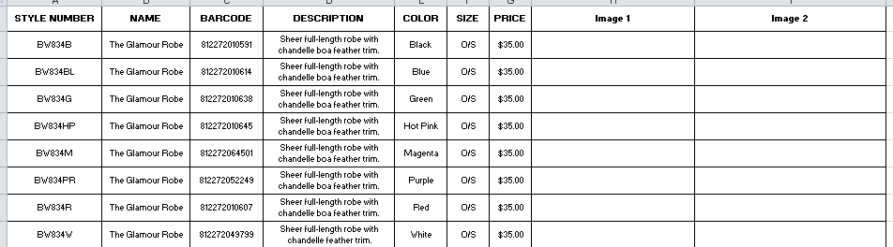
A spreadsheet will be presented to the client by his supplier as per the below example:

Once the program has generated the URL’s, the product spreadsheet will be listed below:
- If multiple images are provided with the same Style Number, with a front and back image, the URL should be listed under ‘Image 1’ and ‘Image 2’ columns, as per the below:

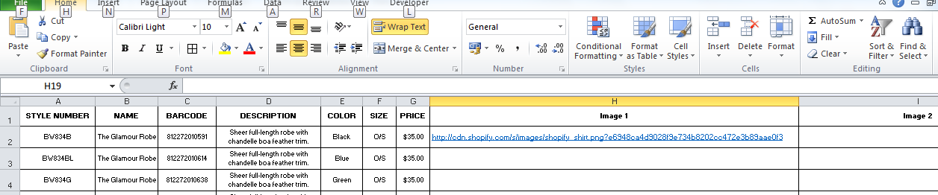
- If a single image is provided with the same style number, with a front image only, the URL should be listed under ‘Image’ 1 column only. As per the below:

