Socket.io is a library for web socket.

What is Web Socket?

* It is a communication Protocol like HTTP/FTP/SMTP

|  |  |
| --- | --- |
| HTTP | Web Socket |
| Client Request From Server. | A connection Established between client and server. |
| One Way Communication. | Two Way communication. |
| Request  Response |  |
|  | Has event created and other side listen to that event as soon as the changes occur it will notify at this event which it is listening. |

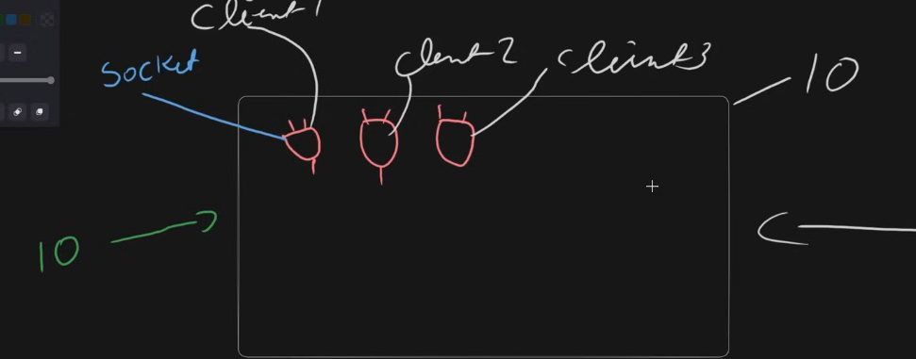

* Library used for this Purpose is “Socket.IO”. ( <https://socket.io/> )
* “IO” this word refers to whole circuit (also called server).
* “Socket” this word refers to the specific connection.
* “Broadcast” this word is used to trigger the function to all the socket except the one who triggers it.
* “To”(To Trigger event for particular Sokcet Room) there is a concept of room in socket . every socket is in its room. Also every socket has its ID. This can be also used for private chats
  + Socket.to(<Room-ID>).emit
* “JOIN”(To JOIN people in room) when we want to send private Messages to the multiple sockets but not all (Like whatsapp groups) then the concept of JOIN came into place . Each socket has its room separately . But for JOIN we create a combine room of all of those which we want to share message.
  + Socket.join(<ROOM_NAME>)
* “emit” this is used to send message or trigger event.
* “ON” this is used to receive data at the particular event.
* So by above details (IO.emit means sending message to the whole circuit ) on the other side (socket.emit means sending message to the specific socket only).