311 Complaints in the Beach BIA (2022–2025)
Introduction
- Research Objectives
- To identify the most common types of complaints in the Beach BIA area. These complaints reflect how residents interact with city services, and what issues they experience most frequently - such as waste collection, road operations, or enforcement.
- To analyzes how 311 complaint volumes in the Beach BIA change over time, including year-to-year trends, monthly patterns, and recurring seasonality. It also compares time-trend differences across the five major service categories to highlight periods of heightened service pressure and shifts in resident behavior.
- Through analyzing over 1,000,000 service requests, this study helps us better understand public service needs and local infrastructure challenges in the Beach BIA area.

- Data Description
This study uses the 311 Service Requests - City of Toronto’s Open Data Portal from 2022 to 2025, with roughly 450,000 records each year. After filtering the data for the Beach BIA area (postal codes M4E, M4L, M4M), the study obtained around 20,000 valid records for analysis.

There are several key variables that are most relevant to this analysis:
- Created Date records when each complaint was submitted.
- Postal Code helps us to group complaints by section within the Beach BIA area. The location is recorded as the first three characters of the postal code of the service request.
- Service Request Type represents the complaint category.
- Status indicates whether the request is open or closed, which helps to see how many issues have been resolved.
- Division shows which city department is responsible for handling the request.
Together, these variables allow both categorical and temporal analysis. The report focuses on counts, seasonal behaviors, and year-to-year variation within the Beach BIA.

Exploratory Data Analyses
- Overall Complaint Volume (2022–2025)
1.1 Investigating the number of complaints from 2022 to 2025
Across the Beach BIA area, there are 24 sections in total, and the distribution is quite uneven: Collections contains over 28,000 complaints, which is a lot more than the next largest section - Toronto Animal Services. Other sections, such as District Operations, Road Operations, and Investigation Services, also show a noticeable number of complaints. In contrast, smaller sections like Traffic Safety have very few cases. This pattern suggests that waste collection and related services are the main sources of public concern.
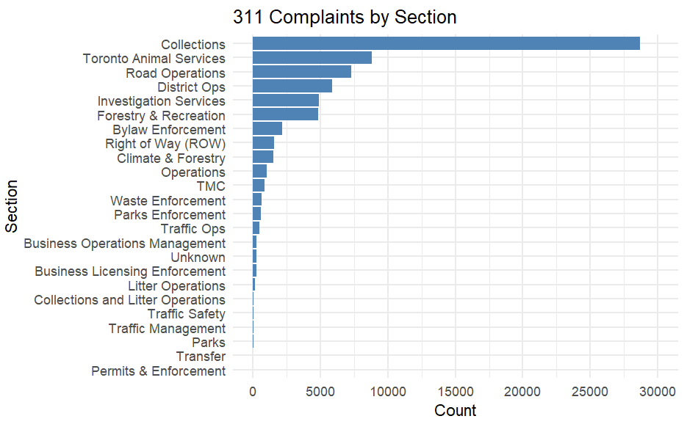
The distribution is highly skewed, with Collections accounting for the majority of complaints and all other sections are at considerably lower levels.

1.2 Complaints across different categories from 2022 to 2025
There are 5 major categories. Based on pie chart below, Waste and Environmental complaints make up almost half of all records, around 42 percent. These mainly include issues like garbage pickup and recycling. The second largest group is Traffic and Road Operations, accounting for about 19 percent of total complaints, followed by Animal and Parks Enforcement, Municipal Operations, and Enforcement and Investigation.
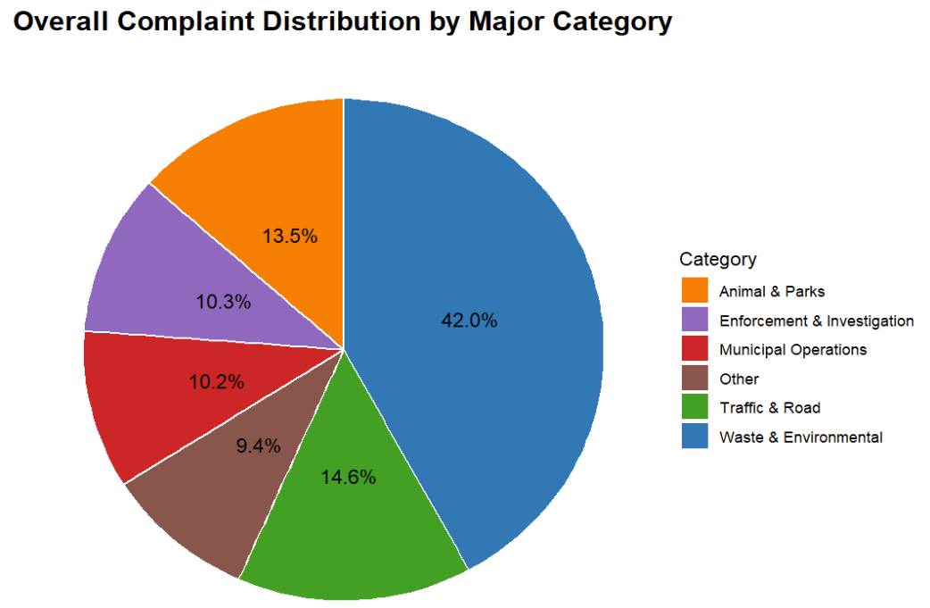
The complaint distribution is heavily concentrated in the Waste & Environmental category, while all other categories exhibit substantially lower proportions.

1.2.1 Traffic & Road Operations: 10227 Complains total (14.6%)
It contains Road Operations (7300), Right of Way (1569), TMC (863), Traffic Ops (473), Traffic Safety (11), Traffic Management (9), and Transfer (2).
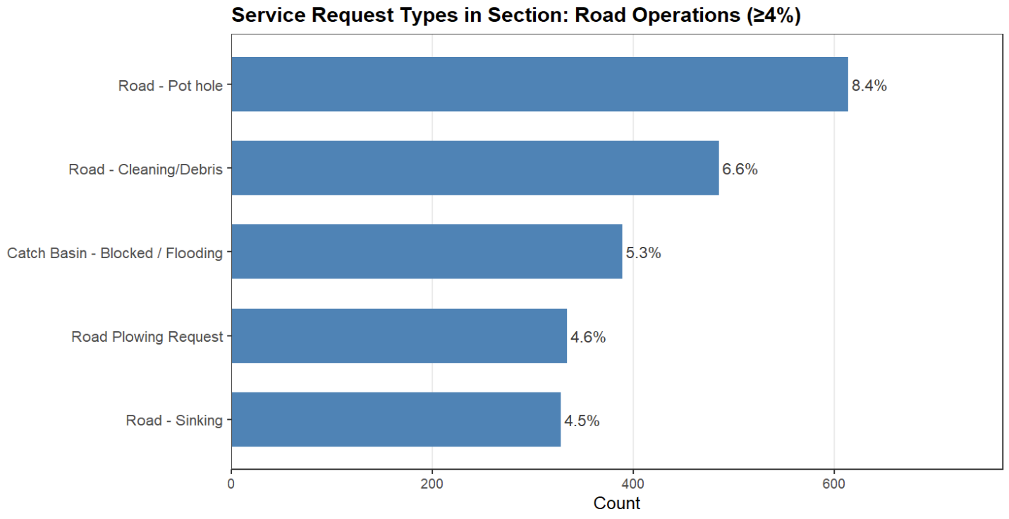
Potholes dominate Road Operations complaints, followed by road debris and blocked catch basins.

Although it’s not the dominant category, the volume and recurrence of these issues indicate aging infrastructure and weather-related vulnerability.

    - Municipal Operations: 7133 Complaints Total (10.2%)
It contains District Ops (5892), Operations (1000), Business Operations Management (241).
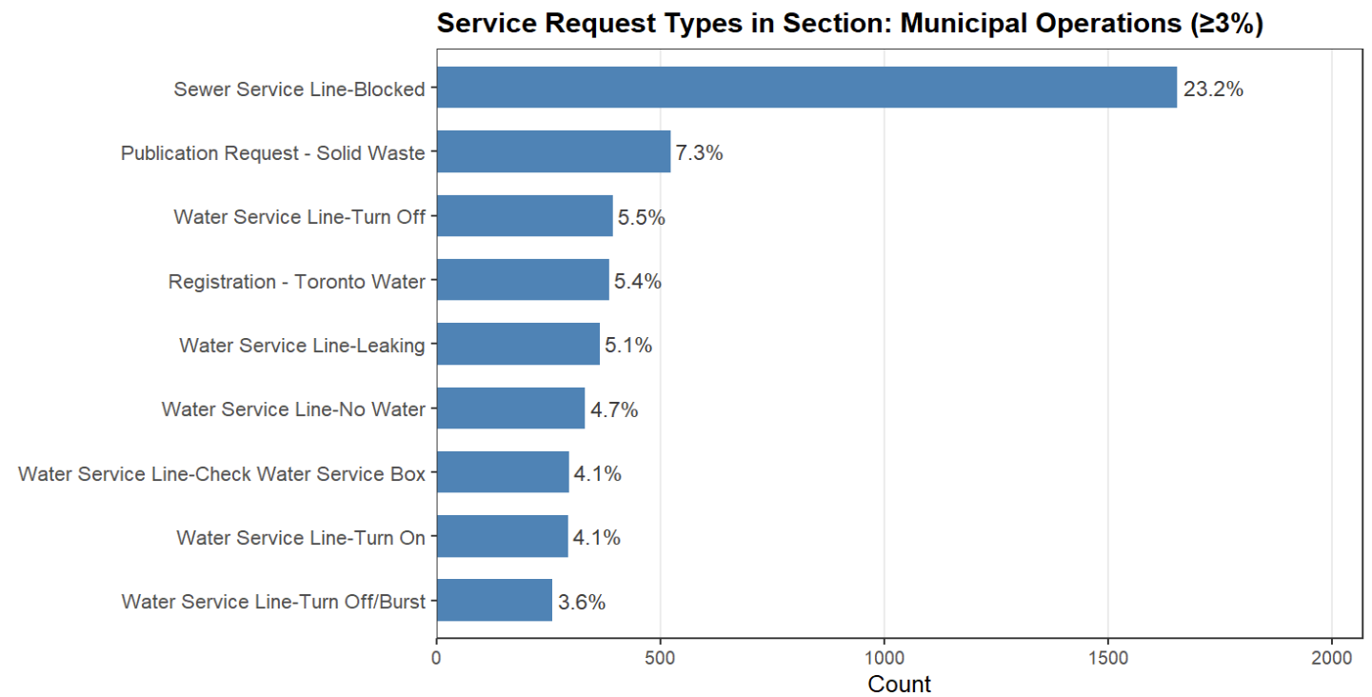
Sewer service line blockages dominate this section, which is far exceeding every other request type. The next largest categories, including solid waste publication requests and water service turn-off/on and leakage issues, account for substantially smaller shares. Overall, the section is heavily driven by sewer-related problems and a wide range of water service concerns.

These complaints highlight the community’s expectations for consistent cleanliness and functioning public spaces.

    - Enforcement & Investigation: 7251 Complaints total (10.3%)
It contains Investigation Services (4875), Bylaw Enforcement (2145), and Business Licensing Enforcement (229).
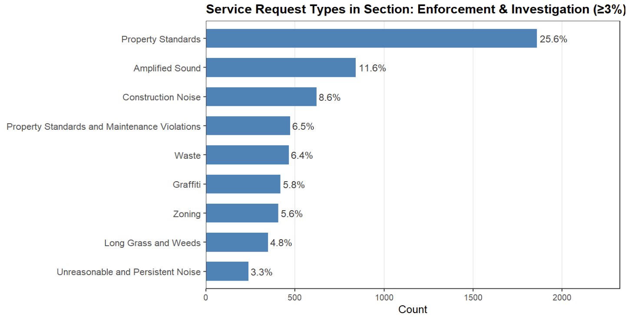
The distribution is highly skewed toward Property Standards violations, with secondary concentrations in noise-related complaints and a broad set of lower-frequency enforcement issues.

The high level of Investigation Services complaints also suggests increasing community attention to property maintenance and bylaw compliance.

    - Waste & Environmental Enforcement: 29452 Complaints total (42.0%).
It contains Collections (28681), Waste Enforcement (629), Litter Operations (126), and Collections and Litter Operations (16).
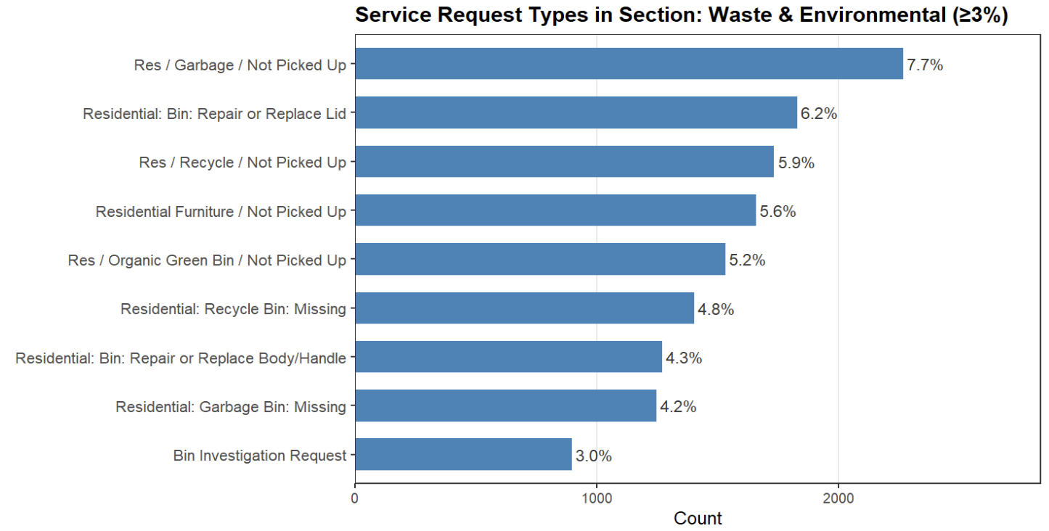
The Waste & Environmental category is characterized by a strong concentration of missed-collection events and bin maintenance issues, with all top request types reflecting household waste service reliability.

This category represents almost half of all reported issues. And within this category, most complaints come from the Collections section, followed by Waste Enforcement and Litter Operations. And since Collections makes up most of this category, it’s important to take a closer look at that section to understand what specific problems residents report. Within each section, there are many detailed service types, we called it sub-sections here. For example, within Collection, sub-sections include “Not Picked Up”, “Repair or Replace Lid”. These details help pinpoint the exact cause of frequent complaints.
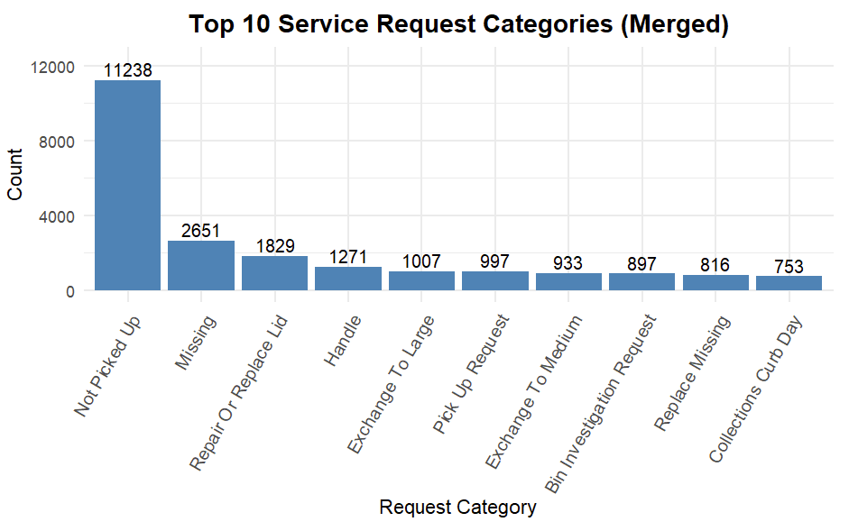
The distribution is heavily skewed toward missed collection events, with the remaining merged categories—primarily bin maintenance issues—appearing at significantly lower frequencies.

Here we can see the top 10 complaint categories in the Collections section. The dominant issue is “Not Picked Up”, which is nearly four times higher than the second most common type, “Missing”. After that, we see other recurring issues like bin repair or replacement and handle damage.

Most of these problems are directly related to garbage or recycling operations, which suggests that the main challenges lie in routine service delivery. This gives us a clear focus area that improving collection efficiency could significantly reduce the majority of complaints. This also indicates that recycling pickup is the single biggest problem in this area. Other recurring issues include missing bins and handle or lid damage, and these are related to bin management issues.

    - Animal & Parks Enforcement: 9425 Complaints total (13.5%)
It contains Toronto Animal Services (8812), Parks Enforcement (604), and Parks (9).
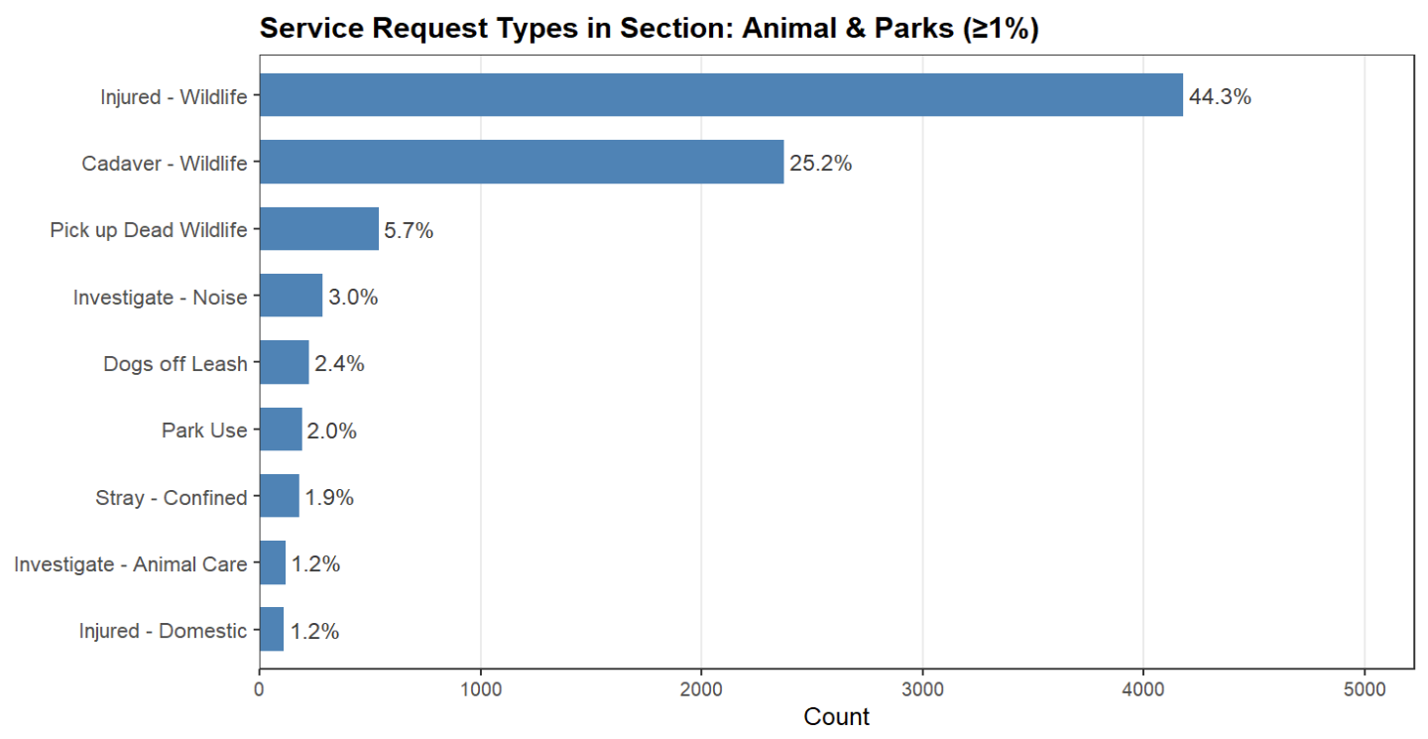
The distribution reflects a strong concentration in wildlife-related service calls, indicating that wildlife management constitutes the core responsibility within the Animal & Parks section.

The high frequency of complaints directed to Toronto Animal Services indicates that animal-related interactions—pets, wildlife, and shared public spaces—form a significant component of community life and municipal service demand in the Beach BIA.

- Time Trend Analysis of Complaint Volumes (2022–2025)
  - Overall Time Trends
2.1.1 Daily and Monthly Complaint Trend in 2024
Figure 2.1 plots the daily complaint counts for 2024 together with a 7-day moving average.
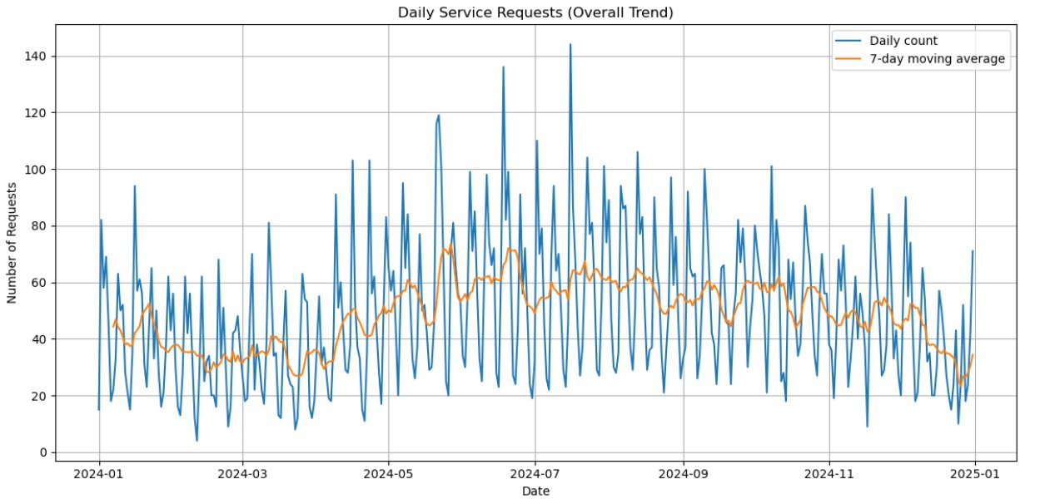figure2.1
The raw series is highly volatile, with frequent day-to-day swings, but the smoothed line reveals a clearer story:
- Q1 2024 shows moderate daily volumes with a slight upward drift, consistent with a typical winter–spring ramp-up.
- From late spring to mid-summer, the 7-day average rises to its highest level, indicating a concentrated increase in service demand.
- From September onwards, the moving average gradually declines, and daily counts become lower and more stable as the city moves into late fall and early winter.
On the monthly aggregation (Figure 2.2), the pattern is even clearer:
Monthly complaints peak between May and July and decline steadily towards December, reinforcing the view that 2024 follows a strong seasonal cycle with a summer high and winter low. So we developed a model to decompose the seasonal effect and overall trend.
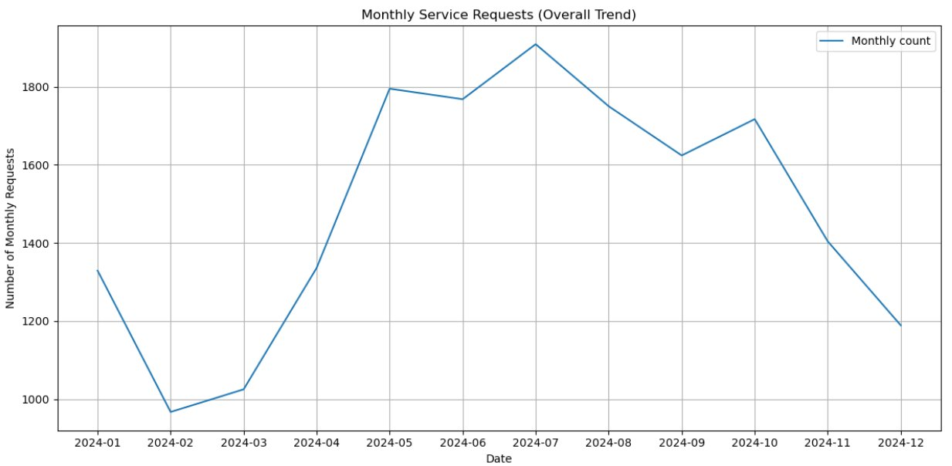
figure 2.2

- Yearly and Monthly Complaint Trend, 2022–2025
Figure 2.3 summarises yearly and monthly complaint volumes from 2022 to 2025.
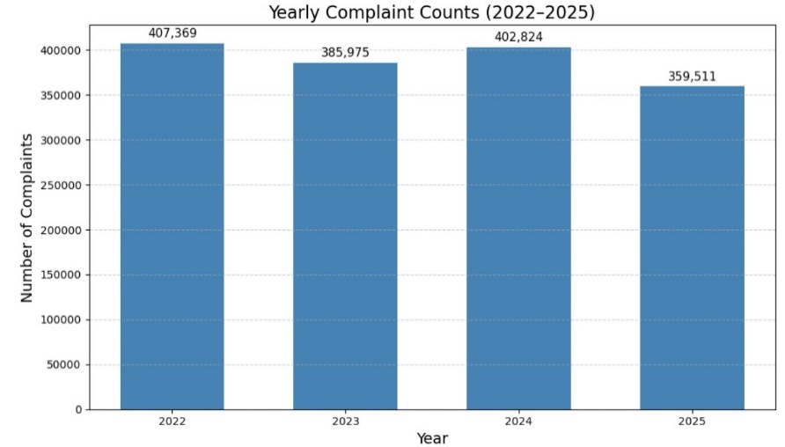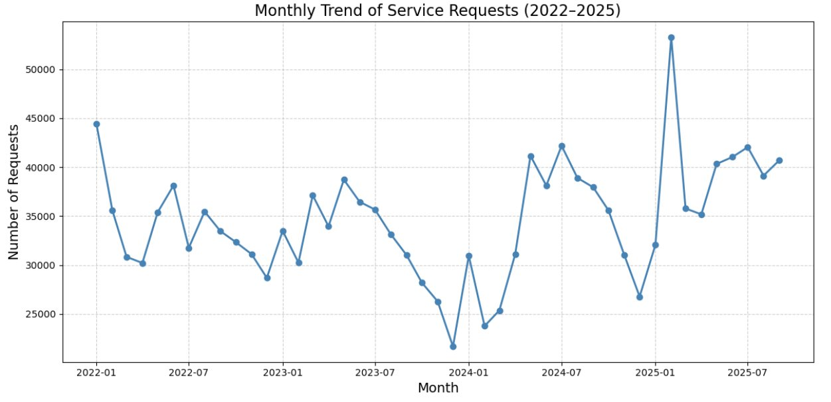
figure 2.3
Several medium-term patterns emerge:
- Overall level: Across all four years, complaint volumes remain high, with no evidence of structural decline. The relatively low figure for 2025 is because the data only covers up to October.
- Within-year shape: Each year retains a similar “U-shaped” pattern: lower complaint volumes in winter months, rising into spring, and peaking around summer before easing in late autumn.
From a business perspective, this indicates that demand for municipal services is both structurally high and seasonally sensitive. So resource planning, particularly staffing and contractor capacity, needs to account for higher loads in Q2–Q3 and lower loads in Q4–Q1.

- Overall Trend and Seasonality (Additive Decomposition)
To separate long-term trends from recurring seasonal effects, an additive time-series decomposition was applied to the monthly complaints series.

The model assumes:
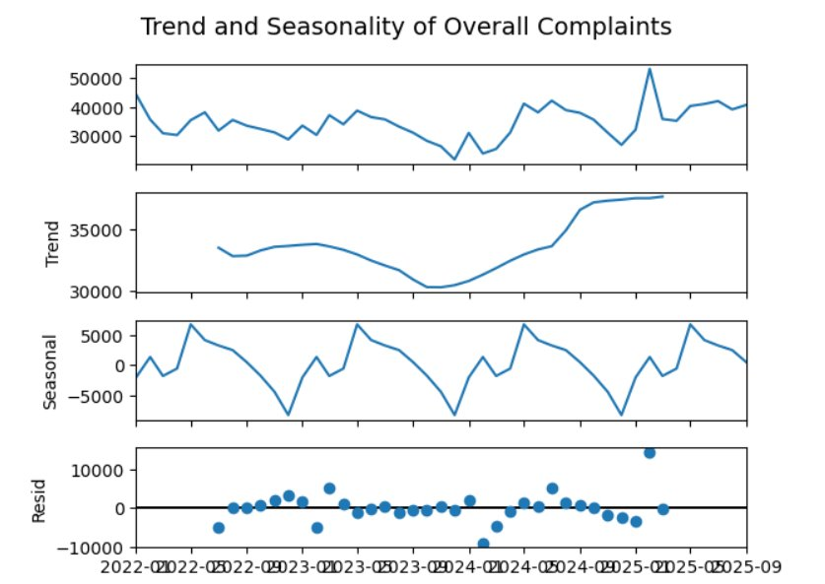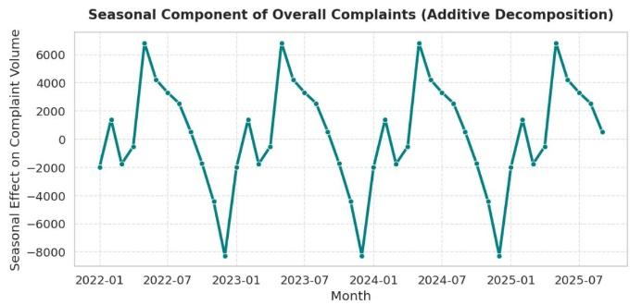
The results show:
- Trend component: The trend is relatively flat in 2022–early 2023, followed by a gradual upward shift after mid-2023, pointing to a post-pandemic rebound in service usage and reporting.
- Seasonal component: There is a robust annual seasonal pattern: complaints peak in spring and early summer (April–June) and drop sharply in late fall and winter (November–December).
- Residuals: The residual component is centred around zero with no strong remaining structure, suggesting that the additive model captures the main dynamics well
The strong and stable seasonality implies that, beyond random shocks, a large proportion of fluctuations in complaint volume is predictable based on the time of year.

Time Trends by Major Complaint Categories
To understand which services drive the overall pattern, we repeat the trend and seasonality analysis for the five major categories defined previously..
- Traffic & Road Operations
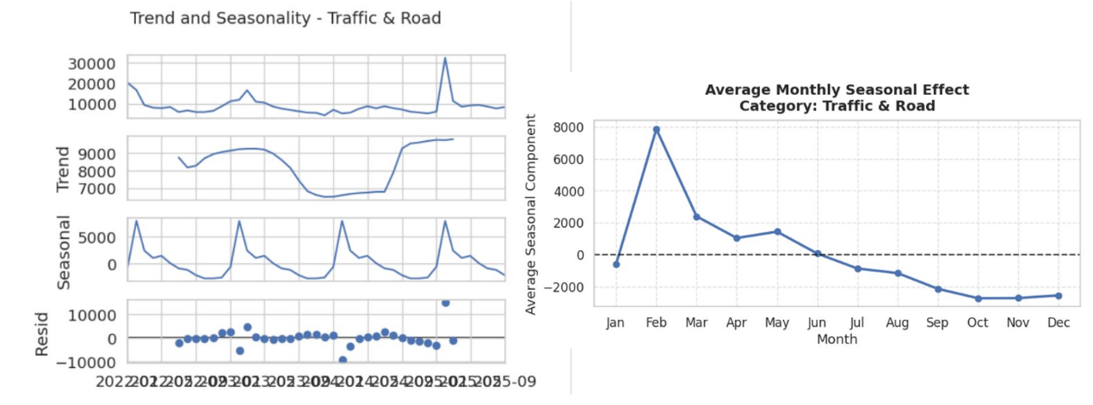
For Traffic & Road Operations, monthly complaints stay within roughly 7,000–9,000 cases, indicating a structurally high but stable baseline.
Periodic surges are observed and are likely associated with extreme weather events, construction seasons, or major traffic disruptions. Seasonal decomposition shows:
- Highest seasonal deviations in February (around +8,000 above average), reflecting winter-related road issues such as snow, ice, and potholes.
- Complaints gradually decrease through spring and summer, reaching the lowest point in October–December (below −2,000).

- Municipal Operations
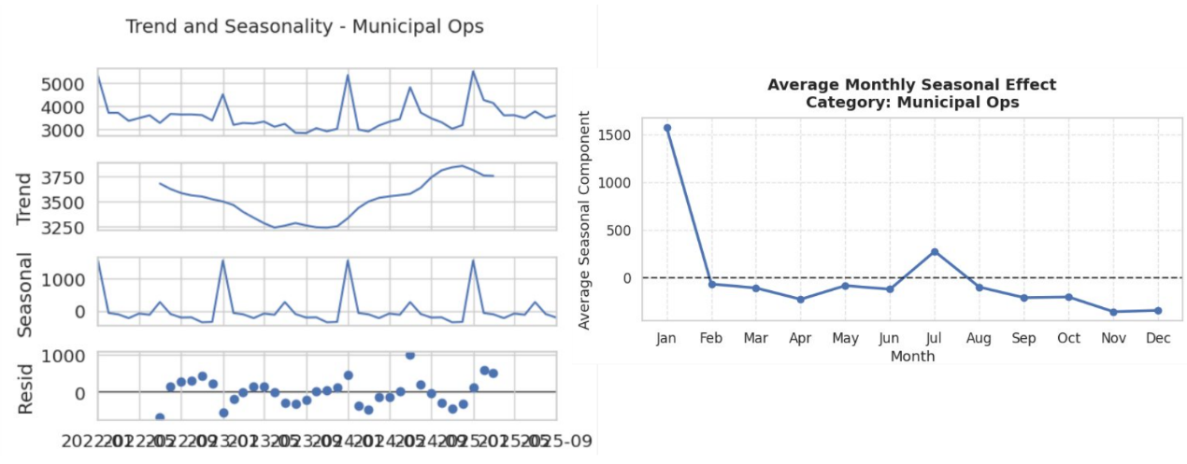
Municipal Operations shows a steady growth in total service requests, with trend gradually increasing over the period.
Seasonality is milder but still present:
- January consistently records the highest seasonal deviation (about +1,500 above baseline), likely due to billing cycles, water service issues and winter-related operations.
- March–April and November–December are below average, suggesting quieter periods between major operational cycles.
- A small secondary peak in July indicates summer-related municipal works.
- Enforcement & Investigation
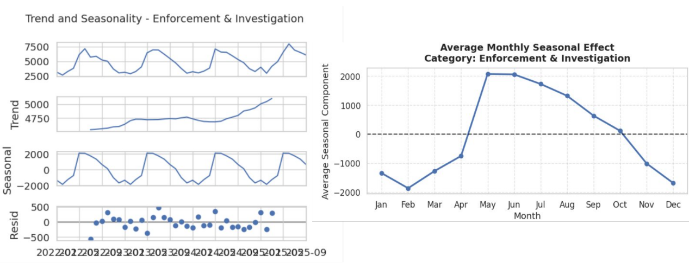
For Enforcement & Investigation, the trend shows a gradual increase in overall reporting activity, consistent with strengthened enforcement and higher citizen expectations.
Seasonality is strong:
- Complaints are about +2,000 above average in May–June, aligning with more outdoor activities, inspections, and community events.
- In winter months, complaints fall −1,500 to −2,000 below average, reflecting reduced field enforcement and fewer observable infractions.
- Waste & Environmental Enforcement
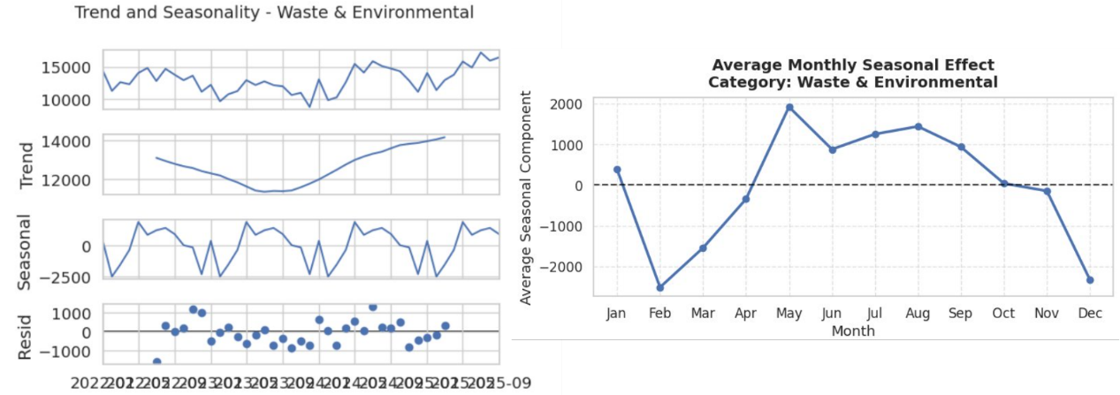
Waste & Environmental Enforcement exhibits one of the clearest upward trends: the overall level has been rising since 2023, indicating steady growth in environmental concerns and reporting.
- Seasonally, complaints peak around May–July (+2,000 above baseline), when higher temperatures and outdoor activities amplify waste, odour, and cleanliness issues.
- Complaints drop sharply in February and December (−2,000 below average), consistent with reduced waste generation and outdoor exposure in winter.
- Animal & Parks Enforcement
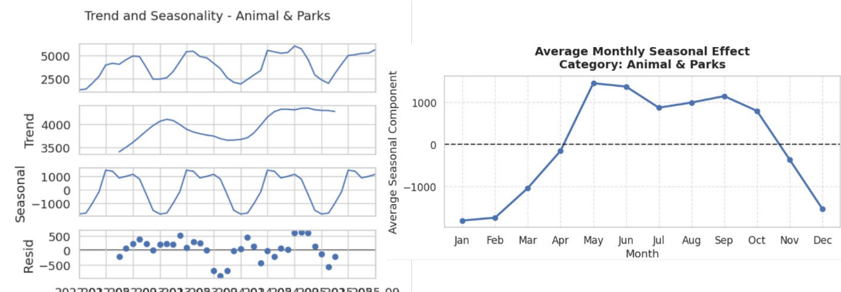
For Animal & Parks Enforcement, the trend increases moderately over time, reflecting growing use of parks and heightened sensitivity to animal-related issues.
- Seasonal effects are highest from May to September (+1,000 above average), coinciding with park usage, dog-off-leash incidents, and wildlife interactions in warmer months.
- The lowest values occur in December to February (−1,000 below average), mirroring reduced park activities during winter.

- Bike-Related 311 Service Requests in the Beach BIA (2022–2025)
This section is about all bike-related 311 service requests submitted within the Beach BIA between 2022 and 2025. It represents an important component of public space management, active transportation infrastructure, and seasonal mobility patterns in the community.

Bike-related complaints were identified by searching the keywords from Service Request Type: “bike” and “bicy” (to capture “Bicycle Stand (Post & Ring)”).
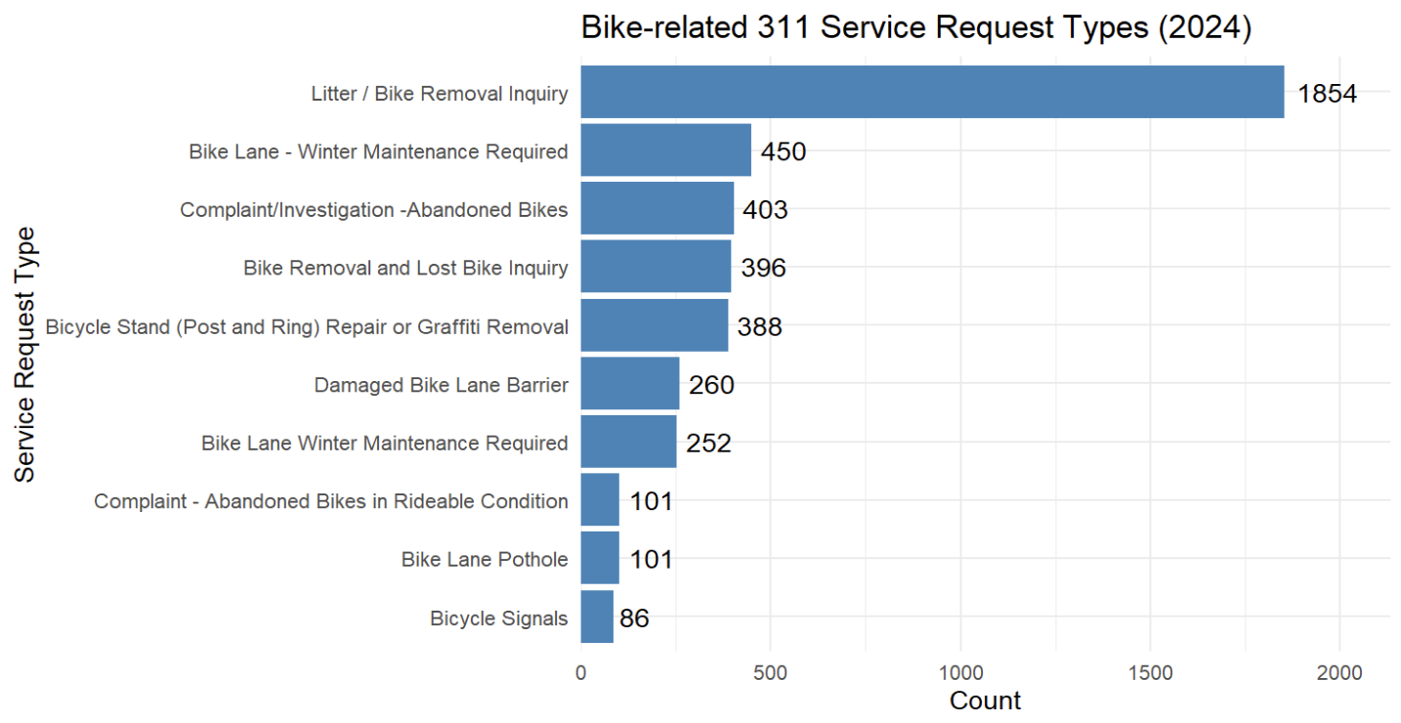
The distribution indicates a strong concentration in removal- and maintenance-related service calls, with infrastructure repair categories contributing comparatively modest shares.

3.1 Overall Complaint Volume (2022–2025)
Across the four-year period, the Beach BIA recorded a modest but consistent number of bike-related service requests.

The majority fall into three recurrent themes:
- Abandoned bikes / bike removal
- Bike lane winter maintenance
- Bike lane damage (such as potholes, barriers)
Beginning in 2025, a new category - Bicycle Stand (Post & Ring) - appears, reflecting increased attention to cycling infrastructure maintenance. Although bike-related complaints represent only a small proportion of total 311 requests, their patterns highlight important operational and seasonal behaviors.
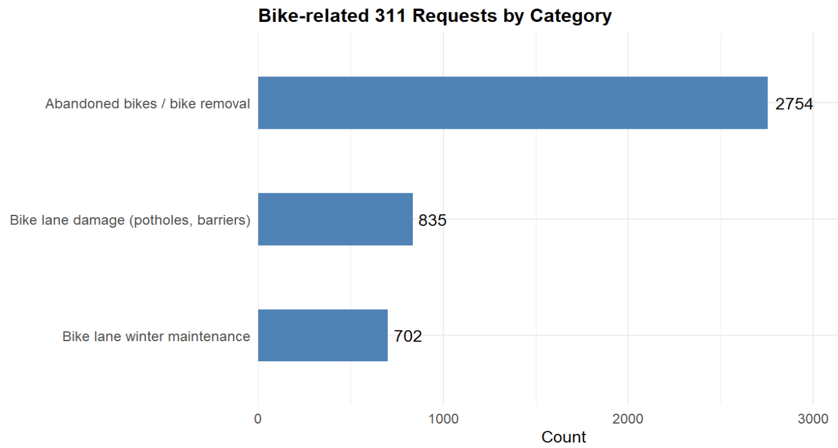
Abandoned-bike and removal cases constitute the largest share of bike-related requests, while infrastructure-related issues and winter maintenance represent substantially smaller but still meaningful portions.

3.2 Overall pattern
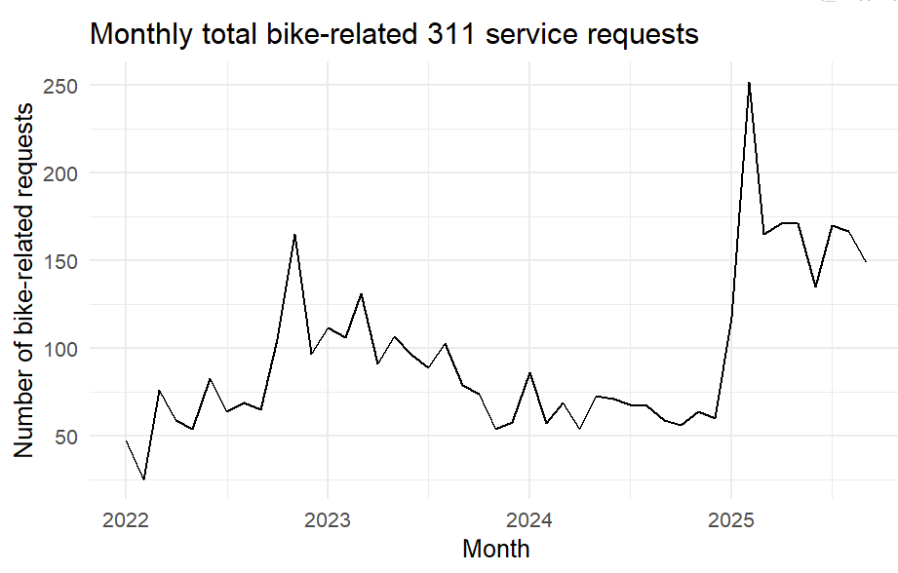
Bike-related request volumes show clear seasonal peaks during warmer months, modest declines through 2024, and a sharp rise in early 2025 following the introduction of new reporting categories.
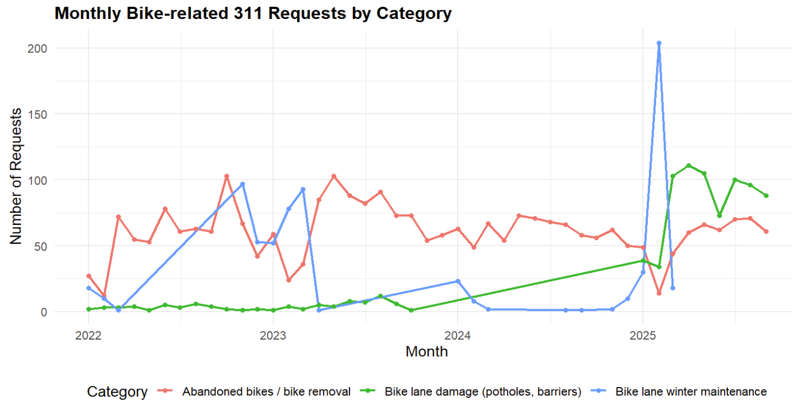
Abandoned-bike reports remain consistently the dominant category across years, while lane-damage requests rise gradually and spike in early 2025. Winter-maintenance requests show strong seasonal peaks, including an exceptional surge in early 2025 associated with new reporting activity.

From 2022 to 2024, the series fluctuates within a relatively narrow range—typically between 50 and 150 requests per month—with mild peaks occurring around mid-year and lower activity in winter months. Although year-to-year variation exists, the overall level of requests remains fairly consistent during this three-year period. A major change appears in 2025, where the monthly counts rise sharply, reaching a pronounced peak of nearly 250 requests early in the year. After this spike, volumes remain elevated relative to previous years, stabilizing around 140–170 requests per month. This shift suggests a structural increase in bike-related reporting activity during 2025, departing from the earlier, more moderate pattern observed in 2022–2024.

3.3 Monthly Pattern
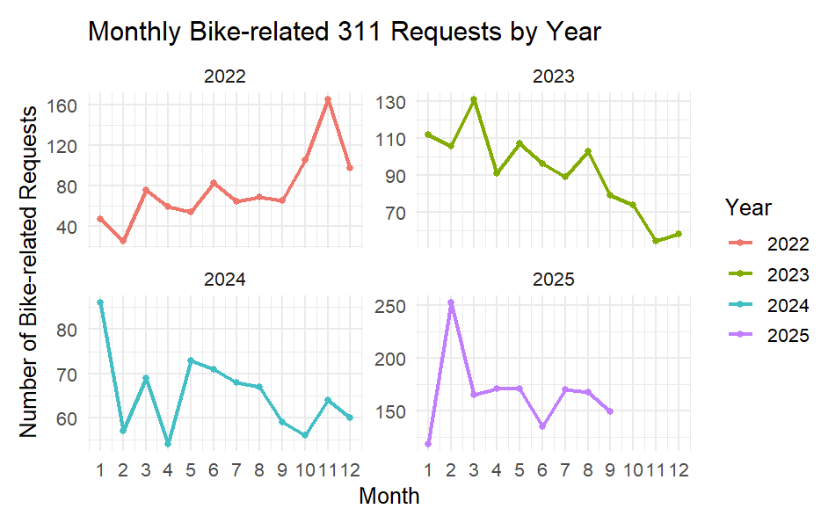
Across all years, bike-related requests show clear seasonality, with higher volumes in spring–summer and lower levels in winter. The year 2025 exhibits a pronounced early-year surge due to expanded reporting categories, while 2022–2024 display more stable seasonal patterns.
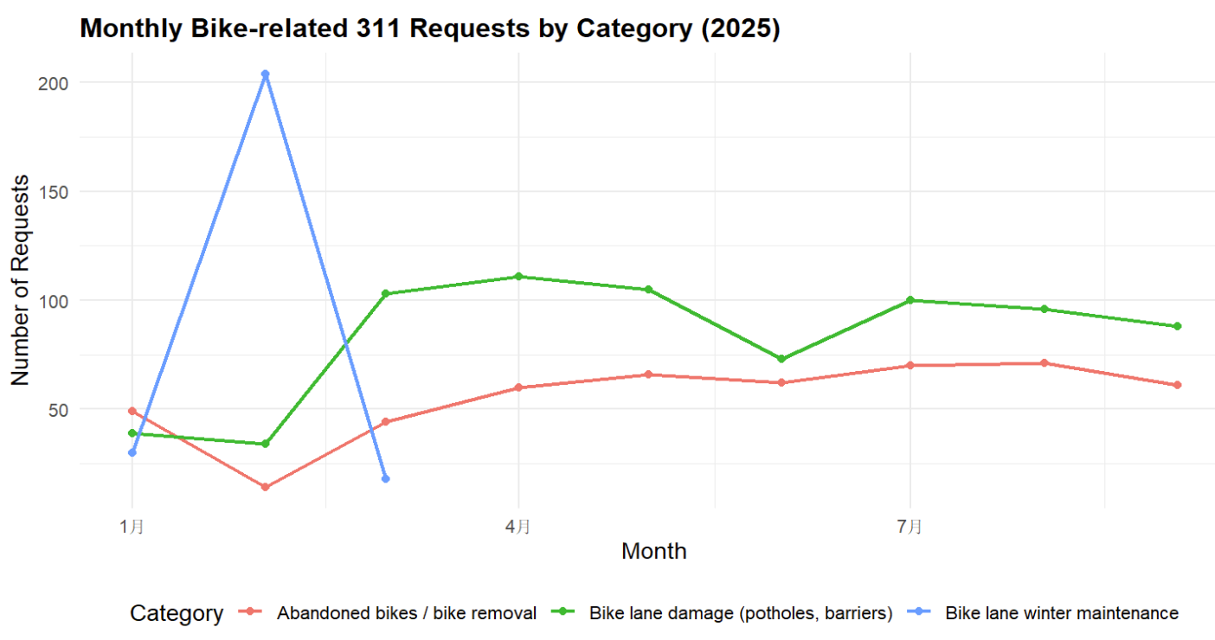
In early 2025, bike lane winter maintenance experiences a sharp spike in February, reflecting exceptional winter-related issues. Starting in spring, bike lane damage becomes the dominant category, remaining elevated through summer and fall. Abandoned bike–related requests show a steadier, moderate pattern across the year with gradual increases into mid-summer.

Requests tend to be lowest during winter months (December–February), when cycling volume drops and outdoor activity is reduced. Counts typically rise in the spring, increase further during early to mid-summer, and then gradually decline again in the late fall. The relatively low number of bike-related requests at the beginning of 2022 may be partly influenced by lingering COVID-19 effects. 2025 stands out sharply, with one extreme early-year peak and a higher sustained baseline afterward. Winter peaks correspond to the challenges of maintaining bike lanes under snow and ice conditions.

- Graffiti-Related 311 Service Requests in the Beach BIA (2022–2025)
This supplemental report summarizes all graffiti-related 311 service requests submitted within the Beach BIA between 2022 and 2025. Graffiti is a key issue in public-space management because it affects perceived safety, cleanliness, and the overall image of commercial streets and transit corridors. Understanding when and how often graffiti is reported helps the BIA plan cleaning cycles, coordinate with City divisions, and target communication or prevention campaigns.
Graffiti-related complaints were identified by searching for the keyword “graffiti” in the Service Request Type field. All records where graffiti was explicitly mentioned—whether on buildings, fences, utility boxes, sidewalks, transit infrastructure, or street furniture—were included. Rather than separating each subtype, all matching requests were grouped into a single “graffiti-related” category for time-trend and seasonality analysis.

4.1 Overall Complaint Volume (2022–2025)
Across the four-year period, the Beach BIA recorded a moderate but steady volume of graffiti-related complaints. Monthly counts generally fall in the 150–600 request range, with clear peaks in some mid-year months when graffiti activity and visibility are higher.
While there is month-to-month volatility, the decomposed trend component indicates a gradual upward drift from 2022 through 2025 rather than a sharp structural break. This suggests that graffiti remains a persistent, ongoing management issue rather than an isolated spike confined to a single year.
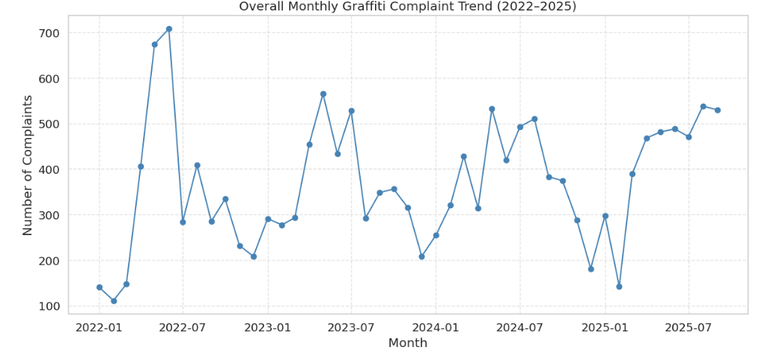

4.2 Seasonal Pattern
The average monthly seasonality plot for 2022–2025 shows a strong and intuitive seasonal cycle:
- Complaint volumes are lowest in winter, particularly in December and February, when colder temperatures, shorter daylight hours, and less pedestrian traffic reduce both graffiti activity and the likelihood of it being reported.
- Starting in March, graffiti-related requests increase sharply, peaking in May at more than double the winter baseline.
- Elevated volumes continue through June, July, and August, with only a gradual decline into early fall.
- From October onward, the average number of complaints falls back toward winter levels.
This pattern is consistent with higher outdoor activity, more construction hoarding, and greater use of public and semi-public spaces in the warmer months, which both encourages graffiti and makes it more visible to residents, businesses, and visitors. Similarly to the overall pattern. 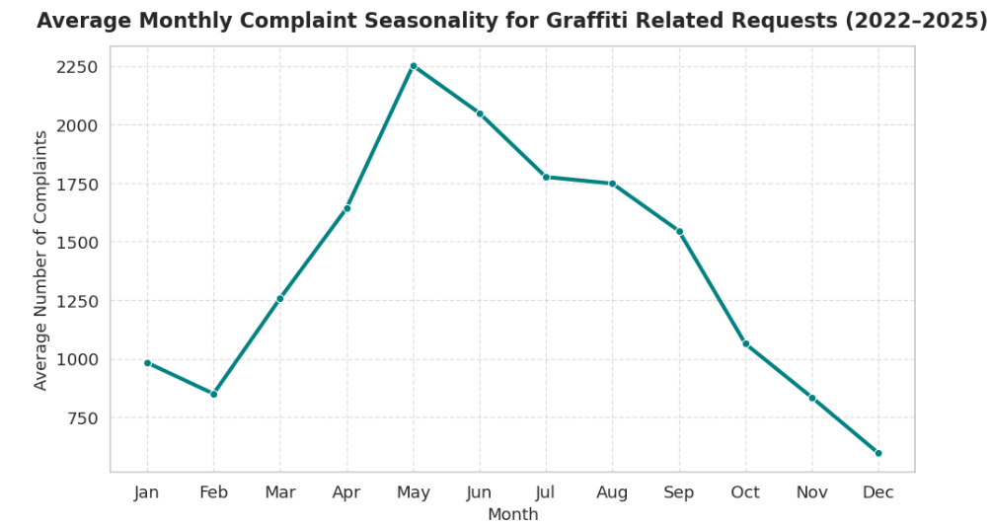

Discussion
Waste collection and related services are the main sources of public concern.
Across the city’s complaint system, time trends are shaped by three interacting forces:
- Post-COVID structural rebound.
While our dataset starts in 2022, the upward trend after mid-2023 is consistent with a gradual return to normal mobility and public space usage after earlier COVID-19 restrictions. As residents resumed commuting, recreation and in-person services, more issues became visible and more complaints were filed.
- Strong, predictable seasonality.
All major categories show systematic peaks in late spring and summer and troughs in winter, especially for outdoor-dependent services such as roads, waste, animal control and parks. May caused by following reasons:
  - Weather and daylight: more activity and visibility in warmer months.
  - Foot traffic and business activity: higher exposure along commercial streets during spring and summer.
This suggests that a large part of the workload is forecastable, enabling more proactive staffing, contractor scheduling and budget allocation.
- Category-specific pressure points.
  - Traffic & Road faces its highest pressure in winter (February) due to snow and road conditions.
  - Municipal Operations peaks at the start of the year, likely linked to utility cycles.
  - Enforcement & Investigation, Waste & Environmental, and Animal & Parks are most stressed in late spring and summer when people and activities move outdoors.

