BUSINESS & SYSTEM FLOW
Unified Communication-to-Deal Association
How emails, meetings, contacts, accounts, deals, and discovered participants now work together
Core principle: A contact relationship identifies candidate deals; the current deal team disambiguates the communication. If the evidence identifies multiple deals, the system does not guess.

Implementation reference | July 20, 2026

1. Executive summary
The previous email matcher, meeting matcher, downstream mapping service, and participant lookup paths have been consolidated into one communication hydration pipeline. New communications and historical replay now apply the same business rule instead of maintaining different behavior in separate services.
Automatic association rule: Associate an email or meeting only when it contains at least one approved contact participant from an open deal, contains the deal owner or an active internal user participant, and exactly one deal satisfies both conditions.

What the new flow guarantees
- New email and meeting sync use the same worker and matching policy.
- Deals created after earlier conversations can recover retained email and meeting history.
- Ambiguous communication remains on contact/account activity and is never guessed onto a deal.
- Newly discovered customer participants can recover their history through one bounded replay hop.
- Participant removal and meeting cancellation clean up stale deal activity.
- Retries are safe and downstream work runs only after the association transaction commits.

2. End-to-end flow
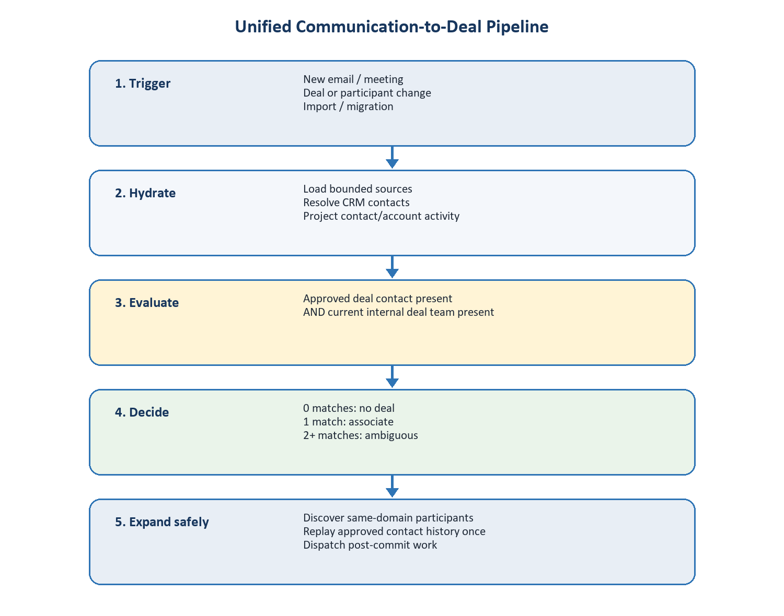
Figure 1. Every trigger converges on the same bounded hydration and association pipeline.

3. Entry points and processing modes
All business triggers dispatch a single worker entry point: deal.hydrate_contact_communications.
Mode | Input | When it runs | Purpose
Changed source | Email/event IDs | Provider sync | Process only newly changed communications.
Contact replay | Contact IDs | Manual or discovery replay | Recover retained history for known contacts.
Deal replay | Deal IDs | Deal/participant lifecycle | Re-evaluate history for requested deals.

Bounded execution: Modes are mutually exclusive, and each task accepts at most 100 source, contact, or deal IDs. The worker does not perform an organisation-wide communication scan.

Trigger map
Business event | Replay scope | Why it is needed
Email synchronized | Changed email | Map new mail immediately after provider rows commit.
Meeting synchronized | Changed event | Map new or changed calendar activity.
Deal created | Deal | Recover conversations that happened before the deal existed.
Participant added or removed | Deal | Add new history or remove unsupported associations.
Lead converted | Deal | Apply the same replay to the newly created deal.
CRM/CSV import | Imported deals | Recover retained communication after migration/import.
Scheduled initial backfill | Bounded deal batches | Provide migration and publication-failure recovery.

4. Exact matching decision
For every email or meeting, the service builds communication evidence and compares it with every eligible open deal.
- Resolve sender, recipient, organiser, and attendee identities to CRM contacts.
- Find open deals where one of those contacts is an approved contact participant.
- Require the same communication to contain the deal owner or an active internal user participant.
- Count all deals satisfying both conditions.
- Create a deal association only when the count is exactly one.
Eligible deals | Decision | User-visible result
0 | Unmatched | Activity remains visible through contact/account relationships.
1 | Associate | One deal-owned activity is created or retained.
2 or more | Ambiguous | No deal is selected; contact/account activity remains.

No date heuristic: There is no 90-day rolling window and no deal-created-date cutoff. Current relationship evidence determines association, including for older retained communications.

Targeted replay still checks global ambiguity
A replay requested for Deal A evaluates every eligible deal. This prevents Deal B from being hidden merely because the current task targets Deal A. If both A and B qualify, the communication remains ambiguous. If only B qualifies, the Deal A replay observes that fact but cannot write to Deal B.

5. Live email flow
- The email integration commits the email and participant addresses.
- It dispatches hydration with the changed email ID.
- Hydration resolves or creates valid external contacts and reuses existing CRM contacts.
- Contact/account activity is projected first.
- The unified association rule evaluates all open candidate deals.
- A unique result creates the email-to-deal association and deal activity.
- After commit, attachment extraction and deal insight/memory processing are dispatched.
There is no separate email mapper and no second scan of the organisation's mailbox.

6. Live meeting flow
- Calendar integration commits the event, organiser, and attendee rows.
- It dispatches hydration with the changed event ID.
- Hydration resolves attendees to contacts and projects relationship activity.
- The same approved-contact plus internal-deal-team rule is evaluated.
- A unique result creates the meeting-to-deal association and deal activity.
- A cancelled event deactivates its existing deal association instead of creating a new one.
Separate concern: Recording-bot lifecycle remains owned by calendar synchronization. Recording scheduling is not duplicated inside CRM deal association.

7. Historical replay
Historical replay solves the case where communication happens before a deal or participant relationship exists. Deal creation and participant changes load approved deal contacts, load all retained emails and meetings involving those contacts, and pass them through the same matching rule.
Situation | Replay action | Expected outcome
Deal created after two meetings | Replay approved deal contacts | Old meetings map only if current evidence uniquely identifies the deal.
Contact added later | Replay that deal/contact history | Earlier qualifying email and meetings become visible on the deal.
Imported deal | Replay committed imported deal IDs | Migration does not depend on deals existing during mailbox integration.
Participant removed | Reconcile, then replay remaining contacts | Unsupported historical links are removed.

8. Participant discovery
Discovery runs only after a communication has been confidently linked to exactly one deal. Other external contacts on that communication can then be considered as deal participants.

Discovery safeguards
- The discovered contact must belong to an existing customer domain for the deal.
- Unrelated vendors, advisers, copied partners, role mailboxes, resources, and internal identities are rejected.
- The first five communication-discovered participants per deal are auto-approved.
- Later discovered participants are pending and cannot anchor future matching.
- Discovery is serialized per deal with a transaction advisory lock.

One-hop expansion
When discovery auto-approves a contact, the service replays that contact's retained emails and meetings once. Discovery is disabled during this replay, preventing an uncontrolled A-to-B-to-C contact graph from expanding the deal indefinitely.

9. Correction and cleanup rules
Change | System response | Data treatment
Contact participant removed | Revalidate active links | Mark unsupported associations removed and soft-delete deal projections.
Meeting cancelled | Deactivate meeting link | Mark association cancelled and remove the deal activity projection.
Multiple matching deals | Stop automatic selection | Retain contact/account visibility; report ambiguity.
Duplicate worker delivery | Reuse unique association | No duplicate deal card or participant expansion.
Downstream publication fails | Keep committed association | Log failure; bounded scheduled replay provides recovery.

10. Transaction and retry behavior
- Each bounded hydration batch owns one tenant transaction.
- Association uniqueness is the retry boundary; inserts use ON CONFLICT DO NOTHING.
- Existing contacts and deterministic activity identities are reused.
- Every source, deal, participant, and association query includes organisation scope.
- Participant last-contact time is updated for valid existing and newly created associations.
- Research, attachment extraction, and deal insights dispatch only after the transaction commits.

11. Business scenarios
Scenario | Evidence | Result
One known buyer + deal owner | One open deal qualifies | Automatically associate.
Known buyer without deal team | Contact condition only | Do not associate.
Buyer and seller participate in two deals | Two open deals qualify | Ambiguous; do not guess.
Old meeting, new deal | Current participants uniquely identify deal | Historical replay associates meeting.
Copied vendor on linked email | Vendor domain is outside customer domains | Do not create deal participant.
Additional customer employee | Same customer domain on uniquely linked communication | Discover participant; approve within cap and replay once.
Approved contact removed | Existing association no longer satisfies rule | Remove association and deal projection.

12. Architecture change summary
Before | Now
Separate email and meeting matcher tasks | One hydration worker for live and historical sources
Independent matcher services | One shared communication-to-deal association policy
Separate participant lookup/rematch behavior | Participant discovery inside the confident-association flow
Different paths for new and historical data | The same rule for changed sources, contacts, and deals
Potential organisation-wide scans | Bounded source/contact/deal IDs

Implementation shape: The business pipeline has one entry point. Internally, contact hydration owns identity resolution and activity projection, while CommunicationDealAssociationService owns deal selection, association persistence, reconciliation, and safe participant discovery.

13. Acceptance checklist
- New email can map without running a legacy deal mapper.
- New meeting applies the same deal rule as email.
- Deal creation can recover previous email and meeting history.
- Participant addition recovers that participant's qualifying history.
- Participant removal removes unsupported deal links.
- Discovery performs no more than one historical expansion hop.
- Targeted replay considers global ambiguity but writes only the requested deal.
- Retries create no duplicate associations or deal activity cards.
Final business rule: Contacts establish relevance. Current internal deal participation establishes deal context. Uniqueness authorizes automatic association.

