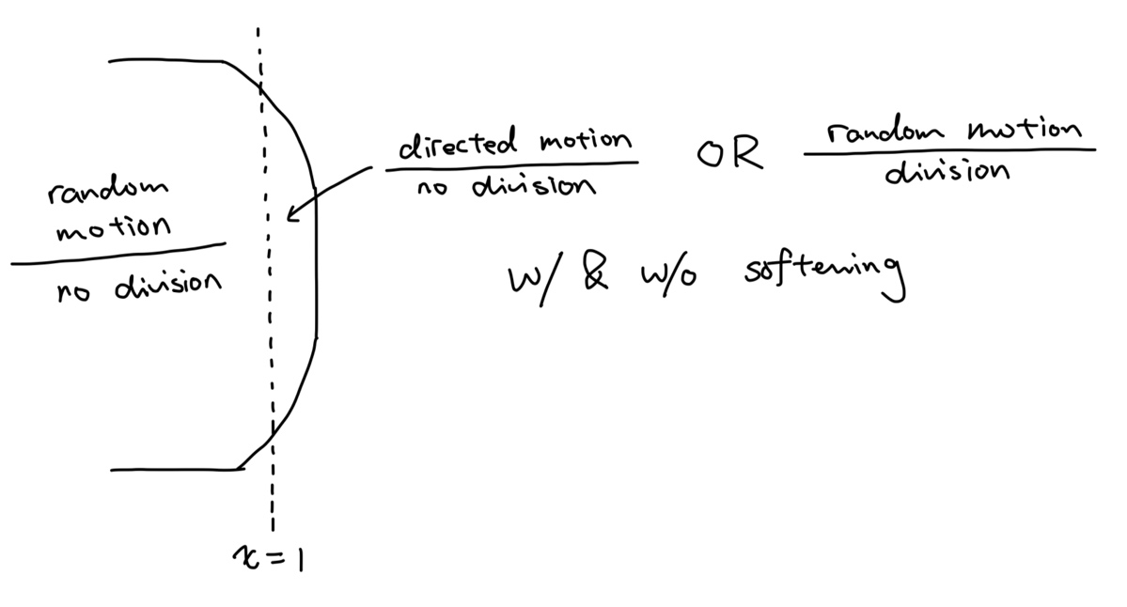
For this hypothesis, we designate cells with an x-coordinate less than 1 to exhibit random motion without undergoing cell division. We then test two scenarios for cells with an x-coordinate greater than or equal to 1: in scenario A, cells exhibit directed motion without cell division; in scenario B, cells exhibit random motion and undergo cell division.

“dir_mo_with_softening.mp4” and “dir_mo_without_softening.mp4” are scenario A with and without softening. The velocity of directed motion is defined as F_pull = [x-0.3,0]

“rand_mo_with_softening.mp4” and “rand_mo_without_softening.mp4” are scenario B with and without softening.

