Guide on using Unity for this project specifically as there are so many things I modified, seriously… too many.

General:

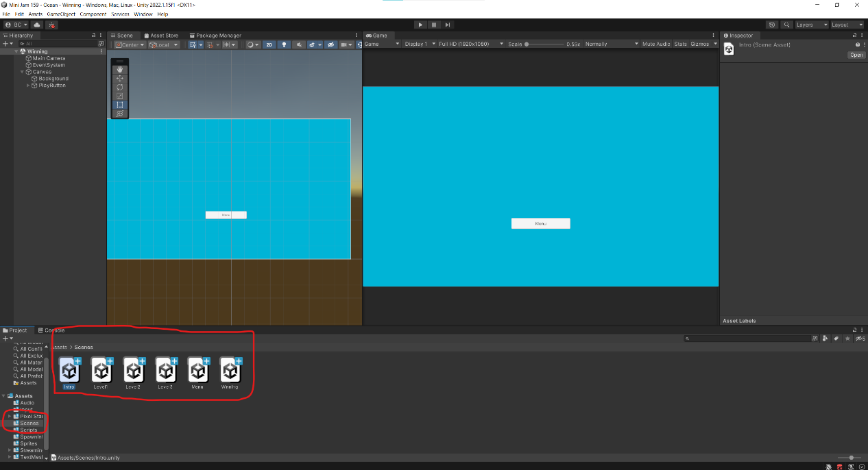

This is how you find different levels, double click on each to open up the level.

Art:

Menu:q

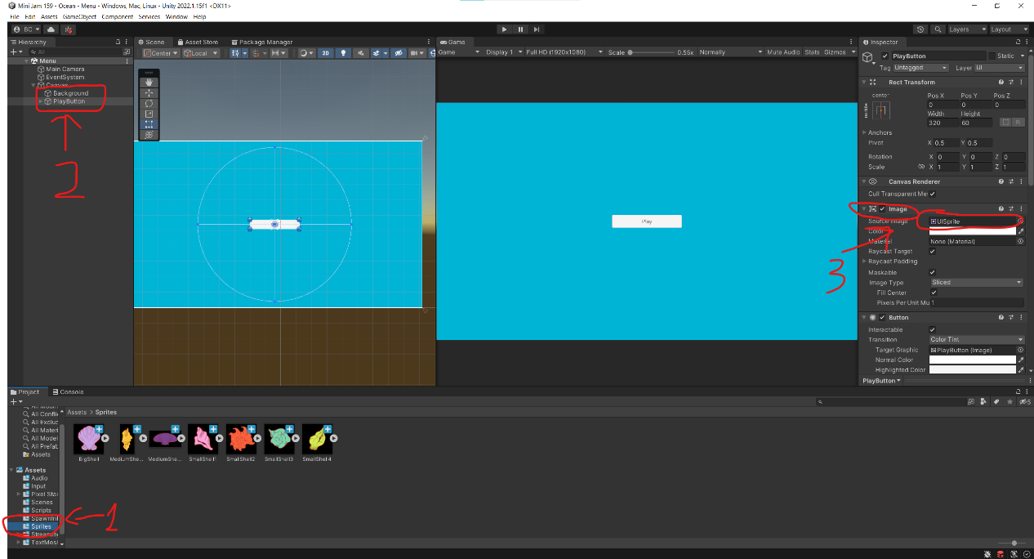

Place the image in the folder shown in 1.(this will be persisting through the levels)

For menu, clock on background, you might need to expand the tree in hierarchy by clicking the triangle next to canvas. Then you can see Image in inspector and you can replace the source image with the background. Same with button, if you don’t want the text, you can remove it by deleting the child of PlayButton, you can find it by clicking the triangle next to playbutton.

Level 1

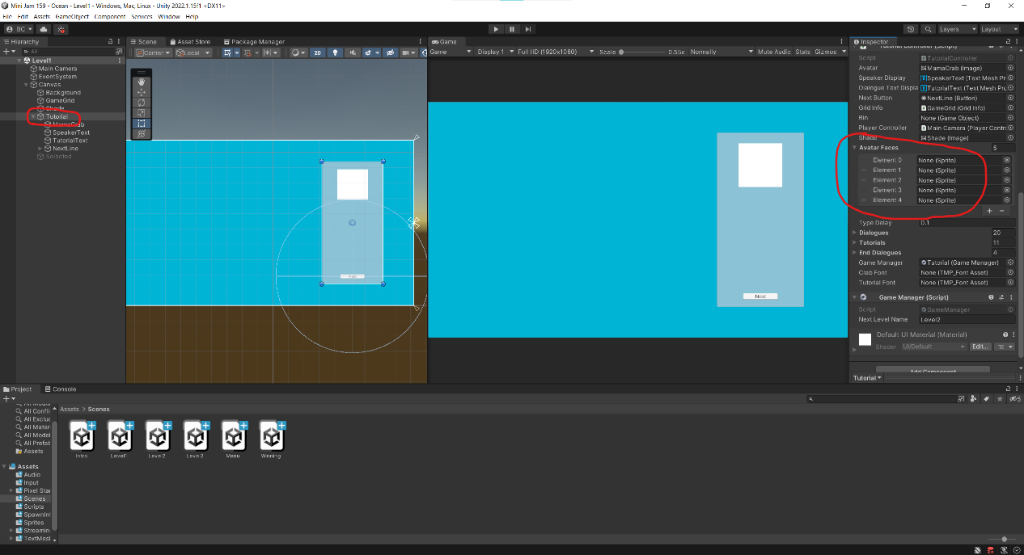

In Level 1, you will need to swap out the background same as before. However here comes the tricky bit, in tutorial, you have a list called Avatar Faces, this is the avatar for mam crab etc. The list goes from top to bottom:

Mama Crab Neutral

Mama Crab Concerned

Mama Crab Happy

Baby Crab 1

Baby Crab 2

Baby Crab 3

Baby Crab 4

If there is not enough slots, press the + sign to add another, same needs to be done in intro

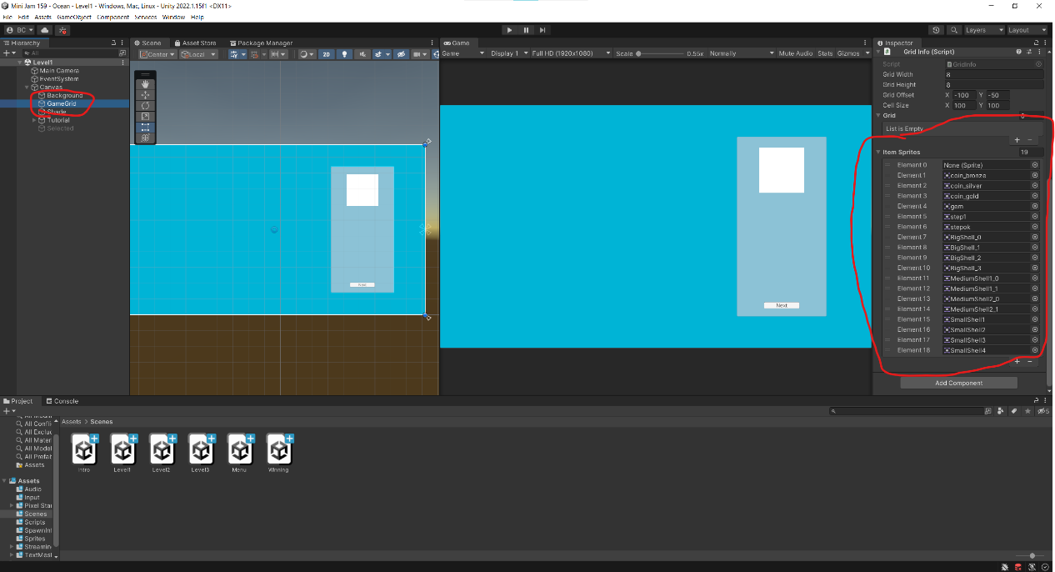

Now for the tiles:

In this list, the tiles go from top to bottom:

Empty Tile

Coral

Treasure Chest

Pufferfish

Pufferbomb

Octopus

Ink

Bigshell top left

Bigshell top right

Bigshell bottom left

Bigshell bottom right

Vert medium shell top

Vert medium shell bottom

Horizontal medium shell left

Horizontal medium shell right

Small shell 1

Small shell 2

Small shell 3

Small shell 4

Custom shell 1

Custom shell 2

Custom shell 3

Custom shell 4

Inked shell 1

Inked shell 2

Inked shell 3

Inked shell 4

I hope this is a complete list.

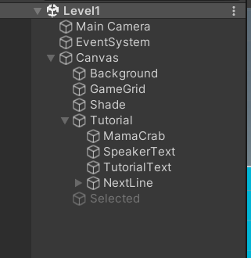 Similar to before, change the image of NextLine to change the button, remove the text if necessary.

Level 2:

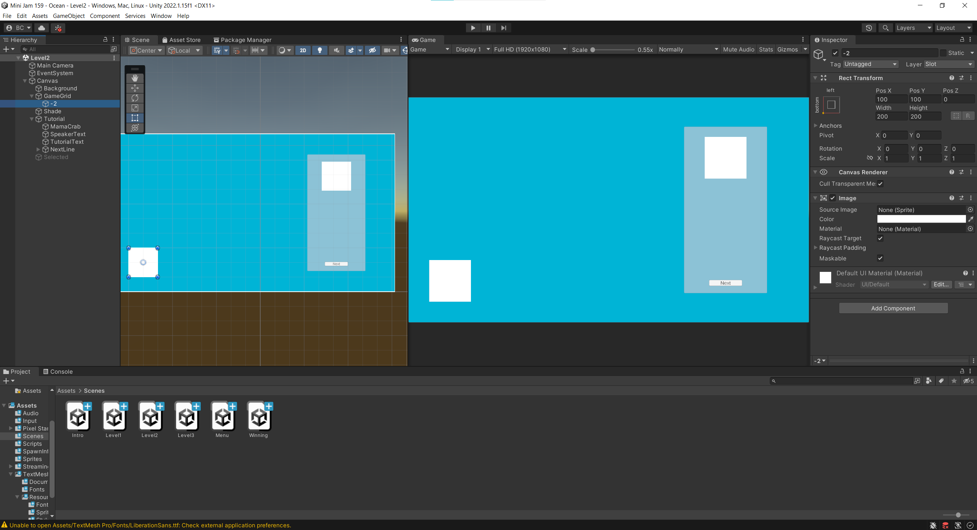

Same as level 1, the only difference here is with the introduction of whirlpool, you need to change the image of this object called -2 to whirl pool.

Level 3 is basically the same as level 2, and winning screen is basically the same as menu

Audio:

First of all, load all the audio clips into the folder as shown in the image(for cleanness really)

Menu:

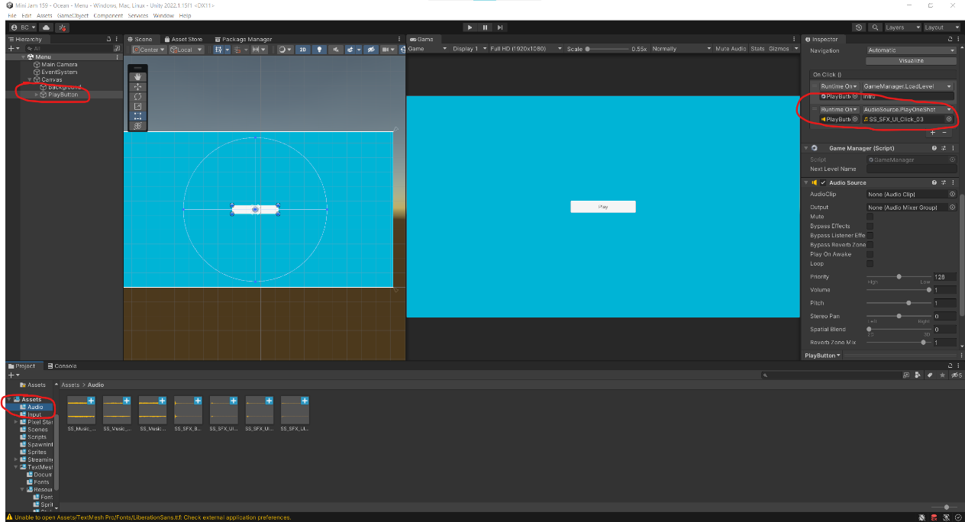

In case you want to use a different button sound, find the button and change the slot shown on image, drag the clip into the slot. Don’t change the slot in audio source, it won’t do anything.

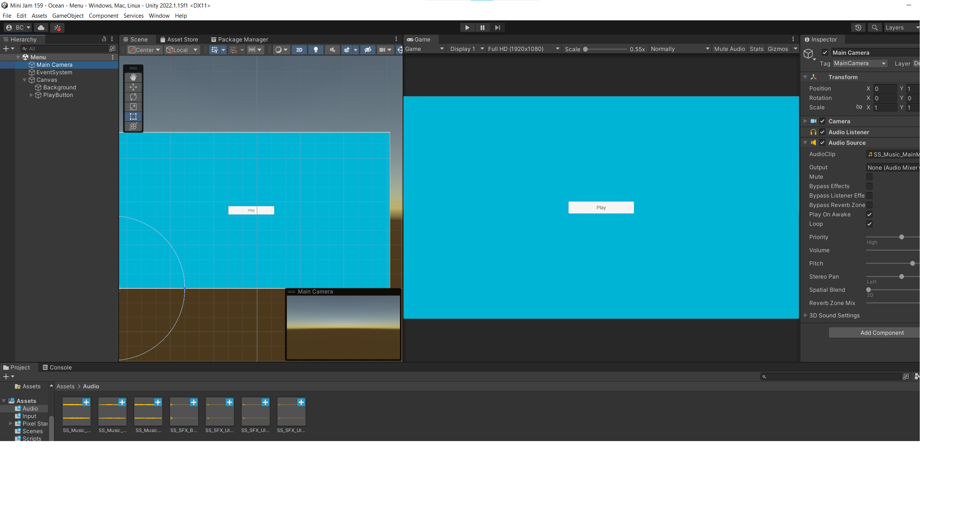

The BGM needs to be changed here in audio source’s audio clip

Level 1

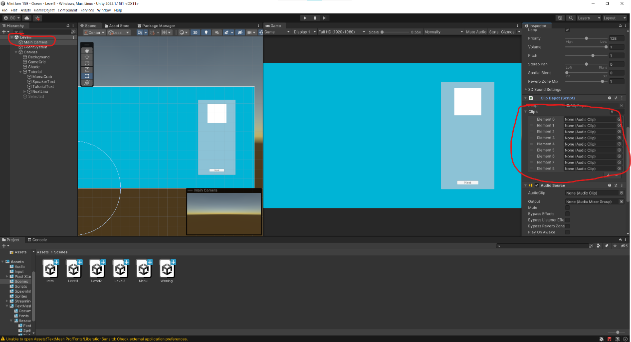

For level 1, the button audio is the same, but this time is called NextLine. The slots shown above are for SFX, slot them in the same order as your asset list:

Merge Sound

Bubble Sound

UI Sound

Coral Sound

Chest Sound

Custom Shell Stinger

Wave Sound

Level Complete Sound

Ink Sound

Then for the BGM, there are two audio sources here in main camera, PUT THE BGM IN THE FIRST AUDIO SOURCE!!! (sorry for caps), if you want to change it.

Level 2 and 3 follow the same procedures.

Then winning screen is basically the same as menu.

Design:

Oh boy there is a lot to say here.