**ReadMe - 100% Voice Controlled FPS Game**

You can use this on any game, but I mapped it to Halo's default keybindings. Therefore, you can either change the scancodes the code uses to press different keys, or change your in-game bindings to:

* W - forward
* SHIFT + W – sprint forward
* Q - melee
* R - reload
* G - grenade
* E - pick up weapon
* SPACEBAR - jump

This is diagram explains how the program works: (order of precedence: very loud >> very low or high >> everything else)

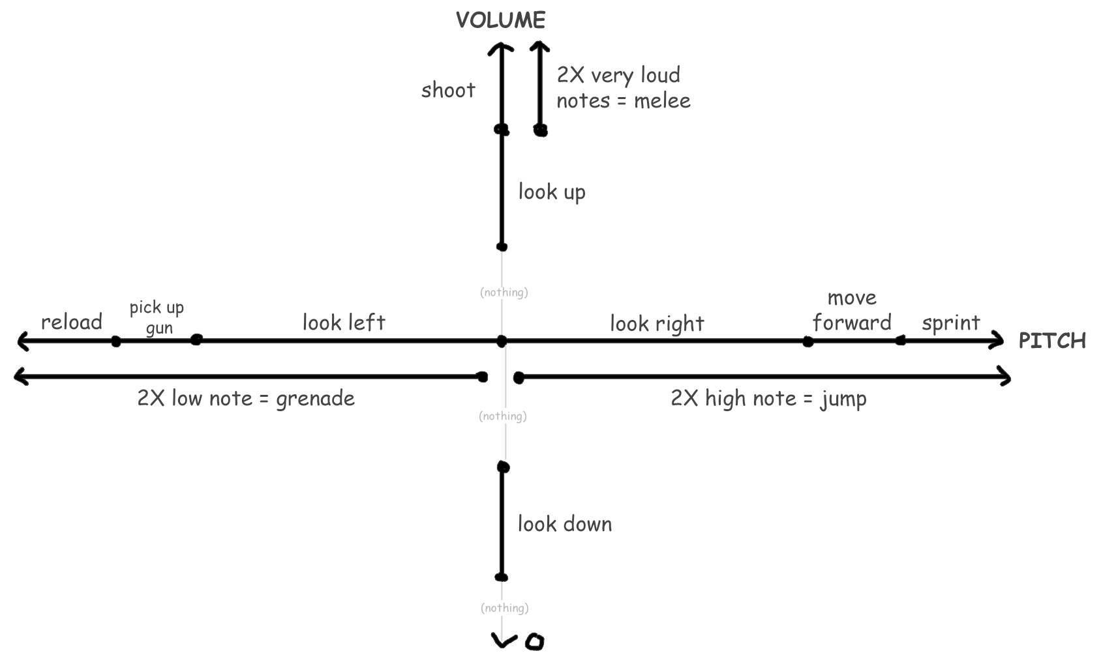

“L” exits the program, or just exit out of the terminal window. Enjoy!