# Blank Schedule

Note: There are some hints for using Word effectively at the bottom

|  |  |  |  |  |  |  |  |
| --- | --- | --- | --- | --- | --- | --- | --- |
| **Time** | **Monday** | **Tuesday** | **Wednesday** | **Thursday** | **Friday** | **Saturday** | **Sunday** |
| 7 - 7:30 AM | private | study |  |  |  | private | church |
| 7:30 – 8 AM | Class | study | class | study |  | work | church |
| 8 – 8:30 AM | Class | study | class | study | class | work | church |
| 8:30 – 9 AM | class | study | class | study | class | work | church |
| 9 – 9:30 AM | class | study | class | study | class | work | church |
| 9:30 – 10 AM | class | study | class | study | class | work | church |
| 10 – 10:30 AM | class | study | class | study | class | work | church |
| 10:30 – 11 AM | class | study | class | study | class | work | church |
| 11 – 11:30 AM | class | class | class | study | class | work | church |
| 11:30 – noon | class | class | class | class | class | work | church |
| Noon – 12:30 PM | class | class | class | class | class | work | church |
| 12:30 – 1 PM | class | class | class | class | class | study | church |
| 1 – 1:30 PM | class | class | class | class | class | study | church |
| 1:30 – 2 PM | class | work | class | class | class | study | church |
| 2 – 2:30 PM | class | work | class | class | class | study | church |
| 2:30 – 3 PM | class | work | class | study | work | study | study |
| 3 – 3:30 PM | class | work | class | study | work | study | study |
| 3:30 – 4 PM | study | work | class | study | work | study | study |
| 4 – 4:30 PM | study | work | class | study | work | study | study |
| 4:30 – 5 PM | study | work | work | study | work | study | study |
| 5 – 5:30 PM | study | work | work | study | work | study | study |
| 5:30 – 6 PM | study | work | work | work | work | study | study |
| 6 – 6:30 PM | study | work | work | work | work | study | study |
| 6:30 – 7 PM | study | work | work | work | work | study | study |
| 7 – 7:30 PM | study | work | work | work | work | study | study |
| 7:30 – 8 PM | study | work | work | work | work | study | study |
| 8 – 8:30 PM | study | work | work | work | work | study | study |
| 8:30 – 9 PM | study | work | work | work |  | study | study |
| 9 – 9:30 PM | study | work | work | work |  | study | study |
| 9:30 – 10 PM | sleep | sleep | sleep | sleep | sleep | study | study |
| 10 – 10:30 PM | sleep | sleep | sleep | sleep | sleep | study | sleep |
| 10:30 – 11 PM | sleep | sleep | sleep | sleep | sleep | study | sleep |
| 11 – 11:30 PM | sleep | sleep | sleep | sleep | sleep | sleep | sleep |
| 11:30 - midnight | sleep | sleep | sleep | sleep | sleep | sleep | sleep |
| Midnight-12:30 AM | sleep | sleep | sleep | sleep | sleep | sleep | sleep |
| 12:30 –1 AM | sleep | sleep | sleep | sleep | sleep | sleep | sleep |
| 1 – 1:30 AM | sleep | sleep | sleep | sleep | sleep | sleep | sleep |
| 1:30 – 2 AM | sleep | sleep | sleep | sleep | sleep | sleep | sleep |
| 2 – 2:30 AM | sleep | sleep | sleep | sleep | sleep | sleep | sleep |
| 2:30 – 3 AM | sleep | sleep | sleep | sleep | sleep | sleep | sleep |
| 3 – 3:30 AM | sleep | sleep | sleep | sleep | sleep | sleep | sleep |
| 3:30 – 4 AM | sleep | sleep | sleep | sleep | sleep | sleep | sleep |
| 4 – 4:30 AM | sleep | sleep | sleep | sleep | sleep | sleep | sleep |
| 4:30 – 5 AM | sleep | sleep | sleep | sleep | sleep | sleep | sleep |
| 5 – 5:30 AM | sleep | sleep | sleep | sleep | sleep | sleep | sleep |
| 5:30 – 6 AM | sleep | sleep | sleep | sleep | sleep | sleep | sleep |
| 6 - 6:30 AM | sleep | sleep | sleep | sleep | sleep | sleep | sleep |
| 6:30 – 7 AM | sleep | sleep | sleep | sleep | sleep | sleep | sleep |

# Some tips/tricks:

* **Type as little as possible!**  
  You can copy a cell, select a bunch of other cells, and paste the first cell into all the selected cells. In the above example I filled in the ‘sleep’ column by typing sleep ONCE into the first cell, copying it, and pasting it into all the others.
* **Want to merge individual cells into larger ones?**  
  You can also merge cells into larger blocks. Select the cells you want to merge, right-click and select ‘Merge Cells’ from the context menu.
  + You can break up merged cells by selecting a cell, right-clicking on it, and selecting ‘Split Cells’
* **Don’t like when the day starts?**  
  You can select whole rows (hover your mouse near the left-most column, until the mouse cursor becomes an arrow). Once you’ve selected them you can cut them out and paste them elsewhere
* **Want yellow background for your cells** (like the ‘class’ cells, above)?  
  What black background with automatic white text (like the ‘sleep’ cells, above?)   
  In Word 2013 you can select one or more cells, right-click on the selection, and then select the ‘Shading’ option in order to color-code a given cell, like so:  
  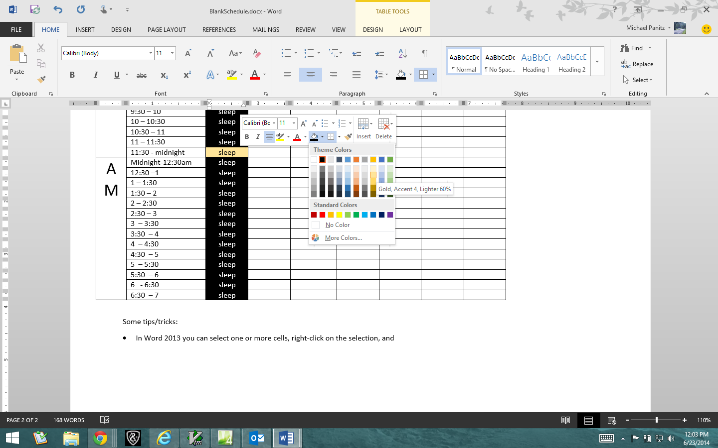
  + This is how the ‘class’ times were given the yellow background, and the ‘sleep’ times black background in the above table
* **Want to adjust the column sizes?**  
  The columns *should* resize themselves as you type. If not open the ‘View’ ribbon, then check of ‘Ruler’ inside the ‘Show’ panel. Put the cursor inside the table and you’ll see the columns in the ruler at the top of the screen. You can resize columns by clicking, holding, and dragging the spaces between the columns, like so:
* 