**The characterization of cloud in reunion**

Chao TANG1 ✉, Béatrice MOREL1, Nathalie PHILIPPON2, Thierry PORTAFAIX3, Miloud BESSAFI1,

✉ Chao TANG

Email: [chao.tang@univ-reunion.fr](mailto:chao.tang@univ-reunion.fr)

1. Laboratoire d'Energétique, d'Electronique et Procédés, ENERGY-lab, Université de La Réunion, La Réunion, France

2 CRC, UMR6282 Biogéosciences CNRS-UBFC, bât. Sciences Gabriel, 6 blvd Gabriel, 21000 Dijon, France

3 LACy (Laboratoire de l'Atmosphère et des Cyclones), UMR8105, CNRS – Université de la Réunion – Météo-France, Saint Denis de la Réunion, France

# Microsoft word live editing link (login not required):

<https://1drv.ms/w/s!AhhWTWH2RB5fjetdI4NDwqHBFknlIA>

# Google Drive real time backup (without live editing):

<https://docs.google.com/document/d/1YAUEVlxqM1g7M8y9fNNj1f-l_JvcCOyy/edit?usp=sharing&ouid=115400583048984110222&rtpof=true&sd=true>

Abstract

Keywords: South West Indian Ocean, cloud cover,

k

# Introduction

The cloud for SSR prediction: Riihimaki et al., 2021:

A 5-year, 1-minute resolution observational dataset of clouds and solar radiation was produced that includes two metrics of the variability in surface solar irradiance due to cloud type and fractional sky cover. Multiple regression models were trained to fit observations of surface solar irradiance variability from those two cloud property predictors. We found that ensemble tree-based methods, Random Forest and Gradient Boosting Machine, have the least overfitting issues and showed the best performance with an R2 of 0.42. While the observational data trained in this study was only from one site, the U.S. Department of Energy (DOE) Atmospheric Radiation Measurement (ARM) Southern Great Plains (SGP) site in Oklahoma, initial comparisons of the seasonality of the statistics suggest that these results are relatively weather regime independent; the generality of such a finding across sites will be tested in future work. The observational data and developed machine learning model are being used to create a numerical weather prediction model parameterization to enable day-ahead solar variability prediction in a computationally efficient way. This is a first step towards creating a new paradigm of predicting day-ahead variability with the potential to provide a new tool to improve grid operation, planning, and resilience.

==================================

Previous studies:

Cloud Type product issued from retrievals of the Spinning Enhanced Visible and InfraRed Imager onboard MeteoSat Second Generation (MSG-SEVIRI) offers a classification of clouds at 3 km spatial resolution and 15 min time resolution over the period 2010–2014. This cloud type classification was used for a diurnal and seasonal analysis to exam its role on the annual forests greenness in central Africa (between 0 and 5°N and 12–19°E). In this study Philippon et al. (2016) redefined 7 cloud type according to cloud altitude and their optical properties; then

The climatological distribution of low-cloud fraction (LCF) over south Indian Ocean and its seasonality is presented by using satellite data, and lined to the storm-track activity and subtropical high. (Miyamoto et al., 2018).

Li et al. (2014) have shown some evidence of linkage between the cloud vertical structure and large-scale climate by exploring large-scale atmospheric dynamics, meteorological processes, and tropospheric cloudiness.

Using the DARDAR mask product based on Cloud–Aerosol Lidar and Infrared Pathfinder Satellite Observation (CALIPSO) and CloudSat measurements (between 2007 and 2010), the characterization of the spatial, seasonal and vertical variability of clouds over the whole southwest Indian Ocean is investigated in the latitudinal band between 10 and 30◦S (Vérèmes et al., 2019).

In the southwest Indian Ocean, vertical distribution of tropical clouds and their temporal variability of at the diurnal and seasonal scales are investigated in the northern part of Reunion Island (55.5°E; 21.1°S) using data from a 95 GHz cloud radar during 2016–2018 (Durand et al., 2021).

Kahn et al., 2008

Chen et al., 2000

In the present study, the focus is put on Reunion island.

This paper is organized as follows: Section 2 presents the data used in this study and the methods to XXX. The results are shown in section 3. Then conclusions are made in section 4 followed by a brief discussion.

# Context, Data

## climate of Reunion Island

* topography, circulation, pr, see Mialhe et al., 2020

## SAFNWC/GEO cloud type product

Reference of this data (to confirmed):

<https://www.nwcsaf.org/web/guest/scientificdocumentation#NWC/GEO%20v2018>

Fig. 1 spatial coverage of downloaded SAF_NWC cloud product in general projection.

Fig. 2 Spatial coverage of SAF_NWC cloud product over Reunion Island (24/26 pixels in the latitude/longitude direction)

### Data completeness

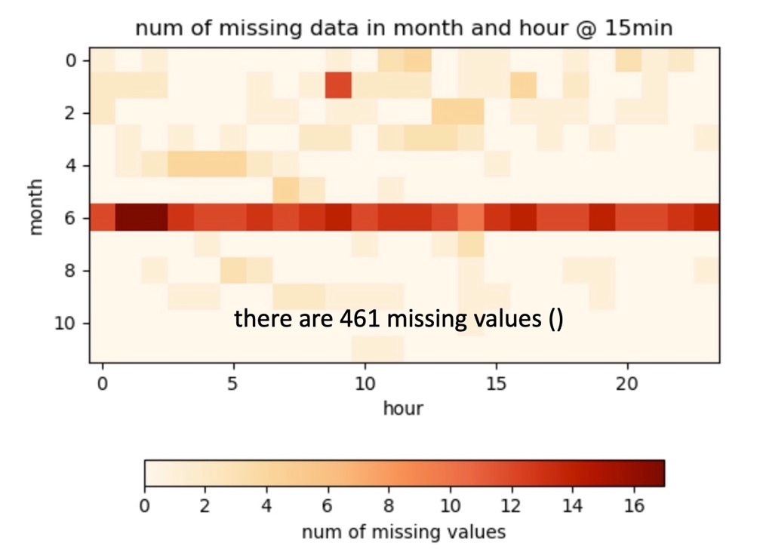

Fig. 3 Number of missing data in month and hour of the year 2019. The total number of records of one pixel depends on the number of days in corresponding month and the frequency of data (every 15 minutes). The total number of missing values is indicated on the plot.

* Each pixel should have about 120 values (30 days * 4 values / hour).
* July: few missing data are found, even still only less than 15%.

### Data quality

Ct_condition ?

* Recent study on the reliability of SAF_NWC data
* Validation report: User accuracy for low opaque, high opaque, semi-transparent high clouds : between 79% and 96% depending on illumination

### Data treatment

We selected the closest SAF_NWC pixels to the respective Campus stations.

### regroup of cloud types

In SAF_NWC CT products, a pixel is either clear-sky or cloudy or partly cloudy (fractional clouds).

After excluding, grouping or reallocating some classes, 7 classes are defined: clearskies (’CS’), ultra-low (’vLow’), low (’Low’), medium (’Med’), highopaque (’HOp’), very high opaque (’vHOp’), and semi-transparentclouds (’sTp’, , last column).

Table Columns 1–4: cloud type value, name, type of clouds in presence, and frequency (in percentage) over our study period and region, of the 15 initial classes of clouds of the SAFNWC cloud type. columns 5–7: the 7 classes finally retained for our study and the final name attributed. Column 4, parenthesis: final frequency after the reallocation of the fractional clouds.

|  |  |  |  |  |  |
| --- | --- | --- | --- | --- | --- |
| Cloud type class | Initial classification name | Type of clouds in presence | Frequency in %  (Campus/Reunion) | Final classification | Final name |
| 1 | Cloud-free land |  |  | Clear sky | CS |
| 2 | Cloud-free Sea |  |  | excluded |  |
| 3 | Snow over land |  |  | excluded |  |
| 4 | Sea ice |  |  | excluded |  |
| 5 | Very low clouds |  |  |  | vLow |
| 6 | Low clouds |  |  |  | Low |
| 7 | Mid-level clouds |  |  |  | Mid |
| 8 | High opaque clouds |  |  |  | HOp |
| 9 | Very high opaque clouds |  |  |  | vHOp |
| 10 | Fractional clouds |  |  | Reallocated  pixels covered by fractionalclouds, i.e., sub-pixel water clouds. These pixels were reprocessedand reallocated so that they fall into the cloud type most frequentlyobserved among the 8 neighbouring pixels. |  |
| 11 | High semitransparent thin clouds |  |  |  | sTp |
| 12 | High semitransparent moderately thick clouds |  |  |  |
| 13 | High semitransparent thick clouds |  |  |  |
| 14 | High semitransparent above low or medium clouds |  |  |  |
| 15 | High semitransparent above snow/ice |  |  |  |
| FillValue | No data or corrupted data |  |  | excluded |  |

## All sky camera

Attention:

Seasonal varying sunshine duration, hours of the daytime.

cloud fraction from camera: Aebi et al., 2018.

# Methods

## Cloud type annual cycles

The annual cycles of Cloud type in the site of Campus are presented during the year 2019 (first look).

## Cloud type correlation vs SSR

First the distribution type (gaussian or not) is checked to know if Pearson correlations

and biases are appropriate or not.

3.3

## Clustering of the mean annual cycles Low Level Cloud.

Linked

# variability of cloud in Reunion

the characterization of cloud in reunion

## Campus Saint-Denis

1. get 2019 data in Saint-Denis Campus in pandas DataFrame
2. regroup or select cloud types
3. show annual cycles in 2019 by (month or 2 weeks (1440) or bi-month)
4. diurnal cycles in different seasons.
5. Plot as well the mean of SSR and Pr.
6. And lacy cloud types. From 2019-09 to 2020-08.
7. Lacy cloud fraction (multi-year, from old and new camera)

monthly and diurnal:

Fig. 4 examples of monthly and diurnal cloud type, from [Philippon et al. (2016)](#_ENREF_8" \o "Philippon, 2016 #60).

## SSR classification

### SSR climatology over Reunion

# Discussion and Conclusion

Summary:

climate change impacts:

Perspective:

This study focusses on the SSR variability due to climate variabilities, where the analysis is at regional scale, over Reunion area. However, more detailed variation at local scale is still missing. Uniformly distributed anomalous SSR (see the classification of SSR anomaly in section 3.1) implies an investigating at smaller scales, such as the cloud process and topography lifting, etc, which is a perspective of this study.

# Acknowledgments

The study is supported by the Europe Union and the Region of Reunion Island through the scientific project SWIO-Energy (Solar and Wind energy in the Indian Ocean) of University of Reunion. Thanks to CCuB to provide the computational resource for the OLR regimes classification, and CCuR for the classification of SARAH-E SSR anomaly.

Thank you to xxx for his thorough rereading of the manuscript.

# Appendix

# References

Engeland K, Borga M, Creutin J-D, François B, Ramos M-H, Vidal J-P (2017) Space-time variability of climate variables and intermittent renewable electricity production – A review Renewable and Sustainable Energy Reviews 79:600-617 doi:<https://doi.org/10.1016/j.rser.2017.05.046>

Fauchereau N, Pohl B, Reason C, Rouault M, Richard Y (2009) Recurrent daily OLR patterns in the Southern Africa/Southwest Indian Ocean region, implications for South African rainfall and teleconnections Climate Dynamics 32:575-591

Hersbach H et al. (2020) The ERA5 global reanalysis Quarterly Journal of the Royal Meteorological Society 146:1999-2049 doi:<https://doi.org/10.1002/qj.3803>

IEA (2021) World Energy Outlook 2021

Ineichen P (2008) A broadband simplified version of the Solis clear sky model Solar Energy 82:758-762 doi:<https://doi.org/10.1016/j.solener.2008.02.009>

Ineichen P (2016) Validation of models that estimate the clear sky global and beam solar irradiance Solar Energy 132:332-344 doi:<https://doi.org/10.1016/j.solener.2016.03.017>

Jäger-Waldau A (2021) Overview of the Global PV Industry☆. In: Reference Module in Earth Systems and Environmental Sciences. Elsevier. doi:<https://doi.org/10.1016/B978-0-12-819727-1.00054-6>

Liu L et al. (2020) Optimizing wind/solar combinations at finer scales to mitigate renewable energy variability in China Renewable and Sustainable Energy Reviews 132:110151 doi:<https://doi.org/10.1016/j.rser.2020.110151>

Macron C, Pohl B, Richard Y, Bessafi M (2014) How do Tropical Temperate Troughs Form and Develop over Southern Africa? Journal of Climate 27:1633-1647 doi:10.1175/jcli-d-13-00175.1

Pohl B, Dieppois B, Crétat J, Lawler D, Rouault M (2018) From synoptic to interdecadal variability in Southern African rainfall: toward a unified view across time scales Journal of Climate 31:5845-5872

Vigaud N, Pohl B, Crétat J (2012) Tropical-temperate interactions over Southern Africa simulated by a regional climate model Climate Dynamics 39:2895-2916 doi:10.1007/s00382-012-1314-3

Yin J, Molini A, Porporato A (2020) Impacts of solar intermittency on future photovoltaic reliability Nature Communications 11:4781 doi:10.1038/s41467-020-18602-6

Aebi, C., Gröbner, J., Kämpfer, N., 2018. Cloud fraction determined by thermal infrared and visible all-sky cameras. Atmos. Meas. Tech. 11(10), 5549-5563.

Chen, T., Rossow, W.B., Zhang, Y., 2000. Radiative Effects of Cloud-Type Variations. Journal of Climate 13(1), 264-286.

Durand, J., Lees, E., Bousquet, O., Delanoë, J., Bonnardot, F., 2021. Cloud Radar Observations of Diurnal and Seasonal Cloudiness over Reunion Island. Atmosphere 12(7), 868.

Kahn, B.H., Chahine, M.T., Stephens, G.L., Mace, G.G., Marchand, R.T., Wang, Z., Barnet, C.D., Eldering, A., Holz, R.E., Kuehn, R.E., Vane, D.G., 2008. Cloud type comparisons of AIRS, CloudSat, and CALIPSO cloud height and amount. Atmos. Chem. Phys. 8(5), 1231-1248.

Li, Y., Thompson, D.W.J., Stephens, G.L., Bony, S., 2014. A global survey of the instantaneous linkages between cloud vertical structure and large-scale climate. Journal of Geophysical Research: Atmospheres 119(7), 3770-3792.

Mialhe, P., Pohl, B., Morel, B., Trentmann, J., Jumaux, G., Bonnardot, F., Bessafi, M., Chabriat, J.-P., 2020. On the determination of coherent solar climates over a tropical island with a complex topography. Solar Energy 206, 508-521.

Miyamoto, A., Nakamura, H., Miyasaka, T., 2018. Influence of the Subtropical High and Storm Track on Low-Cloud Fraction and Its Seasonality over the South Indian Ocean. Journal of Climate 31(10), 4017-4039.

Philippon, N., de Lapparent, B., Gond, V., Sèze, G., Martiny, N., Camberlin, P., Cornu, G., Morel, B., Moron, V., Bigot, S., Brou, T., Dubreuil, V., 2016. Analysis of the diurnal cycles for a better understanding of the mean annual cycle of forests greenness in Central Africa. Agricultural and Forest Meteorology 223, 81-94.

Riihimaki, L.D., Li, X., Hou, Z., Berg, L.K., 2021. Improving prediction of surface solar irradiance variability by integrating observed cloud characteristics and machine learning. Solar Energy 225, 275-285.

Vérèmes, H., Listowski, C., Delanoë, J., Barthe, C., Tulet, P., Bonnardot, F., Roy, D., 2019. Spatial and seasonal variability of clouds over the southwest Indian Ocean based on the DARDAR mask product. Quarterly Journal of the Royal Meteorological Society 145(725), 3561-3576.