Article Title: Why Moms Are Getting Online Degrees

Article Content:
The number of students enrolled in online courses exploded by nearly 1 million in 2009, according to The Boston Globe. About 600,000 of those students are moms, according to Classes and Careers. Of those women, 400,000 work part-time or full-time jobs while attending online classes.
Obviously, there's something mothers find attractive about online college courses. When you look at some of the reasons moms choose online degrees instead of traditional classroom educations, it becomes obvious why so many of them take the online option.

Online Colleges Offer More Flexible Schedules
The typical college course requires students to spend three hours per week in the classroom. Successful students usually spend an extra two or three hours per credit hour studying outside of the classroom. Even a three-hour, entry-level course, therefore, could require 12 hours of a student's time.
It's tough for the average person (parent or not) to find 12 hours of time for studying. Mothers, however, have it much tougher. According to a Cornell study, parents with two children spend about 7.5 hours a day raising their kids. Even scarier is the revelation that a stay-at-home mom and her husband put in an average total of 7.7 hours per day raising the kids while working mothers and fathers spend a total of 7.3 hours. Working or not working doesn't seem to make much of a difference when it comes to time spent raising children. Considering that 63.9 percent of mothers with children under 6 work part-time or full-time jobs, mothers don't get much of a break.
For many moms, the flexibility of online degrees allows them to complete classes successfully while staying committed to their families and jobs.

Traditional Schooling Costs Three Times More
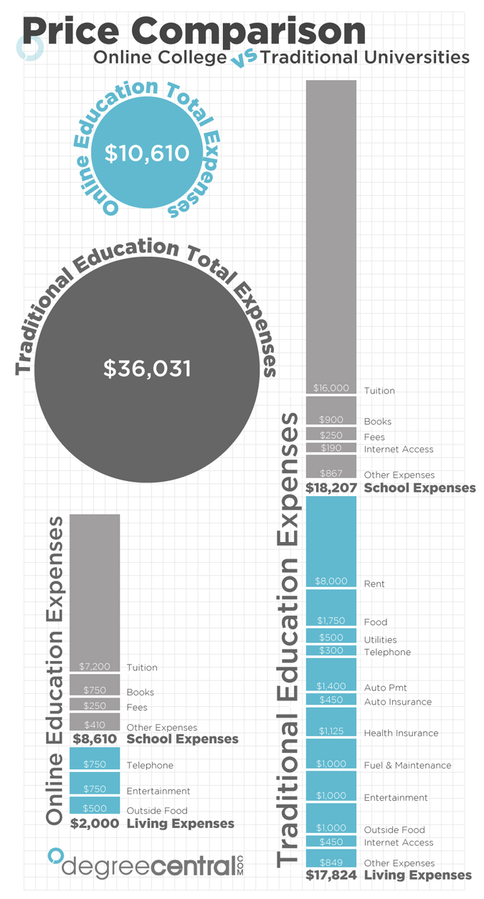
Tuition tends to increase by about 8 percent every year, according to FinAid.org. That's more than double the general inflation rate. The average cost of college in 1980 was over $7,000 per year. Today, it's over $17,000 per year.
Online colleges, however, have lower operating costs, which means they can often offer lower tuition prices.

Online Students Are More Likely to Succeed
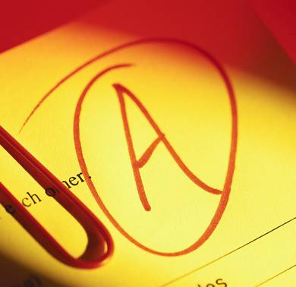
Online classes still carry a small stigma, but recent studies have rapidly eroded that perception. The fact of the matter is that students who take online classes tend to perform better than students who take traditional classes.
According to a study performed by the U.S. Department of Education, students doing at least some of their work online typically ranked in the 59th percentile in tests. Students who only learned in traditional classrooms, however, fell into the 50th percentile.

Given the pressures that many mothers feel to "have it all," online education just makes sense. It can offer more flexibility, cost less and make success easier.

Resources:
http://www.classesandcareers.com/advisor/guides-for-college-moms/online-college-for-moms/
http://www.boston.com/news/nation/articles/2010/11/17/online_college_enrollment_surged_in_09/
http://www.astrosociety.org/education/resources/success.html
http://www.finaid.org/savings/tuition-inflation.phtml
http://bits.blogs.nytimes.com/2009/08/19/study-finds-that-online-education-beats-the-classroom/
http://www.news.cornell.edu/chronicle/97/5.15.97/raising_kids.html
http://www.bls.gov/news.release/famee.nr0.htm

About Emily Green
Emily Green is a freelance writer with more than 6 years professional experience in blogging, copywriting, content, SEO, dissertation, technical, and theses writing. She has written more than a thousand webpage content articles ranging from mobile devices in tech to online degrees, student finances and beyond. When she's not writing for Copy for Bylines, she likes to read, bike and take her dog to the park.

