Teensy Batdector Manual V0.1

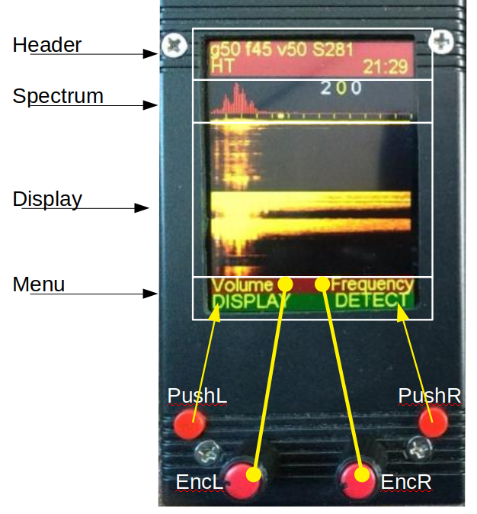
(foto credit Edwin )
Controls
The frontend of the batdetector has 4 controls, 2 pushbuttons (PushL and PushR) and 2 encoders (EncL and EncR). The encoders also have a pushbutton function.

Pushbuttons (PushL PushR)
The pushbuttons are used to switch between options based on the setting that is visible on the bottomline of the MENUsection. In the image above the bottomline of the MENU states DISPLAY for PushL and DETECT for PushR. If the user presses PushL the display-mode will change, and if the user presses PushR the detector-mode will change. The pushbuttons step through all possible options in a cyclic manner.

Encoders(EncL EncR)
The encoders are used to step through the menu (see below) and allow selecting a specific menu-item and then changing the setting for that item.
To do this the user rotates the encoder until it shows the menu-item on screen (in yellow) that needs changing. Then the user presses the Encoder and the colour of the menu-item changes from yellow to white. The encoder can now be used to control the setting of this menu-item by rotating (up is clockwise) the encoder. After setting the menu-item the encoder needs to be pressed again to confirm the setting and the colour of the menu will change from white to yellow again.
The left-encoder has the full menu available but the right encoder only can be used to set a few (the most used) options.

Screensections
The screen is divided in 4 sections, a header, a small spectrum , a dynamic display and a menu.

The header shows for several parameters (gain(g), frequency(f), volume(v) and samplerate(s) the current settings on the 1st line of text. The 2nd line shows on the left the current detector-mode (HT=heterodyne) and on the right the current time.

The spectrumsection shows a compact spectrum of the latest processed sounds, every 10Khz of the spectrum is shown with a yellow divider on the bottom and the yellow dot shows (for heterodyne detecting) the current frequency for heterodyne detecting,
On the topright 3 figures appear that will show the low-peak-high frequency (in Khz) of the latest detection.

The displaysection is used to show the incoming signals, it can be set to 3 modes (waterfall (as shown above), spectrum, no display). The spectrum shows a live spectrumgraph, the waterfall shows the spectrum over time and will scroll upwards every time a new signal is detected that has a peak above a set frequency (user set with menu TE_low).

The 1st line of the menusection shows the menu item that can be changed by the encoders. The left encoder has access to all menu items but the right encoder is limited to a smaller set of the same menu. The 2nd line of the menu shows the setting for a specific item that is controlled by the pushbuttons. In the example above for instance pushing PushL will step the display through its modes and pushing PushR will change the detector-mode.
The current options for the menu (version 0.90) are :
- Volume (0..90)
This set the volume of the headphones.
- Gain (0..63)
This sets the amplification (gain) of the microphone signal
- Frequency
Used in Heterodyne detection, is used to choose the center-frequency
- SampleRate (8,11,16,22,32,44,48,88,96,176,192,234,281,352)
The samplerate controls the maximum frequency that can be detected. Default this is set at 281k which translates to a maximum detection frequency of (roughly) 140khz.
- Denoise
Initiates a denoising routine that denoises the output on the screen (removes background noise) but has no effect on recordings or audio-output over the headphones.
- Preset
Preset currently has 2 settings Default or USER. If preset is set to Default at startup it will use for all user-controlled variables the pre-programmed setting. If preset is set to user it will use the settings the user has saved in Eeprom at startup.
- ButtonL
This menu-option can be used to set the Left Pushbutton to control a specific feature. By default the Left Pushbutton controls the Display but it can also be set to RECORD to allow easy recording.
- Time
This allows the user to set the systemtime of the teensy, this is only logical if the detector has been build with a 3v coinbattery for the RealTimeControl.
- TE_Speed (5..30)
This controls the speed of the Auto_TimeExpansion replay
- TE_Low (15..35)
Sets the lowest frequency (in Khz) where signals will be triggering Auto_TimeExpansion
- Play
Can be used to replay – TimeExpansion – earlier recordings
- PlayDirect (ONLY FOR DEBUGGING)
Is used to test (using a specific! Prerecorded file) some functionality.

PushButton options
The right pushbutton (PushR) is currently fixed to set the detectormode. The detector can be set to the following modes :

- HT : manual heterodyne.
This sets the detector as a normal heterodyne. When selecting this the encoders will (by default) be change to allow control of the volume (left) and the frequency(right). The centre-frequency is set in Khz and the produced audio is based on the difference in frequencies between the incoming signal and the centre-frequency.
- Auto HT : automatic heterodyne
This is the same as the HT mode but the centre-frequency is automatically controlled and will track the peak.
- Auto_TE : automatic TimeExpansion
In this mode the detector will wait for an incoming highfrequent signal and then directly replay that signal but at a slowed down speed. During this time (currently) no new signals can be detected and therefore in this mode you can also miss clicks of bats.
- FD : Frequency Divider
All incoming signals are divided by X (to be checked!!) to change them from ultrasonic to audible.
- PASS
The detector does not process the signal and just allows you to listen to the audible part.

The left PushButton (PushL) is by default set to control the DISPLAYmode. The display can be set to spectrum, waterfall and no display (see screensection). But the function of the PushButton can also be set to RECORD or PLAY by using the option ButtonL in the menu of the left-encoder.

- DISPLAY (see above)
- RECORD
When selected the detector is set to record raw data at the press of a button. When the left pushbutton is pressed a recording will start (the filename will be shown) and when the left pushbutton is pressed again the recording will stop.
- PLAY (not functional TO BE IMPLEMENTED)
This controls the play of previous recorded files at a lower samplerate.

(c(

Bat-Detector : Short Manual
This doc manual: Vers: 0.1 from Remis 30,09,19
Original design: https://forum.pjrc.com/threads/38988-Bat-detector
Software version: 0.89 from Corbee
PCB and original photo from Edwin

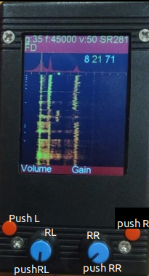 | Gain ; FHT ; Volume ; Sample Rate  Detect Mode  Screen in spectrogram display mode  Push Left (PL) PR Push Right (PR)  Rotary Left (RL) Rotary Right (RR)  Push Rotary Left Push Rotar Right

Button Menus:

Software version | V0.89
Action | Menu display | What | After Push RL again, then
Turn one step RL | Volume 50 | Change Volume | Turn RL , Push to confirm
Turn one step RL | Gain | Adjust MIC gain | Turn RL , Push to confirm
Turn one step RL | Frequency | Set FHT | Turn RL , Push to confirm
Turn one step RL | ButtonL | Set action result from PL | Turrn RL to choose  RECORD  PLAY  or DISPLAY  Push to confirm. See (1)
Turn one step RL | Denoise | ????
Turn one step RL | Spectrum | ????
Turn one step RL | SetTime | Change current time | Turn RL , Push to confirm
Turn one step RL | SampleR | Change SR | Turn RL, Push to confirm
Turn one step RL | Preset DEFAULT | To store current paremeters | See explanation below
Turn one step RL | TE_Spd 20 | Change speed for TE mode
Turn one step RL | TE_low15 | Change Low_F for TE_mode
Turn one step RL | Play | Play a recorded File
Turn one step RL | PlayR | ??????
Turn one step RL | Param10 | DON’T USe | DON’T USE

RL : The Rotary RIGH use the same principle to toggle beetween Frequency , volume, and Gain values.

PR : To select one of the detecting Mode.

PL and PR can have other effect if used after RL and RR for menu confirmation.

(1) PL : in DISPLAY mode : selectt the display : Simple spectrum ; No display ; Spectrogram
if RECORD : Start ; Stop record to SD card
if PLAY : Play a recorded file from SD card ???? which SR ?
PLAYr :??????

Frequency: value (Khz) of center frequency (FHT) for HT mode.

Detecting mode details:

PASS: no change on sound: you will see the spectrum of incoming signal. Use it to check microphone noise floor, gain (don’t saturate) and volume,

HT: Heterodyne : All the incoming sounds are shifted to audio range around FHT. If FHT=40Khz and incoming signal is 41Khz, the audio output will be at 1Khz. Same for incoming signal at 39Khz.

Auto_HT: The bat detector check pic frequency and adjust FHT to have an audible sound

Auto TE: Time expansion ? limits ?

FD: ?

TE_low : set de frequency limit under which BatDetector stop to search pic of frequency : to remove noise or crickets sounds effect in Auto_HT mode.

CHANGE A PARAMETER: Example for TE_low value

Turn RL until TE_low
Press RL : T_Low switch from yellow to white
Turn RL : Topdisplay show chnage value Tl19
Press RL : T_low switch from white to yellow

STORE ALL PARAMETERS:

After power on and adjusting your parameters (gain , frequency, TE_low…, detect mode) you can store theses parameters to recovers this setup at next power on. They are stored in _User
Turn RL until Press_Default.
Press RL : switch from yellow to white
Turn RL to select Press_User
Press RL ; switch from white to yellow
SD card : can be used to save a recorded audio file with original sample rate: prefered ‘’good’’ SD card: no low cost. Must be formatted in FAT32.

Read audio file on audacity:
After recording file on SD card you can read it again on computer to see

_select proper Sample Rate (SR) and register an audio file (record on and record off)
_turn-off the BatDetector
_remove the SD card and copy the *.raw file on your desktop
_import audio file under Audacity : <FILE<IMPORT<RAW DATA, in the dialog select Audacity will ask ;
-Encoding : set to signed 16bit
-Byte Order: Little Endian
-Channels : 1 channel
-Start Offset:0
-import : 100%
-sample rate: set that to your recorded rate in Hz with bat detector

After that you will see the file but you can’t listen to it since it is still ultrasonic. To listen use EFFECT-CHANGE SPEED and set that for instance to 0.1 (10 times slower replay so all frequencies are 10 times lower).

