# Topic 2 Notes:

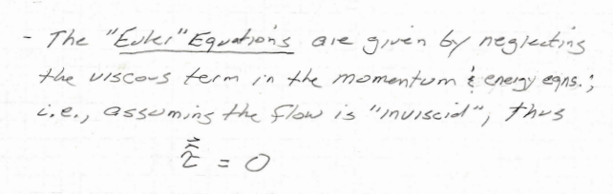

# Topic 3 Notes:

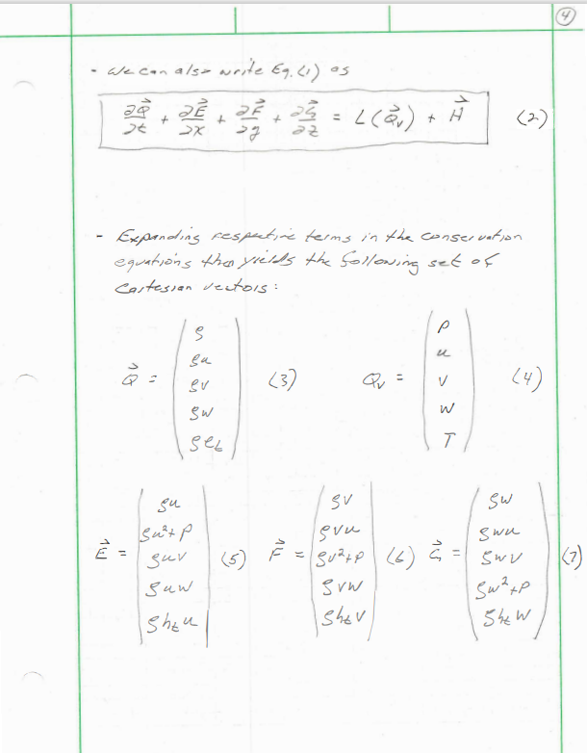

# Topic 23.1 Notes:

